|  |  |  |  |  |  |  |
| --- | --- | --- | --- | --- | --- | --- |
| **I LIKE ME** | | | | | | |
| **Stage: 3,** Year 5 | **Unit Duration:**8 Lessons | | | **Weeks** 1 2 3 4 5 6 7 8 | | **Terms** 1 2 3 4 |
| **Enduring Understandings**  E.1 As we are created in the image and likeness of God, all aspects of who we are in its essence is good.  E.2 Change and growth is a part of who we are.  E.3 The way people cope with change affects our health and wellbeing.  E.4 We have a responsibility to make wise decisions about our body and our relationships. | | | **Essential Questions**   * How does my body grow and change? * How do body changes affect the way I think and feel? * How do my values affect the choices I make? | | | |
| **Major Outcomes** Knowledge and Understanding **GDS3.9** Explains and demonstrates strategies for dealing with life changes  ***Skills***  **COS3.1** Communicates confidently in a variety of situations  ***Values and Attitudes***  **V1** Refers to a sense of their own worth and dignity | | | **Lesson Overview**   1. How am I similar and different to others? (E.1) 2. What are my strengths and achievements? (E.1) 3. What factors impact on my body image? (E.1,E.2, E.3) 4. How do I feel in different situations? (E3, E4) 5. How does my body grow and change? (E.2)   6. How does puberty begin? (E.2, E.4)  7. What’s happening for the boys and the girls? (E.2, E.3, E.4)  8. How do I cope with physical change? (E.3, E.4) TEACHER NOTES  * **Parents are to be informed by letter prior to commencement of the unit. See sample on website** [**http://pdhpek10.weebly.com/k-6-pdh-sample-units.html**](http://pdhpek10.weebly.com/k-6-pdh-sample-units.html) * **Regularly send the student workbooks home each week for comment/feedback.** * This unit deals with a sensitive topic and needs to be dealt with according to the school’s policy and within the Catholic context. * Teachers provide link to clips from Kids Health website in their term Curriculum Information Note. * Resources need to be approved by the principal and parents are to be informed of the content of the lesson. * Teacher review sample FAQs for Sexuality Education in the Support Materials Section   <http://pdhpek10.weebly.com/k-6-pdh-sample-units.html> | | | |
| **Contributing Outcomes** Knowledge and Understanding **IRS3.11** Describes roles and responsibilities in developing and maintaining positive relationships  ***Skills***  **DMS3.2** Makes informed decisions and accepts responsibility for consequences  **INS3.3** Acts in ways that enhance the contribution of self and others in a range of cooperative situations  **PSS3.5** Suggests, considers and selects appropriate alternatives when resolving problems  ***Values and Attitudes***  **V2** Respects the rights of others to hold different values and attitudes from their own  **KidsMatter SEL Focus**  **Major:** Relationship Skills – Communication; Self Awareness -Recognising Strengths; Self-Awareness - Identifying emotions; Self- Management - Managing emotions; Responsible Decision Making -Respecting others; Social Awareness – Appreciating Diversity, Social Awareness – Perspective Taking; Relationship Skills – Building Relationships  **Minor:** Self Awareness - Identifying emotions;  Self-Awareness - Recognising Strengths; Social Awareness – Appreciating Diversity | | |
| **Catholic Dimension/Towards Wholeness (TW) (Also refer to overview of TW for this unit)** **Growth and Development** God has created each of us to grow into the fullness of life. We are made in God’s image and therefore, we are of inherent dignity and worth. Our sexuality is an intrinsic part of ourselves, to be celebrated and expressed with joy and responsibility, according to God’s plan. Each person grows and changes, passing through stages on a journey towards full maturity. God is with us on this journey, reassuring and challenging. We are never alone. Interpersonal relationships Human beings find their true place within community; they grow towards maturity through the relationships they maintain. We all depend on each other and, as we mature, we grow in awareness of our responsibility for each other. Alone and isolated we cannot develop our gifts and live as God intended. Among family, friends, members of our peer group and others, we find our place as contributing members of society. It calls us all to enter freely into loving and forgiving relationships that are embedded in community, to develop such qualities as honesty, respect, empathy, openness and a commitment to equality. | | | | | | |
| **Foundation Statements**  Students examine key factors that contribute to a balanced lifestyle and keeping safe and healthy. They examine nutritional information, disease prevention and the effects of drugs on the body and they identify behaviours that impact on wellbeing. Students assess the safety of situations in home, school, water and road environments and identify appropriate responses. They describe and practise a range of personal safety strategies that could be used in threatening or abusive situations. They take responsibility for personal decisions, recognising the effects that decisions have on self and others.  Students describe the factors that influence personal identity and examine the physical, social and emotional changes that occur during puberty. They devise strategies for coping with change, grief and loss. They value the differences between individuals and challenge discrimination and harassment. Students value different roles and responsibilities in relationships, the importance of communication and they practise positive ways to deal with conflict. | | | | | | |
| **Suggested correlations with other KLAs**  English   * Narrative Text (concept development) * Explanation * Personal Recount * Information Report   Creative Arts   * Drama – Performing and Appreciating | | | Mathematics   * Data Representation   + Length   + Mass * Working mathematically   ***HSIE***   * Cultures   + Cultural influences   - Belief Systems | | | |
| **Technology** The following websites have been selected to enhance various concepts being taught throughout this unit. Most of the sites listed can be linked to more than one of the lessons being taught. Teachers may like to add them to the school intranet site. Some of the following sites have a great deal of information and it is important for the teacher to choose sections that are relevant to the needs and maturity of his/her class.  * + - * [http://pbskids.org/itsmylife/body/puberty/index.html](https://webmail.dbb.org.au/OWA/redir.aspx?SURL=-k2_r84UM6yKlBfkO4EjAjE-ufb8HZ56RpIyBvBnZWwuS1BxSaTSCGgAdAB0AHAAOgAvAC8AcABiAHMAawBpAGQAcwAuAG8AcgBnAC8AaQB0AHMAbQB5AGwAaQBmAGUALwBiAG8AZAB5AC8AcAB1AGIAZQByAHQAeQAvAGkAbgBkAGUAeAAuAGgAdABtAGwA&URL=http%3a%2f%2fpbskids.org%2fitsmylife%2fbody%2fpuberty%2findex.html) - for use by children for their reference, with teacher direction       * [http://kidshealth.org/kid/grow/index.html](https://webmail.dbb.org.au/OWA/redir.aspx?SURL=P9z2HkgUqFLdoc6lQqE_oSzLhubpeF0P157fVk80mg4uS1BxSaTSCGgAdAB0AHAAOgAvAC8AawBpAGQAcwBoAGUAYQBsAHQAaAAuAG8AcgBnAC8AawBpAGQALwBnAHIAbwB3AC8AaQBuAGQAZQB4AC4AaAB0AG0AbAA.&URL=http%3a%2f%2fkidshealth.org%2fkid%2fgrow%2findex.html) - for use by children for their reference, with teacher direction       * [http://www.pamf.org/preteen/mybody/](https://webmail.dbb.org.au/OWA/redir.aspx?SURL=Dyv62QUZkhdfsLO4Cg_l0V45HJ4zMBo54QDydh89ed8uS1BxSaTSCGgAdAB0AHAAOgAvAC8AdwB3AHcALgBwAGEAbQBmAC4AbwByAGcALwBwAHIAZQB0AGUAZQBuAC8AbQB5AGIAbwBkAHkALwA.&URL=http%3a%2f%2fwww.pamf.org%2fpreteen%2fmybody%2f)  - good medical information for parents | | | | | | |
| **Subject Matter** ***Growth and Development***Personal Identity  * Influences on self-esteem and behaviours * Feelings * about self and others * Gender images and expectations  The BodyBody systems  * Functions * Interrelationships  Human SexualityChanges at puberty  * Menstruation | | **Changes** Identify changes  * Physical, social, emotional * Methods of coping with change * Activity, relaxation, stress management * Grief and loss   + Dealing with emotions  Values  * Importance of values * Influences on personal values * Uniqueness of self * Identity, development, goals  Challenging discrimination | | | Interpersonal relationships **Relationships** Personal rightsImportance of positive relationships  * Challenging discrimination   + Anti-discrimination legislation  GroupsTypes of groupsWorking with othersSharing and helpingInteracting with adultsCommunicationSupporting others  * Recognising and articulating feelings | |
| **Unit Evaluation**  Sample teacher and student unit evaluations are included at the end of the unit. | | | **Assessment**  Assessment strategies are included in each unit/lesson.  The assessment task for this unit is in Lesson 1. | | | |

An Overview of Towards Wholeness (TW) in the PDH Unit

**I Like Me - Stage 3**

**Key God’s Word:**

**Our body is a gift of God, ‘God’s temple’ (1 Cor 3:16) to be treated with respect. (TW p. 19)**

**It is our responsibility to be faithful to ourselves, others and God in all areas of our life. (Ecc 25: 1-2). (TW p. 24)**

**Each individual is created in the image and likeness of God. (Gen 1:27-28:2:23-24) (TW p. 26)**

|  |  |  |
| --- | --- | --- |
| **Enduring Understandings** | **Beliefs and Values** | **Lesson Overview/Links** |
| E.1 As we are created in the image and likeness of God all aspects of who we are in its essence is good. | * Every person is unique, with God-given gifts. TW p.19 * We are created in the image and likeness of God. TW p.19   + God calls me to become a complete person, to build a strong sense of self worth, to grow and develop to my full potential. TW p.24 | 1. How am I similar and  different to others?  2. What are my strengths and achievements?  3. What factors impact on my  body image? |
| E.2 Change and growth is a part of who we are. | * Every person is unique, worthy of respect and love, created in the image and likeness of God. TW p.24 * Our body is a gift of God. TW p.19 * We should appreciate and respect our body and the bodies of others. TW P.25 * Sexuality is a God-given gift. TW p.26 | 3. What factors impact on my  body image?  5. How does my body grow and change?  6. How does puberty begin?  7. What’s happening for the  boys and the girls? |
| E.3.The way people cope with change affects our health and wellbeing. | * We should be aware of emotions as contributing to the richness of life. TW p.26 * As we grow and develop we enjoy all our capacities and gifts, our intellect, our emotions, our spirit, our will and our physical bodies. TW p.27 | 3. What factors impact on my  body image?  4. How do I feel in different  situations?  7. What’s happening for the  boys and the girls?  8. How do I cope with physical  change? |
| E.4. We have a responsibility to make wise decisions about our body and our relationships. | * We have an obligation to care for others and ourselves. TW P.25 * We appreciate and respect our bodies and the bodies of others. TW p.26 | 4. How do I feel in different  situations?  6. How does puberty begin?  7. What’s happening for the  boys and the girls?  8. How do I cope with physical change? |

**Lesson 1 How am I similar and different to others?**

|  |  |  |  |
| --- | --- | --- | --- |
| **Enduring Understandings** | **Outcomes** | **Indicators** | |
| E.1. As we are created in the image and likeness of God all aspects of who we are in its essence is good. | COS3.1 Communicates confidently in a variety of situations  GDS3.9 Explains and demonstrates strategies for dealing with life changes  V1 Refers to a sense of their own worth and dignity  V2 Respects the rights of others to hold different values and attitudes from their own | * Articulates the   characteristics that make  them unique   * Recognises a range of influences on personal identity * Accepts themselves as they grow and change * Appreciates the similarities and differences between themselves and others | |
| **KidsMatter SEL Focus:** Major - Relationship Skills – Communication; Minor - Self Awareness - Identifying emotions; Self Awareness - Recognising Strengths | | | |
| **Suggested Learning Experiences**  Note:   * **Parents are to be informed by letter prior to commencement of the unit. (See sample on PDHPE website** [**http://pdhpek10.weebly.com/k-6-pdh-sample-units.html**](http://pdhpek10.weebly.com/k-6-pdh-sample-units.html) * **Regularly send the student workbooks home each week for comment/feedback.**   Teacher introduces the unit by asking students to identify the differences in a ‘[Spot the Difference](http://pics-about.space/cute-astronaut?p=1#img6408729523341719164)’ cartoon.  Teacher poses the following stimulus questions for students to discuss in pairs: What is different about you and the person sitting next to you?  * How can these differences complement each other or work well together? * What is the same about you and the person sitting next to you? * How would you feel if you were the same as the person sitting next to you? * What are your strengths - What you are good at and passionate about? The teacher may link this to the SEL continuum? <http://wellbeing.dbbcso.org/component-2.html>   Pairs present their similarities and differences to the class. Highlighting the positives of diversity and the importance of knowing your strengths. Eg, one may be good at writing, the other illustrating how they could complement and work well together in a particular situation.  TW: Review the definition of the word unique. Bring the students to a common understanding that every person is unique, with God-given gifts and worthy of respect and love. In pairs, each student identifies the unique qualities/characteristics of their partner. Choose one of these qualities/characteristics and explains why it makes this person worthy of respect and love.  Individually, students begin the *Personal Dossier* Activity that highlights their personal identity and strengths. In small groups, students share their initial dossier ideas. (This may be added to and continued throughout the unit.)  Complete the *Similarities/Differences* Activity sheet. e.g.: Chris - I am like Jai because we both like dogs. I am different to Caitlyn because she likes Barbies | | | |
| **Resources**   * *SEL continuum* [*http://wellbeing.dbbcso.org/component-2.html*](http://wellbeing.dbbcso.org/component-2.html) * Spot the Difference cartoon * Personal Dossier Activity * A3 Art paper, textas, glue, scissors, * Magazines * *Similarities/Differences* Activity | | | **Assessment**  Portfolio task  Personal Dossier |

**Similarities and Differences – Personal Dossier**

A dossier means a file of information about a person. Include in your dossier:

* Name in full
* Favourite colour
* Strengths – What are you good at? What are you passionate about?
* Learning and wellbeing goals
* Hobbies/interests
* Nickname
* Fingerprint/handprint/footprint
* Hair colour
* Eye colour

TW: Catholic Beliefs and Values

* We are created in the image and likeness of God.
* Every person is unique, with God-given gifts and worthy of respect and love.
* God calls me to become a complete person, to build a strong sense of self-worth, to grow and develop to my full potential.
* Family and pet photos
* Names of friends (at school and outside school)
* What activities I do with my friends
* What activities I do with my family
* What profession/career I want to learn
* Happiest memories
* Proudest moments
* Names and age of siblings
* Place and date of birth

## Favourite food

* Favourite TV show
* Favourite group/band/singer
* Favourite sporting team/individual

Present your dossier on cardboard, in a scrap book or on sheets of A3 paper. Use magazine pictures and drawings to present your dossier.



Explain how:

* the CatholicBeliefs and Values above, influences the way you think and act towards others in your class, school and community.

Understanding your SEL strengths can impact on how well you engage in learning?

* Explains and demonstrates strategies for dealing with life changes.

**Similarities and Differences**

**This task provides students with the opportunity to demonstrate their standard of achievement of the following outcomes:**

|  |  |  |  |  |
| --- | --- | --- | --- | --- |
| **Outcomes** | **Indicators** | **Working towards** | **Achieved with support** | **Achieved** |
| COS3.1 Communicates confidently in a variety of situations | Articulates the characteristics that make them unique |  |  |  |
| GDS3.9 Explains and demonstrates strategies for dealing with life changes | Recognises a range of influences on personal identity |  |  |  |

|  |  |  |
| --- | --- | --- |
| **Group Member** | **Similarities to you** | **Differences from you** |
|  |  |  |
|  |  |  |
|  |  |  |
| **4.** |  |  |

**Lesson 2 What are my strengths and achievements?**

|  |  |  |  |
| --- | --- | --- | --- |
| **Enduring Understandings** | **Outcomes** | | **Indicators** |
| E.1 As we are created in the image and likeness of God all aspects of who we are in its essence is good. | GDS3.9 Explains and demonstrates strategies for dealing with life changes  INS3.3 Acts in ways that enhance the contribution of self and others in a range of cooperative situations  V1 Refers to a sense of their own worth and dignity | | * Identifies own strengths and achievements as well as those of peers * Acknowledges the strengths and achievements of others * V1 Refers to a sense of their own worth and dignity |
| **KidsMatter SEL Focus:** Major - Self Awareness -Recognising Strengths; Self-Awareness - Identifying emotions | | | |
| **Suggested Learning Experiences**  Several students are selected to share some information from their Personal Dossier (Lesson 1). Teacher discusses and reinforces the concept of being unique. Teacher also identifies strengths using the SEL continuum.  Students are asked to think of an achievement in their life and share with the class by responding to the following questions:   * Why was this an achievement in your life? * How did you feel about this achievement? * How do you think your friends and family felt about this achievement? * Did this achievement influence your future behaviour? How? * How did your SEL skills influence your achievements? * Who and/or what influenced you to achieve this proudest moment?   Students use coloured stars on which to write or draw:   * three strengths -things they believe they are good at * three things they have achieved * three things that their friends and family believe they are good at.   Students paste their stars in their books with a heading ‘My Personal Strengths and Achievements’.  Each student traces around their hand and chooses one strength or achievement (identified and recorded on their star) and then records this on their hand/foot cut-out. As a class, students share their strengths and paste their hand cut-out on a wall display titled, ‘Our Class Strengths and Achievements’.  Students identify and practise ways to acknowledge the achievements of others – pat on the back, merit certificates, school assembly, applause, prizes, parent and teacher recognition (verbal comments).  Whilst awards are important, the teacher discusses the difference between intrinsic versus extrinsic motivation. Students discuss the importance of doing something because it is the right thing to do for personal growth, meaning, identity and living in a community, class or family, rather than to do something just to get an award (extrinsic). | | | |
| **Resources**   * SEL continuum <http://wellbeing.dbbcso.org/component-2.html> * Coloured paper, textas, scissors, glue * Cardboard for star and hand/foot cut-outs * Paper for wall chart, or blutac hand/foot cut-outs on wall | | **Assessment**  Teacher observation of student responses to questions relating to strengths and achievements and of students complementing each other’s achievements | |

**Lesson 3 What factors impact on my body image?**

|  |  |  |  |
| --- | --- | --- | --- |
| **Enduring Understandings** | **Outcomes** | | **Indicators** |
| E.1 As we are created in the image and likeness of God all aspects of who we are in its essence is good.  E.2 Change and growth is a part of who we are.  E.3 The way people cope with change affects our health and wellbeing. | DMS3.2 Makes informed decisions and accepts responsibility for consequences  GDS3.9 Explains and demonstrates strategies for dealing with life changes  V1 Refers to a sense of their own worth and dignity | | * Discerns the reliability of what is presented in the media regarding body image * Explores how expectations of males and females can influence their choices and options * Appreciates that their physical, social, emotional and intellectual development is unique * Accepts themselves as they grow and change |
| **KidsMatter SEL Focus:** Major - Self Management - Managing emotions;Self-Awareness - Identifying emotions**;** Minor – Social Awareness – Appreciating Diversity | | | |
| **Suggested Learning Experiences**  Look at some examples of how male and female bodies are portrayed in the media. Use magazine pictures, Barbie and Ken dolls etc. Recall some of the images presented on television or in the magazines.  Brainstorm and discuss some phrases and feelings associated with popular body image, eg beautiful, cool, trendy, hunky, skinny, muscular, attractive, gorgeous, elegant, hunk, six pack.  TW Discuss the differences between real people and models and why models are portrayed in an unrealistic way. Refer to Youtube clip - [www.**you**tube.com/watch?v=wla5slC6Qhs](http://www.youtube.com/watch?v=wla5slC6Qhs)  As Catholics we believe that we are created in the image and likeness of God.  In small groups explore how the media and society’s perceptions, distort this belief and the uniqueness and worth of each person AND how SEL skills influence how we think and feel.  In pairs, complete the *Gender and Body Image* Activity**.** Share your response with the next pair.  Debate discussion topic ‘The media affects body image and our self-worth’. changed from ‘The early sexualisation of children is a real concern’  TW: Remind students that we should appreciate and respect our body and the bodies of others. In light of this Catholic belief, students discuss the following questions:   1. Why is it important to like ourselves as we really are? 2. How does body image affect self-esteem? 3. How does being a boy/girl affect the way we might feel about our body? 4. What factors influence our body image?   5. How can you improve your body image and self-esteem? Eg, focus on how SEL skills influence how we think and feel eg. Growth v fixed mindset, strengths, positive self-talk, pick friends that value you, refocus things from the negative to the positive. | | | |
| **Resources**   * Magazines and catalogues * Dolls ( Barbie and Ken) * *Gender and Body Image* Activity | | **Assessment**  Student responses to *Body Image* Activity | |

Gender and Body Image

[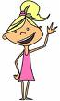](http://images.google.com.au/imgres?imgurl=http://www.drawingcoach.com/image-files/cartoon_girl_st5.gif&imgrefurl=http://www.drawingcoach.com/cartoon-girl.html&usg=__stUoQqyE5hANumtRbeRnRpM0V_o=&h=238&w=141&sz=6&hl=en&start=3&um=1&tbnid=Fqxxc2VcWTlauM:&tbnh=109&tbnw=65&prev=/images?q=cartoon+girl&hl=en&rlz=1W1ADSA_en&um)

[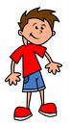](http://images.google.com.au/imgres?imgurl=http://www.teachmecartoons.com/images/cartoon-boys.jpg&imgrefurl=http://www.teachmecartoons.com/how-to-draw-a-cartoon-boy.html&usg=__JgnxyClSRiTihaUqRIig7eHAMWk=&h=494&w=283&sz=24&hl=en&start=1&um=1&tbnid=kU7_iedZB0yP0M:&tbnh=130&tbnw=74&prev=/images?q=cartoon+boy&hl=en&rlz=1W1ADSA_en&um)

|  |
| --- |
| * How are boys expected to dress? |

|  |
| --- |
| * How are girls expected to dress? |

|  |
| --- |
| * What body images are portrayed as popular by the media for girls? |

|  |
| --- |
| * What body images are portrayed as popular by the media for boys? |

|  |
| --- |
| * How do SEL skills effect the way a person sees their body image and how they cope with changes in their body? |

|  |
| --- |
| * What might happen to a person who feels they do not fit the accepted shape/image? |

|  |
| --- |
| What do you think Jesus would say is important for young people to remember about the way you look and act? |

**Lesson 4 How do I feel in different situations?**

|  |  |  |  |
| --- | --- | --- | --- |
| **Enduring Understanding** | **Outcomes** | **Indicators** | |
| E.3 The way people cope with change affects our health and wellbeing.  E.4We have a responsibility to make wise decisions about our body and our relationships. | COS3.1 Communicates confidently in a variety of situations  DMS3.2 Makes informed decisions and accepts responsibility for consequences  IRS3.11 Describes roles and responsibilities in developing and maintaining positive relationships  V2 Respects the rights of others to hold different values and attitudes from their own | * Articulates feelings in a variety of situations * Identifies strategies to manage negative feelings and express their feelings appropriately * Shows sensitivity to the needs, rights and feelings of others   + Appreciates the similarities and differences between themselves and others | |
| **KidsMatter SEL Focus:** Major - Self Management - Managing emotions | | | |
| **Suggested Learning Experiences**  Brainstorm feelings and list on flashcards using the *Feelings Faces* Activity. Describe an experience related to each emotion/feeling, eg worried – When my dad was in hospital.  Students mime their response to the following situations:  An itchy back Stepping out of a warm house into the cold  Winning first place in a race Receiving a surprise birthday gift  Eating your favourite dinner Being in the dark and having a cat brush past you  Cutting yourself on paper Having untrue things said about you  Handling a spider Arguing with a sibling  Discuss the feelings experienced during the mimes noting whether they are positive or negative and whether they create a physical sensation (eg goose bumps, butterflies in the stomach, racing heart-beat) or emotion (eg frightened).  Recall negative or unpleasant feelings listed on cards. Discuss physical responses associated with these feelings, eg facial expressions, trembling, shouting, butterflies in stomach. Discuss appropriate and inappropriate ways to express feelings. List some strategies to help manage negative feelings, including putting things into perspective. (Is it a big thing or a little thing?) Students complete the *I Feel Good* Activity.  TW: TEACHER NOTE: It is essential that students are made aware of the importance of identifying and sharing their feelings and knowing that emotions contribute to the richness of life.  Using the “Pain of a Project” Encounter (REDI, 2003, The Big Move) students read the Information Sheet sections on “causes of stress”. In pairs students create a mobile that clearly identifies some of the factors that create stress. Students read the section of the Information Sheet “how to manage stress”. Students prepare a cartoon strip in which they are having a conversation with Carla & trying to find out what is causing Carla to be stressed & making suggestions as to how she could manage her stress.  Review the SEL continuum and discuss how SEL skills influence the way a person copes with change? How a person can improve their SEL skills?  **HOME TASK**  Interview an adult at home using the *How Do You Feel?* Activity.  Discuss how the adults SEL skills influence the way they cope with change? How can a person improve their SEL skills? | | | |
| **Resources**   * *SEL continuum* [*http://wellbeing.dbbcso.org/component-2.html*](http://wellbeing.dbbcso.org/component-2.html) * *I Feel Good* Activity; *How Do You Feel?* Activity * Board of Studies. NSW. (1998). *PDHPE K–6 Teaching Kit Playing a Part Interpersonal Relationships Stage 3 Feelings Faces* Activity*.* p 57. Flashcards or Make your own feeling faces cards. * Commonwealth Department of Education, Science & Training. (2003). REDI: The Big Move. Canberra: Author. | | | **Assessment**  Student responses to feelings situations |

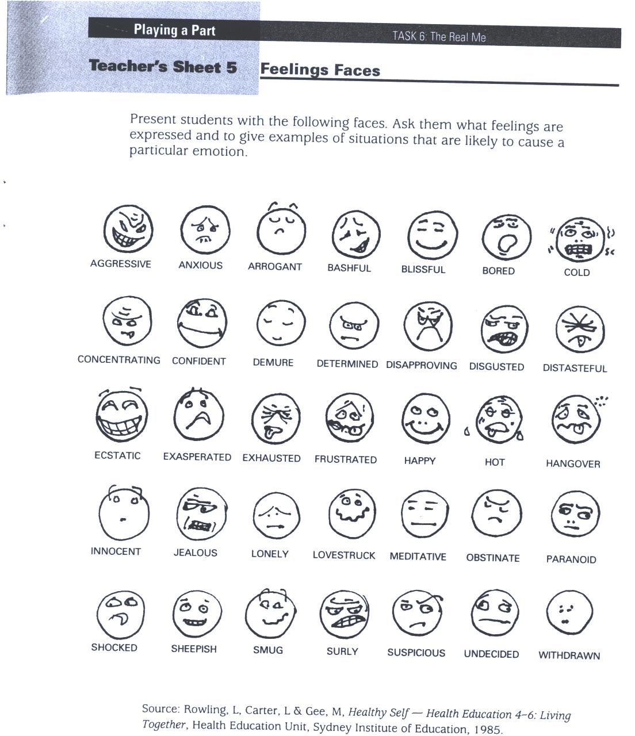

Adapted and reproduced with kind permission from: Board of Studies. NSW. (1999). *Personal Development. Health and Physical Education K–6 Teaching Kit. Playing a Part Interpersonal Relationships*. Stage 3. Sydney: BOS. p 57.



I Feel Good!

|  |
| --- |
| Describe something that makes you feel good.  (This may be a person, place or activity.) |

|  |
| --- |
| List some words to describe the feelings  and emotions this creates. |

|  |
| --- |
| Why are SEL skills important in helping you to manage negative  feelings? |

|  |
| --- |
| What could you do each day to create some  positive feelings? |

Don’t forget Jesus can help us to be positive if we ask Him.



How Do You Feel?

Interview an adult at home and record their responses to the following questions:

1. What is one of your happiest memories from your childhood?

____________________________________________________________

____________________________________________________________

____________________________________________________________

2. What things made you feel unhappy or angry when you were a child?

____________________________________________________________

____________________________________________________________

____________________________________________________________

3. What do you do each day to make yourself happy?

____________________________________________________________

____________________________________________________________

____________________________________________________________

4. What can you do to help overcome negative feelings?

____________________________________________________________

____________________________________________________________

____________________________________________________________

5. How can you improve your SEL skills?

____________________________________________________________

____________________________________________________________

____________________________________________________________

**Lesson 5 How does my body grow and change?**

|  |  |  |  |
| --- | --- | --- | --- |
| **Enduring Outcomes** | **Outcomes** | | **Indicators** |
| E.2. Change and growth is a part of who we are. | GDS3.9 Explains and demonstrates strategies for dealing with life changes  COS3.1 Communicates confidently in a variety of situations  V1 Refers to a sense of their own worth and dignity | | * Recognises that many changes occur in a predictable sequence * Describes aspects of physical development * Designs and presents a timeline of life stages * Accepts themselves as they grow and change |
| **KidsMatter SEL Focus:** Major - Responsible Decision Making -Respecting others | | | |
| **Suggested Learning Experiences**  TW: TEACHER NOTE: It is important to inform the students that they are going to be talking about the body and how it changes as they grow. Our body is a gift of God, ‘God’s Temple. (1 Cor. 3:16) The changes are a gift from God and should be understood and respected. Explain that the correct terms of the sexual parts of our body will be used and therefore, they need to be sensible during the lesson.  **Note:** To provide the **opportunity for parents to engage** with their child it is suggested to send their PDH book home at the end of each week with a class question or an invitation to make comment and provide feedback.  Throughout this unit **review the following class values/rules** for the sensitive issues unit:   * Respect each other’s opinions (no put downs) * Respect people’s privacy – do not use people’s names * Keep confidential what others say in class (do not go and tell younger students) * Respect each other’s feelings e.g the right to pass for student/teacher   Guide a controlled discussion on how students can best show their appreciation of the gift of their body. “What lifestyle choices indicate a healthy respect for our body?” E.g. (physical-diet and exercise, social- friendships, sexual- body image and gender stereotyping).  Students construct a life stages timeline from birth to old age. Students write words such as baby, child, teenager, adult, middle age, old age at various stages along the timeline. Using magazines, students cut out appropriate pictures of each developmental stage and paste them along their timeline.  In groups, students list the physical changes of each stage, eg baby has no teeth, head relative to body size, hair growth, weight, height. As a class, discuss the similarities and differences between the different stages of growth and development.  Introduce Home Task and discuss who they should interview. After Home Task, discuss responses.  **HOME TASK**  Students interview a parent/carer about when they went through puberty. Can you remember how it felt when you first noticed changes? Did you feel excited? Were you anxious? How did you cope with the changes? Did you talk with your Mum and Dad about it? How do SEL skills help you to cope with changes? How can they be improved? | | | |
| **Resources**   * Research and recording tools | | **Assessment**  Student work samples of time-line  Interview responses | |

**Lesson 6 How does puberty begin?**

|  |  |  |  |
| --- | --- | --- | --- |
| **Enduring Understanding** | **Outcomes** | **Indicators** | |
| E.2. Change and growth is a part of who we are.  E.4.We have a responsibility to make wise decisions about our body and our relationships. | GDS3.9 Explains and demonstrates strategies for dealing with life changes  COS3.1 Communicates confidently in a variety of situations  V1 Refers to a sense of their own worth and dignity | * Recognises that many changes occur in a predictable sequence * Devises questions to clarify understandings related to puberty * Accepts themselves as they grow and change | |
| **Suggested Learning Experiences**  TW: Our body is a gift of God, ‘God’s temple’ (1 Cor 3:16) to be treated with respect.  It is our responsibility to be faithful to ourselves, others and God in all areas of our life.  Each individual is created in the image and likeness of God.  Students use their timeline from the previous lesson and discuss why do we change?  Teacher focuses students’ attention on changes from child to teenager and how everyone has their own body clock for changes in physical development.  In small groups, students brainstorm changes they know that will occur during puberty for **both boys and girls**. Record these on A3 paper. As a class, groups share their responses by pinning their A3 paper on the wall and the class walks past each group’s responses and can add ideas to each list.  For the following activities, it is recommended that teachers preview the video clips prior to the lesson. You may also consider whether you split the boys and girls at some stage for question time or a debrief. You may also need to copy and paste the link in your browser, as some computers will not enable the link.  Watch clip: *What Boys want to know about Puberty* - changes for boys, different rates as normal  <http://kidshealth.org/kid/grow/body_stuff/boys_puberty.html>  (It briefly mentions sperm fertilising woman’s egg. Student’s may ask questions, however, teachers would be advised to leave a detailed explanation of reproduction until the Year 6 Unit and give the children the option of speaking with their parents).  Watch clip: *Are you Normal? Girls and Puberty* – answers questions such as: When will my [breasts](http://kidshealth.org/kid/grow/girlstuff/breasts_bras.html) grow? What's the "normal" age to get your [first period](http://kidshealth.org/kid/talk/qa/when_period.html)?  [http://kidshealth.org/kid/grow/girlstuff/puberty-normal-video.html](http://kidshealth.org/kid/grow/girlstuff/puberty-normal-video.html#cat20449)  Watch clip: *Menstruation* – explains The Menstrual Cycle  <http://kidshealth.org/kid/grow/girlstuff/when_period.html>  **TEACHER NOTE:**  **It is suggested that teachers provide the above video clips on their Curriculum Note for the term.**  Refer to *Teacher Information sheet 1 ‘How does puberty begin? The role of hormones’***.**   * In groups children write: “A definition for puberty and write it down.”  Use one, three, six strategy. (Individual, with two others and then group of six.) Class develops whole class definition. * Discuss the role of hormones and puberty. Teacher needs to emphasise the role of the pituitary gland in the stimulation of the sex glands and the production of sex hormones. * Discuss the importance of talking with mum or dad. How have you or how can you talk with your mum or dad about this important issue? | | | |
| **Resources**   * A3 Paper * Kids Health (1995 – 2015) The Nemours Foundation. http://kidshealth.org/kid/grow/ | | | **Assessment**  Students contribution to discussion about changes during puberty |

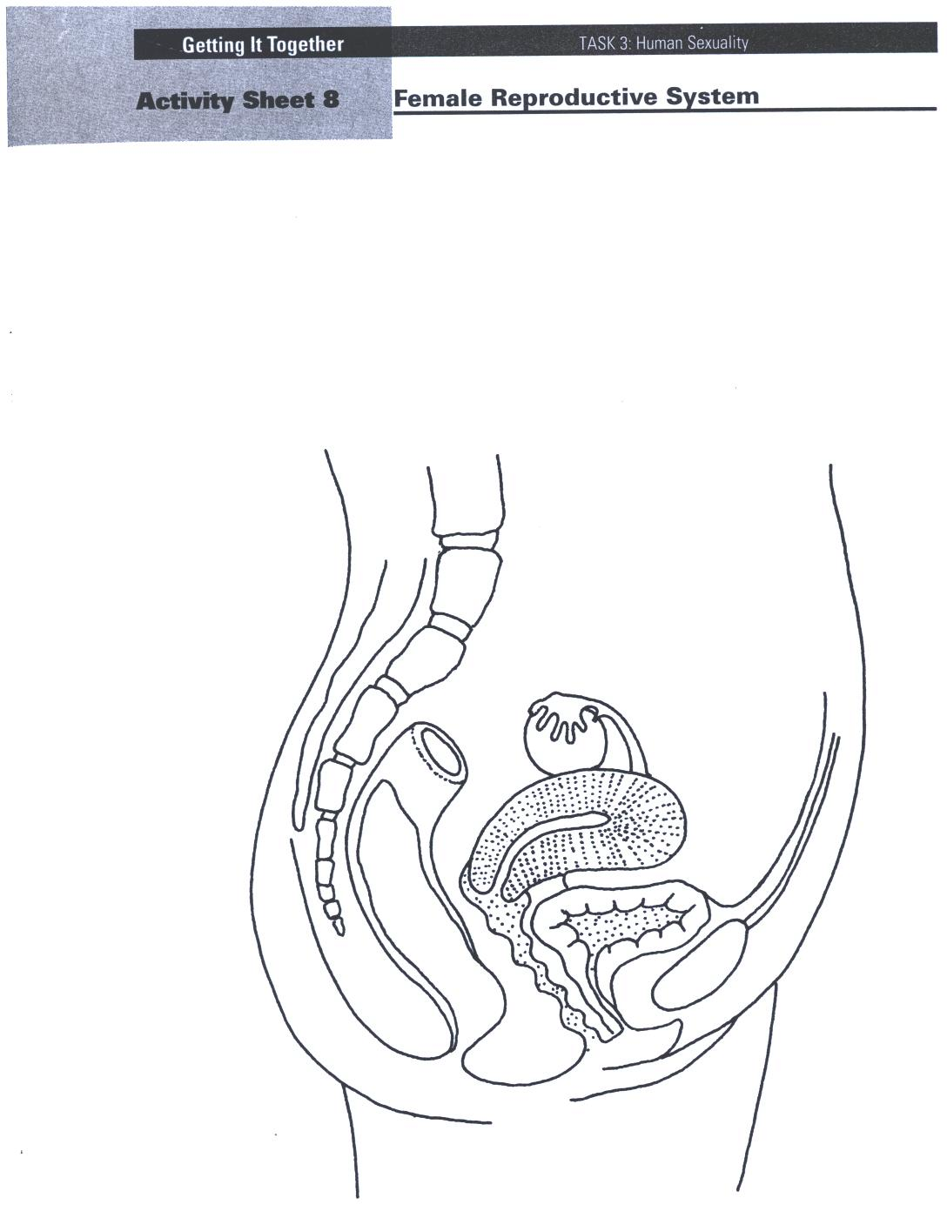

|  |
| --- |
| Reproduced from: Board of Studies NSW (1998) *Personal Development, Health and Physical Education K–6 Teaching Kit: Interpersonal Relationships; Growth and Development;* and *Safe Living* Stages 1-3. |

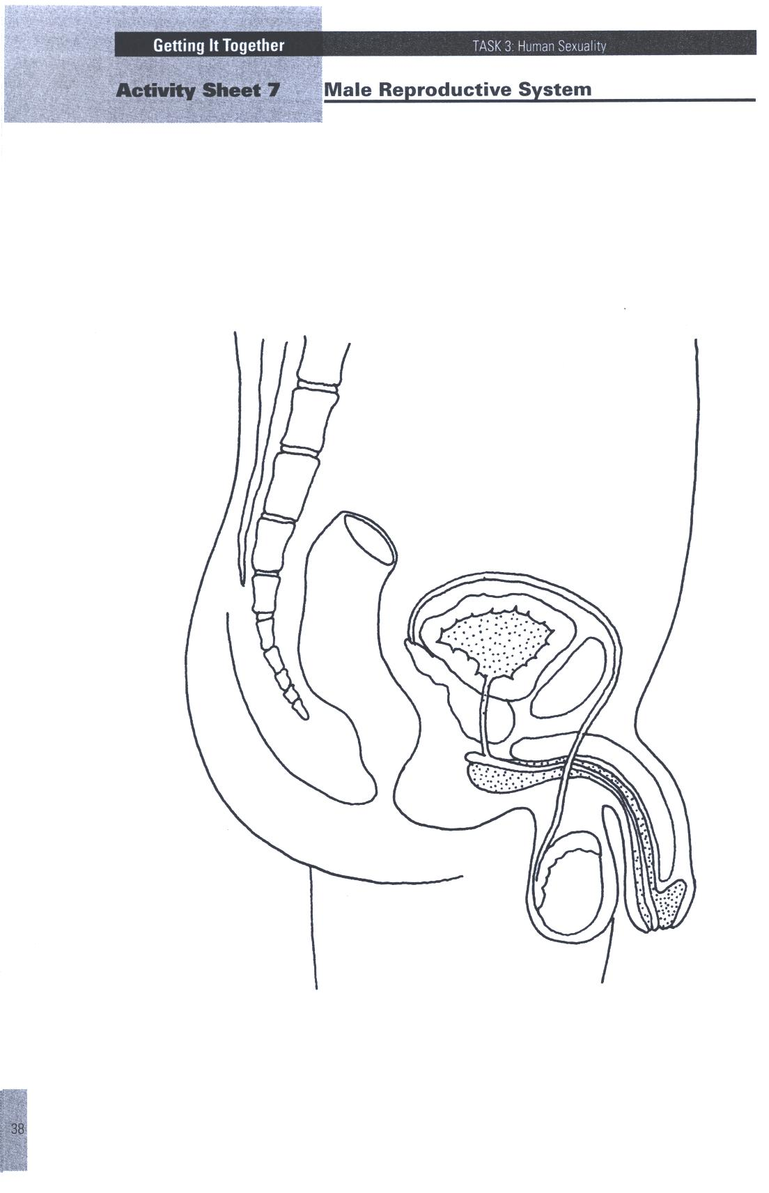

|  |
| --- |
| Reproduced from: Board of Studies NSW (1998) *Personal Development, Health and Physical Education K–6 Teaching Kit: Interpersonal Relationships; Growth and Development;* and *Safe Living* Stages 1-3. |

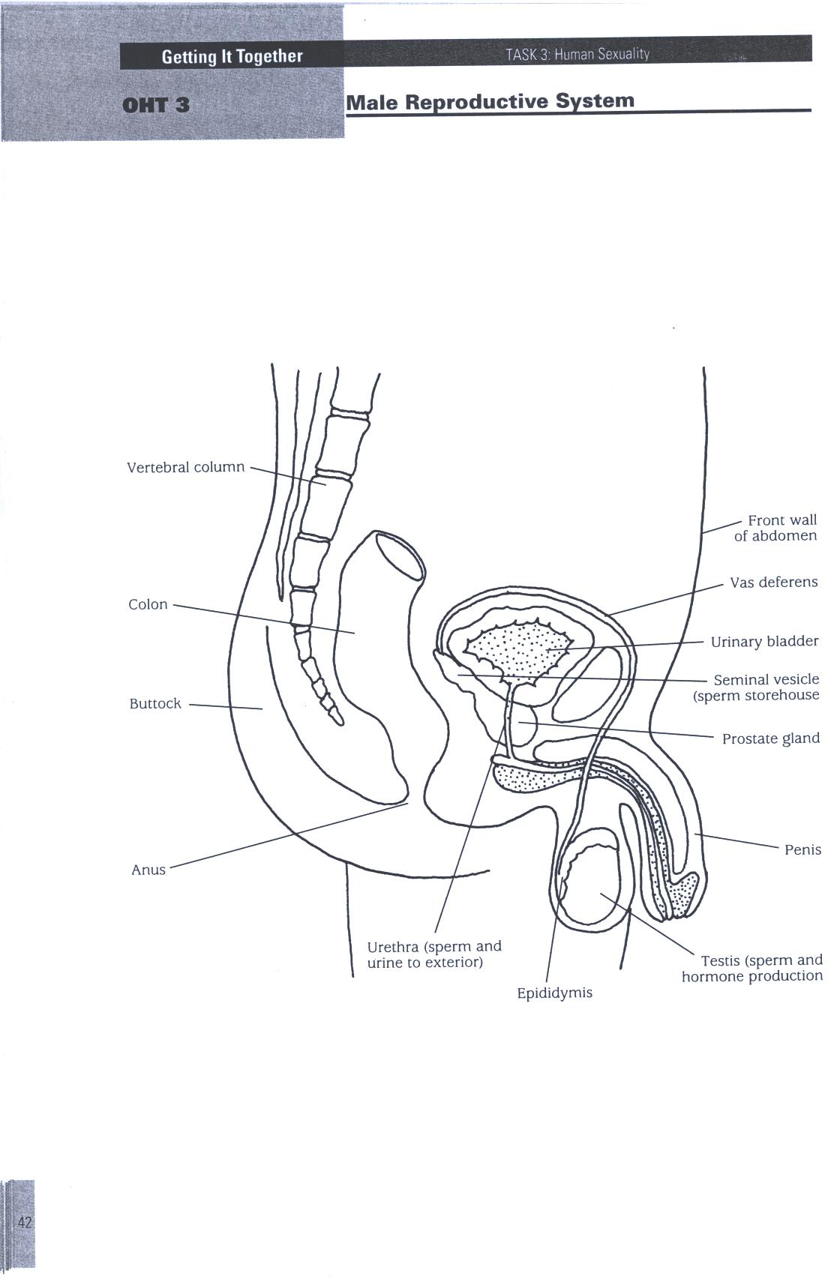

|  |
| --- |
| Reproduced from: Board of Studies NSW (1998) *Personal Development, Health and Physical Education K–6 Teaching Kit: Interpersonal Relationships; Growth and Development;* and *Safe Living* Stages 1-3. |

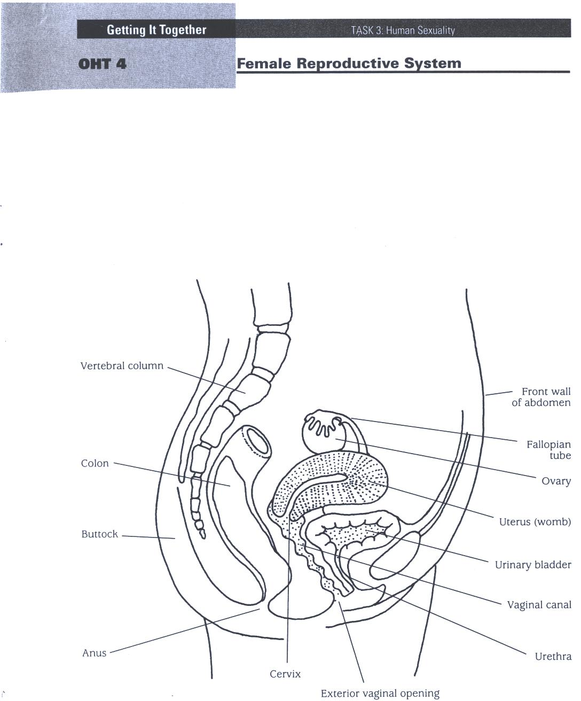

|  |
| --- |
| Reproduced from: Board of Studies NSW (1998) *Personal Development, Health and Physical Education K–6 Teaching Kit: Interpersonal Relationships; Growth and Development;* and *Safe Living* Stages 1-3. |

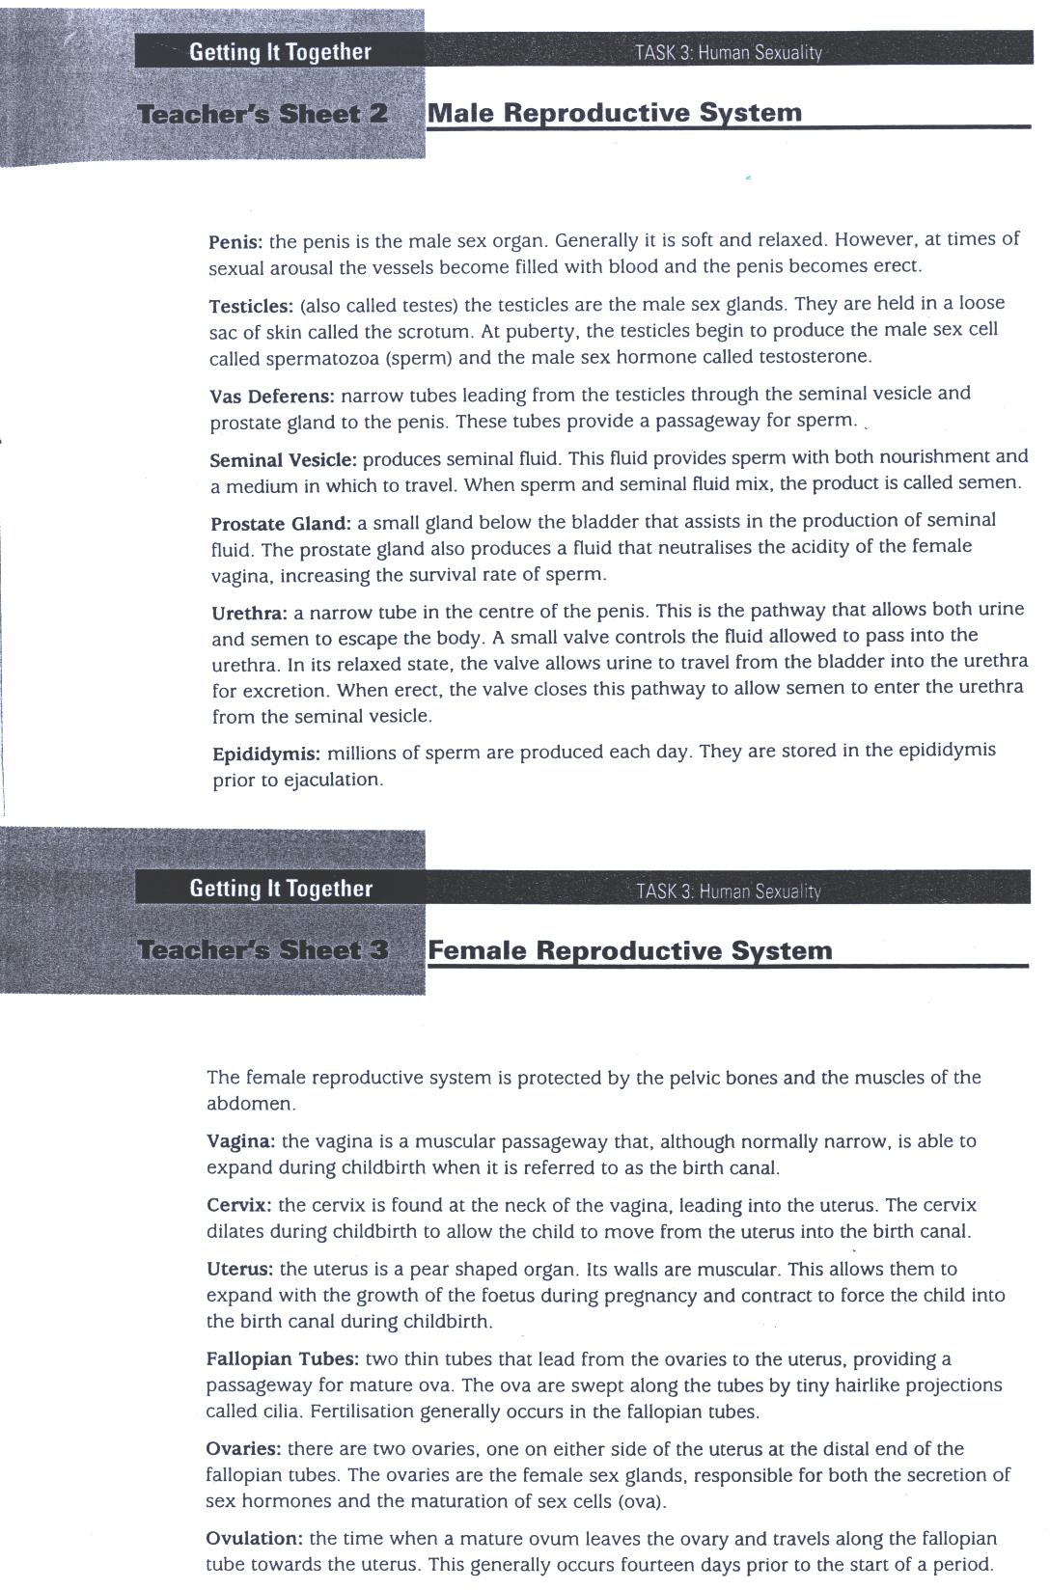

|  |
| --- |
| Reproduced from: Board of Studies NSW (1998) *Personal Development, Health and Physical Education K–6 Teaching Kit: Interpersonal Relationships; Growth and Development;* and *Safe Living* Stages 1-3. |

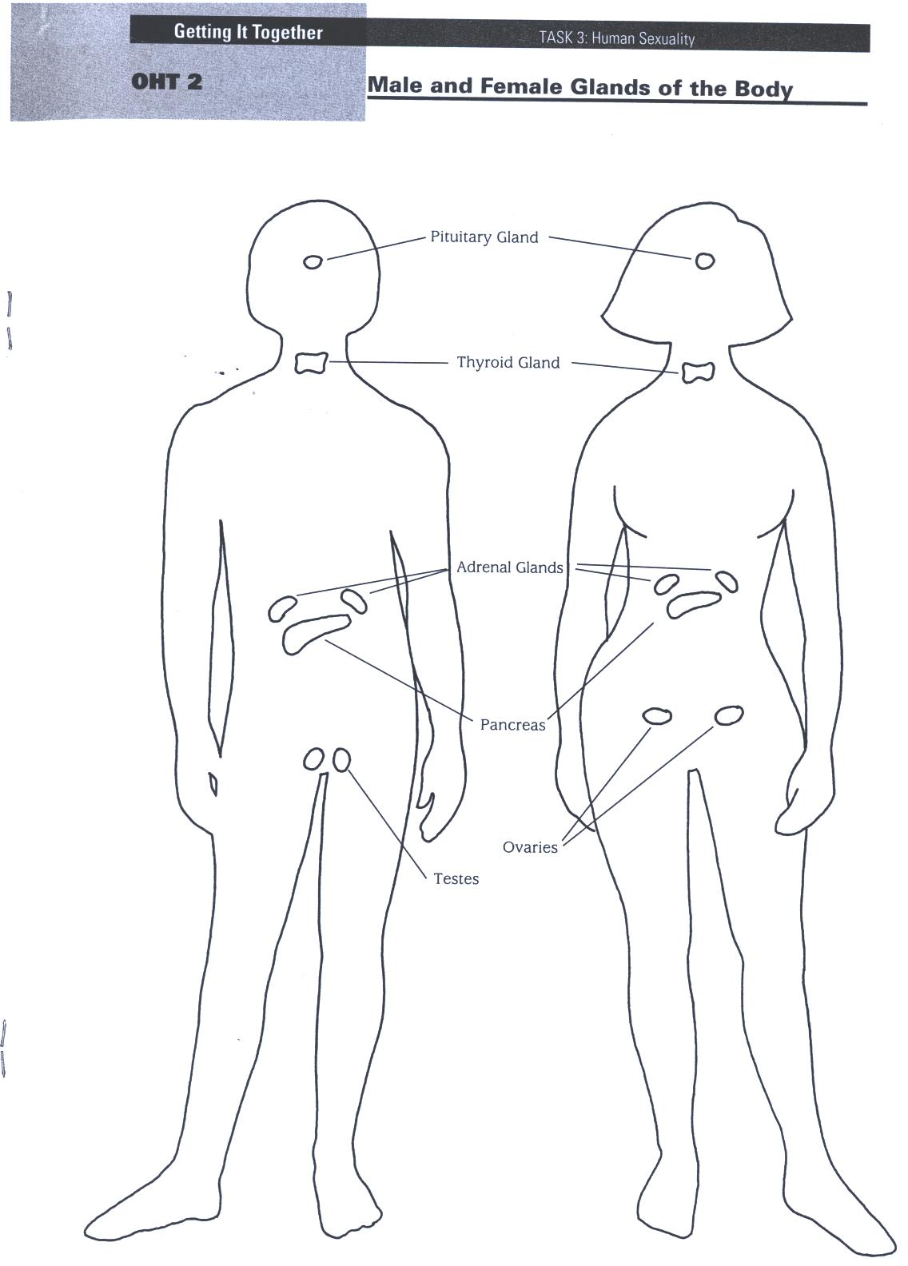

|  |
| --- |
| Reproduced from: Board of Studies NSW (1998) *Personal Development, Health and Physical Education K–6 Teaching Kit: Interpersonal Relationships; Growth and Development;* and *Safe Living* Stages 1-3. |

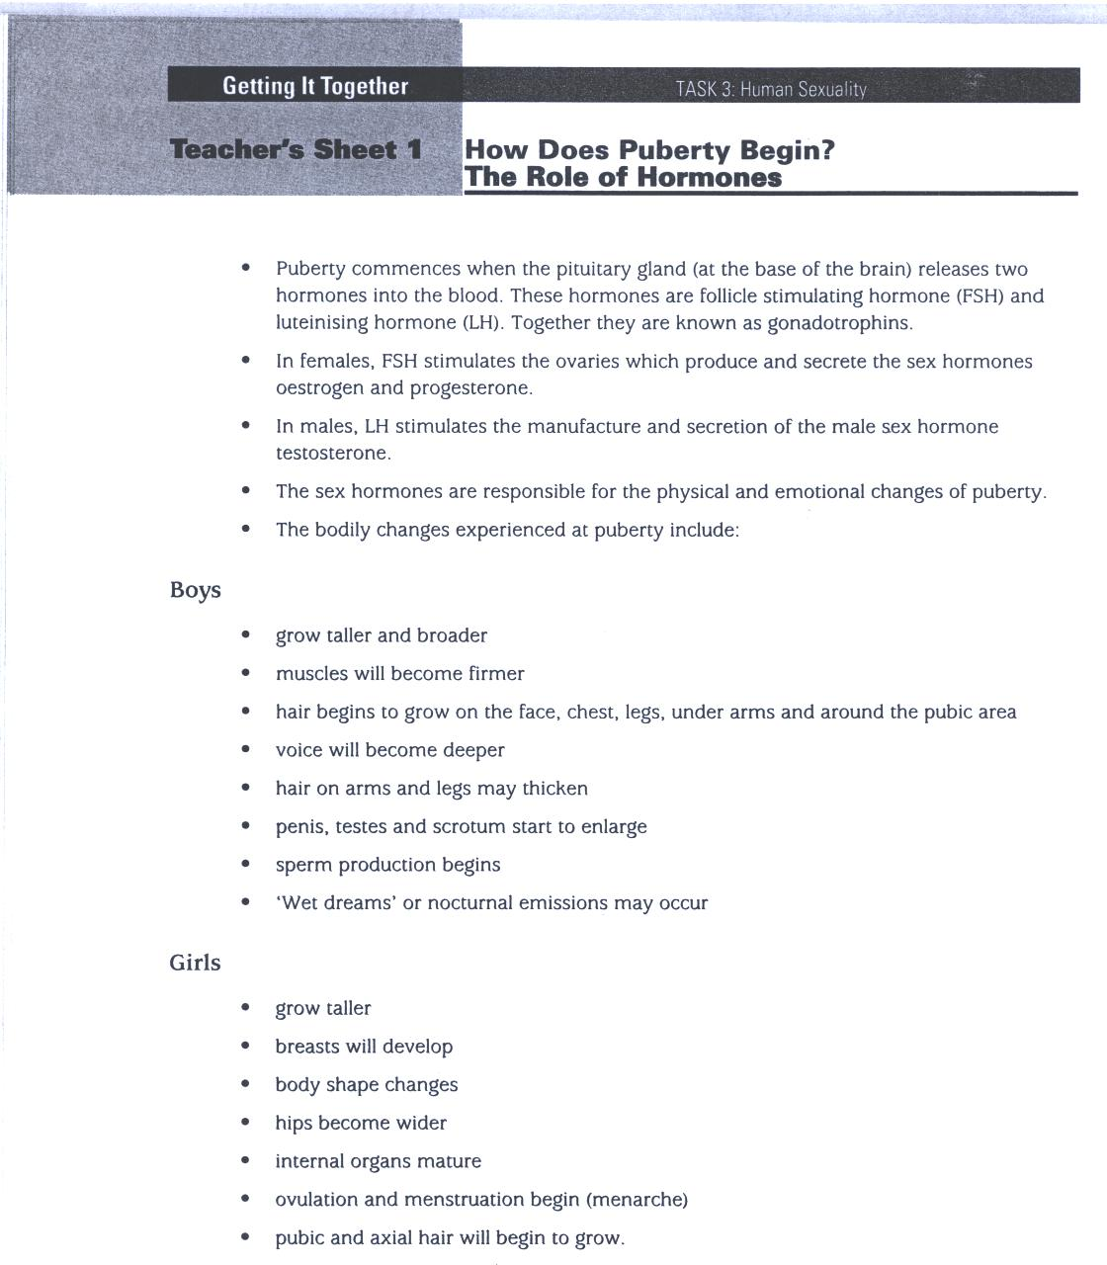

|  |
| --- |
| Reproduced from: Board of Studies NSW (1998) *Personal Development, Health and Physical Education K–6 Teaching Kit: Interpersonal Relationships; Growth and Development;* and *Safe Living* Stages 1-3. |

**Lesson 7 What’s happening for the boys & the girls?**

|  |  |  |  |
| --- | --- | --- | --- |
| **Enduring Understandings** | **Outcomes** | **Indicators** | |
| E.2 Change and growth is a part of who we are.  E.3 The way people cope with change affects our health and wellbeing.  E.4We have a responsibility to make wise decisions about our body and our relationships. | GDS3.9 Explains and demonstrates strategies for dealing with life changes  COS3.1 Communicates confidently in a variety of situations  V1 Refers to a sense of their own worth and dignity | * Recognises that many changes occur in a predictable sequence * Describes aspects of physical development and labels parts of the reproductive system * Uses correct terminology when referring to male and female reproductive body parts * Accepts themselves as they grow and change | |
| **KidsMatter SEL Focus:** Major – Social Awareness – Appreciating Diversity, Social Awareness – Perspective Taking | | | |
| **Suggested Learning Experiences**  TW : Explain to the children that as we grow and develop we enjoy all our capacities and gifts, our intellect, our emotions, our spirit, our will and our physical bodies. God wants us to embrace these changes, and to feel proud of who we are, showing that we each have dignity and worth. This is sometimes a very difficult thing to do.  Teacher reads: “Hair in Funny Places” by Babette Cole. Challenge the students to show respect when reading the book, and let them know it may be embarrassing to hear some of the correct terms for the ‘private’ or sexual parts of the body. While this is presented in an amusing way and may make them laugh, explain the difference between laughing ‘with’ rather than laughing ‘at’.  Using the book and the information from the previous lesson, discuss and outline the key changes to the body.  Activity: Read the following scenarios:  Scenario 1: Jessica was travelling home on the bus and some boys in her class say aloud, “You’ve got big boobs.” She was hurt and embarrassed.  Scenario 2: During the swimming class some girls teased James and said, “You only have a little penis.” He was embarrassed and thought that something was wrong with him.  In reference to the belief, ‘We should appreciate and respect our body and the body of others,’ in small groups discuss:   * What school rule was broken in these scenarios? * What do you think Jessica and James were thinking and feeling? * What could Jessica and James do? * What should the bystanders do to stop this type of teasing? * What Catholic values could these students try to live up to?   Students are provided with some student reflection time and are invited to respond to the content of this lesson (through writing, illustration and/or prayer). Refer to Towards Wholeness statements on display. Their responses may reflect their feelings and emotions during this time of change. (SEL) | | | |
| **Resources**   * Cole, B. (1999). *Hair in Funny Places.* London: Red Fox. | | | **Assessment** Student reflection responses |

**Lesson 8 How do I cope with physical changes?**

|  |  |  |  |
| --- | --- | --- | --- |
| **Enduring Understandings** | **Outcomes** | | **Indicators** |
| E.3 The way people cope with change affects our health and wellbeing.  E.4We have a responsibility to make wise decisions about our body and our relationships. | GDS3.9 Explains and demonstrates strategies for dealing with life changes  PSS3.5 Suggests, considers and selects appropriate alternatives when resolving problems  V1 Refers to a sense of their own worth and dignity | | * Recognises that many changes occur in a predictable sequence * Describes aspects of physical development * Suggests strategies to cope with changes during puberty * Appreciates that their physical, social, emotional and intellectual development is unique * Appreciates and accepts the importance of developing a personal value system |
| **KidsMatter SEL Focus:** Major - Relationship Skills – Building Relationships – Social Awareness | | | |
| **Suggested Learning Experiences**  Students consider the following case study and respond to the questions:  *Tom is 12 years old. He is a keen basketballer. In the past year he has outgrown both his favourite tracksuit and his running shoes. At training last week, Tom tripped over his own feet. He is becoming worried about the way his body is changing.*   1. Why would Tom be worried? 2. What would be causing these changes? 3. What advice would you give Tom about the changes he is experiencing and the way he is feeling?   Discuss the five SEL skills. <http://wellbeing.dbbcso.org/component-2.html> In small groups ask the students to outline how each SEL skill can assist them to manage/cope with different situations/issues.  Discuss the importance of *Social Awareness* and how it helps coping with changes. According to the *Kids Matter* website, Social Awareness is defined as respecting and understanding others, and appreciating differences between people. <https://www.kidsmatter.edu.au/families/about-behaviour/getting-along/what-social-and-emotional-learning-all-about>  Students journal their feelings about the changes of puberty and how to cope with these changes.  TW: Revise the belief, ‘We have an obligation to care for others and ourselves and appreciate and respect our bodies and the bodies of others.’  In reference to this, students work in small groups to discuss the following scenarios and present their responses to the class.  ***Scenario 1****: Eamonn has developed a number of pimples on his face. He feels embarrassed and covers them with his hand when he talks with others. What could he do to maintain healthy skin?*  ***Scenario 2****: Jacquie has begun to develop breasts earlier than her friends. She wears a loose jumper to cover up and avoids contact with others whenever possible. How can she overcome her self-conscious feelings?*  ***Scenario 3****: Tuan has started her first period. The school swimming carnival is on tomorrow and Tuan is an excellent swimmer. She is anxious about participating. What could she do?*  Students design a chart of coping strategies for puberty as a class display.  TW: Teacher concludes this lesson with a group reflection. Teacher revises the *Beliefs and Values* taught in the unit. (Refer to the Towards Wholeness Overview at the beginning of the unit.) Multiple copies of these are scattered around a prayer space. After students choose one of these beliefs/values that they think will assist and guide them when they begin to go through this time of physical change, they sit around the prayer space. Students are invited to share their choice of belief/value with a partner or respond in their journal. The reflection is concluded with all students reading Ecc 25: 1-2; “It is our responsibility to be faithful to ourselves, others and God in all areas of our life.” | | | |
| **Resources**   * SEL Continuum <http://wellbeing.dbbcso.org/component-2.html> * Multiple copies of the Unit’s Beliefs and Values. * Kids Matter Website – What is social and emotional learning? <https://www.kidsmatter.edu.au/families/about-behaviour/getting-along/what-social-and-emotional-learning-all-about> Australian Government – Department of Health | | **Assessment**  Students chart of coping strategies for puberty. | |

**TEACHER REFLECTION - UNIT EVALUATION**

|  |  |  |  |  |  |
| --- | --- | --- | --- | --- | --- |
|  | Low  1 | 2 | 3 | 4 | High |
| A. **A. EVIDENCE**  **To what extent does the assessment evidence provide:** |  |  |  |  |  |
| 1. A valid and reliable measure of the targeted outcomes/enduring understandings? |  |  |  |  |  |
| 2. Sufficient information to support inferences about each  student’s understanding/level of achievement? |  |  |  |  |  |
| 3. Opportunities for students to demonstrate their understandings through authentic learning tasks? |  |  |  |  |  |
| **B. LEARNING EXPERIENCES AND INSTRUCTION**  **To what extent did students:** |  |  |  |  |  |
| 1. Achieve the outcomes and the enduring understandings of the unit (the big ideas as opposed to basic facts and skills)? |  |  |  |  |  |
| 2. Know where they were going and why (in terms of unit goals, requirements, and evaluative criteria)? |  |  |  |  |  |
| 3. Deepen their knowledge and understanding of the outcomes & big ideas of the Unit (through inquiry, research, problem solving, and experimentation)? |  |  |  |  |  |
| 4. Receive explicit instruction on the knowledge and skills needed to equip them for the required performances? |  |  |  |  |  |
| 5. Have opportunities to rehearse, revise, and refine their work based on feedback? |  |  |  |  |  |
| 6. Self-assess and set goals prior to the conclusion of the unit? |  |  |  |  |  |

**PTO**

**1. What did students learn? (What knowlege and skills did they learn to deepen their understanding of the outcomes/big ideas of the unit?)**

**2. How do you know what they learnt? (What evidence do you have to support your judgement?)**

**3. What would you refine to improve student learning outcomes?**

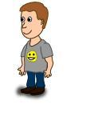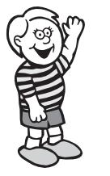

**Student Unit Reflection**

**Stage 3**

**Student Name:**  **Class:**

**Unit/Topic:**

Think about the Personal Development and Health Education Unit you have just finished which focused on keeping yourself happy, healthy and safe, then complete the sentences below.

|  |  |
| --- | --- |
| Two important things I have learnt about/learnt to do during this unit are… | What I learnt will help me in my life because… |
| A question about this unit that I asked in class was… | Something that still puzzles me is... |
| A question about this unit that I asked at home was… | I have changed my ideas about… |
| Something I am going to value/appreciate more about myself because of what I have learnt in this unit is… | If I wanted to research more about this unit I could… |
| Something I am going to value/appreciate more about others because of what I have learnt in this unit is… | I think the effort I put into my learning in this unit was:  (Circle one number)  **No effort** 0 1 2 3 4 5 6 7 8 9 10 **Most effort** |