PERSONAL POWER
Stage: 3 Yr 6 | Unit Duration: 10 Lessons |  |  | Weeks 1 2 3 4 5 6 7 8 9 10 |  | Terms 1 2 3 4
Enduring Understandings:  E.1 Relationships with the people, the events and the things of this world are an essential part of students’ growing understanding of themselves.  E.2 All human beings are entitled to feel safe, be respected and treated with dignity.  E.3 Safe living is concerned with protection of individuals through the promotion of safe practices and environments. |  |  | Essential Questions:  - How can I recognise abuse and develop personal skills to protect myself?  - What is the role of power in relationships?
Major Outcomes  Knowledge and Understanding  IRS3.11 Describes roles and responsibilities in developing and maintaining positive relationships  Skills  INS3.3 Acts in ways that enhance the contribution of self and others in a range of cooperative situations  Values and Attitudes  V4 Increasingly accepts responsibility for personal and community health |  |  | Contributing Questions/Lesson Overview  1. What are positive relationships? (E.1)  2. How can power be used responsibly? (E.1)  3. How can boys and girls use power? (E.2)  - How can I keep my relationships safe? (E.1, E.2, E.3)  - How should I respond to coercion? (E.1, E.2)  - What is bullying? (E.1, E.2)  - What is abuse? (E.2)  - How do I recognise sexual abuse? (E.2, E.3)  - How do I identify and respond to risky situations? (E.3)  - How do I create personal safety plans? (E.3)  KidsMatter SEL Focus  Major: Relationship Skills – Building Relationships; Responsible Decision Making - Assuming personal Responsibility; Responsible Decision Making - Respecting others; Responsible Decision Making - Problem-Solving;  Relationship Skills – Refusal; Relationship Skills – Negotiation; Social Awareness – Perspective-Taking; Responsible Decision Making – Analysing situations;  Minor: Social Awareness – Perspective Taking; Self Awareness - Recognising Strengths; Responsible Decision Making – Problem Solving; Responsible Decision Making - Assuming personal Responsibility
Contributing Outcomes

Knowledge and Understanding
SLS3.13 Describes safe practices that are appropriate to a range of situations and environments
Skills
COS3.1 Communicates confidently in a variety of situations
DMS3.2 Makes informed decisions and accepts responsibility for consequences

PSS3.5 Suggests, considers and selects appropriate alternatives when resolving problems

Values and Attitudes
V3 Enjoys a sense of belonging

Catholic Dimension/Towards Wholeness (TW) (Also refer to overview of TW for this unit)
Safe Living
This strand seeks to develop an ability and a commitment to act in ways that will protect self and others from harm. It emphasises respect for the human person and the development of a co-operative, caring society. Sound Christian decision-making is based on a well-formed conscience which draws inspiration from the life and teaching of Christ and from his Church. Within this strand, students learn to respect the rights of others and to value acceptance, tolerance, justice and personal freedom. They learn that their own decisions have consequences for themselves and others
Interpersonal Relationships
Human beings find their true place within community; they grow towards maturity through the relationships they maintain. We all depend on each other and, as we mature, we grow in awareness of our responsibility for each other. Alone and isolated we cannot develop our gifts and live as God intended.
Among family, friends, members of our peer group and others, we find our place as contributing members of society. It calls us all to enter freely into loving and forgiving relationships that are embedded in community, to develop such qualities as honesty, respect, empathy, openness and a commitment to equality.
Growth and Development
God has created each of us to grow into the fullness of life. We are made in God’s image and therefore, we are of inherent dignity and worth. Our sexuality is an intrinsic part of ourselves, to be celebrated and expressed with joy and responsibility, according to God’s plan. Each person grows and changes, passing through stages on a journey towards full maturity. God is with us on this journey, reassuring and challenging. We are never alone.

Foundation Statements
Students examine key factors that contribute to a balanced lifestyle and keeping safe and healthy. They examine nutritional information, disease prevention and the effects of drugs on the body and they identify behaviours that impact on wellbeing. Students assess the safety of situations in home, school, water and road environments and identify appropriate responses. They describe and practise a range of personal safety strategies that could be used in threatening or abusive situations. They take responsibility for personal decisions, recognising the effects that decisions have on self and others.

Students describe the factors that influence personal identity and examine the physical, social and emotional changes that occur during puberty. They devise strategies for coping with change, grief and loss. They value the differences between individuals and challenge discrimination and harassment. Students value different roles and responsibilities in relationships, the importance of communication and they practise positive ways to deal with conflict.

Suggested Correlation With Other KLAs  English  - Narrative Text (concept development)  - Personal Response  - Literary Description  - Poetry |  |  | Creative Arts  - Drama – Performing and Appreciating  - Visual Arts – Making and Appreciating  Science & Technology  Information and Communication
Technology

The following websites have been selected to enhance various concepts being taught throughout this unit. Most of the sites listed can be linked to more than one of the lessons being taught. Teachers may like to add them to the school intranet site. Some of the following sites have a great deal of information and it is important for the teacher to choose sections that are relevant to the needs and maturity of his/her class.
- www.bullyingnoway.com.au
- www.netalert.gov.au
- http://www.brainpop.com/health/personalhealth/cyberbullying/
- http://www.cyh.com/HealthTopics/HealthTopicDetailsKids.aspx?p=335&np=286&id=1629
- http://www.cyh.com/HealthTopics/HealthTopicDetailsKids.aspx?p=335&np=286&id=1695
- http://www.cyh.com/HealthTopics/HealthTopicDetailsKids.aspx?p=335&np=288&id=1545
- http://kidshealth.org/kid/feeling/emotion/bullies.html
- http://kidshealth.org/kid/feeling/friend/peer_pressure.html?tracking=K_RelatedArticle

Subject Matter  Interpersonal Relationships  Relationships  - Personal rights  - Rights and responsibilities  - Sources of power  - Coercion  - Harassment  - Types of abuse  - Effects of abuse  - Solving problems  - Importance of positive relationships  - Relating to people  - Changing networks  - Strengthening networks  - Challenging discrimination  Communication  - Appropriate expression of feelings |  | - Assertiveness  - Supporting others  Families  - Parental responsibilities and rights  Growth and Development  The Body  - Appropriate and inappropriate touching  Personal Identity  - Gender images and expectations  Values  - Challenging discrimination  Safe Living  Personal Safety  - Protection |  |  | - Warning signs and signals  - Identifying risk situations, people and places  - Reacting to unsafe situations  - Assertiveness  - Rights and responsibilities  - Maintaining/extending networks  - Responding to risk situations  - Bribes, threats  - Safety plans  Home and Rural Safety  - Responsibility for self and others  - Safety plans
Unit Evaluation  Sample teacher and student unit evaluations are included at the end of the unit. |  |  | Assessment  Assessment strategies are included in each lesson.

An Overview Of Towards Wholeness (TW) In The PDH Unit
Personal Power – Stage 3

Key God’s Word

‘Treat others as you would like them to treat you.’ Mt 7;12 (TW p. 31)

‘God wants us to be safe and will protect us as we come and go now and forever.’ – Ps.121:5-8 (TWp.41)

’Jesus modelled a spirit of gentleness and non-condemnation for our dealings with others. All people are of value and must be treated with dignity and respect’ – Mk. 12 : 28-34. (TWp.23)

Our body is the ‘temple of the Holy Spirit’ (1 Cor.6:19) and as such is a sacred place where God dwells. It is always worthy of respect.( p. 26)
Enduring Understandings | Beliefs and Values | Lesson Overview/Links
E.1 Relationships with the people, the events and the things of this world are an essential part of students’ growing understanding of themselves. | - Positive relationships are sustained by sympathy, love, trust and forgiveness. They enhance sense of worth. TW p.30  - Each person has rights and responsibilities in relation to personal safety. TW p.41 | 1. What are positive relationships?  2. How can power be used responsibly?  4. How can I keep my relationships safe?  5. How should I respond to coercion?  6. What is bullying?
E.2 All human beings are entitled to feel safe, be respected and treated with dignity. | - All human beings are entitled to justice, freedom from coercion, dignity, friendship, tolerance and hope. TW p.37  - We appreciate and respect our body and the bodies of others. TW p.35 | 3. How can boys and girls use power?  4. How can I keep my relationships safe?  5. How should I respond to coercion?  6. What is bullying?  7. What is abuse?  8. How do I recognise sexual abuse?
E.3 Safe living is concerned with protection of individuals through the promotion of safe practices and environments. | - A communal approach to safe living and the establishment of caring networks is essential for the provision of safe environments. TW p.41 | 4. How can I keep my relationships safe?  8. How do I recognise sexual abuse?  9. How do I identify and respond to risky situations?  10. How do I create personal safety plans?
Lesson 1 What are positive relationships?

Enduring Understandings | Outcomes |  | Indicators
E.1 Relationships with the people, the events and the things of this world are an essential part of students’ growing understanding of themselves. | IRS3.11 Describes roles and responsibilities in developing and maintaining positive relationships  INS3.3 Acts in ways that enhance the contribution of self and others in a range of cooperative situations  V3 Enjoys a sense of belonging |  | - Develops and maintains a personal network of trusted adults who could provide advice and support  - Demonstrates appropriate actions that show concern for others and develop positive relationships  - Displays a commitment to developing and maintaining positive relationships
KidsMatter SEL Focus: Major - Relationship Skills – Building Relationships
Suggested Learning Experiences
Using Relationships Acrostic Activity, teacher models a poem of the word RELATIONSHIPS or develops a mind map. As a class, share understandings of the term ‘relationships’ and discuss why relationships are important. Brainstorm words that could be used in their own acrostic poem of RELATIONSHIPS or mind map.
Using My Relationships Activity, students identify and list at least 10 people with whom they have a connection or relationship. Draw symbols or use codes to indicate which relationships are closest. Discuss the terms ‘trust’, ‘respect’, ‘forgiveness’ and ‘sympathy’. Students further code relationships, by identifying those people whom they trust, and identify those people with whom they feel comfortable.
TW: The ultimate Christian model of relationships is to be found in the person of Jesus. Bring the students to the understanding that positive relationships are sustained by sympathy, love, trust and forgiveness. They enhance a sense of worth. Recall some of the people with whom Jesus had relationships and identify in what ways they were sustained by love, trust and forgiveness. Students choose 3 people from their list of 10 and identify how their relationship with each person is sustained by sympathy, love, trust and forgiveness.
Of those 3 people (in the above task), students choose 1 and map the progression of this relationship from when they first met till now. Students prepare a series of steps/events that have contributed toward the closeness of the relationship, eg. I first met Toby at softball practice when I was 7. We loved playing together in the team. We slept over at each other’s houses and built a tree house together. When we were 9, Toby came on holidays with my family. Students are invited to share with a small group or the class.
Teacher discusses with students that positive relationships are like a recipe – the right ingredients and method make the product successful. Discuss that trust, respect and care are vital ingredients.
HOME TASK:
Students create a ‘recipe’ for positive relationships.

Resources  - Relationships Acrostic Activity  - My Relationships Activity |  | Assessment  Recipe for positive relationships

Adapted and reproduced with kind permission from: Department of Education and Training. (1998). Stage 3. Child Protection Education: Curriculum materials to support teaching and learning in PDHPE. Sydney: DET. pp 64–65.

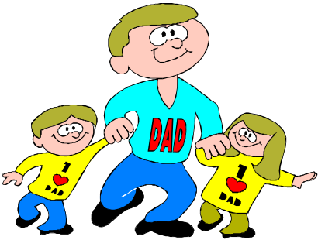

Relatives who care

Easy going

Loving

Adults who are trusted
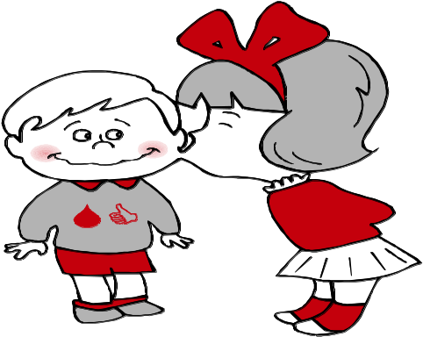

Talk to when I need advice

Interact with my friends

Open minded

New kid next door

Sister
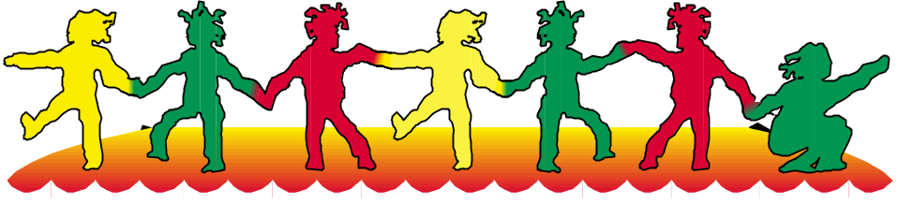

Happy

Important
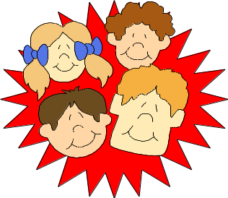
Personal

Support

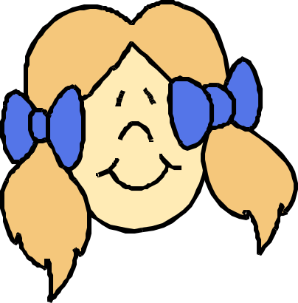



Lesson 2 How can power be used responsibly?

Enduring Understandings | Outcomes |  | Indicators
E.1 Relationships with the people, the events and the things of this world are an essential part of students’ growing understanding of themselves. | IRS3.11 Describes roles and responsibilities in developing and maintaining positive relationships  DMS3.2 Makes informed decisions and accepts responsibility for consequences  V3 enjoys a sense of belonging |  | - Describes the factors that influence positive use of power  - Values positive relationships  - Evaluates personal decisions regarding the use of power
KidsMatter SEL Focus: Major - Responsible Decision Making - Assuming personal Responsibility; Responsible Decision Making - Respecting others; Minor – Social Awareness – Perspective-Taking

Suggested Learning Experiences

TW: Positive relationships are sustained by sympathy, love, trust and forgiveness. They enhance sense of worth.
Each person has rights and responsibilities in relation to personal safety.

As a class, develop a definition of power. Power is being able to do something or make something happen. Power can be the ability to make others do things. Recall sources of power from the unit You, Me and Us (if taught previously), or review content on Sources of Power Fact Sheet.

Discuss the statement, “Everyone has power and that it is how we use our power that is important.”
Discuss the importance of negotiation in relationships.

In small groups, students receive a set of cards from the Card Game Activity. The cards are placed face-down in a pile. Students take turns to choose a card and identify the power used in the situation and whether power was used in a responsible or abusive way. Students divide the cards into 2 piles depending on whether the card was classified as responsible or abusive. Identify if the power used in these situations was responsible or abusive.

In their groups, students discuss their own use of power in various situations – at home, at school, in the neighbourhood, with relatives.

Students identify their power by completing the following statements:
I have power when _______________________________________
I can use my power in a responsible way by _____________________

Teacher selects several students to share their sentences with the class.
Resources  - Department of Education and Training. (1998). Child Protection Education Stage 3: Curriculum materials to support teaching and learning in PDHPE. Sydney: DET. Sources of Power Activity. p 151. Card Game Activity. p 152. |  | Assessment  Student’s sentences regarding the responsible use of power

Adapted and reproduced with kind permission from: Department of Education and Training. (1998). Stage 3. Children Protection Education. Curriculum materials to support teaching and learning in PDHPE. Sydney: DET. pp 79-81 and 151-153.
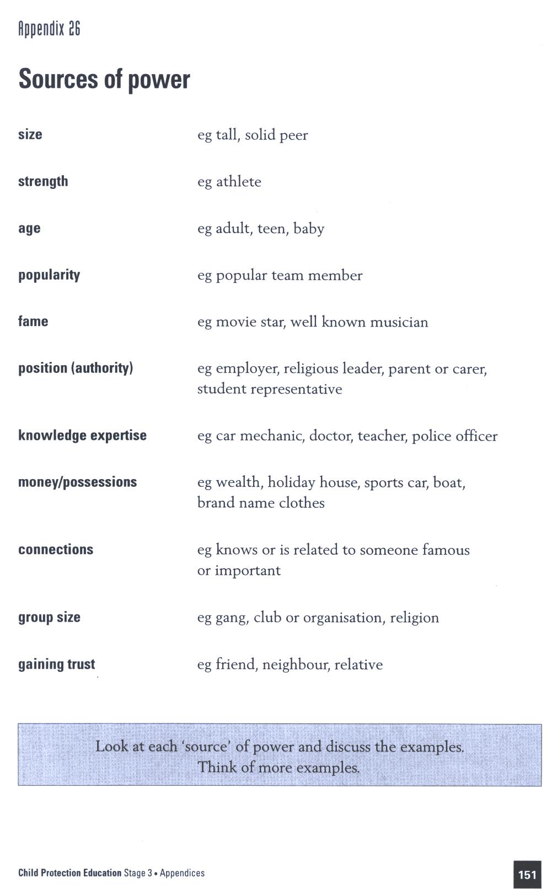

Reproduced from: NSW Department of School Education and Training (1998) Child Protection Education: Curriculum materials to support teaching and learning in PDHPE, Stages 1, 2 and 3.
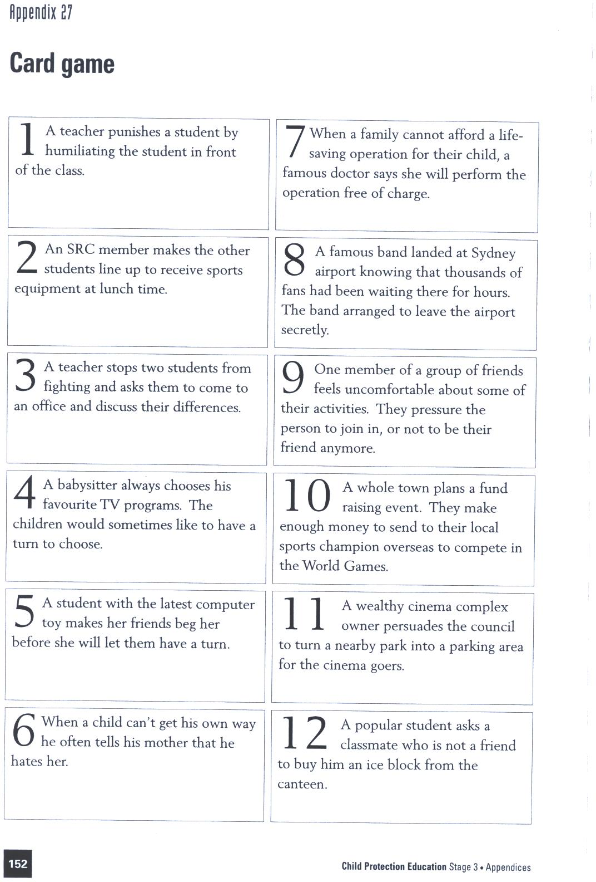

Reproduced from: NSW Department of School Education and Training (1998) Child Protection Education: Curriculum materials to support teaching and learning in PDHPE, Stages 1, 2 and 3.
Lesson 3 How can boys and girls use power?

Enduring Understandings | Outcomes |  | Indicators
E.2 All human beings are entitled to feel safe, be respected and treated with dignity. | IRS3.11 Describes roles and responsibilities in developing and maintaining positive relationships  INS3.3 Acts in ways that enhance the contribution of self and others in a range of cooperative situations  V3 Enjoys a sense of belonging |  | - Identifies gender stereotypes that affect the use of power  - Expresses appropriate use of power to support the rights and feelings of others  - Values positive relationships
KidsMatter SEL Focus: Major - Responsible Decision Making - Problem-Solving
Suggested Learning Experiences

As a class, identify one male and one female super hero from a well-known TV show, cartoon or computer game. For each character, the class brainstorms the character’s sources of power and the ways they use their power, eg Batman uses power to fight evil and save Gotham City.

TW: Teacher brings the students to the understanding that all human beings are entitled to justice, freedom from coercion, dignity, friendship, tolerance and hope. Give examples of how abusing power takes away these rights.

In pairs, students complete the Super Heroes and Power Activity and share their answers with another pair.

Discuss the following as a class:
- What are some situations where girls use power in the school?
- What are some situations where boys use power in the school?
- How does boys’ use of power affect other boys?/girls?
- How does girls’ use of power affect other girls?/boys?
- When is the use of power by girls or boys unfair or not OK?
- What should students do and say if they see power being abused in the class/playground?

In small groups, discuss how these situations could be improved by changing the way power is used. Groups report suggestions to the class.

Resources  - Super Heroes and Power Activity |  | Assessment  Student work sample of Super Heroes and Power Activity

Adapted and reproduced with kind permission from: Department of Education and Training (1998). Stage 3 Child Protection Education: Curriculum materials to support teaching and learning in PDHPE. Sydney: DET pp 81–82.

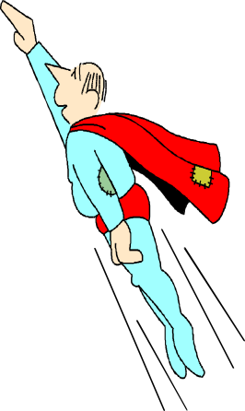

Choose your favourite Super Hero from a TV show, book or computer game.

My favourite Super Hero is ___________________

My Super Hero has the power to _______________

1. What are some of the messages that these characters (super heroes) give to boys and girls about using power?
----------------------------------------------------
----------------------------------------------------
----------------------------------------------------

2. Are these responsible ways of using power? Explain why/not
----------------------------------------------------
----------------------------------------------------
----------------------------------------------------

3. In the show/cartoon/game which ways of using power are presented as most valuable/favourable?
--------------------------------------------------
--------------------------------------------------
--------------------------------------------------

4. If boys and girls believe these messages about power, how might it affect the way they act?
--------------------------------------------------
--------------------------------------------------
--------------------------------------------------

Lesson 4 How can I keep my relationships safe?

Enduring Understandings | Outcomes |  | Indicators
E.1 Relationships with the people, the events and the things of this world are an essential part of students’ growing understanding of themselves.  E.2 All human beings are entitled to feel safe, be respected and treated with dignity.  E.3 Safe living is concerned with protection of individuals through the promotion of safe practices and environments. | SLS3.13 Describes safe practices that are appropriate to a range of situations and environments  PSS3.5 Suggest, considers and selects appropriate alternatives when resolving problems  V4 Increasingly accepts responsibility for personal and community health |  | - Identifies individuals and services in the community that help protect their wellbeing  - Suggests strategies to help a friend who may be subject to abuse  - Appreciates the need for safe practices in a range of situations and environments
KidsMatter SEL Focus: Major - Relationship Skills - Refusal
Suggested Learning Experiences
Share ideas of a safe place and describe the characteristics that make it safe – warm, cosy, relaxed, fun, protected by my parents. Discuss the early warning signs that students might feel in a dangerous or scary situation. Eg:
- butterflies in the stomach
- goosebumps
- racing heart
- sweaty palms
TW: Teacher explains that communal approaches to safe living and the establishment of caring networks, is essential for the provision of safe environments.
What would you do if a friend or family member were doing something that made you feel unsafe? – Teacher reinforces the No Go Tell response. Students suggest ways to get safe and ways to stay safe in situations. List people and organisations who can help keep us safe eg Kids Help Line (ph: 1800 551 800), Salvation Army etc.
TW: Teacher reinforces the need to appreciate and respect our body and the body of others. Remind students that each person has rights and responsibilities in relation to personal safety. Bring students to the understanding that developing strategies to keep ourselves and others safe shows responsibility and an effort to uphold our rights.
Students prepare a Safety Strategies poster including examples of how to stay safe – get away, don’t keep an unhappy secret, get help from a friend/adult, distract the person, and people they can go to.

HOME/SCHOOL TASK Students describe and/or illustrate a safe place, a safe sound, a safe person and a safe feeling using the Safe and Unsafe Activity.
Resources  - Safe and Unsafe Activity  - Butchers paper, magazines, scissors and glue |  | Assessment  Student work sample of Safety Strategies Poster
Adapted and reproduced with kind permission from: Board of Studies. (1999). NSW. Personal Development. Health and Physical Education K–6 Modules. Sydney: BOS. p 252.

 | Safe | Unsafe
Place

Sound

Person

Feeling
DID YOU KNOW THERE IS A KIDS HELP LINE?

PHONE: 1800 551 800 24 HOURS A DAY TOLL FREE

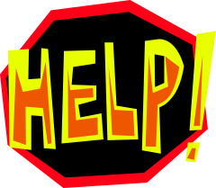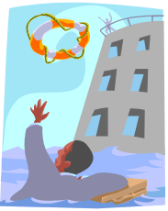Lesson 4 – Safety Strategies

Student _______________________________________

This task provides students with the opportunity to demonstrate their standard of achievement of the following outcomes:

Outcomes | Indicators | Working Towards | Achieved with support | Achieved
SLS3.13 Describes safe practices that are appropriate to a range of situations and environments | Identifies individuals and services in the community that help protect their wellbeing
PSS3.5 Suggests, considers and selects appropriate alternatives when resolving problems | Suggests strategies to help a friend who may be subject to abuse
TASK:
Students prepare a Safety Strategies poster including examples of how to stay safe – get away, don’t keep an unhappy secret, get help from a friend/adult, distract the person.

Lesson 5 How should I respond to coercion?

Enduring Understandings | Outcomes |  | Indicators
E.1 Relationships with the people, the events and the things of this world are an essential part of students’ growing understanding of themselves.  E.2 All human beings are entitled to feel safe, be respected and treated with dignity. | IRS3.11 Describes roles and responsibilities in developing and maintaining positive relationships  INS3.3 Acts in ways that enhance the contribution of self and others in a range of cooperative situations  V4 Increasingly accepts responsibility for personal and community health |  | - Recognises situations where coercion is used to influence people  - Practises assertive ways to deal with different types of harassment and coercion  - Appreciates the need for safe relationships
KidsMatter SEL Focus: Major - Relationship Skills – Negotiation; Minor: Self Awareness-
Recognising Strengths
Suggested Learning Experiences
Teacher explains the terms 'coercion' and 'harassment'. Coercion occurs when one person makes or tries to make another person do something that they don’t want to do. Coercion may involve guilt, threats, force or bribes. Harassment is any act that is not wanted and offends or humiliates a person. It is usually directed at a person who is considered different in some way.
Students give examples for each:
Coercion: I won’t be your friend if you don’t….., You can’t come with us if you don’t…., I’ll let you have a turn of my game if you….
Harassment: Calls you names in front of others, puts things in or touches your belongings.
TW: Teacher shares with the students the belief that all human beings are entitled to justice, freedom from coercion, dignity, friendship, tolerance and hope.
Discuss the difference between a gift and a bribe. A gift is given without conditions or expectations. A gift becomes a bribe when the giver expects a favour or act in return. Teacher asks students to: share times when they may have been bribed; or to examples of bribes that may occur in their lives.
TW: Revise the belief that each person has rights and responsibilities in relation to personal safety. Discuss some possible responses to harassment, coercion and bribes and list some suitable strategies for dealing with them.
In small groups, students create a scenario involving harassment and coercion and the associated risk relating to:
- Drug use, alcohol, smoking
- Road safety
- Water safety
- Breaking school rules
- Bullying
- Being online
OR use the scenario from the Not Guilty Encounter (REDI 2003 The Big Move)
Prepare assertive responses and role-play the scenarios for the class with evidence of making strong and positive decisions against decisions.
Students respond to the following questions:
- How would you feel in these situations?
- What reactions would your body have to these bribe situations?
- What strategies were used to coerce the student in the scene?
- What plans could you put into practice to improve these situations?
- What coercive language was used?
- How could peers positively influence each other for a safe outcome?
Resources  - Commonwealth Department of Education, Science & Training. (2003). REDI: The Big Move |  | Assessment  Student’s responses to questions after watching the scenarios

Adapted and reproduced with kind permission from: Department of Education and Training. (1998). Stage 3. Child Protection Education: Curriculum materials to support teaching and learning in PDHPE. Sydney: DET. p 83–86.
Lesson 6 What is bullying?
Enduring Understandings | Outcomes |  | Indicators
E.1 Relationships with the people, the events and the things of this world are an essential part of students’ growing understanding of themselves.  E.2 All human beings are entitled to feel safe, be respected and treated with dignity. | SLS3.13 Describes safe practices that are appropriate to a range of situations and environments  IRS3.11 Describes roles and responsibilities in developing and maintaining positive relationships  COS3.1 Communicates confidently in a variety of situations  V4 Increasingly accepts responsibility for personal and community health |  | - Devises strategies to respond to risky and dangerous situations  - Analyses the effects of actions that enhance or disrupt relationships  - Models behaviour that reflects sensitivity to the needs, rights, feelings of others  - Demonstrates assertive responses to express their need for safety  - Appreciates the need for safe relationships
KidsMatter SEL Focus: Major - Responsible Decision Making - Respecting others; Social Awareness – Perspective-Taking
Suggested Learning Experiences
TW: Remind the children, positive relationships are sustained by sympathy, love, trust and forgiveness. They enhance sense of worth. Students recall their ‘Recipes for Relationships’ from Lesson 1. Discuss that relationships don’t always stay the same. List some factors that may cause a relationship to change, in light of what sustains positive relationships.
Students brainstorm ingredients in relationships that may indicate that a relationship should not continue unless changes are made, eg bullying, abuse, violence, lying, being neglected, being ignored.
Students read the book Willy the Champ. As a class respond to and discuss the questions in the Willy the Champ Activity.
Review the concept of bullying. Briefly discuss:
- stereotypes – not all bullies are strong, large and not all who are bullied are weak, small etc.
- types of bullying – physical, emotional, social.
- gender of bullies.
- places where children are bullied – on the bus, at lunchtime, in class, with a large crowd of observers, in places with little adult supervision, toilets, internet, mobile phones.
- why children bully each other – consider the 4 basic needs and the abuse of power.
- the role of the bystander: it is everyone’s responsibility to stop bullying.
As a class, discuss how Willy kept himself safe by ending the relationship with Millie or making the relationship less close.
As a class, list some ideas of what could be said to end a relationship or make it less close if it was necessary. Role play some of the suggestions.
Using the Not Guilty Encounter (REDI,2003, The Big Move) students click on each of the characters to learn the story and create a profile of each character in the story. Eg.
Character | Qualities
Karen
Abby
Carla
Seow Ling
Kiri (Lifeguard)
In pairs, draw a cartoon sketch of the bullying taking place in the Not Guilty scene. Students identify who is being bullied, who is doing the bullying, what type of bullying is happening and how could the girls get help to stop the bullying.
In small groups, students role-play their cartoon and the audience suggests different conclusions to the story that involve positive use of power.
Resources  - Browne, A. (1996). Willy the Champ. London: Walker.  - Willy the Champ Activity  - Commonwealth Department of Education, Science & Training. (2003). REDI: The Big Move |  | Assessment  Student responses in role plays

Adapted and reproduced with kind permission from: Department of Education and Training. (1998). Stage 3. Child Protection Education:
Curriculum materials to support teaching and learning in PDHPE. Sydney: DET. pp 65–67.

Read the story Willy the Champ and answer these questions.
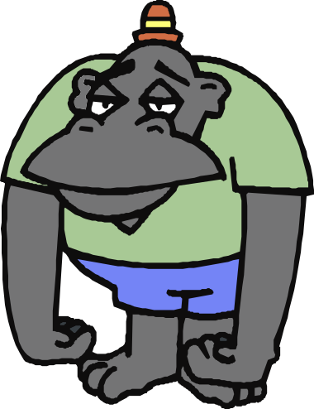

- How did the gorillas relate to Willy?

- How did Willy relate to Millie?

- Which relationship do you think was positive? Explain why.

- What could Willy do to improve the relationship with the gorillas?

- Imagine the gorillas were bullying Willy at the pool. What appropriate strategies could Willy use to deal with this situation?

Lesson 7 What is abuse?

Enduring Understandings | Outcomes |  | Indicators
E.2 All human beings are entitled to feel safe, be respected and treated with dignity. | SLS3.13 describes safe practices that are appropriate to a range of situations and environment  IRS3.11 Describes roles and responsibilities in developing and maintaining positive relationships  PSS3.5 Suggests, considers and selects appropriate alternatives when resolving problems  V4 Increasingly accepts responsibility for personal and community health |  | - Identifies factors that contribute to different types of abuse  - Analyses the effects of actions that enhance or disrupt relationships  - Suggests strategies to help a friend who may be subject to abuse  - Appreciates the need for safe relationships
KidsMatter SEL Focus: Minor – Social Awareness – Perspective-Taking
Suggested Learning Experiences
List some basic needs that children require to be safe and healthy in body and mind (freedom, fun, belonging, power, food, clothing, housing, medical needs, emotional needs). These needs are based on children’s rights.

TW: All human beings are entitled to justice, freedom from coercion, dignity, friendship, tolerance and hope. We appreciate and respect our body and the bodies of others.
Revise the belief that each person has rights in relation to personal safety. Discuss the responsibility that adults have to ensure that children’s basic needs and rights are met. Differentiate between needs and wants. Note that when adult carers refuse to provide for children’s basic needs this is neglect. Give some examples of neglect.

Teacher informs students that neglect is a type of abuse. Harm that is not accidental is abuse. As a class, students brainstorm words that they associate with the term abuse. Classify responses according to type of harm : physical (body), emotional (feelings), mental (thinking). Complete True/False Statements Activity.

Define emotional abuse: Emotional abuse is when carers of a child continually use words and actions that hurt the child’s feelings and thoughts. Complete Emotional Abuse Act.

Display definition for physical abuse: Physical abuse is non-accidental harm or injury to a child by a carer or other person. Physical abuse harms a child physically. It can also harm a child’s emotions and thinking. List some injuries, harm or actions that may be classified as abuse and suggest what effect they think abuse may have on a person.

Distribute segments of the story Danny using the Danny Activity. Children work in small groups to determine the correct sequence of the story and identify some of Danny’s feelings, thoughts and behaviours that could show he was affected by abuse or neglect. Suggest whom Danny could tell about his problems.

Write about what you could do as Danny’s friend to help him feel better about himself using the How might abuse have affected Danny? Activity.

Resources  - Department of Education and Training. (1998). Stage 3. Child Protection Education: Curriculum materials to support teaching and learning in PDHPE. Sydney: DET. True/False Statements Activity.  p 126. Emotional Abuse Activity. p 134. Danny Activity. pp 141, 142, 143. |  | Assessment  Student’s completion of writing task: How could you help Danny feel better about himself?

Adapted and reproduced with kind permission from: Department of Education and Training. (1998). Stage 3. Child Protection Education: Curriculum materials to support teaching and learning in PDHPE. Sydney: DET. pp 32–33, 37, 126, 134, 141–143.
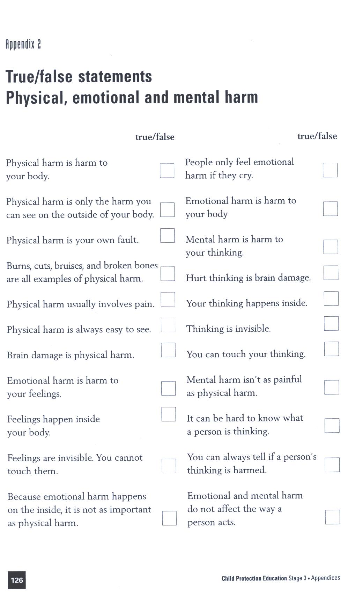

Reproduced from: NSW Department of School Education and Training (1998) Child Protection Education: Curriculum materials to support teaching and learning in PDHPE, Stages 1, 2 and 3.
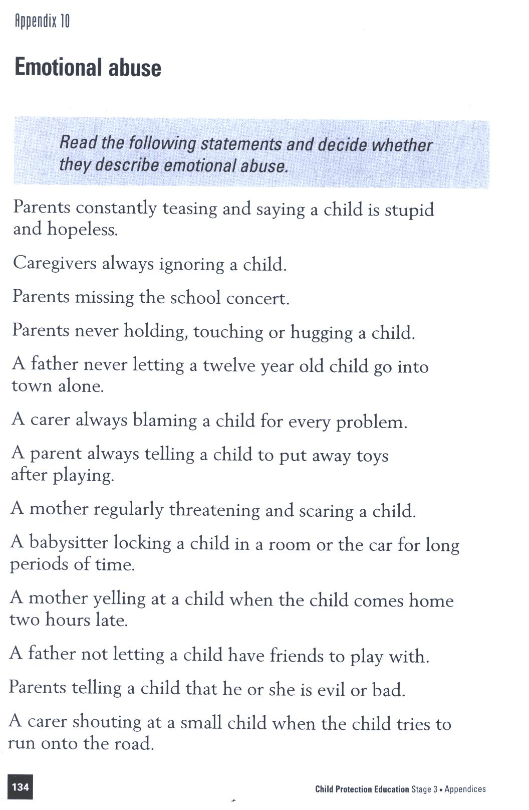

Reproduced from: NSW Department of School Education and Training (1998) Child Protection Education: Curriculum materials to support teaching and learning in PDHPE, Stages 1, 2 and 3.
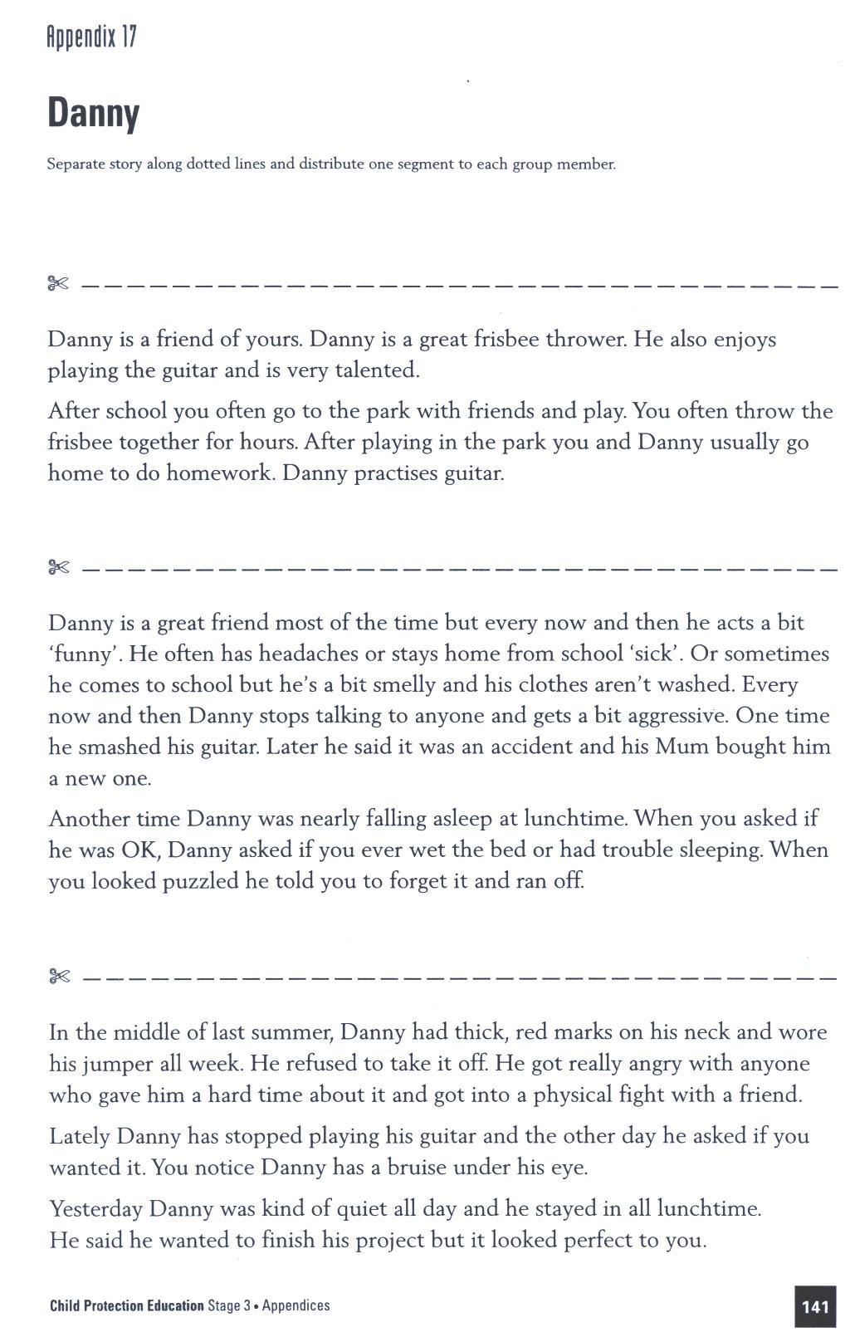
Reproduced from: NSW Department of School Education and Training (1998) Child Protection Education: Curriculum materials to support teaching and learning in PDHPE, Stages 1, 2 and 3.
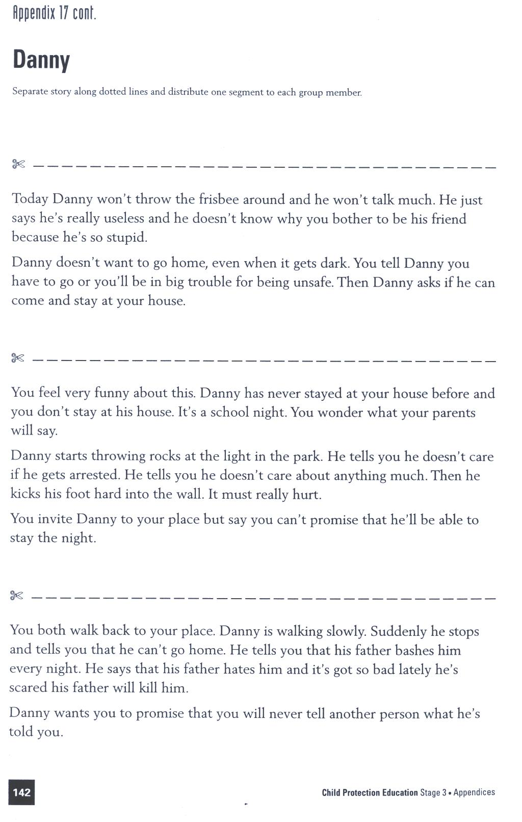
Reproduced from: NSW Department of School Education and Training (1998) Child Protection Education: Curriculum materials to support teaching and learning in PDHPE, Stages 1, 2 and 3.
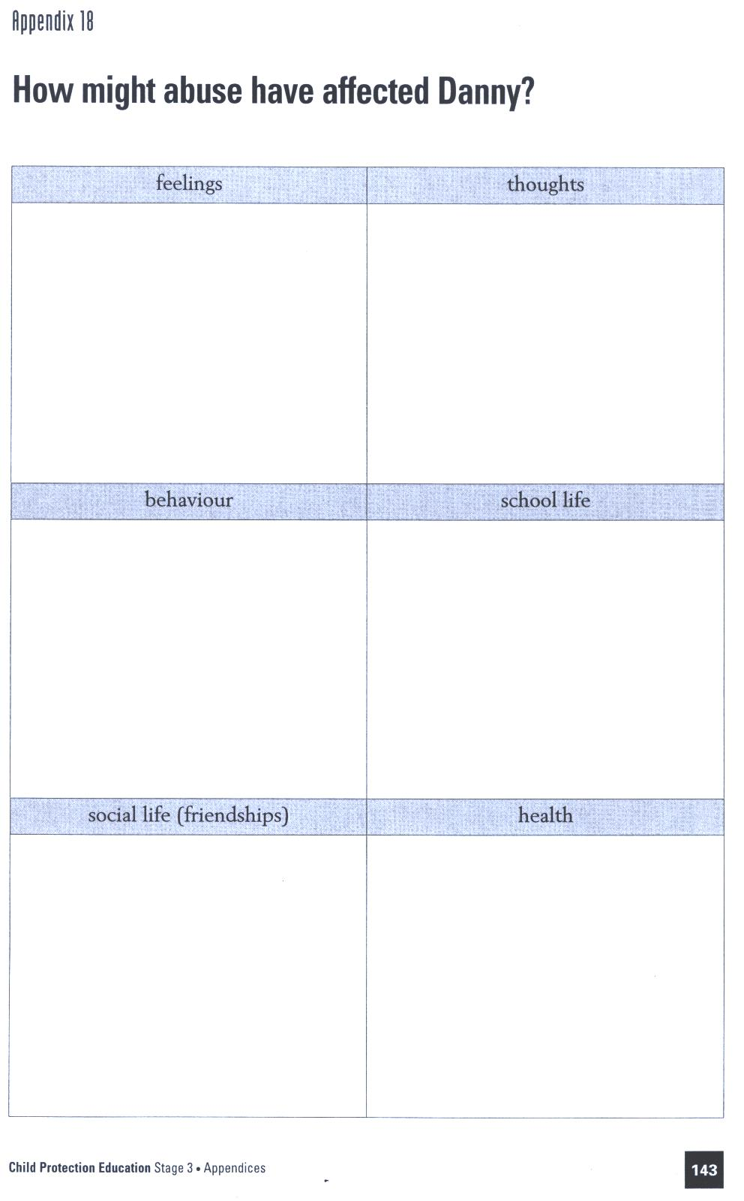
Reproduced from: NSW Department of School Education and Training (1998) Child Protection Education: Curriculum materials to support teaching and learning in PDHPE, Stages 1, 2 and 3.
Lesson 8 How do I recognise sexual abuse?

Enduring Understandings | Outcomes |  | Indicators
E.2 All human beings are entitled to feel safe, be respected and treated with dignity.  E.3 Safe living is concerned with protection of individuals through the promotion of safe practices and environments. | SLS3.13 describes safe practices that are appropriate to a range of situations and environments  PSS3.5 Suggests, considers and selects appropriate alternatives when resolving problems  V4 Increasingly accepts responsibility for personal and community health |  | - Devises strategies to respond to risky and dangerous situations  - Demonstrates assertive ways to deal with different types of harassment or abuse  - Appreciates the need for safe practices in a range of situations and environments
KidsMatter SEL Focus: Major - Responsible Decision Making – Analysing situations; Responsible Decision Making - Assuming personal Responsibility; Minor - Responsible Decision Making - Problem-Solving
Suggested Learning Experiences
As a class, students brainstorm a list of private objects and personal information (such as name, address, telephone numbers). Students then brainstorm private parts of the body. These are parts which are usually covered in public and not freely shared with others. Teacher discusses that some cultures include the mouth and lips as private parts and need to be covered.
TW: Whilst discussing private parts of the body, share with students the following scripture and belief: Our body is the ‘temple of the Holy Spirit’ (1 Cor.6:19) and as such is a sacred place where God dwells. Therefore we need to appreciate and respect our body and the bodies of others.
Teacher poses the question: When might it be OK for another person to touch a child’s sexual (private) parts? – Injured, sick, need cleaning if young.
Teacher reads scenarios from Card Game Activity. Students decide if the suggested situation is an example of sexual abuse.
Teacher poses the following questions: What should you do if someone touches or tries to touch the sexual parts of your body for the wrong reasons? (Say NO, GO away from the situation if you can and TELL a trusted adult about the touch so it will stop). Students suggest trusted adults.
What should you do if someone shows you photos, magazines or videos of the sexual parts of a person’s body? Why is it OK for teachers to show you diagrams of the sexual parts of the body in lessons? As a class, discuss how inappropriate behaviour of others can be a warning sign that harm might follow.

Resources  - Department of Education and Training. (1998 ). Stage 3. Child Protection Education. Curriculum materials to support teaching and learning in PDHPE. Sydney: DET. Card Game Activity. p 133. |  | Assessment  Student ability to classify situations as sexual abuse – card game

Adapted and reproduced with kind permission from: Department of Education and Training. (1998). Stage 3. Child Protection Education: Curriculum materials to support teaching and learning in PDHPE. Sydney: DET. pp 29-33, 37, 133.
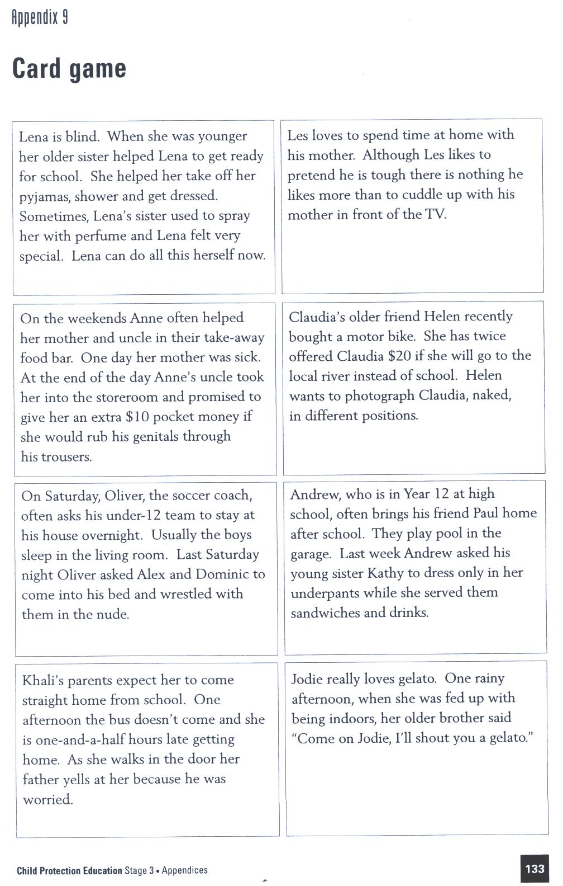

Reproduced from: NSW Department of School Education and Training (1998) Child Protection Education: Curriculum materials to support teaching and learning in PDHPE, Stages 1, 2 and 3.
Lesson 9 How do I identify and respond to risky situations?

Enduring Understandings | Outcomes |  | Indicators
E.3 Safe living is concerned with protection of individuals through the promotion of safe practices and environments. | SLS3.13 Describes safe practices that are appropriate to a range of situations and environment  DMS3.2 Makes informed decisions and accepts responsibility for consequences  V4 Increasingly accepts responsibility for personal and community health |  | - Identifies factors which contribute to risky situations  - Predicts the consequences of their choices  - Appreciates the need for safe practices in a range of situations and environments
KidsMatter SEL Focus: Major - Relationship Skills – Building Relationships; Minor - Responsible Decision Making - Assuming personal Responsibility
Suggested Learning Experiences
Students brainstorm things that they are allowed to do now that they weren’t allowed to do when they were younger. Teacher highlights that as children grow older they are allowed more independence and with independence comes responsibility for personal safety.
Review qualities of people they trust. Identify five people they trust that belong to their support network who they could go to for help. Discuss how their support network may have changed since they were in Kindergarten. Do friends /peers appear in their networks? Why/why not?
TW: Revise the understanding that a communal approach to safe living and the establishment of caring networks is essential for the provision of safe environments.
Identify places in the local community where students could go for help if they felt unsafe. For example, Kids Helpline, Police Station, network members.
Recall how our body alerts us to the possibility of danger/harm by sending us messages/feelings. For example: butterflies in the stomach, goosebumps, racing heart, sweaty palms
Students divide butchers paper into 3 columns as below:
  - Places I feel safe
  - Features that suggest safety
  - Features that suggest I should STOP and THINK
Suggest a variety of situations/locations as examples and complete the table.
Complete What If Activity in pairs, giving suggested action that could be taken as a response to at risk situations. Teacher adds following ‘what if…’ on the issue of cybersafety.

You are in a chatroom and somebody asks you to give them, your private email address.

At Risk
Possible Risk

No Risk

Resources  - Department of Education and Training. (1998 ). Stage 3. Child Protection Education. Curriculum materials to support teaching and learning in PDHPE. Sydney: DET. What If Activity. p 137. |  | Assessment  Teacher observation of student responses to What if Activity
Adapted and reproduced with kind permission from: Department of Education and Training. (1998). Stage 3. Child Protection Education: Curriculum materials to support teaching and learning in PDHPE. Sydney: DET. p 137.
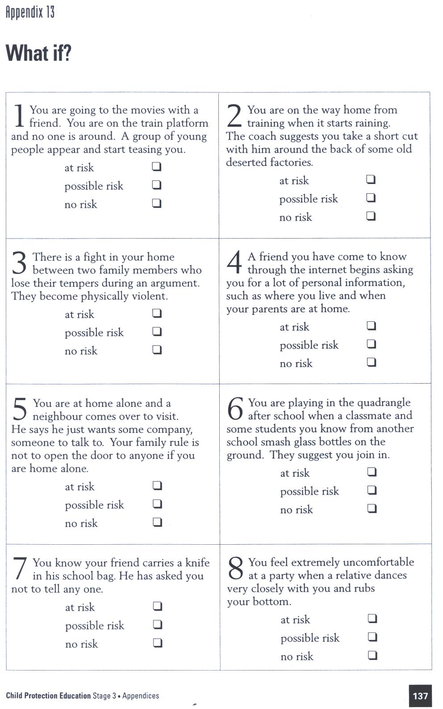

Reproduced from: NSW Department of School Education and Training (1998) Child Protection Education: Curriculum materials to support teaching and learning in PDHPE, Stages 1, 2 and 3.

Lesson 10 How do I create personal safety plans?
Enduring Understandings | Outcomes |  | Indicators
E.3 Safe living is concerned with protection of individuals through the promotion of safe practices and environments. | SLS3.13 describes safe practices that are appropriate to a range of situations and environment  IRS3.11 describes roles and responsibilities in developing and maintaining positive relationships  V4 increasingly accepts responsibility for personal and community health |  | - Demonstrates ways to improve unsafe environments/situations  - Identifies individuals and services in the community that help protect their wellbeing  - Develops and maintains a personal network of trusted adults who could provide advice and support  - Appreciates the need for safe practices in a range of situations and environments
KidsMatter SEL Focus: Minor - Responsible Decision Making - Problem-Solving
Suggested Learning Experiences
As a class, brainstorm safety plans in the school such as emergency evacuations and responses to play injuries. Teacher highlights that the most important aspect of a plan is that it is made in advance.
Present the Safety Plan Checklist to the class. In pairs, students use the Safety Plan Checklist to devise plans for one of the examples from the Planning for Safety Scenarios Activity. Students record plans and present to the class. Compare suggestions for the same scenario.
Teacher reminds students that no matter what plans they make for safety, unexpected things can happen or we may choose to take risks that result in unsafe situations.
TW: Teacher asks the class:
- When might we need to seek help from another person?
- When we seek help from another person, what are we hoping will happen?
- What are some things that an adult can do to support us?
- What are some things that a peer or friend can do to support us?
Revise the belief that a communal approach to safe living and the establishment of caring networks, is essential for the provision of safe networks.
Students select or are designated one of the scenarios from the Managing Risks Activity and devise a plan using Reducing Risk – On the Street and Reducing Risk – At Home Alone Activities. Record and share with a partner.
HOME TASK
Students prepare a wallet card with the names and contact details of their network members. Include Kids Helpline, phone: 1800 55 1800.
Resources  - Butchers paper and textas  - Department of Education and Training. (1998 ). Stage 3. Child Protection Education. Curriculum materials to support teaching and learning in PDHPE. Sydney: DET. pp 112, 167–170, 104–105.  - Planning for Safety – Scenarios Activity. page 168.  - Managing Risks Activity  - Reducing Risk – On the Street Activity and At Home Alone Activity. pp 169–170.  - Safety Plan Checklist Activity. p 167 |  | Assessment  Student work sample of personal safety plan using a scenario from the Managing Risks Activity.
Adapted and reproduced with kind permission from: Department of Education and Training. (1998). Stage 3. Child Protection Education: Curriculum materials to support teaching and learning in PDHPE. Sydney: DET. pp 102-105, 112, 167-170.
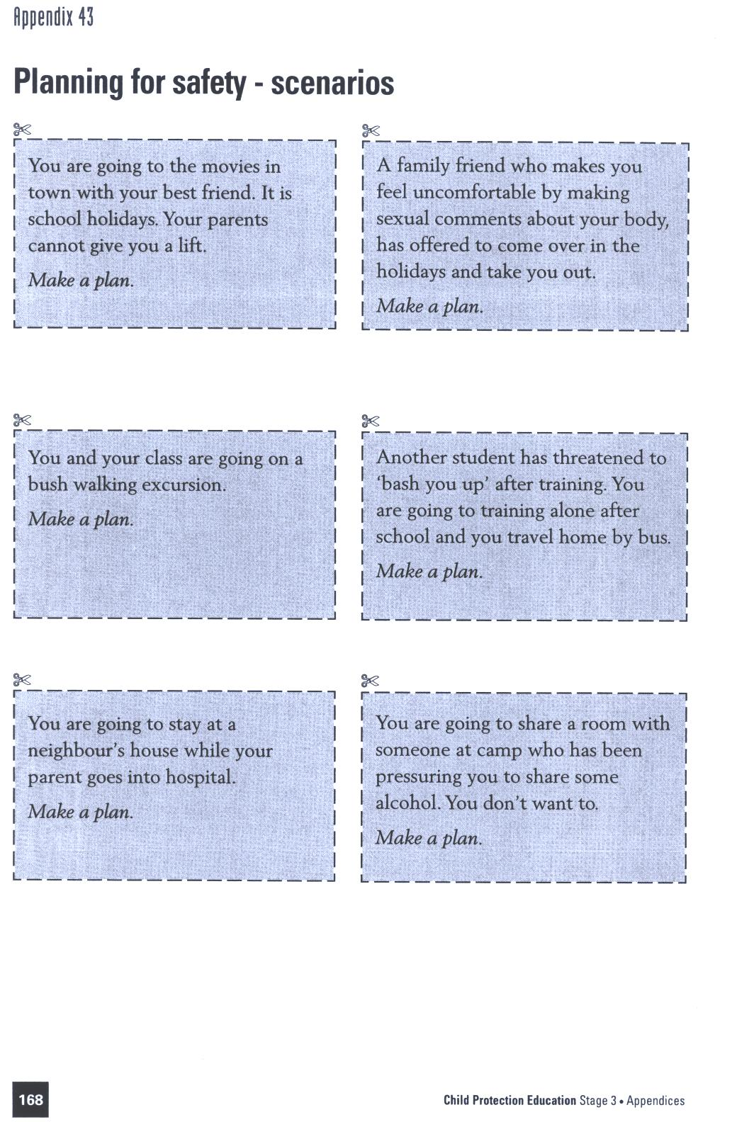

Reproduced from: NSW Department of School Education and Training (1998) Child Protection Education: Curriculum materials to support teaching and learning in PDHPE, Stages 1, 2 and 3.


1. Nancy has arranged to meet her Aunt in the local park. She is half an hour early so she sits down on a bench to wait. An older girl sits down beside her. The girl is holding an open bottle of whisky.

2. Doug has caught the train into town to meet his friends at the cinema. There are groups of young people hanging around the town centre. He notices someone has a knife.

3. Mimi is at home alone on a Saturday morning. There is a knock at the door.

4. Pete has stayed longer at the homework centre than he planned. He has to walk home in the dark.

5. Van’s parents have gone out for the evening. He is at home alone with his younger brother.

6. Marta is first to get home each day because her parents work. She has to walk some distance from the bus stop. When she arrives home one day she notices that the front window is wide open.

7. Adnan is riding his bicycle home from his friend’s place. There are not many people around.

Reproduced from: NSW Department of School Education and Training (1998) Child Protection Education: Curriculum materials to support teaching and learning in PDHPE, Stages 1, 2 and 3.

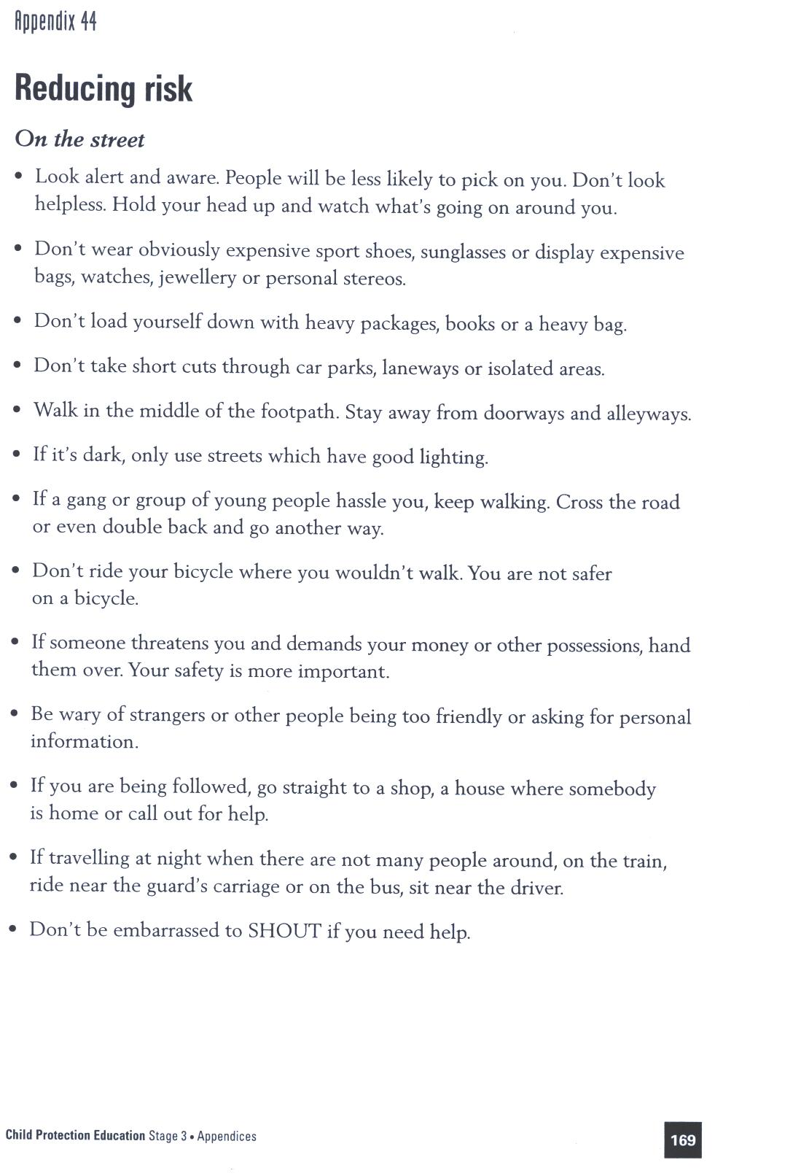

Reproduced from: NSW Department of School Education and Training (1998) Child Protection Education: Curriculum materials to support teaching and learning in PDHPE, Stages 1, 2 and 3.
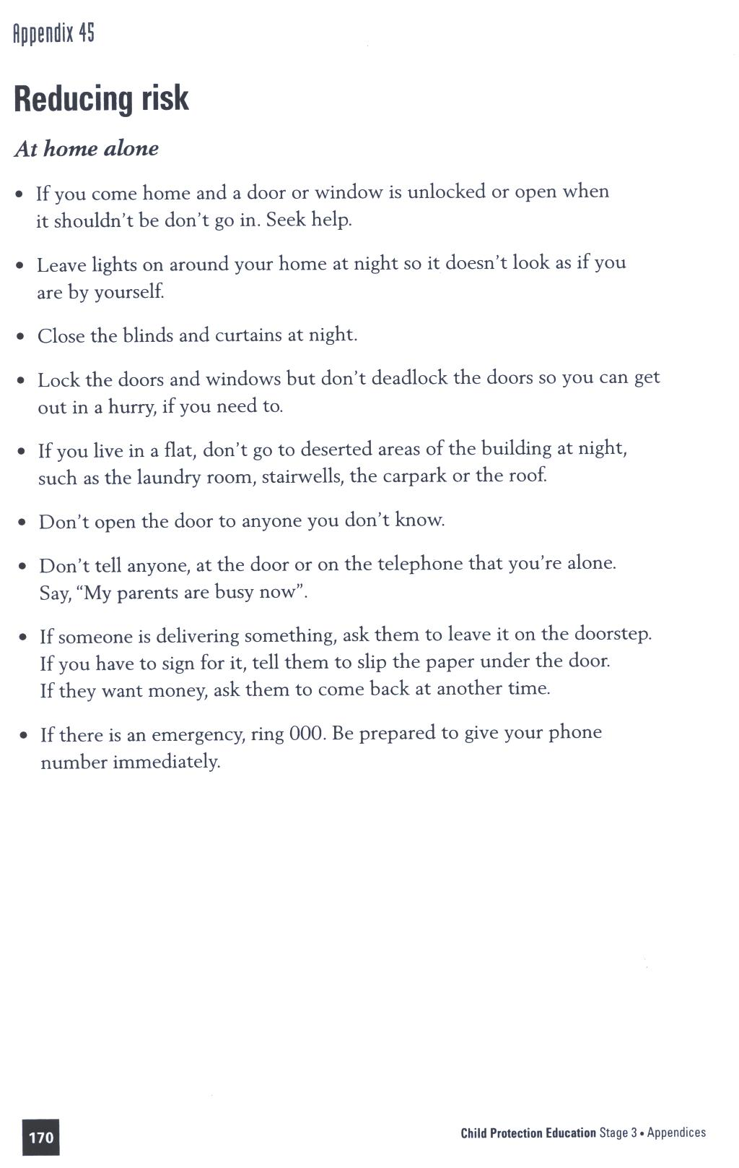

Reproduced from: NSW Department of School Education and Training (1998) Child Protection Education: Curriculum materials to support teaching and learning in PDHPE, Stages 1, 2 and 3.
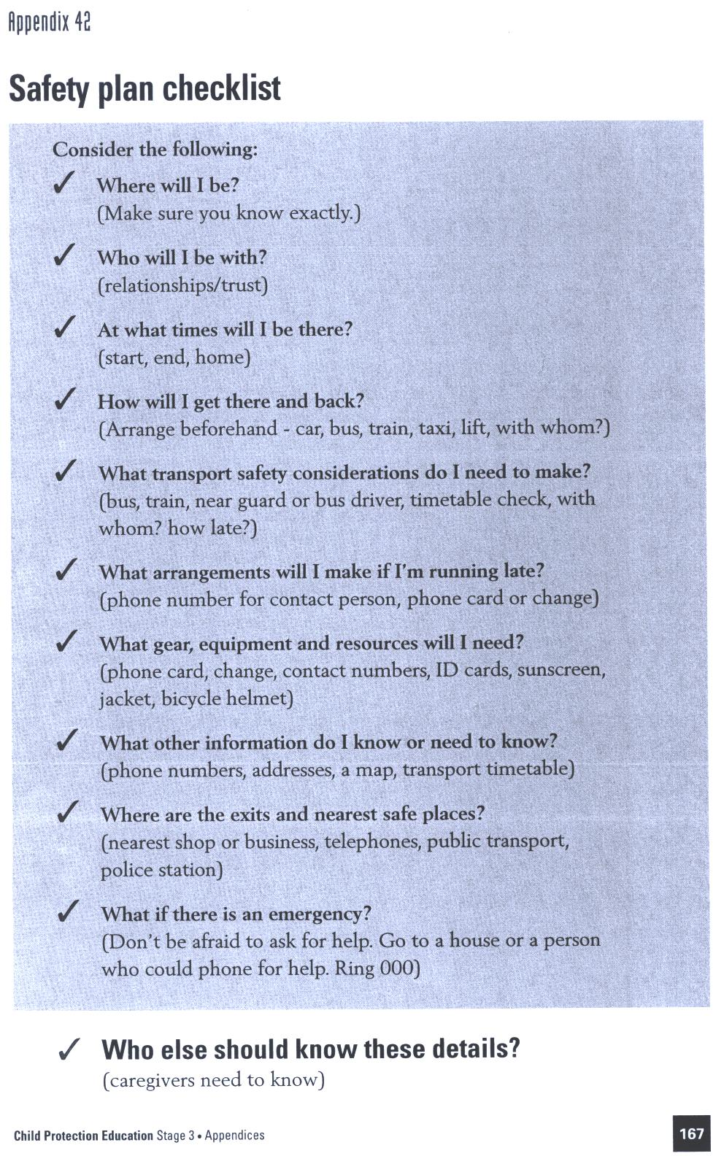

Reproduced from: NSW Department of School Education and Training (1998) Child Protection Education: Curriculum materials to support teaching and learning in PDHPE, Stages 1, 2 and 3.

TEACHER REFLECTION - UNIT EVALUATION

Unsatisfactory
Satisfactory

Poor
Good

A. A. EVIDENCE
To what extent does the assessment evidence provide:
1. A valid and reliable measure of the targeted outcomes/enduring understandings?
2. Sufficient information to support inferences about each
student’s understanding/level of achievement?
3. Opportunities for students to demonstrate their understandings through authentic learning tasks?
B. LEARNING EXPERIENCES AND INSTRUCTION
To what extent did students:
1. Achieve the outcomes and the enduring understandings of the unit (the big ideas as opposed to basic facts and skills)?
2. Know where they were going and why (in terms of unit goals, requirements, and evaluative criteria)?
3. Deepen their knowledge and understanding of the outcomes & big ideas of the Unit (through inquiry, research, problem solving, and experimentation)?
4. Receive explicit instruction on the knowledge and skills needed to equip them for the required performances?
5. Have opportunities to rehearse, revise, and refine their work based on feedback?
6. Self-assess and set goals prior to the conclusion of the unit?

PTO
1. What did students learn? (What knowlege and skills did they learn to deepen their understanding of the outcomes/big ideas of the unit?)

2. How do you know what they learnt? (What evidence do you have to support your judgement?)

3. What would you refine to improve student learning outcomes?

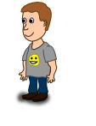
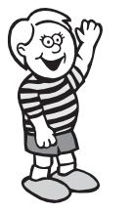
Student Unit Reflection
Stage 3

Student Name: Class:
Unit/Topic:
Think about the Personal Development and Health Education Unit you have just finished which focused on keeping yourself happy, healthy and safe, then complete the sentences below.

Two important things I have learnt about/learnt to do during this unit are… | What I learnt will help me in my life because…
A question about this unit that I asked in class was… | Something that still puzzles me is...
A question about this unit that I asked at home was… | I have changed my ideas about…
Something I am going to value/appreciate more about myself because of what I have learnt in this unit is… | If I wanted to research more about this unit I could…
Something I am going to value/appreciate more about others because of what I have learnt in this unit is… | I think the effort I put into my learning in this unit was:  (Circle one number)  No effort 0 1 2 3 4 5 6 7 8 9 10 Most effort

