FIT FOR LIFE
Stage: 3 | Unit Duration: 10 Lessons |  | Weeks 1 2 3 4 5 6 7 8 9 10 |  |  | Terms 1 2 3 4
Enduring Understandings  E.1 Our responsibility towards God’s gift of life is to make lifestyle choices that improve our health and quality of life.  E.2 We have a responsibility to live life to the full by participating in regular physical activity.  E.3 We have a responsibility to make informed decisions about our nutrition and how it affects our health. |  |  |  | Essential Questions:  - What contributes to an active and healthy lifestyle?  - How can I be responsible for maintaining my own health and well –being?
Major Outcomes  Knowledge and Understanding  ALS3.6 Shows how to maintain and improve the quality of an active lifestyle  Skills  DMS3.2 Makes informed decisions and accepts responsibility for consequences  Values and Attitudes  V5 Willingly participates in regular physical activity |  |  |  | Lesson Overview  1. How do my lifestyle choices affect my health? (E.1)  2. How can I improve my lifestyle? (E.1)  3. What are lifestyle risk factors? (E.1)  4. What are lifestyle risk factors? (E.1)  5. What is physical activity? (E.2)  6. What are the components of fitness? (E.2)  7. How can fitness be measured? (E.2)  8. How can I exercise safely? (E.2)  9. How does diet contribute to a healthy lifestyle? (E.3)  10. Why are nutrients important for a healthy lifestyle? (E.3)  KidsMatter SEL Focus  Major: Responsible Decision Making - Problem-Solving; Self-Management - Goal setting; Relationship Skills – Communication;  Minor: Social Awareness – Perspective-Taking; Self-Management - Goal setting; Responsible Decision Making – Analysing situations; Responsible Decision Making - Problem-Solving; Social Awareness – Appreciating Diversity
Contributing Outcomes

Knowledge and Understanding
GDS3.9 Explains and demonstrates strategies for dealing with life changes
PHS3.12 Explains the consequences of personal lifestyle choices
Skills
PSS3.5 Suggests, considers and selects appropriate alternatives when resolving problems
Values and Attitudes
V4 Increasingly accepts responsibility for personal and community health
Personal Health Choices
Throughout our lives, we all face having to make personal decisions relating to nutrition, hygiene, consumerism, drug use and disease prevention. So many conflicting opinions and values influence children in making decisions that have direct relevance to their health and well-being. Taught from a Catholic perspective, this strand seeks to develop the children’s abilities to observe, explore, interpret and judge, informed by an emerging integrated value system that is based on the values of the Gospel.
Growth and Development
God has created each of us to grow into the fullness of life. We are made in God’s image and therefore, we are of inherent dignity and worth. Our sexuality is an intrinsic part of ourselves, to be celebrated and expressed with joy and responsibility, according to God’s plan. Each person grows and changes, passing through stages on a journey towards full maturity. God is with us on this journey, reassuring and challenging. We are never alone.
Foundation Statements

Students examine key factors that contribute to a balanced lifestyle and keeping safe and healthy. They examine nutritional information, disease prevention and the effects of drugs on the body and they identify behaviours that impact on wellbeing. Students assess the safety of situations in home, school, water and road environments and identify appropriate responses. They describe and practice a range of personal safety strategies that could be used in threatening or abusive situations. They take responsibility for personal decisions, recognizing the effects that decisions have on self and others.

Students describe the factors that influence personal identity and examine the physical, social and emotional changes that occur during puberty. They devise strategies for coping with change, grief and loss. They value the differences between individuals and challenge discrimination and harassment. Students value different roles and responsibilities in relationships, the importance of communication and they practice positive ways to deal with conflict.

Suggested Correlation With Other KLAs  English  - Explanation  - Procedure  - Exposition (oral)  Creative Arts  - Dance – Performing  - Music – Organising Sound |  |  |  | Science and Technology  - Information and Communication  - Product and Services  - Designing/making a circuit/obstacle course to improve physical fitness  Mathematics  - Data Representation  - Working Mathematically  - Time
Technology

The following websites have been selected to enhance various concepts being taught throughout this unit. Most of the sites listed can be linked to more than one of the lessons being taught. Teachers may like to add them to the school intranet site. Some of the following sites have a great deal of information and it is important for the teacher to choose sections that are relevant to the needs and maturity of his/her class.

- http://pbskids.org/itsmylife/body/foodsmarts/index.html
- http://www.brainpop.com/health/nutrition/
- http://www.brainpop.com/health/personalhealth/fitness/preview.weml
- http://pbskids.org/itsmylife/body/solosports/index.html
- http://kidshealth.org/kid/stay_healthy/index.html
- http://kidshealth.org/kid/grow/index.html
- http://pbskids.org/itsmylife/index.html
- http://www.kidnetic.com/kore/Fitness.aspx

Subject Matter  Personal Health Choices  Making Decisions  - Decision-making process  - family/peers  - other significant people  - Making health decisions  - Evaluating decisions  Nutrition  - Nutritional needs across lifespan  - Energy intake/energy expenditure  - Variety of food choices  - Food preparation, storage  - Special needs/considerations  - Salt/sugar intake  - Saturated fats  Health Services and Products  - Health information and services  - Influence of media  Drug Use  - Effects of drugs |  | Preventative Measures  - Disease prevention  - lifestyle diseases, eg development of heart disease  Active Lifestyle  Components of an Active Lifestyle  - Use of leisure time  - balance of active/passive pursuits  - adequate rest  - enjoyment  - Community contacts for outside school interests  - Lifestyle risk factors  - exercise, nutrition, smoking  - Disease prevention  - Accumulated activity  Effects of Physical Activity  - Effects of physical activity on the body  - immediate, long-term  - strength  - flexibility |  |  | - cardiovascular endurance  - muscular strength  - muscular endurance  - balance  - speed  - Monitoring personal fitness and activity progress  Growth and Development  Personal Identity  - Setting goals  The Body  - Body systems  - functions  - interrelationships  - Effects of nutrition, activity  Changes  - Identify changes  Values  - Importance of values  - Influences on personal values
Unit Evaluation  Sample teacher and student unit evaluations are included at the end of the unit. |  |  |  | Assessment  Assessment strategies are included in each lesson. A sample assessment task for this unit is in Lesson 8.

An Overview Of Towards Wholeness (TW) in the PDH Unit
Fit For Life - Stage 3

Key God’s Word:

Our body is a gift of God, ‘God’s temple’ (1 Cor 3:16) to be treated with respect. (TW p. 19)

The Sabbath is the climax of God’s creative activity: ‘for six days you shall labour and do all your work, but the seventh day is the Sabbath of the Lord your God; on that day you shall not work.’ (Ex 20:8-10) (TW p. 18)

Enduring Understandings | Beliefs and Values | Lesson Overview/Links
E.1. Our responsibility towards God’s gift of life is to make lifestyle choices that improve our health and quality of life. | - We have a duty to care for our whole selves, that is, our mental, social, physical, cultural and spiritual selves. TW p.17  - Our responsibility towards our gift of life is to make lifestyle choices that ensure health and well-being. TW p.35 | 1. How do my lifestyle choices affect my health?  2. How can I improve my lifestyle?  3. What are lifestyle risk factors?  4. What are lifestyle risk factors?  10. Why are nutrients important for a healthy lifestyle?
E.2. We have a responsibility to live life to the full by participating in regular physical activity. | - We are called to live life to the full. TW p.17  - We have a responsibility to promote our health by making wise decisions. TW p.38 | 5. What is physical activity?  6. What are components of fitness?  7. How can fitness be measured?  8. How can I exercise safely?
E.3. We have a responsibility to make informed decisions about nutrition and how it affects our health. | - We have a responsibility to promote our health by making wise decisions. TW p.37  - We should appreciate and respect our body... TW p.25  - Life is a precious gift entrusted to us by God. TW p.41 | 9. How does diet contribute to a healthy lifestyle?  10. Why are nutrients important for a healthy lifestyle?

Footnote:
- We were all created by a loving, caring God whose intention is that we should leave active and fulfilling lives. (TW p.17)
- We are entrusted, by God, with the care of and nurture of our physical selves. Consequently, we need to be discerning about our choices of food and drink. (TW p.35)
Lesson 1 How do lifestyle choices affect my health?

Enduring Understandings | Outcomes |  | Indicators
E.1. Our responsibility towards God’s gift of life is to make lifestyle choices that improve our health and quality of life. | ALS3.6 Shows how to maintain and improve the quality of an active lifestyle  DMS3.2 Makes informed decisions and accepts responsibility for consequences  V4 Increasingly accepts responsibility for personal and community health |  | - Identifies the factors that contribute to a healthy lifestyle  - Predicts the consequences of their choices  - Values the need to pursue healthy lifestyles
KidsMatter SEL Focus: Major - Responsible Decision Making - Problem-Solving; Minor – Social Awareness – Perspective Taking
Suggested Learning Experiences
Teacher reads the Who is Healthy? Case studies (from Stage 2). Discuss what factors in each case study are healthy and unhealthy.

In pairs, students create a definition for health. Present the WHO definition of health and the components of health outlined on the What Influences My Health? Activity. How did the students' definition compare with the WHO definition?

TW: Bring the students to an understanding that we have a duty to care for our whole selves, that is, our mental, social, physical, cultural and spiritual selves. Our responsibility towards our gift of life is to make lifestyle choices that ensure health and well-being. Refer to and discuss, the four areas of health outlined in the What Influences My Health? Activity (physical, social, mental, spiritual). Discuss each area. Ask children questions to develop their understanding of each area of health, eg. Spiritual Health- How are you connected to your Catholic faith? How does my faith influence my decisions/choices?

In small groups, brainstorm a list of factors that may affect your health. Students organise the list under the headings of Rest, Relaxation, Exercise and Diet. Students identify which factors they have a choice about. Share with a partner.

Develop the idea that a combination of factors contribute to a healthy lifestyle and that it is important to have a balance of these factors. Many of these factors are related to choice, and the decisions we make, eg. diet and exercise. There are some factors that you may not have a choice about, or your parents may choose for you, eg. inherited illness, activities you are allowed to participate in, some food choices. Health is influenced by lifestyle choices, hospitals, doctors and health products.

In pairs, using the What Influences My Health? Activity, make a list of activities that students have a choice about under the headings: Positive Lifestyle Factors; Negative Lifestyle Factors. And /or debate the topic ‘Homer Simpson is healthy’.

Resources  - Who Is Healthy? case studies  - What Influences My Health? Activity |  | Assessment  Student work sample of What Influences My Health? Activity

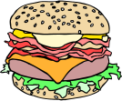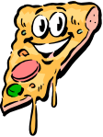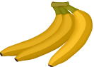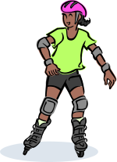
- Sam is 31 years old and has smoked since he was 15. He works in an office and does no exercise except for a little gardening on the weekend. Sam played football every weekend in winter until he was 25. He still looks fit and is not overweight. Sam lives with his wife and three children but does not play very much with his children and has started to fight with his wife.

- James is a 50-year-old office worker. He gave up smoking 10 years ago and four weeks ago stopped work because it was getting too stressful. He is a big man carrying extra weight. He has lots of friends and he tells great jokes. James likes eating out with his friends four times a week. He has started a new business from home so he can spend more time with his family.

- Elyse is a 42-year-old teacher with three children. She works at school full time, but sometimes does not get enough sleep because she has asthma. Elyse tries to cook healthy meals for her family and does not drink alcohol or smoke. She plays netball on weekends in winter and walks three times a week for 45 minutes with friends. She spends a lot of time in the car driving her children to sport and other activities and goes to Mass each week.

- Caitlin is a very fit 25-year-old fitness instructor. She spends an hour each day doing her own exercises at the gym. Caitlin teaches fitness classes to adults and children for four hours each day. She tries to eat healthy food which is low in fat. Sometimes Caitlin does not go out with her friends because she would rather go to the gym than stay out late at a party and drink alcohol. She lives alone, does not have many friends and visits her family every month.

- Liam is 50 years old and has heart disease. Six months ago Liam was told by his doctor to start eating foods low in fat and to walk for 30 minutes each day. He feels healthy and has lost weight since going on the new diet and exercising program. Liam has a wife, two children and four grandchildren. He is happy and has lots of friends and sometimes goes to church.
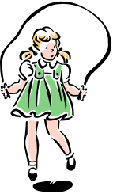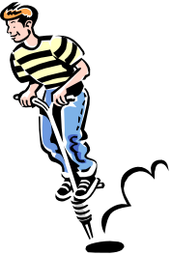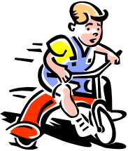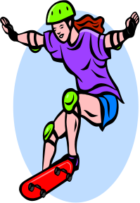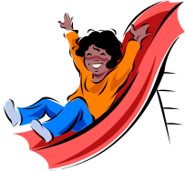
WHAT INFLUENCES MY HEALTH?

The World Health Organisation defines health as: ‘a state of complete, mental, physical and social wellbeing and not merely the absence of disease and infirmity’.

Catholic Values/Beliefs: We have a duty to care for our whole selves, that is, our mental, social, physical, cultural and spiritual selves. Our responsibility towards our gift of life is to make lifestyle choices that ensure health and well-being.

The four areas of health are:

- Physical health – having a healthy body (fitness, being well and not sick, energy, good nutrition, body weight, well-functioning body organs)
- Social health – having positive relationships that are loving, caring and cooperative
- Mental health – being able to make decisions, express our feelings, cope with life and think positively about ourselves (self-esteem) and life
- Spiritual health – being connected to our Catholic faith, being a disciple of Jesus, being connected to our family, friends and community.

I think health is _______________________________________________________________________________________________________________________________________________________________________________________________________________

I think health is influenced by
_______________________________________________________________________________________________________________________________________________________________________________________________________________

The decisions and choices I make can affect my health. List the positive and negative lifestyle choices that you can make. Identify one health issue for each negative lifestyle factor.

Positive lifestyle factors☺ | Negative lifestyle factors☹ | Health issue?
Example:  Rest | Not enough sleep | Stress
Lesson 2 How can I improve my lifestyle?

Enduring Understandings | Outcomes |  | Indicators
E.1. Our responsibility towards God’s gift of life is to make lifestyle choices that improve our health and quality of life. | ALS3.6 Shows how to maintain and improve the quality of an active lifestyle  PHS3.12 Explains the consequences of personal lifestyle choices  PSS3.5 Suggests, considers and selects appropriate alternatives when resolving problems  V5 Willingly participates in regular physical activity |  | - Lists behaviours that contribute to a healthy lifestyle  - Identifies barriers to participation in physical activity and suggests ways to modify or overcome them  - Formulates strategies to improve fitness  - Values the importance of physical activity to personal health
KidsMatter SEL Focus: Major - Responsible Decision Making - Problem-Solving;
Self-Management - Goal setting

Suggested Learning Experiences

TW: In the Bible it says: ‘For six days you shall labour and do all your work, but the seventh day is the Sabbath of the Lord your God; on that day you shall not work.’ (Ex 20:8-10)
Discuss with the students that in our effort to care for our wholeselves and make lifestyle choices that ensure health and well-being, we should monitor all aspects of our work, rest, leisure and exercise.

As a class, recall the positive and negative lifestyle factors discussed in Lesson 1, eg. poor diet, lack of physical activity, stress, smoking, drug taking, poor relationships, not enough rest or relaxation.

In pairs students create and draw an unfit cartoon character and describe his/her unhealthy lifestyle behaviours. Present to class. Choose one of the characters invented by the students and as a class suggest ways that the character could improve their lifestyle, eg. eating a balanced diet, participating in regular physical activity, making friends, watching less television, setting aside time to rest.

HOME TASK: TW: Remind students that life is a gift from God and we have a responsibility to make lifestyle choices that ensure health and well-being. Students describe their own lifestyle and identify one long-term and one short-term goal to improve it. Use the goal-setting process outlined in the My Lifestyle Goals! Activity and develop a plan to improve these two areas. Share your goals at home. How can your family support you in achieving these goals?

Resources  - Drawing materials  - My Lifestyle Goals! Activity |  | Assessment  Student work sample of lifestyle goals
MY LIFESTYLE GOALS!
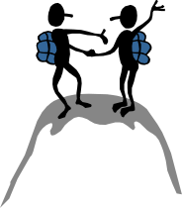
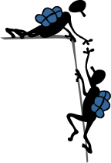

Catholic Values and Beliefs: Our responsibility towards our gift of life is to make lifestyle choices that ensure health and
well-being.

Choose one short-term and one long-term goal related to our lifestyle.

Steps for achieving your goal | Short-term goal | Long-term goal
- What is the goal?

- What will I need to do to achieve the goal/Plan?
(include family support)

- What are some of the barriers?

- How can I overcome these barriers?

- What is my starting date? Act and put the plan into action

- What is my expected completion date? Evaluate

Parent:__________________________ Student:_____________________________
Lesson 3-4 What are lifestyle risk factors?

Enduring Understandings | Outcomes | Indicators
E.1. Our responsibility towards God’s gift of life is to make lifestyle choices that improve our health and quality of life. | V4 Increasingly accepts responsibility for community and personal health  GDS3.9 Explains and demonstrates strategies for dealing with life changes  PHS3.12 Explains the consequences of personal lifestyle choices  DMS3.2 Makes informed decisions and accepts responsibility for consequences | - Values the need to pursue healthy lifestyle  - Describes the effect of poor lifestyle choices on the systems of the body  - Identifies lifestyle risk factors  - Predicts the consequences of their choices
KidsMatter SEL Focus: Minor - Self Management - Goal setting

Suggested Learning Experiences
TW: Bring the students to the understanding that our responsibility towards our gift of life is to make lifestyle choices that ensure good health and well-being. Our body is a gift of God, ‘God’s temple’ (1 Cor 3:16) to be treated with respect. What does this mean? In what ways do some people not treat their body as a temple?
As a class, review the lifestyle factors which negatively affect our health. Identify these as lifestyle risk factors, eg:
- physical inactivity | - exposure to the sun
- poor eating habits | - poor relationship skills
- smoking | - poor coping skills
- drug and alcohol abuse | - mental health issues – depression/anxiety
In pairs, discuss and identify the risk factors for each of the following: heart disease, skin cancer, asthma, injuries, poisoning, obesity, eating disorders, diabetes, high levels of fat and cholesterol, high blood pressure and higher stress levels. Share your response with the next pair. As a class, summarise and record the risk factors in your book.
In small groups students research one of the following lifestyle diseases/illnesses. Research the risk factors/causes, prevention and support services for:
- Heart disease
- Cancer
- Asthma
- Diabetes
Present the information to the class. Students may choose their method of presentation, eg. flow chart, story map, newspaper/magazine article, poster, PowerPoint.

What lifestyle changes can I make to keep me healthy?
What can I do to increase my physical activity?

Activity
Students design physical activity cards that include fitness components.

Give to PE teacher to use as warm ups/cool down activities

eg
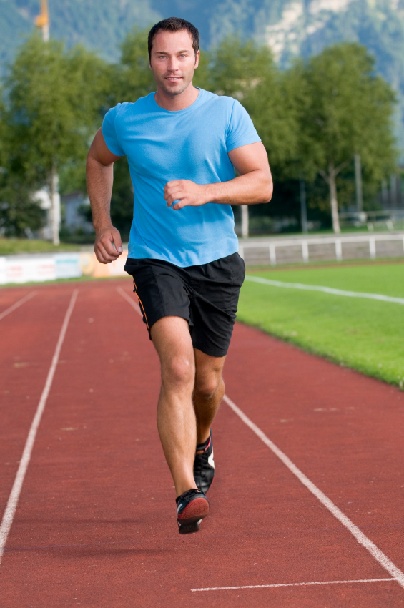
Run around the netball court 3 times

Fitness Component:
Cardio-respiratory endurance

Resources  - Teacher reference material at: www.heartfoundation.org.au, www.cancercouncil.com.au, www.nationalasthma.org.au www.jdrf.org.au, www.healthykids.nsw.gov.au  - Children’s Hospital Westmead - www.chw.edu.au  - Department of Health Fact Sheets |  |  | Assessment  Student’s participation in presentation
Resources  - Teacher reference material at: www.heartfoundation.org.au, www.cancercouncil.com.au, www.nationalasthma.org.au www.jdrf.org.au, www.healthykids.nsw.gov.au  - Children’s Hospital Westmead - www.chw.edu.au  - Department of Health Fact Sheets |  |  | Assessment  Student’s participation in presentation
Lesson 5 What is physical activity?
Enduring Understandings | Outcomes | Indicators
E.2. We have a responsibility to live life to the full by participating in regular physical activity. | ALS3.6 Shows how to maintain and improve the quality of an active lifestyle  PHS3.12 Explains the consequences of personal lifestyle choices  DMS3.2 Makes informed decisions and accepts responsibility for consequences  V5 Willingly participates in regular physical activity | - Generates personal goals based on their understanding of what it means to be fit  - Describes a definition of fitness which relates to everyday activities  - Applies decision-making processes when choosing recreational pursuits  - Recognises the value of lifelong commitment to regular physical activity
Suggested Learning Experiences
TW: Teacher presents the following belief to the class: We are called to live life to the full. We were all created by a loving, caring God whose intention is that we should lead active and fulfilling lives. How does this belief relate to physical activity?
As a class, review the different ways to be active. Ensure that the discussion includes more than just organised sports. For example, riding my bike, gardening, walking the dog, walking to the shop and riding my skateboard. Identify the active and passive activities. Discuss what is meant by the term leisure, eg. spare time, not at work, fun, enjoyable. Identify which activities are aerobic.
Teacher Note: Continuous activities requiring large muscle groups, eg. walking, running, cycling, swimming. Aerobic activity improves heart and lung function.

Using the What is Physical Activity? teacher fact sheet, the teacher reviews and discusses the meaning of the terms:
- Physical activity
- Exercise
- Fitness
Students discuss what are the effects of physical activity on the body using the Student Fact Sheet. In small groups select one body system and research the effects of physical activity on the body.
Using the Physical Activity Survey interview 4 students (2 boys and 2 girls) about the types and benefits of physical activity. Discuss similarities and differences regarding gender.
Invite a local identity who demonstrates a high level of fitness and a healthy lifestyle (eg. Personal trainer, Yoga/Pilates instructor, sporting identity.) As a class, develop some interesting questions to ask them, relating to their lifestyle, prior to their visit.

Reflection; Students revisit their personal goals from Lesson 2 to apply their new learnings.
Resources  - What is Physical Activity? Teacher Fact Sheet  - Physical Activity Survey  - www.healthykids.nsw.gov.au  - Magazine/newspaper articles about sportspeople  - Effects of physical activity on the body Student Fact Sheet |  |  | Assessment  Student work sample of Physical Activity Survey
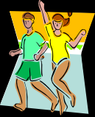

Physical activity can mean different things to different people.
Everyone should be active for 30 minutes each day to gain health benefits.

Physical Activity | Is an activity where we are active and need energy, eg exercise, fitness, sport, leisure activities and household activities (gardening, vacuuming), walking the dog.
Exercise | Is a type of physical activity to help people get fit. Exercise helps people to: lose weight, improve muscle tone/strength, improve fitness and energy, reduce stress. It is planned and done regularly.
Physical Fitness | Is what you get out of doing physical activity. Being fit can help you in two ways:  1. Health benefits – stronger heart, better breathing/respiration, better flexibility, more energy, stronger muscles, a healthy weight (not obese), improved confidence or self-esteem, more friends, etc.  2. Skill benefits – improved agility, balance, speed, power, coordination and reaction time.

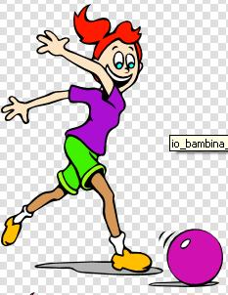

PHYSICAL ACTIVITY SURVEY

Survey 4 students (2 boys and 2 girls) in your class

 | Student 1 | Student 2 | Student 3 | Student 4
Name

Age

During the last week how many times have you been physically active? (1, 2, 3, 4 or more?)

What type of physical activity do you most enjoy?

What type of things prevent you from being physically active? eg time, cost, don't like it, no facilities, no-one to exercise with, too tired.

What are the two most important benefits of physical activity?

What were the similarities and differences?
__________________________________________________________________________________________________________________________________________________________________________________________________________________________________________________________________________________________________________________

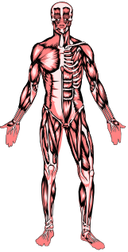
BODY SYSTEM | EFFECTS OF EXERCISE
Circulatory System: consists of blood, the heart and blood vessels. It is the transport system for the body and delivers oxygen and nutrients to all parts of the body and removes carbon dioxide and wastes. | Circulation is improved, resting heart rate is slower, working heart rate is higher, blood pressure is lower.
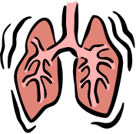Respiratory System: consists of the mouth, nose, lungs, ribs, bronchioles and diaphragm. Breathing is the main function of this system. Breathing is the process by which air is moved in and out of the lungs. It is controlled by the brain. | Lungs grow stronger and can exercise for greater amounts of time without getting puffed, when resting time between breaths is longer, breaths are deeper.
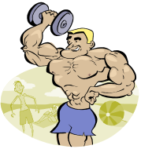Muscular System: consists of over 600 muscles in the body. The role of muscles is to contract. When the muscles contract, the body is able to move. | Muscles become firm, toned and more shapely, muscles can work for longer periods of time without getting tired, muscle strength improves over time.

DID YOU KNOW?
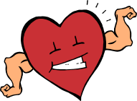Other Benefits of Physical Activity:  - Better weight control  - Less stress  - Better social life – friends  - Better flexibility  - More energy | The Heart: is a muscular pump that keeps the blood circulating through the body. It is slightly larger than a clenched fist and is the shape of a large pear. The heart beats about 100,000 beats per day. In one day the heart can pump about 12,000 litres of blood, which is enough to fill a small petrol tanker.
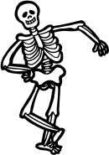Everyone: should be active for 30 minutes each day – ideally seven days a week – to gain health benefits. | Skeletal System: consists of 206 bones. It provides a frame for the body and protects vital organs. It works with the muscles to help the body move.

Lesson 6 What are the components of fitness?

Enduring Understandings | Outcomes |  | Indicators
E.2. We have a responsibility to live life to the full by participating in regular physical activity. | ALS3.6 Shows how to maintain and improve the quality of an active lifestyle  DMS3.2 Makes informed decisions and accepts responsibility for consequences  V5 Willingly participates in regular physical activity |  | - Designs fun and safe physical activities  - Chooses appropriate activities to develop components of fitness  - Values the importance of physical activity to personal health
KidsMatter SEL Focus: Minor - Responsible Decision Making – Analysing situations

Suggested Learning Experiences

Discuss and compare the type of fitness and exercise routines required for various physical activities, eg. gymnastics, dance, marathon running, sprinting, weight-lifting, ball games etc.
In pairs, list and describe the components of fitness using the Components of Fitness Activity.
Students complete the Mix and Match Fitness Components Activity.

TW: Bring students to the understanding that we have a responsibility to promote our health by making wise decisions. We can appreciate the God-given gift of our bodies by making wise decisions about our lifestyle. One of the pre-requisites for a healthy lifestyle is exercise.
Discuss the need to participate in activities that improve ALL components of fitness.

Fitness Component Relay – In their groups, students brainstorm a list of physical activities. Teacher records these activities on the board. Teacher calls out one of these physical activities. In their teams/groups, students must confer, decide on the component of fitness that is MOST used in this Activity and one student from each group walks to the front of the room and pins their fitness component under the activity heading on the board. Points are awarded for correct responses.

Using the list of activities on the board as stimulus, students design an indoor/outdoor physical activity circuit or obstacle course that uses a variety of fitness components. Students record their circuit/obstacle course ideas and present it to the class.

Resources  - Components of Fitness Activity  - Mix and Match Fitness Components Activity  - Butchers paper |  | Assessment  Teacher observation of student contribution to fitness component game

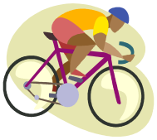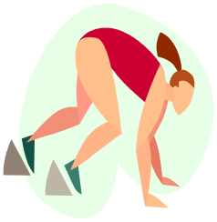

List some activities that develop each of the components of fitness.

Fitness Component | Activity
Muscular endurance – ability of muscles to keep going

Cardio-respiratory endurance – ability of circulatory and respiratory systems to keep going when exercising without getting too tired
Muscular strength – ability to push, pull, lift or carry

Flexibility – ability to bend, stretch, twist and turn

Power – strength in a burst (explosive movement)

Agility – ability to change direction quickly | Playing tag with my friends
Reaction time – ability to respond to stimulus | Catching a ball when fielding close to the stumps in a cricket game
Speed | Running for the bus
Balance

Coordination – ability to sequence, timing and movement of body parts

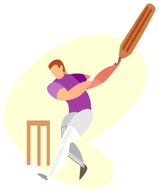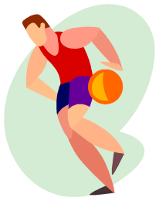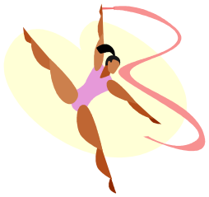
Match the following activities with the components of fitness.
- long-distance running
- throwing a discus
- doing the splits
- juggling
- diving in the pool when the gun goes in a race
- 100 metres race
- basketball dribbling around a player
- lifting a heavy wheelbarrow
- riding a skateboard
- bursting off from the blocks in a sprint start

Fitness Component | Activities

Speed
Agility
Muscular endurance
Reaction time
Strength
Cardio-respiratory endurance
Power
Coordination
Balance
Flexibility

Lesson 7 How can fitness be measured?

Enduring Understandings | Outcomes |  | Indicators
E.2. We have a responsibility to live life to the full by participating in regular physical activity. | ALS3.6 Shows how to maintain and improve the quality of an active lifestyle  PSS3.5 Suggests, considers and selects appropriate alternatives when resolving problems  V5 Willingly participates in regular physical activity |  | - Describes procedures to measure components of fitness  - Selects the most appropriate ways to measure the components of fitness  - Values the importance of physical activity to personal health
Suggested Learning Experiences

Revise the components of fitness discussed last week. As a class, brainstorm some ways to measure each component of fitness. Together, decide on the most appropriate activities if the class were to design a test to measure each component. Consider factors such as safety, equipment, time etc.

Demonstrate how to measure carotid and arterial pulse. Students practise measuring arterial pulse. In groups, students measure their own pulse rate before, during and after exercise and compare the difference between the measurements. The following may be assessed: cardiovascular endurance, muscle strength, muscle endurance, flexibility and ideal body weight. ACHPER's Australian Fitness Award is an ideal way of assessing specific aspects of fitness.

Using the Your Pulse Activity measure and record how hard the body is working. Have students take pulse rates when:
- The body is at rest
- Immediately after exercise
- After 1 minute rest
- After 2 minute rest
Note: there is a wide range of resting pulse rates.

Using the Skipagraph Activity, have students graph their pulse rates and recovery time after skipping.

Note: Recovery rate is a rough approximation of fitness. The more fit the heart and blood system is, the faster the return to a normal resting heart rate.

Resources  - National Heart Foundation. (1996). Heart Health Manual. A Resource Kit for Primary Teachers. Your Pulse Activity and Skipagraph Activity, pages 613 and 615.  - Stopwatch or clock/watch with second hand |  | Assessment  Student’s participation in Cardiovascular Endurance Activity

Reproduced from: National Heart Foundation (1996) Heart Health Manual, a Resource Kit for Primary Teachers.
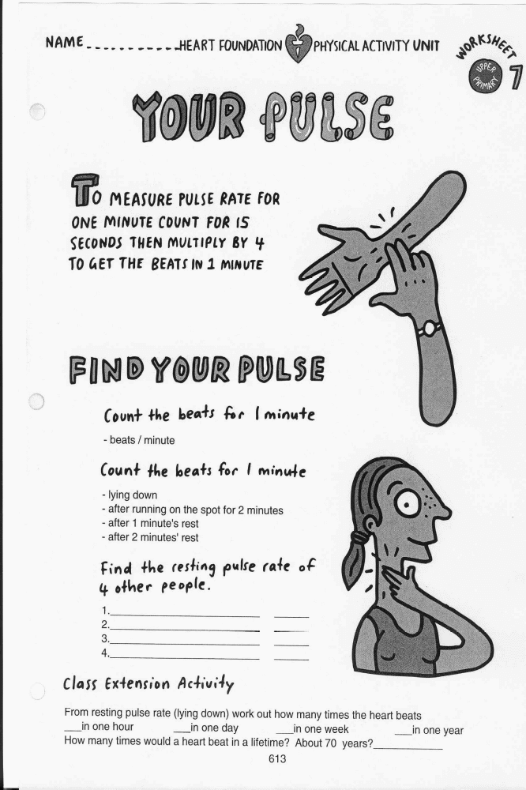

Reproduced from: National Heart Foundation (1996) Heart Health Manual, a Resource Kit for Primary Teachers.

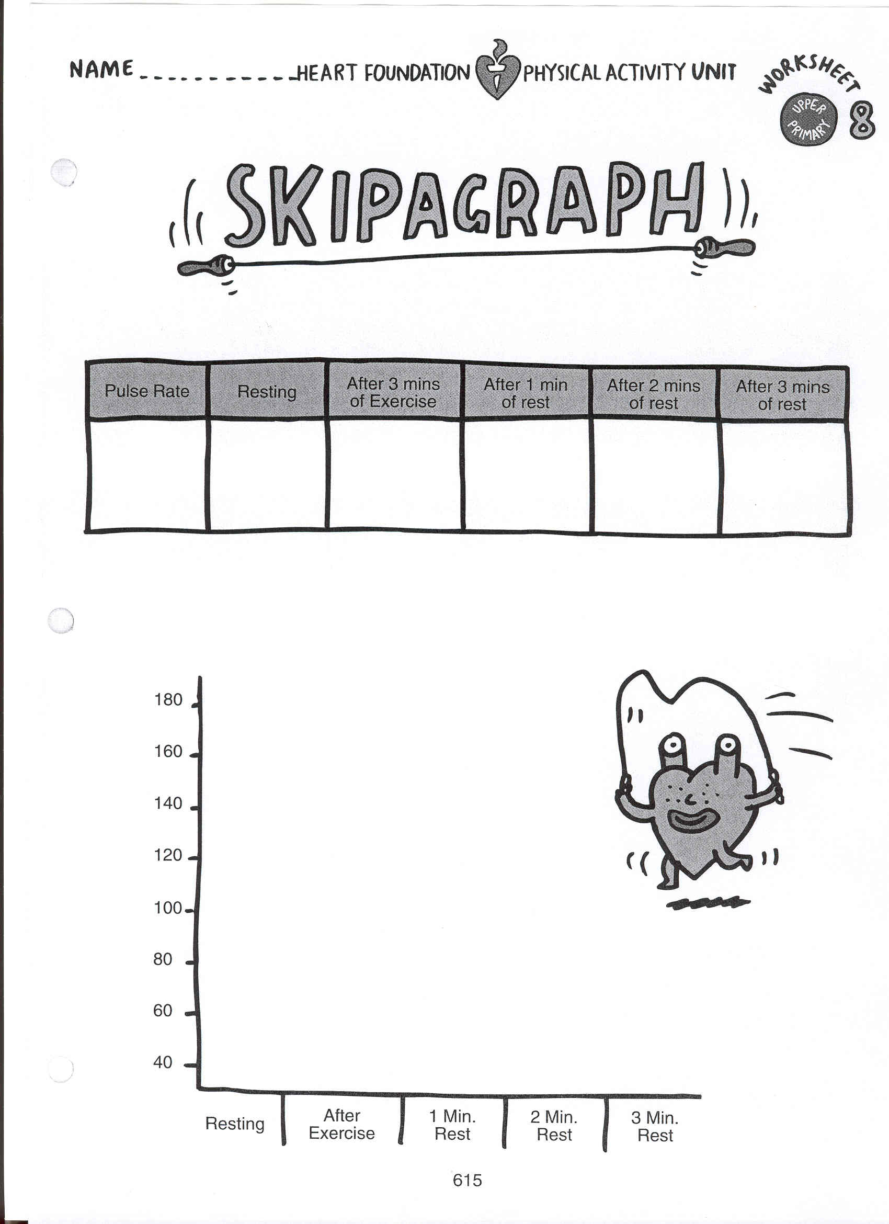

Reproduced from: National Heart Foundation (1996) Heart Health Manual, a Resource Kit for Primary Teachers.

Lesson 8 How can I exercise safely?

Enduring Understandings | Outcomes |  | Indicators
E.2. We have a responsibility to live life to the full by participating in regular physical activity. | ALS3.6 Shows how to maintain and improve the quality of an active lifestyle  DMS3.2 Makes informed decisions and accepts responsibility for consequences  V5 Willingly participates in regular physical activity |  | - Identifies appropriate warm-up stretches for a variety of sports/activities  - Designs fun and safe physical activities  - Identifies safe practices associated with exercise  - Values the importance of physical activity to personal health
KidsMatter SEL Focus: Major - Self Management - Goal setting; Relationship Skills – Communication; Minor - Responsible Decision Making - Problem-Solving
Suggested Learning Experiences
Students participate in a brief running game to increase body temperature before stretching. Teacher models a range of fun warm-up stretches – knee tag, unders and overs, twister, and identifies the muscle groups which are being stretched.

Discuss the importance of warm-up and stretching for safe participation in physical activities.
List safe practices for stretching. Identify some unsafe stretches/practices. Choose some well-known sports people and identify the muscle groups they would primarily need to stretch.

Identify some other requirements to enable safe participation in exercise:
- Use of safety equipment
- Participating according to rules
- Drinking adequate water

Discuss some reasons why drinking adequate water is important.
- Small fluid losses can cause muscles to become weak and tired.
- Greater losses result in heatstroke and even death.
- The body requires at least 6 glasses of water a day. With exercise more water is needed.
- Fluid should be taken before, during and after exercise. Water is the best way to replace fluid (See note on sports drinks in Lesson 9).

In small groups, students devise a ‘new game’ using various modified equipment, eg paper plate, golf ball and spoon, toilet roll, crumpled paper ball, balloon. Groups must prepare:
- Aim of the game
- Number of players
- Playing space
- Rules
- Safety requirements
- Scoring
Resources  - Materials for modified game |  | Assessment  Small group creation of a new game, using given criteria.
Lesson 8 – Creating a Game

This task provides students with the opportunity to demonstrate their standard of achievement of the following outcomes:

Outcomes | Indicators | Working towards | Achieved with support | Achieved
ALS3.6 Shows how to maintain and improve the quality of an active lifestyle | Designs fun and safe physical activities
DMS3.2 Makes informed decisions and accepts responsibility for consequences | Identifies safe practices associated with exercise

In small groups, students devise a ‘new game’ using various modified equipment.

Groups must prepare:

- Aim of the game
- Number of players
- Playing space
- Rules
- Safety Requirements
- Scoring

Lesson 9 How does diet contribute to a healthy lifestyle?

Enduring Understandings | Outcomes |  | Indicators
E.3. We have a responsibility to make informed decisions about nutrition and how it affects our health. | PHS3.12 Explains the consequences of personal lifestyle choices  PSS3.5 Suggests, considers and selects appropriate alternatives when resolving problems  GDS3.9 Explains and demonstrates strategies for dealing with life changes  V4 Increasingly accepts responsibility for personal and community health |  | - Explains the need for good dietary habits  - Discusses food needs for growth and activity  - Recognises a range of influences on dietary requirements  - Values the need to pursue a healthy lifestyle
KidsMatter SEL Focus: Minor - Self Management - Goal setting
Suggested Learning Experiences

TW: Discuss the responsibility we have to promote our health by making wise decisions. (Revise some of these wise decisions that have been discussed in previous lessons in regards to lifestyle and exercise.) Bring the students to the understanding that we are entrusted, by God, with the care of and nurture of our physical selves. Consequently, we need to be discerning about our choices of food and drink. Brainstorm what knowledge we need to have in order to do this?

Review what are healthy and unhealthy foods? Discuss how eating patterns have changed over the years. Eg. More processed/fast/junk foods available; Longer working hours=less time to prepare healthy fresh meals.

Introduce the Australian Dietary Guidelines (2013) Dietary Guidelines for Children and Adolescents(www.nhmrc.gov.au) and discuss why its introduction has been necessary, eg 25% of children are overweight or obese, one-third of children under 12 years do not eat any fruit or fruit products, 1 in 5 children do not eat any vegetables, high-fat diets are more common. Children have poor eating habits and tend to miss meals, eat food poor in nutrients – high fat, salt, sugar and frequently snack between meals.
The Dietary Guidelines for Children and Adolescents
- Encourage and support breastfeeding
- Children need appropriate food and physical activity to grow and develop normally
- Enjoy a wide variety of nutritious foods
- Eat plenty of breads, cereals, vegetables (including legumes) and fruits
- Low-fat diets are not suitable for young children
- Encourage water as a drink. Alcohol is not recommended for children. TEACHER NOTE:
Discuss the effectiveness of sports drinks in replenishing fluid and glucose loss.
- Eat only a moderate amount of sugars and goods containing added sugars
- Choose low-salt foods

Use the Australian Guide to Healthy Eating Poster and ask students to recall and record what they have eaten in the last 24 hours (for breakfast, lunch, dinner and any snacks). Students compare their response to the Australian Guide to Healthy Eating poster. Discuss variety and balance and any differences between the students’ eating patterns and the recommended daily intake. Students add what they should eat for a balanced diet and healthy options.

Students complete the eating pattern sentences:
- The three best things are . . .
- The three things I need to improve are . . .
- The three things that influence my eating patterns are . . .

Resources  - Australian Guide to Healthy Eating  - Dietary Guidelines for Children & Adolescents at: www.nhmrc.gov.au |  | Assessment  Student work sample of the Healthy Food Plate and observation of Nutrient Group Work

The Australian Guide to Healthy Eating
Food Facts!

Teacher Fact Sheet

Food Group | Breads, Cereals, Rice, Pasta, Noodles | Vegetables, Legumes | Fruit | Milk, Yogurt, Cheese | Meat, Fish, Poultry, Eggs, Nuts, Legumes
Examples | Wheat  Oats  Rice  Barley  Millet  Corn | Lentils  Seeds  Dried peas, beans  Chick peas  Cauliflower  Cabbage  Broccoli  Carrots  Endive  Pumpkin  Leek  Cucumber  Mushroom  Zucchini  Bok Choy  Taro  Eggplant | Apricot  Apple  Cranberry  Kumquat  Grape  Kiwi fruit  Lychee  Pawpaw  Plum  Rambutan  Tamarillo  Date  Fig  Star fruit  Avocado  Lemon  Nashi  Persimmon | Full cream milk  Reduced fat milk  Soy Evaporated milk  Flavoured milk  Hard and soft cheeses  Custard  Yogurt – plain, reduced-fat, full-fat and flavoured | Lean beef  Chicken  Pork  Veal  Duck  Kangaroo  Fish  Eggs  Nuts  Sunflower seeds  Turkey  Legumes
Nutrients provided by foods in this group | Carbohydrate  Protein  Fibre  Vitamins  Minerals including foliate, thiamin, riboflavin, niacin and iron | Vitamins  Minerals  Foliate  Dried beans, peas, chick peas and lentils provide protein and iron | Vitamins especially C and foliate  Carbohydrate – sugar and fibre | Calcium  Protein  Riboflavin  Vitamin B12 | Protein  Iron  Niacin  Vitamin B12  Red meat – Zinc

Extra foods
Some foods do not fit into the 5 food groups. They are not essential to provide the nutrients the body needs. Some contain too much fat, salt, sugar. These foods are likely to contribute large amounts of energy. People who are very active can eat more of them than people who are less active. Examples of these foods include: biscuits, cakes, desserts, pastries, soft drinks, lollies, crisps, pies, pasties, sausage rolls and chocolate.

Fats and Oils
Margarine and oil also fit into the extra foods which should only be eaten sometimes or in very small amounts.
Lesson 10 Why are nutrients important for a healthy
lifestyle?

Enduring Understandings | Outcomes |  | Indicators
E.3. We have a responsibility to make informed decisions about nutrition and how it affects our health. | PHS3.12 Explains the consequences of personal lifestyle choices  DMS3.2 Makes informed decisions and accepts responsibility for consequences  V4 Increasingly accepts responsibility for personal and community health |  | - Describes the factors that influence personal health choices eg. Family, friends, religion, culture and the environment  - Discriminates between a variety of products that are healthy and unhealthy eg. food, drinks. Discerns the reliability of what is presented in the media  - Values the need to pursue a healthy lifestyle
KidsMatter SEL Focus: Minor – Social Awareness – Perspective-Taking; Social Awareness – Appreciating Diversity
Suggested Learning Experiences
As a class, students read the handout Nutrients. In small groups, students research an assigned nutrient and report back to the class about its importance and function (oral exposition). Students might want to consider what would happen if their nutrient was not an integral part of their diet.

Teacher explains that in some cultures a nutritional deficiency can reduce quality of life and in some case, a reduced life expectancy. Australia’s indigenous population currently has a 17- year gap in life expectancy between itself and that of its non-indigenous population.

Students view the PowerPoint. Close the Gap at www.caritas.org.au. to review the Australian Indigenous Health Bulletin and complete the reflection assessment. Australian Guide to Healthy Living p.257-267 Nutrition of Aboriginal and Torres Strait Islanders. The Australian Indigenous Health Bulletin – Close the Gap. Posted 1/8/2008

TW: Revise the belief that life is a precious gift entrusted to us by God. Throughout this unit we have developed knowledge and skills to enable us to care for, appreciate and respect our body…This is our responsibility. Students write or journal a letter to God thanking him for the precious gift of their bodies. They may like to include a pledge of how they will show their gratitude e.g. by eating better food or exercising more regularly. Include examples of ways they currently make wise decisions and try to keep healthy.

Resources  - Nutrients fact sheet  - Australian Guide to Healthy Living p.257-267 Nutrition of Aboriginal and Torres Strait Islanders  - www.caritas.org.au |  | Assessment  Reflection assessment in PowerPoint: Close the Gap
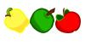
NUTRIENTS

A nutrient is a chemical substance in food that nourishes the body in a certain way.
Foods can be classified into 6 classes of nutrients:

Carbohydrates
- The major source of fuel used by the muscles during exercise
- The only source of fuel used by the brain
- An important source of fibre
- Sources of carbohydrate are bread, pasta, rice, vegetables and noodles

Protein
- Important for growth, repair and maintenance of body tissue
- Can be a source of energy when carbohydrate and fat sources are depleted
- Important for athletes involved in strength training, endurance athletes and adolescents
- Excess will be converted to fat
- Sources of protein are milk, eggs, meat, poultry and fish

Fat
- Provides energy when we are resting
- Conserves body heat
- High levels of fat intake are associated with heart and vascular disease
- Used in the structure of every cell
- Only small amounts are needed for good health

Vitamins
- Essential for energy release and production of red blood cells, promotes healthy skin, nerves and healing wounds
- Supplied by a well-balanced diet of fruits, vegetables, dairy, fish, cereals
- There are 20 different vitamins – vitamin A (retinol), vitamin C, vitamin B1 (Thiamine), vitamin B2 (Riboflavin), Niacin

Minerals
- Calcium
- important for development of bones, teeth and nerves
- sources of calcium are milk and dairy products
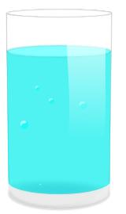
- Iron
- required for production of blood cells and oxygen transport
- sources of iron are red meat, liver, kidneys, lentils, dried fruits

Water
- 60% of the body is made up of water
- Prevents damage to organs by diluting toxic waste
- Required for transport of oxygen to cells
- Required for temperature regulation

Nutrition requirements of different groups
- Young people grow and develop rapidly and have high energy demands as a result of their active lifestyles
- The eating patterns of young people will contribute significantly to their future health
- Carbohydrate and fat give energy for work and physical activity
- Endurance athletes require higher levels of carbohydrates to accommodate higher workloads
- Simple carbohydrates are called sugars – they provide quick release of energy but are converted to fat if not used (sugar, chocolate, honey, biscuits)

TEACHER REFLECTION - UNIT EVALUATION

Unsatisfactory
Satisfactory

Poor
Good

A. A. EVIDENCE
To what extent does the assessment evidence provide:
1. A valid and reliable measure of the targeted outcomes/enduring understandings?
2. Sufficient information to support inferences about each
student’s understanding/level of achievement?
3. Opportunities for students to demonstrate their understandings through authentic learning tasks?
B. LEARNING EXPERIENCES AND INSTRUCTION
To what extent did students:
1. Achieve the outcomes and the enduring understandings of the unit (the big ideas as opposed to basic facts and skills)?
2. Know where they were going and why (in terms of unit goals, requirements, and evaluative criteria)?
3. Deepen their knowledge and understanding of the outcomes & big ideas of the Unit (through inquiry, research, problem solving, and experimentation)?
4. Receive explicit instruction on the knowledge and skills needed to equip them for the required performances?
5. Have opportunities to rehearse, revise, and refine their work based on feedback?
6. Self-assess and set goals prior to the conclusion of the unit?

PTO
1. What did students learn? (What knowlege and skills did they learn to deepen their understanding of the outcomes/big ideas of the unit?)

2. How do you know what they learnt? (What evidence do you have to support your judgement?)

3. What would you refine to improve student learning outcomes?

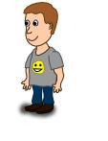
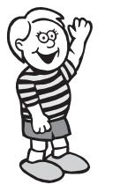
Student Unit Reflection
Stage 3

Student Name: Class:
Unit/Topic:
Think about the Personal Development and Health Education Unit you have just finished which focused on keeping yourself happy, healthy and safe, then complete the sentences below.
Two important things I have learnt about/learnt to do during this unit are… | What I learnt will help me in my life because…
A question about this unit that I asked in class was… | Something that still puzzles me is...
A question about this unit that I asked at home was… | I have changed my ideas about…
Something I am going to value/appreciate more about myself because of what I have learnt in this unit is… | If I wanted to research more about this unit I could…
Something I am going to value/appreciate more about others because of what I have learnt in this unit is… | I think the effort I put into my learning in this unit was:  (Circle one number)  No effort 0 1 2 3 4 5 6 7 8 9 10 Most effort

