SAFE T

(Updated December 2016)
Stage: 2 | Unit Duration: 10 Lessons |  | Weeks 1 2 3 4 5 6 7 8 9 10 |  | Terms 1 2 3 4
Enduring Understandings:  E.1 As we are created in the image and likeness of God we accept responsibility for community and personal health by acting safely.  E.2. Safe practices are essential and involve sound decision making practices.  E.3. Recognise factors affecting personal safety and act appropriately to maintain personal safety. |  |  | Essential Questions:  - How can I analyse the road environment to keep myself and others safe as pedestrians and passengers, and when I ride or skate?
Major Outcomes  Knowledge and Understanding  SLS2.13 Discusses how safe practices promote personal wellbeing  Skills  COS2.1 Uses a variety of ways to communicate with and within groups  Values and Attitudes  V4 Increasingly accepts responsibility for personal and community health |  |  | Contributing Questions/Lesson Overview  1. Where is it safe to cross the road on my way to school?  (E.1)  2 – 3. How are we safe near the roads around our school?? (E.1, E.2)  4. What distractions are there for pedestrians? (E.2)  5. How can we be a safe passenger in the car?? (E.1,E.2)  6– 7. What rules are needed for bus safety? (E.2)  8. Why is it important to ride or skate away from the road? (E.2,E.3)  9. How can I maintain my bicycle for safety?(E.3)  10. How can my helmet protect me?(E.3)  KidsMatter SEL Focus  Major: Responsible Decision Making - Assuming personal Responsibility; Responsible Decision Making – Analysing situations;  Minor: Responsible Decision Making –Analysing situations; Responsible Decision Making – Problem Solving; Responsible Decision Making - Assuming personal Responsibility
Contributing Outcomes

Knowledge and Understanding
IRS2.11 Describes how relationships with a range of people enhance wellbeing
PHS2.12 Discusses the factors influencing personal health choices
Skills
DMS2.2 Makes decisions as an individual and as a group member
PSS2.5 Uses a range of problem-solving strategies
INS2.3 Makes positive contributions to group activities

Catholic Dimension/Towards Wholeness(TW) (Also refer to overview of TW for this unit)

Interpersonal Relationships

Human beings find their true place within community; they grow towards maturity through the relationships they maintain. We all depend on each other and, as we mature, we grow in awareness of our responsibility for each other. Alone and isolated we cannot develop our gifts and live as God intended. Among family, friends, members of our peer group and others, we find our place as contributing members of society. It calls us all to enter freely into loving and forgiving relationships that are embedded in community, to develop such qualities as honesty, respect, empathy, openness and a commitment to equality.

Personal Health Choices

Throughout our lives, we all face having to make personal decisions relating to nutrition, hygiene, consumerism, drug use and disease prevention. So many conflicting opinions and values influence children in making decisions that have direct relevance to their health and well-being. Taught from a Catholic perspective, this strand seeks to develop the children’s abilities to observe, explore, interpret and judge, informed by an emerging integrated value system that is based on the values of the Gospel.

Safe Living

This strand seeks to develop an ability and a commitment to act in ways that will protect self and others from harm. It emphasises respect for the human person and the development of a co-operative, caring society. Sound Christian decision-making is based on a well-formed conscience which draws inspiration from the life and teaching of Christ and from his Church. Within this strand, students learn to respect the rights of others and to value acceptance, tolerance, justice and personal freedom. They learn that their own decisions have consequences for themselves and others.

Foundation Statements
Students describe the factors that influence healthy lifestyle decisions and demonstrate an understanding of the decision making process. They examine how the use of drugs such as tobacco and alcohol can cause harm. They investigate nutritional choices relating to cultural beliefs, special dietary needs and ‘fast food’. Students demonstrate behaviours to stay safe at home, on and near roads, when travelling to and from school, and near water. They demonstrate the capacity to deal with unsafe situations including abuse, bullying and harassment.

Students recognise individual strengths and limitations and they identify characteristics that make them unique. They explore body changes that occur during life, including puberty. Students explain how positive relationships are formed and the importance of effective communication of feelings and needs in maintaining relationships. They recognise the rights, values and feelings of others and devise strategies to solve problems, recognise and accept differences and manage conflict.

Suggested Correlation with Other KLAs  English  - Discussion  - Procedure  Creative Arts  - Drama – Performing and Appreciating  Science and Technology  - Information and Communication  - Investigating different forms of media  - Designing/producing and using technology  - Use of digital technology |  |  | Mathematics  - Data Representation  - Working Mathematically  HSIE  - Social Systems and Structures  - roles and responsibilities  - services and contributions made  by community organisations and groups
Technology

The following websites have been selected to enhance various concepts being taught throughout this unit. Most of the sites listed can be linked to more than one of the lessons being taught. Teachers may like to add them to the school intranet site.

- Safety Town Website
https://www.safetytown.com.au/
- Google Maps

Subject Matter  Interpersonal Relationships  Relationships  - Recognising individual needs  Communication  - Communicating feelings and needs  - Assertiveness  - Encouraging others  - Understanding feelings of others  - Expressing a complaint or problem  Families  - Roles, rights and responsibilities |  | Peers  - Peer influence  Groups  - Roles, rights and responsibilities  Personal Health Choices  Making Decisions  - Influences on decision-making  - Taking responsibility for one’s own decisions  - Risk taking and decisions  Health Services and Products  - Health information and services  - Influences of media |  | Safe Living  Personal Safety  - Influences on safety choices  - Identifying and responding to unsafe situations  - Reducing/eliminating risks  Road Safety  - Pedestrian safety  - safe crossing procedures  - using traffic facilities  - Passenger safety  - safe passenger behaviour  - Safety on wheels  - safe places to ride  - safety equipment
Unit Evaluation  Sample teacher and student evaluations are included at the end of the unit |  |  | Assessment  Assessment strategies are included in each lesson.  The assessment task for this unit is in Lesson 10.

An Overview of Towards Wholeness (TW) in the PDH Unit
Safe T - Stage: 2

Key God’s Word:
The story of the Exodus (Ex 6:6-8; 16:4-8; 17:1-7) and the Good Samaritan (Lk 10:25-37), the many stories of healing (e.g. Mt 20:29-34; Lk 14:1-6) and the story of Jesus’ concern for the safety of the disciples in Gethsemane (Jn 18:1-9) are just some of the many scripture passages which convey a divine concern for the safety and protection of people. TW p.22

Enduring Understandings | Beliefs and Values | Contributing Questions/Lesson Overview
E.1 As we are created in the image and likeness of God we accept responsibility for community and personal health by acting safely. | - Each person has rights and responsibilities in relation to personal safety. TW p.41  - We have a responsibility to protect and care for ourselves and others. TW p.35 | 1. Where is it safe to cross the road on my way to school?  2 – 3. How are we safe near the roads around our school?  5. How can we be a safe passenger in the car?
E.2. Safe practices are essential and involve sound decision making practices. | - Each person has rights and responsibilities in relation to personal safety. TW p.41  - We have a responsibility to protect and care for ourselves and others. TW p.36 | 2 – 3. How are we safe near the roads around our school?  4. What distractions are there for pedestrians?  5. How can we be a safe passenger in the car?  6– 7. What rules are needed for bus safety?  8. Why is it important to ride or skate away from the road?
E.3. Recognise factors affecting personal safety and act appropriately to maintain personal safety. | - Life is a precious gift entrusted to us by God. TW p.41  - Each person has rights and responsibilities in relation to personal safety. TW p.41  - We have a responsibility to protect and care for ourselves and others. TW p.35 | 8. Why is it important to ride or skate away from the road?  9. How can I maintain my bicycle for safety?  10. How can my helmet protect me?

Lesson 1 Where is it safe to cross the road on my way to school?

Enduring understandings | Outcomes |  | Indicators
E.1 As we are created in the image and likeness of God we accept responsibility for community and personal health by acting safely. | SLS2.13 Discusses how safe practices promote personal wellbeing  COS2.1 Uses a variety of ways to communicate with and within groups  V4 Increasingly accepts responsibility for personal and community health |  | - Describes behaviours that can create a safe environment for themselves, their school and community  - Describes safe and unsafe behaviour  - Identifies safe places to cross the road  - Values their health and safety and that of others
Suggested Learning Experiences

TW: Students tell a partner about a time they felt unsafe or thought others were unsafe when crossing a road. Students identify two safe behaviours they practise and two unsafe behaviours they have seen others practise. Students explain why these behaviours are unsafe and their feelings about them. Remind the students that each of us has the responsibility to protect and care for ourselves and others.

IMPORTANT: Teacher needs to register and log in to Safety Town website (ST). This site is used constantly throughout the unit.
Later in the unit, it would be beneficial for all students to have access to their own device for tasks with computer icon ().This allows students to login to ST. (See “How to Log in details”)
Go to Activities tab. Click on List.

Ask students:
What did you do to keep yourself safe when travelling to school today?
What travel choices have you made today? Were they “smart”?

In pairs, students share how they travelled to school, starting at the beginning of their journey and recounting all the decisions they made, e.g. holding hands when crossing the road; getting in the car using the Safety Door, buckling up safely, putting school bags in the car boot or on the floor, sitting quietly in the car, using the Safety Door to get out on the footpath side, using signalised or marked crossings, waiting for the bus away from the road, riding with an adult, wearing a helmet when riding.

Students share one of their partner’s "smart" safe choices with the rest of the class.

Students use Google Maps to find their house and school and highlight their route from home to school. Take a Screenshot.

Students mark where they made their smart choices on the map and share their
journey with a partner.
Class discussion:
How did you know to make this smart choice? Who taught you?
Who helps remind you why this is a smart choice?
Who protects you by helping you to make smart choices? What about when you were younger?
Who do you travel to school with?
In what ways do adults help you to travel to school safely? e.g. identify hazards, hold hands, drive them to school, tell them when to cross the road, direct the route to take, ride with them to school or walk with them as they ride.

Refer to any school rules or policies about travelling to, arriving and departing school. Students walk around the school boundaries and identify the entry and exits, pedestrian areas and areas designed for vehicles. Discuss the need to separate pedestrian traffic from vehicle traffic.

Students create a list of the smart choices the school has made to keep students safe, e.g. signs not to walk through the school carpark, drop off and pick up zones, gate for pedestrians, a pathway to lead pedestrians to the gate, a school crossing supervisor, a pedestrian crossing near the school, bikes to be walked through the school grounds, bus travellers to wait inside school grounds.

Why does the school make road safety rules?
What would it be like if there were no road safety rules?
What could be done to improve road safety at our school?

Display the list of the Key road safety messages. (Use posters)
Students choose one that matches a smart choice they made on their way to school, e.g. Stop! Look! Listen! Think! when crossing at the school pedestrian crossing, Click clack front and back in the car.

Discuss the importance of promoting smart choices and how to keep safe around
roads.

Design a promotion
In groups or pairs, students choose one of the Key road safety messages that could be used to
teach new students about smart safe choices when travelling to and from school.
- Wait till the bus has gone and then use a safe place to cross
- Hold an adult’s hand when you cross the road
- Use a safe place to cross the road

Promotion strategies may include creating a poster, writing a poem, a rap or writing an article for the school website or newsletter.
Resources  - Safety Town Website  https://www.safetytown.com.au/  - How to login details  - School Road Safety Policy.  - Google Maps  - Your school should have these Safety Posters:  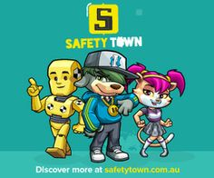 |  | Assessment  Student work sample of safe places to cross the road.

Registering for to Safety Town
It is quick and easy to register a Safety Town account. Go to http://www.safetytown.com.au and click the Enter option.
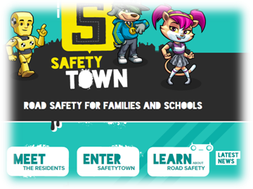

You will be taken to the Activities page. There is a Register option in the top right.
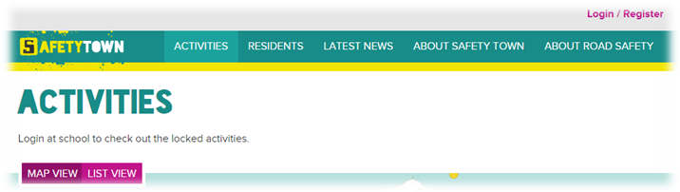

You must have an educational email address to register an account with Safety Town. If you don’t have one and think you should be eligible for an account please contact support@safetytown.com.au
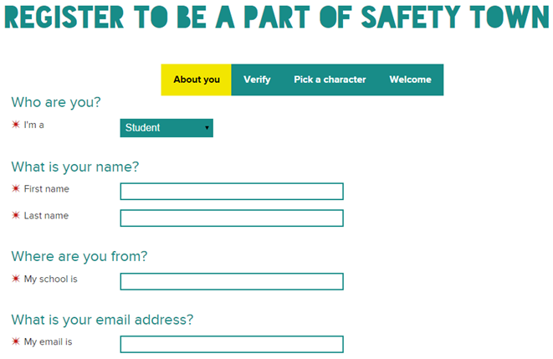

Enter all your details. When you select a school, start typing the name of your school and the list will be populated automatically as you type. Use the down arrows, or press the appropriate option. If you are a Home Schooler, please start typing that and you will see the ‘Home Schooler’ option. Road Traffic Safety educators should use ‘Transport’.
Your password must be at least six characters and contain an uppercase, lowercase, number, and special character.

NOTE: You must choose carefully whether you are a student, teacher or parent as this option cannot be changed after your account is created

When all your information is provided, click the Next, Verify button. You will be informed that a verification email has been sent to your email address.
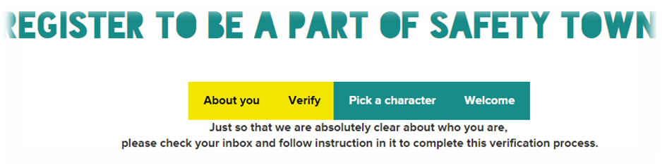
You will now receive an email from Safety Town with an activation link. Copy this link and paste it into your browsers address. You will be taken to the Login page.
One logged in, you have the option of choosing a Safety Town character, name and hobby. The Safety Town character you choose will introduce you to each activity when you choose to do them.
Congratulations and welcome to the Safety Town family. Explore and have fun while learning all about Road Safety!

Logging in to Safety Town

To log into Safety Town go to http://www.safetytown.com.au and click the Enter option.
You will be taken to the Activities page. There is a Login option in the top right.

You are now at the Login page. You can also bookmark this URL to take you directly to the Login page: https://www.safetytown.com.au/accounts/auth/login/
You will be taken to your Profile page.
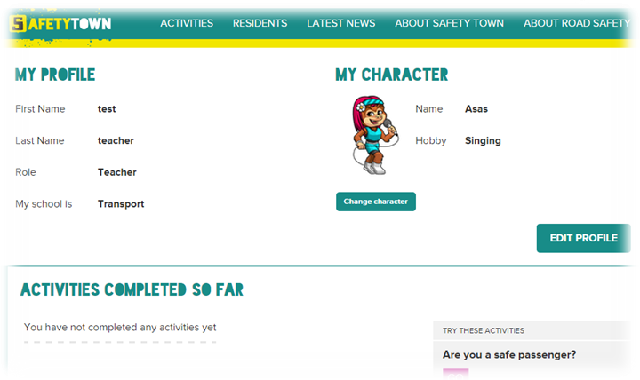
Use the navigation bar at the top to access the site, or try one of the suggested activities that appear on the right side of the page.

Lesson 2-3 How are we safe near the roads around our school?

Enduring understandings | Outcomes |  | Indicators
E.1 As we are created in the image and likeness of God we accept responsibility for community and personal health by acting safely. | SLS2.13 Discusses how safe practices promote personal wellbeing  COS2.1 Uses a variety of ways to communicate with and within groups  V4 Increasingly accepts responsibility for personal and community health |  | - Describes behaviours that can create a safe environment for themselves, their school and community  - Describes safe and unsafe behaviour  - Identifies safe places to cross the road  - Values their health and safety and that of others
Suggested Learning Experiences

Remind children of Key Road Safety Messages:
- Wait till the bus has gone and then use a safe place to cross *
- Hold an adult’s hand when you cross the road
- Use a safe place to cross the road *
(*Use Safety Posters, where applicable)

Teachers share a time they felt unsafe or thought others were unsafe when crossing a road. What rules were not followed?

Students identify two unsafe behaviours they have seen others practise. Students explain why these behaviours are unsafe and their feelings about them.

TW: Remind the students that each of us has the responsibility to protect and care for ourselves and others.

Using images from the Pedestrian Gallery class discuss how each picture has a safe pedestrian behavior. Chn create a list in their books of these.

Go on a class walk around the school and gather digital images identifying how the local school area has been made safe. Eg. Pedestrian crossing, pedestrian island, ‘lollipop’ person, traffic.

Chn return to class and create a Google Slide Presentation identifying safe pedestrian behaviors around our school.

Resources  - Your school should have these Safety Posters: |  | Assessment  Student work sample of safe places to cross the road.

Lesson 4 What distractions are there for pedestrians?

Enduring Understandings | Outcomes |  | Indicators
E.1 As we are created in the  image and likeness of God we  accept responsibility for  community and personal health  by acting safely.  E.2 Safe practices are essential and involve sound decision making. | SLS2.13 Discusses how safe practices promote personal wellbeing  PHS2.12 Discusses the factors influencing personal health choices  COS2.1 Uses a variety of ways to communicate with and within groups  V4 Increasingly accepts responsibility for personal and community health |  | - Describes behaviours that can create a safe environment for themselves, their school and community  - Identifies pedestrian hazards  - Shares ideas, feelings and opinions with others  - Values their health and safety and that of others
KidsMatter SEL Focus: Minor - Responsible Decision Making – Analysing situations
Suggested Learning Experiences

Students present their Google Slides Presentations from previous lesson.

TW: Remind the students that each of us has the responsibility to protect and care for ourselves and others.

Ask students to define ‘distractions’. What does it mean to be distracted?
Students share their own experiences of being distracted in the road environment or elsewhere.
Ask students:
How did you become distracted? e.g. Mum asked me a question while I was playing a game on my iPad. My friend was talking to me while the teacher was giving me instructions.
- What were the consequences of being distracted? e.g. I lost my concentration and lost the game. I wasn’t able to complete the work because I didn’t listen to the teacher’s instructions.
Children watch BTN about Ipod Inattention Story (2:35) What is the safe pedestrian behavior message?
Put chn into groups and allocate one distraction and how it affects them. Role play possible consequence.
Then role play what could have happened if there was no distraction – positive outcome.
Distractions | How could this distraction affect what you do? | Possible consequences
smartphones, iPods, tablets | Might walk onto the road without looking
Music players with headphones | Harder to hear approaching cars causing a false sense of security
Sports equipment | Eyes may be focused on the ground and not focused ahead
Talking with friends | Talking friends may take your attention away from the road causing you to forget to ‘Stop, Look, Listen, Think’

Children then individually write five safe pedestrian behaviours. e.g. Don’t have you music on in your headphones when you’re near a road.

Resources  Safety Town Website  https://www.safetytown.com.au/  Teacher Notes -  Crossing Safety Stage 2 p.109  BTN Ipod Inattention Story (2:35) |  | Assessment  Teacher observation of student responses in class discussion relating to pedestrian hazards.

Lesson 5 How can we be a safe passenger in the car?

Enduring Understandings | Outcomes |  | Indicators
E.1 As we are created in the image and likeness of God we accept responsibility for community and personal health by acting safely.  E.2. Safe practices are essential and involve sound decision making practices. | SLS2.13 Discusses how safe practices promote personal wellbeing  PHS2.12 Discusses the factors influencing personal health choices  COS2.2 Uses a variety of ways to communicate with and within groups  V4 Increasing accepts responsibility for personal and community health |  | - Identifies procedures to improve the safety of car passengers  - States reasons for wearing a seatbelt  - Shares ideas, feelings and opinions with others  - Values their health and safety
KidsMatter SEL Focus: Major - Responsible Decision Making - Assuming personal Responsibility
Suggested Learning Experiences

Teacher needs to register and log in to Safety Town website (ST). This site is used constantly throughout the unit.

Chn view gallery of Passenger Safety Pictures. Identify safe passenger behaviour.

As a class use the scenarios on Rate the Risk to prompt discussion about safe and unsafe passenger behaviour.
Be sure to cover the Key Safety Messages:
- Click clack front and back
- Always buckle up in your seatbelt
- Get in and out of the car on the footpath side

Students view different types of seats on the Safety Town website, then answer the following questions:
What is the difference between a forward-facing car seat and a booster seat?
What type of seat do you currently sit in?
What type of seat does a younger sibling, relative or friend sit in?
Why do you think the type of seat required change as you grow?

Students individually complete the Where do you sit? worksheet .
In pairs, students share answers and compare similarities and differences.
Pairs then join with another pair and compare and discuss responses again. (“1, 3, 6 strategy”)
Students use positional language to record where they and others sit in the car (questions 2 and 4), e.g. back seat between my brothers, back seat, on the left, behind mum.
Report back to class.

As a class, watch the video (which is found under the Keeping Safe in the Car and then Being a Safe Passenger titles) – 1:02
Which car door do you use?
Students record the safe passenger behaviours they identify in the video.

Discuss:
Who is the target audience?
What are the videos trying to convince the audience to do?
What are the main messages that stand out in the videos? Were they effective? Why or why not?

In pairs, students:
- cut up the cards on the Safe or unsafe car passenger? worksheet
- sort car passenger behaviour cards into safe behaviours and unsafe behaviours
- develop a set of their own cards and swap them with another group.
Compare results and as a class discuss choices. What makes behaviour safe or unsafe?

Home Task:
Provide students with worksheet Click clack front and back chatterbox. Students fold the chatterbox to take home for their parents and carers.

TW: By obeying these laws to act safely, we accept responsibility for the health and safety of ourselves and our community.
Resources  Safety Town Website  https://www.safetytown.com.au/  - Where do you sit? worksheet  - Cut up cards for Safe or unsafe car passenger? worksheet |  | Assessment

Lesson 6 - 7 What rules are needed for bus safety?

Enduring understandings | Outcomes |  | Indicators
E.2. Safe practices are essential and involve sound decision making practices. | SLS2.13 Discusses how safe practices promote personal wellbeing  COS2.1 Uses a variety of ways to communicate with and within groups  DMS2.2 Makes decisions as an individual and as a group member  V4 Increasingly accepts responsibility for personal and community health |  | - Recognises behaviours that are risky and identifies people who can help  - Identifies bus safety rules  - Shares ideas, feelings and opinions with others  - Values their health and safety and that of others  - Values the need for safe bus behaviours  - Role plays bus scenarios and identifies responsible behaviours  - Clarifies bus safety facts and opinions
KidsMatter SEL Focus: Major - Responsible Decision Making – Analysing situations
Minor - Responsible Decision Making – Problem Solving
Suggested Learning Experiences

Students share the Chatterboxes from Lesson 5. Can you match any Key Road Safety Messages with the posters in the classroom?

Students share a bus travel experience with a partner.
- Where did you go?
- Why did you travel by bus and not car?
- Who was with you?
- Did you enjoy the bus ride? Why?

Ask students:
- When do you use buses for school? e.g. sport, excursions, school buses
- What are the school rules for bus travel?
- Are there any rules that could be added?
Ask students who travel regularly by bus to explain to non-bus travelers about their experiences.
Teachers might like to use the following questions.:
- how they get to the bus?
- where they wait?
- what do they do on the bus?
- where they get off the bus?
- their plans if they miss the bus or if it is raining?

As a class view and discuss Be a Responsible Bus Passenger? - Start Activity
Make a list of safety messages.

Fact or opinion?
Ask students to discuss the difference between a fact and an opinion.
Students form two concentric circles and turn to face a partner.
Read the following statements aloud. Students discuss with their partner and decide if it is a fact or an opinion. Students justify their responses.
- Buses are more fun to travel in than cars.
- A bus stop can sometimes be a dangerous place for children to play.
- It is dangerous to leave your bags in the aisle of a bus.
- Sitting at the back of the bus is better than sitting down the front.
- You won’t distract the driver if you talk to them in a quiet voice.
- Putting any part of your body outside the bus is dangerous.
- You don’t have to wait for the bus to stop before you leave your seat.
- It is safe to get up and move around the bus when it’s moving if there are not seatbelts.

In pairs, students use the Bus passenger behaviours – safe or unsafe? cards and sort them into two groups, safe or unsafe bus passenger behaviours. Share and discuss.

Divide the class into three groups, one for each stage of a bus journey.
Display the sheets below. As a class, discuss ideas. Add others as necessary, e.g.:
Waiting for the bus | Travelling on the bus | Getting off the bus
Stand away from the road. | Hold onto a seat or rail if standing. | Wait for the bus to stop before you move to the exit.
Stand where the driver can see you. | Put your bag under a seat. | Ring the stop button once.
Wait for the bus to completely stop. | Respect other passengers. | Wait for the bus to move away before you cross the road.
Let other passengers off before you get on. | Stand up for paying passengers. | Never cross the road in front of the bus.
Don’t play games. | Wear a seatbelt if it’s provided. | Ask someone to meet you on the bus stop side.
 | Stay seated while the bus is moving.
 | Don’t distract the driver.

Students identify times when they have been pressured into something unsafe by their friends.
Strategies to deal with peer pressure may include:
- just ignore them
- say you don’t want to
- say you don’t feel safe
- say your mum and dad would be angry with you.

In small groups, students read a Bus safety scenario card. Each group brainstorms possible refusal or coping strategies for the characters in one of the scenarios.
Groups prepare and perform role plays.
TW:. Students identify the responsible behaviours (safe practices) which show the protection and care for ourselves and others.

Resources  Safety Town Website  https://www.safetytown.com.au/  - Bus passenger behaviours – safe or unsafe? cards worksheet  - A3 sheets X 3 with waiting for, travelling on and getting off the bus. |  | Assessment  Student role plays.

Lessons 8: Why is it important to ride or skate away from the road?

Enduring Understandings | Outcomes |  | Indicators
E.2 Safe practices are essential and involve sound decision making practices.  E.3. Recognise factors affecting personal safety and act appropriately to maintain personal safety. | SLS2.13 Discusses how safe practices promote personal wellbeing  PSS2.5 Uses a range of problem solving strategies  INS2.3 Makes positive contributions to group activities  V4 Increasingly accepts responsibility for personal and community health |  | - Identifies safe places to ride  - Identifies ways to improve unsafe environments  - Helps others to achieve set tasks  - Values their health and safety and that of others
KidsMatter SEL Focus: Minor - Responsible Decision Making – Problem Solving
Suggested Learning Experiences

Students indicate if they ride a bike, scooter, skateboard, or skates. Ask:
- Where do you ride? Why do you choose that place?
- Do you feel safe riding? Why or why not?
- Who helps you ride safely? Why?
- What do you do to keep safe when riding?

Students should include the following:
- ride your bike away from the road, vehicles, driveways and car parks
- have adult supervision
- wear a helmet and other safety gear.
Display these statements.

Students watch A Different Perspective. – Ride Safely (2). How could this scenario be avoided?

TW: These responses should take into consideration their responsibility to protect and care for themselves and others.

Use Google maps to identify the local parks and recreation areas students may go to ride. In pairs, students use a strategy such as PMI (Plus, Minus, Interesting) to consider the:
- positives and negatives in terms of safety for riders
- number of places to ride safely in the community
- features that help make or keep the places safe.

Referring to the previous activity, students use Google street view to look at local parks and recreation spaces and consider:
- How could these areas be improved? e.g. user safety, user enjoyment, the needs of multiple age groups, facilities such as sun shelter, toilets, tables
- What would you include in a new off-road riding area? What would make it great to visit and be the safest?
Students share their ideas about a new or improved off-road riding area.

Home Task:
Students develop a sketch or model of a suggested design for a recreation park, including:
- the size of the area
- safety features
- design aspects to be considered e.g. curves, stops and starts, braking time, area for scooters/skateboards
- the needs of bike riders
- catering for a mixture of age groups

Resources  Safety Town Website  https://www.safetytown.com.au/  - A Different Perspective. – Ride Safely (2) |  | Assessment  Student work sample of off-road cycle area.

Lesson 9 How can I maintain my bicycle for safety?

Enduring Understandings | Outcomes |  | Indicators
E.3. Recognise factors affecting personal safety and act appropriately to maintain personal safety. | SLS2.13 Discusses how safe practices promote personal wellbeing  PSS2.5 Uses a range of problem solving strategies  INS2.3 Makes positive contributions to group activities  V4 Increasingly accepts responsibility for personal and community health |  | - Recognises behaviours that are risky and identifies people who can help  - Identifies how to maintain a bicycle  - Identifies ways to improve unsafe environments  - Helps others to achieve set tasks  - Values their health and safety and that of others
Suggested Learning Experiences

Students present home tasks:
- present their design to the whole group
- explain why they included particular aspects of their off-road riding area
- discuss why they would like to ride there.

As a class, students discuss why it is important to maintain a bicycle.

TW: It is important to maintain a bicycle for safety reasons and we ultimately do it to preserve our life – the precious gift given to us by God.

Brainstorm how to maintain a bicycle and check that it is the correct size. Use an actual bike or a bike from the Image Gallery.
Teacher records student responses on board.
(You may be able to get a guest speaker from the local bike shop to talk to the children.)

In pairs go on to the Safety Town website and compare the interactive: Heads up on Helmets with the list developed by the class. Explain why each safety wear and check point was important. E.g. bright green long sleeved top , rear reflector.

In small groups, design an article for the newsletter or poster to educate their peers on how to check their bicycles safety.
Use the 8 point checklist from : Heads up on Helmets and possibl a graphic from the Image Gallery.
Resources  Safety Town Website  https://www.safetytown.com.au/  - Image Gallery  - Heads up on Helmets  - Guest speaker from local bike shop (optional) |  | Assessment  Student work samples of bicycle maintenance article or poster.
Lesson 10: How can my helmet protect me?

Enduring Understandings | Outcomes |  | Indicators
E.3. Recognise factors affecting personal safety and act appropriately to maintain personal safety. | SLS2.13 Discusses how safe practices promote personal wellbeing  INS2.3 Makes positive contributions to group activities  COS2.1 Uses a variety of ways to communicate with and within groups  V4 Increasingly accepts responsibility for personal and community health |  | - Recognises behaviours that are risky and identifies people who can help  - Helps others to achieve set tasks  - Discusses assertive responses to peer pressure  - Values their health and safety and that of others  - Appreciates the importance of wearing a helmet
KidsMatter SEL Focus: Minor - Responsible Decision Making - Assuming personal Responsibility
Suggested Learning Experiences

As a class discuss any stories about friends or family that may have been hurt or injured when riding a wheeled device.

Students watch the video, found out Heads Up on Helmets, Why it’s Important to Wear a Helmet, Helmet Safety. Write three or more important messages they learnt and share them.

In groups, students explore the Helmets and safety gear webpage page to answer the following questions:
- What are the features of a helmet? e.g. hard outer shell, straps, buckle, ventilation holes, helmet liner, standards approved labelling
- How does a helmet work? e.g. it absorbs the impact of the fall and decreases movement of the brain within the skull. It distributes the impact over a greater surface area of the helmet to decrease the risk of a skull fracture.
- Why do we need to wear helmets when we ride? e.g. to protect the brain from injury. Brain damage is permanent and irreversible.
- How do you know a helmet is approved? e.g. all helmets must have an Australian and New Zealand Standards label to indicate that the helmet is approved and has all the safety features required.

Groups share their findings.
Discuss why all riders need to wear a helmet. Ask questions such as:
- What happens if the brain is damaged? e.g. loss of ability to walk, talk and write and fine and gross motor skills.
- Why do you think some people choose not to wear a helmet? e.g. peer pressure, expense, discomfort, inconvenience, don’t understand the risks.
- Why is it considered a risk to not wear a helmet?
- What may be some of the consequences of not wearing a helmet, now and in the future?
- What is the law about wearing a helmet?

Discuss:
- How can friends sometimes influence their decision about wearing a helmet?
- Why is it important to encourage others to wear helmets to keep safe.
Use Safety Posters to promote the key road safety message, Always wear a helmet when you ride or skate.

Students present their role plays / photostories to their class or lower grade.

TW: Life is a precious gift entrusted to us by God. Each person has rights and responsibilities in relation to personal safety. We have a responsibility to protect and care for ourselves and others.

Resources
Play the Rate the Risk (Start Activity) game as a whole class.
During the game, ask students to:
- justify their rating of the risks.
- compare and discuss strategies to reduce the risk.

Students play the Getting it Together - Safety Town Board Game
This game can be played in pairs, small groups, or as a whole class activity in teams.

Resources  Safety Town Website  https://www.safetytown.com.au/  - Helmet Safety Video  - Helmets and safety gear webpage  - Rate the Risk (Start Activity) game  - Getting it Together - Safety Town Board Game  - Your school should have these Safety Posters: |  | Assessment  Role Plays for wearing a helmet.

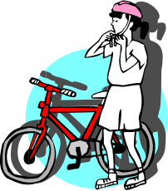How safe is your bike?

Catholic Values/Beliefs: Life is a precious gift entrusted to us by God. Each person has rights and responsibilities in relation to personal safety. We have a responsibility to protect and care for ourselves and others.

Student:__________________________________________

This task provides students with the opportunity to demonstrate their standard of achievement of the following outcomes:

Outcomes | Indicators | Working towards | Achieved with support | Achieved
SLS2.13 Discusses how safe practices promote personal wellbeing | Identifies the 8 point check list for checking the safety of a bike.
DMS2.2  Makes decisions as an individual and as a group member. | Gives reasons for maintaining a safe bike.
Task:

Design an article for the newsletter or poster to educate their peers on how to check their bicycle’s safety.

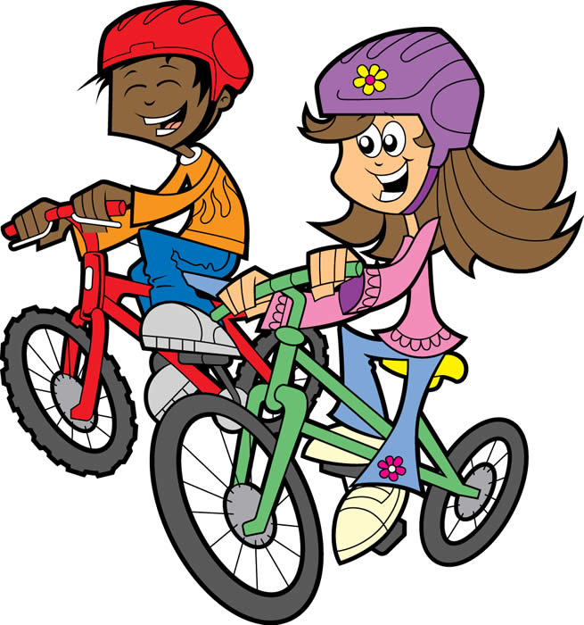

TEACHER REFLECTION - UNIT EVALUATION

Unsatisfactory
Satisfactory

Poor
Good

A. A. EVIDENCE
To what extent does the assessment evidence provide:
1. A valid and reliable measure of the targeted outcomes/enduring understandings?
2. Sufficient information to support inferences about each
student’s understanding/level of achievement?
3. Opportunities for students to demonstrate their understandings through authentic learning tasks?
B. LEARNING EXPERIENCES AND INSTRUCTION
To what extent did students:
1. Achieve the outcomes and the enduring understandings of the unit (the big ideas as opposed to basic facts and skills)?
2. Know where they were going and why (in terms of unit goals, requirements, and evaluative criteria)?
3. Deepen their knowledge and understanding of the outcomes & big ideas of the Unit (through inquiry, research, problem solving, and experimentation)?
4. Receive explicit instruction on the knowledge and skills needed to equip them for the required performances?
5. Have opportunities to rehearse, revise, and refine their work based on feedback?
6. Self-assess and set goals prior to the conclusion of the unit?

PTO

1. What did students learn? (What knowlege and skills did they learn to deepen their understanding of the outcomes/big ideas of the unit?)

2. How do you know what they learnt? (What evidence do you have to support your judgement?)

3. What would you refine to improve student learning outcomes?

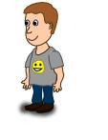
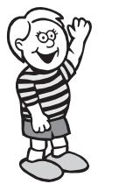
Student Unit Reflection
Stage 2

Student Name: Class:
Unit/Topic:

One important thing I have learnt about/learnt to do during this unit is… | What I learnt will help me in my life because…
A question about this unit that I asked in class was… | Something that still puzzles me is...
A question about this unit that I asked at home was… | If I wanted to research more about this unit I could…
Something I am going to value/appreciate more about myself because of what I have learnt in this unit is… | I think the effort I put into my learning in this unit was:  (Circle one number)  No effort 0 1 2 3 4 5 6 7 8 9 10 Most effort

