PROTECTING ME
Stage: 2,Year 4 | Unit Duration: 10 Lessons | Weeks 1 2 3 4 5 6 7 8 9 10 | Terms 1 2 3 4
Enduring Understandings:  E.1. We each have a responsibility to protect and care for our personal safety and that of others.  E.2 Recognise and develop skills for maintaining positive relationships.  E.3. Recognise that to be healthy means to belong to a community and maintain relationships. |  | Essential Questions:  - What is a positive relationship?  - What is abuse and how can I protect myself and others?
Major Outcomes  Knowledge and Understanding  IRS2.11 Describes how relationships with a range of people enhance wellbeing  Skills  COS2.1 Uses a variety of ways to communicate with and within groups  INS2.3 Makes positive contributions in group activities  Values and Attitudes  V4 Increasingly accepts responsibility for personal and community health. |  | Contributing Questions/Lesson Overview  - What is a positive relationship?(E.2)  - What is trust in a relationship?(E.1,E.2,E.3,E.4)  - What is bullying?(E.3,E.4)  - How can power be abused?(E.3,E.4)  - What are safe and unsafe situations?(E.1)  - What is physical abuse?(E.1,E.3,E.4)  - What is sexual abuse?(E.2,E.3,E.4)  - What are the effects of abuse?(E.3,E.4)  - How can I protect myself and others?(E.1,E.4)  - How can I protect myself and others?(E.1,E.3,E.4)  KidsMatter SEL Focus  Major: Relationship Skills – Building Relationships; Self-Management - Managing emotions; Self-Management - Goal setting; Responsible Decision Making - Respecting others;  Self-Awareness - Identifying emotions; Responsible Decision Making – Analysing situations; Relationship Skills – Refusal; Responsible Decision Making - Assuming personal Responsibility;  Minor: Social Awareness - Appreciating Diversity; Relationship Skills – Communication; Social Awareness - Perspective-Taking, Responsible Decision Making - Assuming Personal Responsibility;
Contributing Outcomes

Knowledge and Understanding
SLS2.13 Discusses how safe practices promote personal wellbeing
Skills
DMS1.2 Makes decision as an individual and as a group member
PSS2.5 Uses a range of problem-solving strategies
Values and Attitudes
V3 Enjoys a sense of belonging
Catholic Dimension/Towards Wholeness (TW) (Also refer to overview of TW for this unit)

Growth and Development
God has created each of us to grow into the fullness of life. We are made in God’s image and therefore, we are of inherent dignity and worth. Our sexuality is an intrinsic part of ourselves, to be celebrated and expressed with joy and responsibility, according to God’s plan. Each person grows and changes, passing through stages on a journey towards full maturity. God is with us on this journey, reassuring and challenging. We are never alone.

Interpersonal relationships
Human beings find their true place within community; they grow towards maturity through the relationships they maintain. We all depend on each other and, as we mature, we grow in awareness of our responsibility for each other. Alone and isolated we cannot develop our gifts and live as God intended.

Alone and isolated we cannot develop our gifts and live as God intended. Among family, friends, members of our peer group and others, we find our peace as contributing members of society. It calls us all to enter freely into loving and forgiving relationships that are embedded in community to develop such qualities as honesty, respect, empathy, openness and a commitment to equality.

Personal Health Choices
Throughout our lives, we all face having to make personal decisions relating to nutrition, hygiene, consumerism, drug use and disease prevention. So many conflicting opinions and values influence children in making decisions that have direct relevance to their health and well-being. Taught from a Catholic perspective, this strand seeks to develop the children’s abilities to observe, explore, interpret and judge, informed by an emerging integrated value system that is based on the values of the Gospel.

Safe Living
This strand seeks to develop an ability and a commitment to act in ways that will protect self and others from harm. It emphasises respect for the human person and the development of a co-operative, caring society. Sound Christian decision-making is based on a well-formed conscience which draws inspiration from the life and teaching of Christ and from his Church. Within this strand, students learn to respect the rights of others and to value acceptance, tolerance, justice and personal freedom. They learn that their own decisions have consequences for themselves and others.
Foundation Statements
Students describe the factors that influence healthy lifestyle decisions and demonstrate an understanding of the decision making process. They examine how the use of drugs such as tobacco and alcohol can cause harm. They investigate nutritional choices relating to cultural beliefs, special dietary needs and ‘fast food’. Students demonstrate behaviours to stay safe at home, on and near roads, when travelling to and from school, and near water. They demonstrate the capacity to deal with unsafe situations including abuse, bullying and harassment.

Students recognise individual strengths and limitations and they identify characteristics that make them unique. They explore body changes that occur during life, including puberty. Students explain how positive relationships are formed and the importance of effective communication of feelings and needs in maintaining relationships. They recognise the rights, values and feelings of others and devise strategies to solve problems, recognise and accept differences and manage conflict.
Suggested Correlation with Other KLAs  English  - Exposition  - Narrative  - Slogans  - Shared Reading  - Talking and Listening  Creative Arts  - Drama – Performing and Appreciating  - Visual Arts – Drawing /Sketching |  | Science and Technology  Information and Communication  - Investigating icons, brochures, signs, symbols related to bullying, sexual assault  - Designing/making a resource to prevent bullying etc  HSIE  - Cultures  - Belief systems  - Cultural characteristics
Technology

The following websites have been selected to enhance various concepts being taught throughout this unit. Most of the sites listed can be linked to more than one of the lessons being taught. Teachers may like to add them to the school intranet site.
- http://en.calameo.com/books/000079643047999afebfc
- http://www.cyberquoll.com.au/index.html
- http://www.cybersmart.gov.au/Young%20Kids/Hectors%20World/Hectors%20World%20stories/Keeping%20your%20personal%20information%20safe/Episode%201.aspx
- http://www.pacerkidsagainstbullying.org/
- http://www.bullyingnoway.com.au/chillout/facts.shtml
- http://www.cyh.com/HealthTopics/HealthTopicDetailsKids.aspx?p=335&np=288&id=1503
- http://www.kidshelp.com.au/kids/fun-stuff/

Subject Matter  Growth and Development  Personal Identity  - Recognising strengths and limitations  - developing strengths  - setting goals  - Recognising attributes of self and others  - Confronting problems  - Feelings about self  The Body  - Systems  - Appropriate/inappropriate touch  Changes  - Changing friendships and relationships  Values  - Definition of values  - personal values  - school values  - family and cultural values  - Rights and responsibilities  - self  - others | Interpersonal Relationships  Relationships  Recognising individual needs  Caring  Trust  Bullying  Fairness  Positive relationships  Types of abuse  Effects of abuse  Different kinds of relationships  Support networks  Communication  Appropriate expression of feelings  Communicating feelings and needs  - Assertiveness  - Managing conflict situations  - Encouraging others  - Understanding feelings of others  - Expressing a complaint or problem  Families  - Roles, rights and responsibilities  Peers  - Rights and responsibilities  Groups  - Roles, rights and responsibilities  - Cooperation and sharing |  |  | Personal Health Choices  Making Decisions  - Analysis of problems  - Decision-making process  - Influences on decision-making  - family/peers  - other significant people, media  - feelings and needs of others  - Taking responsibility for one’s own decisions  Safe Living  Personal Safety  Protection  Warning signals  Safe/unsafe situations  Organisations and networks  - people who can help  Assertiveness (No-Go-Tell)  Influences on safety choices  Identifying and responding to unsafe situations  Reducing/eliminating risks  Secrets  Bribes and threats  Home and Rural Safety  Safe and unsafe places
Unit Evaluation  Sample teacher and student unit evaluations are included at the end of the unit. |  |  | Assessment  Assessment strategies are included in each lesson.  The assessment task for this unit is in Lesson 10.

An Overview of Towards Wholeness (TW) in the PDH Unit
Protecting Me - Stage 2

Key God’s Word:
The gifts of the Spirit are for the good of all, not just for the individual:
‘For in the one Spirit we were all baptised into one body – Jews or Greeks, slaves or free – and we were all made to drink of one Spirit.’ (1 Cor 12:13) TW p.21

We are responsible for each other: ‘In everything do to others as you would have them do to you; for this is the law of the prophets.’ (Mt 7:12) TW p.21

The story of the Exodus (Ex 6:6-8; 16:4-8; 17:1-7) and the Good Samaritan (Lk 10:25-37), the many stories of healing (e.g. Mt 20:29-34; Lk 14:1-6) and the story of Jesus’ concern for the safety of the disciples in Gethsemane (Jn 18:1-9) are just some of the many scripture passages which convey a divine concern for the safety and protection of people. The human needs for security, peace and love draw us to one another and ultimately to God. TW p.22.

Enduring Understandings | Beliefs and Values | Contributing Questions/Lesson Overview Link
E.1. We each have a responsibility to protect and care for our personal safety and that of others. | - We have a responsibility to protect and care for ourselves and others. TW p.26 | 2. What is trust in a relationship?  5. What are safe & unsafe  situations?  6. What is physical abuse?  9. How can I protect myself & others?  10. How can I protect myself & others?
E.2. Recognise and develop skills for maintaining positive relationships. | - Positive relationships are sustained by sympathy, love, trust and forgiveness. TW p.30  - We are responsible for others and ourselves. TW p.34 | 1. What is a positive relationship?  2. What is trust in a relationship?  7. What is sexual abuse?
E.3. Recognise that to be healthy means to belong to a community and maintain relationships. | - Positive relationships are sustained by sympathy, love, trust and forgiveness. TW p.30  - All human life is sacred. TW p.28  - We should appreciate and respect our body and the bodies of others. TW p.25 | 2. What is trust in a relationship?  3. What is bullying?  4. How can power be abused?  6. What is physical abuse?  7. What is sexual abuse?  8. What are the effects of abuse?  9. How can I protect myself & others?  10. How can I protect myself & others?
Lesson 1 What is a positive relationship?

Enduring Understandings | Outcomes |  | Indicators
E.2. The ability to recognise qualities in positive relationships and maintain those in an atmosphere of belonging. | IRS2.11 Describes how relationships with a range of people enhance wellbeing.  COS2.1 Uses a variety of ways to communicate with and within groups  INS2.3 Makes positive contributions in group activities.  V3 Enjoys a sense of belonging. |  | - Explains how positive relationships are developed  - Discusses and shares ideas about positive relationships  - Participates in the development of a definition for relationships.  - Values positive relationships
KidsMatter SEL Focus: Minor - Social Awareness - Appreciating Diversity; Relationship Skills – Communication
Suggested Learning Experiences
In small groups, students use chart paper and textas or ‘Wordart’ to create a graffiti page of words and phrases that relate to the term ‘relationships’. As a class, students create a shared definition of the term ‘relationships’ (connections or links with other people) and record this on chart paper.

TW: As a class, students discuss what is meant by a positive relationship. Discuss the idea that positive relationships are sustained by sympathy, love, trust and forgiveness. Share examples, eg. You show sympathy for your friend when they are worried because they forgot their homework. You show trust in your friend when you rely on them to bring in their materials for the group project.
Students identify and record people with whom they think they have positive relationships. In table format, list the qualities in the relationship that make it a positive relationship, for example:
Person | Reasons for positive relationship
Brother/sister | - We trust each other to share our problems  - We play together at home  - We care for each other when the other is hurt
Mum | - She listens to me talk about my day at school  - She helps me with my homework  - She loves me always  - We respect each other’s feelings when we disagree

In small groups or pairs, students respond to the following questions and record their answers:
- Why do we have relationships? (Relationships can help us. Other people, particularly adults, can help us to be safe and healthy. It can make us happy to have people to share our experiences).
- What makes a positive relationship? (Trust, caring, respect, safety, talking and listening, no forcing, threatening or confusing behaviour).
- Do relationships always stay the same? (Relationships change for many reasons)
- What action could we take if we wanted to change the nature of a relationship? (Talk to the person, refuse their gifts, talk to an adult about the change in the relationship).

Students read the following case study and respond to the questions:
- Has anyone else felt like Arthur?
- What could Arthur do? (Arthur could say ‘no’ politely when his neighbour gave him the next present. Arthur should talk to trusted adults who might help him reduce his closeness of contact with this neighbour).

Case Study
A boy I know called Arthur used to get a present from his neighbour every time the neighbour visited. At first Arthur thought that this was a very special and positive relationship. Arthur thought that because he took these gifts, he had to show that he had a close and friendly relationship with his neighbour. After a while Arthur decided that he didn’t really like his neighbour. However, he knew it was going to very hard to break the closeness of this relationship, because this person had given him a lot of special things.

Resources  - Chart paper and textas  - Computer/Wordart |  | Assessment  Student contribution in discussion and work sample of graffiti page.

Lessons 1-10 Adapted and reproduced with kind permission from: NSW Department of Education and Training. (1997). Child Protection Education. Curriculum materials to support teaching and learning in PDHPE. Stage 2.
Lesson 2 What is trust in a relationship?

Enduring Understandings | Outcomes |  | Indicators
E.1 The ability to recognise qualities in positive relationships and maintain those in an atmosphere of belonging.  E.2 Recognise and develop skills for maintaining positive relationships.  E.3. Recognise that to be healthy means to belong to a community and maintain relationships. | IRS2.11 Describes how relationships with a range of people enhance wellbeing  COS2.1 Uses a variety of ways to communicate with and within groups  INS2.3 Makes positive contributions in group activities.  V3 Enjoys a sense of belonging. |  | - Explains how positive relationships are developed  - Discusses how trust is developed in relationships  - Participates in the development of a class definition for trust  - Values positive relationships
KidsMatter SEL Focus: Major - Relationship Skills – Building Relationships; Minor - Relationship Skills - Communication
Suggested Learning Experiences
As a class, students play some trust games such as:
- Blindfold walk – students form pairs. One student is blindfolded and their partner guides their student safely along a planned route through school buildings and grounds.
- Paint the clown – students are provided with lipsticks, face paint, water and brushes or cotton buds. In pairs, students give their partner directions about where their partner has permission to apply paint and lipstick and what they can paint. Provide mirrors for confirmation.
As a class, students prepare a shared definition of the term ‘trust’. Discuss the following questions:
- How does it feel when you know you can trust someone? (What body signals and feelings do you experience?)
- What are some external signs that tell you that people can be trusted? (How do they act when you play together? What do they do when you need help? What do they do and say when you lend them something?).

TW: Teacher explains that trust is something that is developed or built up in a relationship from our experiences with a person. When we spend time with a person, we learn about how that person acts in certain situations and whether that person keeps his or her word. After a while we start to trust the person.
Trust is a major factor in sustaining positive relationships. Students identify people in their lives whom they trust. Students choose one of these people on which to complete the Wall of Trust Activity. (In each brick the students write a quality or shared experience that has helped them build trust in this person.)

Resources  - NSW Department of Education and Training. (1997). Child Protection Education. Curriculum materials to support teaching and learning in PDHPE. Stage 2. Wall of Trust Activity (p145.)  - Blindfolds (optional)  - Facepaint/lipstick  - Cotton buds, cleansing wipes |  | Assessment  Student contribution in class discussion regarding trust.

Lessons 1-10 Adapted and reproduced with kind permission from: NSW Department of Education and Training. (1997). Child Protection Education. Curriculum materials to support teaching and learning in PDHPE. Stage 2.
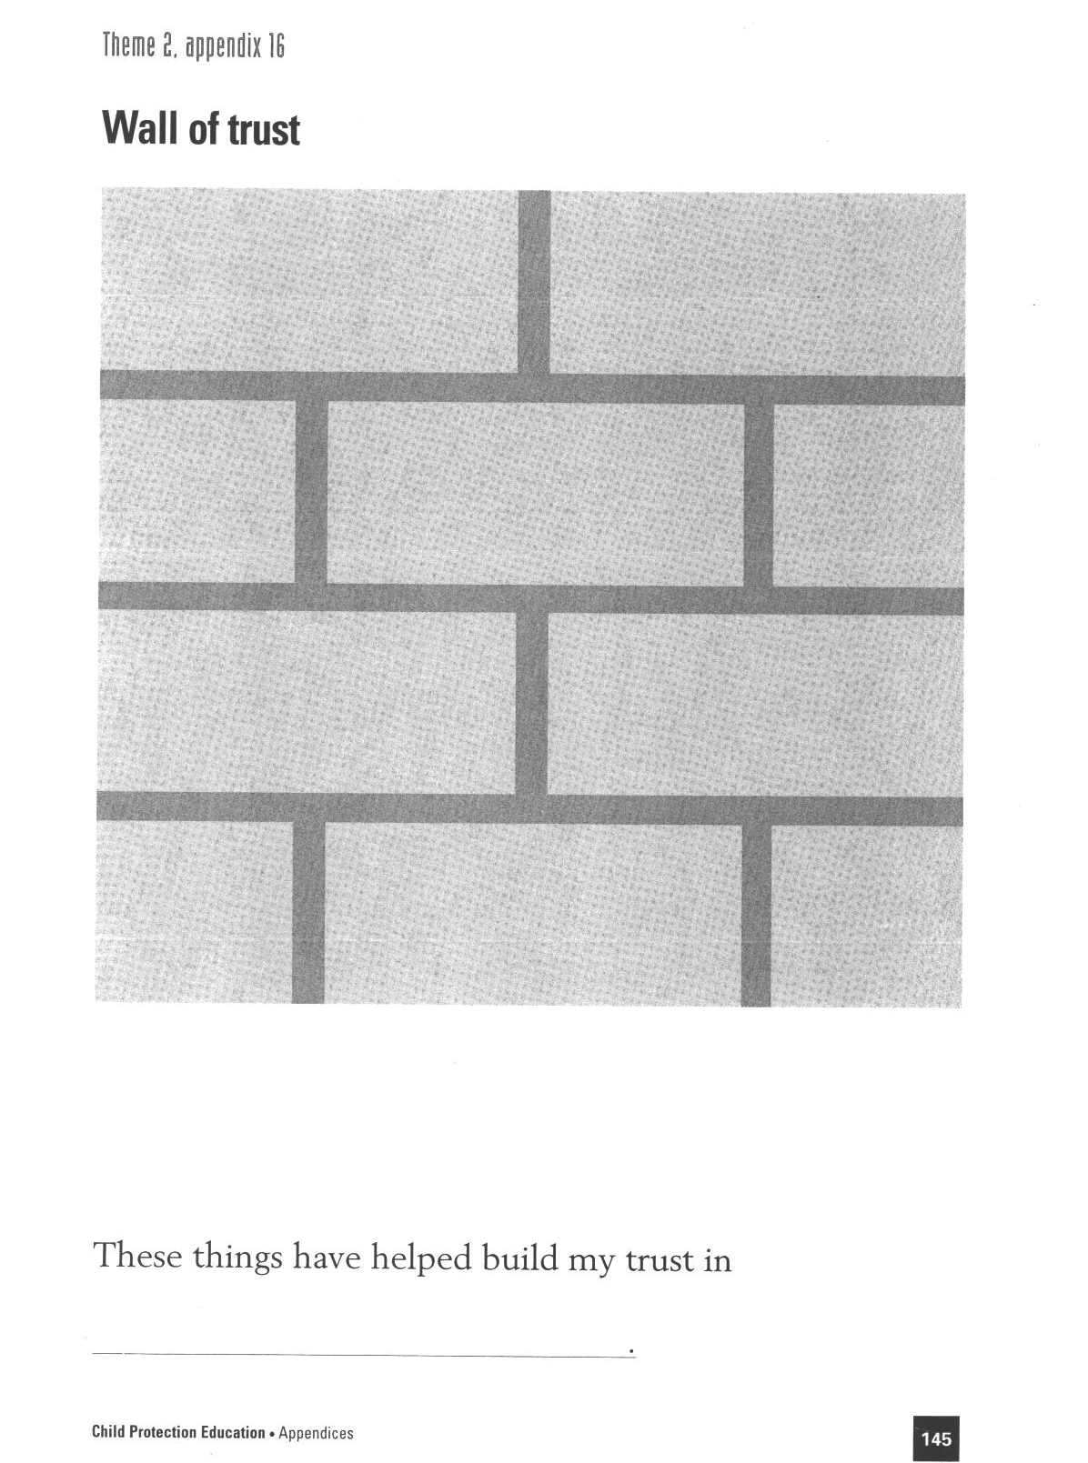

Reproduced from: NSW Department of School Education and Training (1998) Child Protection Education: Curriculum materials to support teaching and learning in PDHPE, Stages 1, 2 and 3.

Lesson 3 What is bullying?

Enduring Understandings | Outcomes |  | Indicators
E.1. We each have a responsibility to protect and care for our personal safety and that of others.  E.3. Recognise that to be healthy means to belong to a community and maintain relationships. | IRS2.11 Describes how relationships with a range of people enhance wellbeing  COS2.1 Uses a variety of ways to communicate with and within groups  INS2.3 Makes positive contributions in group activities  V4 Increasing accepts responsibility for personal and community health |  | - Recognises behaviours that are threatening  - Shares ideas, feelings and opinions with others about issues such as bullying  - Displays tolerance in relation to individual differences  - Values their health and safety and that of others
KidsMatter SEL Focus: Major – Self-Management - Managing emotions; Self-Management - Goal setting
Suggested Learning Experiences
TW: As a class discuss what is bullying and in what forms it can occur (physical, social, emotional). Remind children that we should appreciate and respect our body and the bodies of others. When bullying occurs we are not living out our Catholic values.

In small groups, students draw sketches of children being bullied OR access www.nobully.org.nz/game.htm (or other relevant site) and select the ‘No Bully Game’. Groups download a bullying scene. Students share their drawings of bullying scenes or internet scenes and discuss:
- Who is being bullied?
- Why is the person being bullied?
- What form of bullying is being used? (physical, social, emotional)
- How is the person being bullied reacting?
- What are the bystanders doing?
- What could the person being bullied do?

Students listen to the story Oliver Button is a Sissy and discuss why Oliver is bullied, how he reacts and how they feel about the end of the story. In small groups, students brainstorm a list of anti-bullying strategies that Oliver could use, then share these with the class. For example, ignore the bully, go and talk to or stand with other people, don’t react, stay with your real friends, talk to a teacher, parent or other trusted adult. In small groups, students rewrite the ending of the story and ensure Oliver uses anti-bullying strategies.

Ask students to define the term cyberbullying. Discuss and record how can we be bullied by people using technology? Have students read the information provided on the following site and then using the worksheet “My Action Plan To Stop Cyberbullying” children list the steps they would take if they were being cyberbullied.
http://www.cybersmart.gov.au/Kids/Tips%20to%20stay%20safe%20and%20cybersmart/Cyberbullying.aspx
Resources  - dePaula, T. (1979). Oliver Button is a Sissy. London: Voyager Books.  - Computer/Internet |  | Assessment  Student work sample of rewritten story ending to Oliver Button.
Lessons 1-10 Adapted and reproduced with kind permission from: NSW Department of Education and Training. (1997). Child Protection Education. Curriculum materials to support teaching and learning in PDHPE. Stage 2.

NO-ONE HAS THE RIGHT TO BULLY ANOTHER PERSON

Unfortunately, people don’t always treat each other with respect online, and you, or a friend, may find that you are the target of cyberbullying. You might be teased or have rumours spread about you online, receive nasty messages or even threats. It can happen in school, or at home, or any hour of the day, from people you know, and sometimes people you don’t know. It can leave you feeling unsafe and alone.

If this was happening to me, I would…

Research some rules to keep children safe online.
Lesson 4 How can power be abused?

Enduring Understandings | Outcomes | Indicators
E.1. We each have a responsibility to protect and care for our personal safety and that of others.  E.4. Recognise that to be healthy means to belong to a community and maintain relationships. | IRS2.11 Describes how relationships with a range of people enhance wellbeing  COS2.1 Uses a variety of ways to communicate with and within groups  INS2.3 Makes positive contributions in group activities  V4 Increasing accepts responsibility for personal and community health | - Recognise behaviours which are unfair and may threaten others  - Describe how ideas of fairness and justice can be practised in their behaviour towards others  - Participates in the development of a class definition for power  - Values their health and safety and that of others
KidsMatter SEL Focus: Major - Responsible Decision Making - Respecting others; Minor - Social Awareness - Perspective-Taking, Responsible Decision Making - Assuming Personal Responsibility
Suggested Learning Experiences
Students view a short excerpt of a video or read a story or comic strip about a super hero such as Xena, Superman, Spiderman. As a class, discuss the following questions:
- Why was the hero powerful?
- Who in the story thought the hero was powerful?
- What kind of power did the hero have? (strength, intelligence, weapons, superhuman qualities, fast car, could be trusted).
- Did the villain also have power?
- What kind of power did the villain have?
- Who was the most powerful? Why?
- Which character used their power in a fair or OK way? Why?

As a class, students prepare a definition of power and record this on the board. Power is being able to do something or make something happen. Power can be being able to make others do things.

Students list what gives people power; (age, size, position in the family, school, community or company).
Students form small groups. Each group is provided with a set of Use of Power discussion cards. Students discuss:
- Who is using their power in this situation?
- How is the person using their power?
- Is this a fair or Ok way to use their power?
- Which rights are being respected or not respected?
Students complete the Situations of Power Activity. Teacher informs students that sometimes it can be very hard for children to know when other people use their power in ways that are not OK and do not respect a child’s rights.
Resources  - NSW Department of Education and Training. (1997). Child Protection Education. Curriculum materials to support teaching and learning in PDHPE. Stage 2. Situation of Power Activity and Use of Power Activity. pp 148, 149.  - Video excerpt/story/comic strip of a superhero |  |  | Assessment  Teacher observation of students participation in group discussion of cards.
Lessons 1-10 Adapted and reproduced with kind permission from: NSW Department of Education and Training. (1997). Child Protection Education. Curriculum materials to support teaching and learning in PDHPE. Stage 2.

Situations
of
power

- I have power when

- I can use my power in an unfair and not OK way by

- This might happen

- I can use my power in a fair and respectful way by

- This might happen

- When I use my power in a fair and OK way, I also benefit because

Adapted from: NSW Department of School Education and Training (1998) Child Protection Education: Curriculum materials to support teaching and learning in PDHPE, Stages 1, 2 and 3.

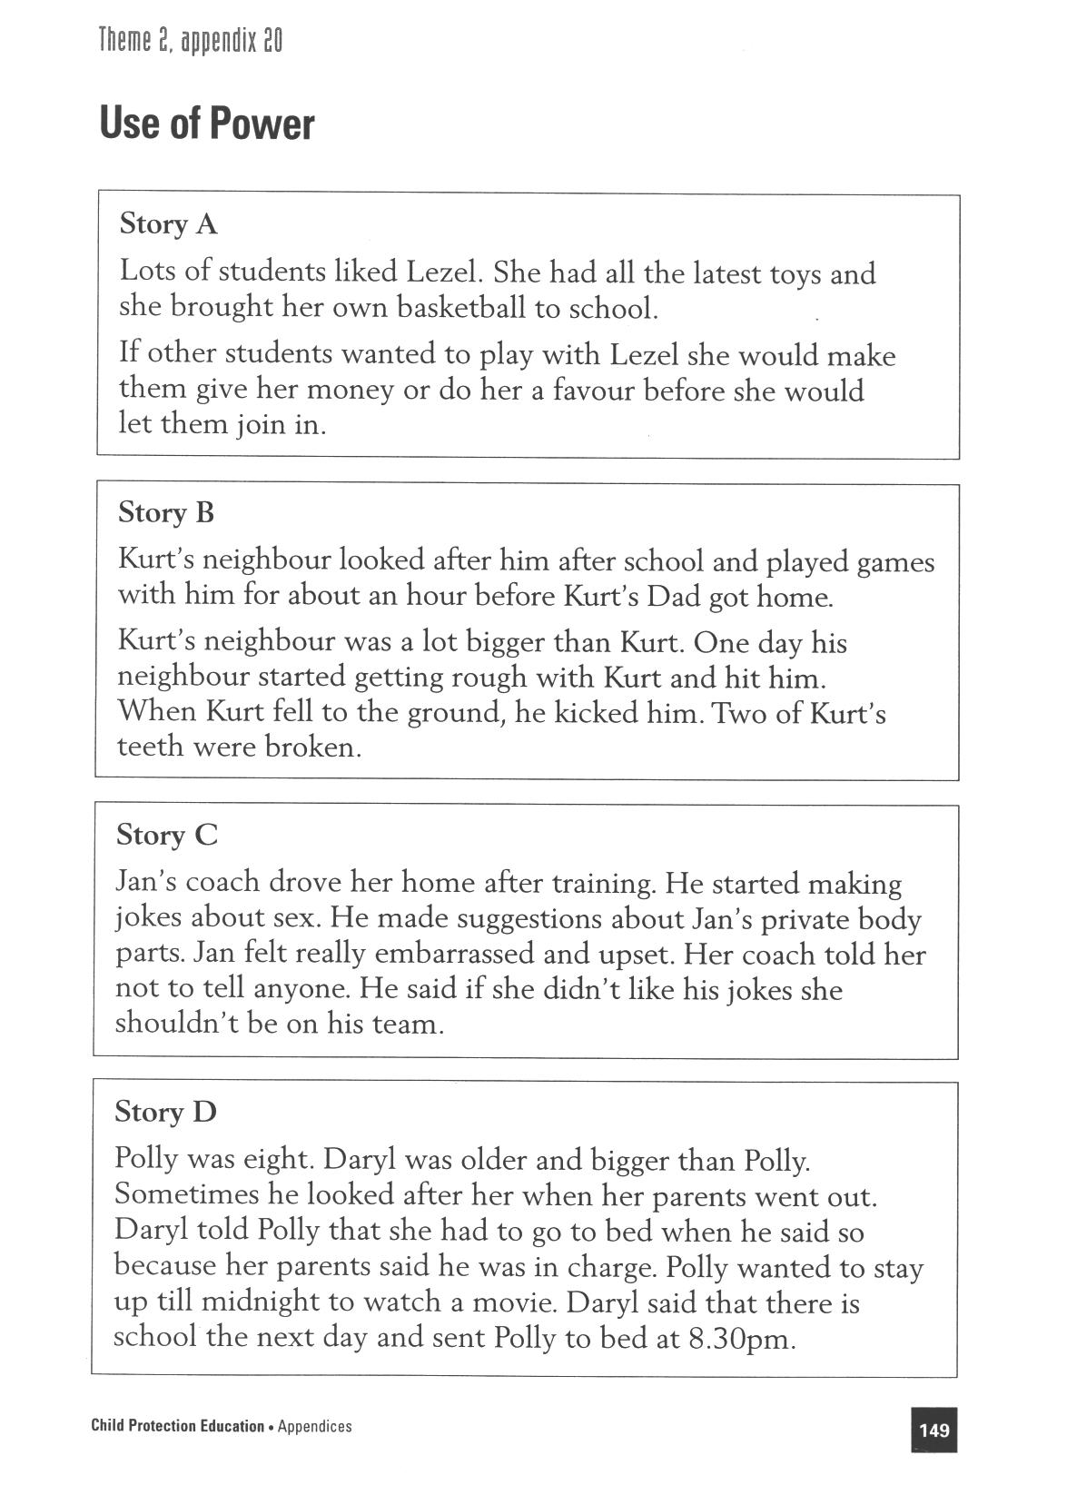
Reproduced from: NSW Department of School Education and Training (1998) Child Protection Education: Curriculum materials to support teaching and learning in PDHPE, Stages 1, 2 and 3.

Lesson 5 What are safe and unsafe situations?

Enduring Understandings | Outcomes |  | Indicators
E.1. We each have a responsibility to protect and care for our personal safety and that of others. | SLS2. 13 Discusses how safe practices promote personal wellbeing  INS2.3 Makes positive contributions in group activities  V4 Increasing accepts responsibility for personal and community health |  | - Recognises how their body reacts and how they might feel in safe and unsafe situations  - Participates in class discussions about feelings.  - Appreciates the need for safe practices in a range of situations
KidsMatter SEL Focus: Major - Self Awareness - Identifying emotions
Suggested Learning Experiences
In small groups, student compile a list of feeling words for each letter of the alphabet, for example, Anger Bad Confused Disappointed Eager
Students brainstorm situations in which they might feel some of these feelings/emotions.
As a class, discuss:
- What are feelings?
- What do we call our body reactions to feelings? (Body signals)
- What do our body signals tell us? (They tell us that our feelings are important and we need to be aware of what they mean and what they are telling us).
- Can we see feelings? (No. They are internal. Sometimes we can see our external body reactions to feelings, eg goose bumps or a red face).
In groups, students identify body signals that are internal and external. Students discuss situations in which they feel safe and unsafe and record these on the board. Teacher chooses an unsafe situation from the board and students identify how their body might feel/react in this situation, eg. butterflies in the stomach, dry mouth, fast heart beat. In their books, students draw an outline of a body in their book and record these feelings on their drawing. Students list private possessions, for example, diary, bank account, letters and contents of a locket. As a class, create a shared definition of private. Using the body outline introduce the concept of private and public body parts.
Students draw another body outline in their book and colour the private parts in red and the public parts in blue. Teacher discusses that the sexual parts of the body are private and are not to be touched by others without permission, eg. in cases such as illness, disease.
TW: Discuss with students that we have a responsibility to protect and care for ourselves and therefore we should tell someone we trust if someone is not respecting our body. Each student records 5 people that they can trust on a drawing of the outline of their hand.
HOME TASK: Students tell those 5 people (if possible) that they trust them and why.
Resources |  | Assessment  Student work sample of body outlines.  Student responses during class discussion about feelings and body reactions.

Lessons 1-10 Adapted and reproduced with kind permission from: NSW Department of Education and Training. (1997). Child Protection Education. Curriculum materials to support teaching and learning in PDHPE. Stage 2.
Lesson 6 What is physical abuse?

Enduring Understandings | Outcomes |  | Indicators
E.1. We each have a responsibility to protect and care for our personal safety and that of others.  E.3. Recognise that to be healthy means to belong to a community and maintain relationships. | IRS2.11 Describes how relationships with a range of people enhance wellbeing.  SLS2.13 Discusses how safe practices promote personal well being  COS2.1 Uses a variety of ways to communicate with and within groups  V4 Enjoys a sense of belonging |  | - Recognises behaviours that are threatening  - Recognises that unsafe situations require informing a trusted adult.  - Shares ideas about what is physical abuse  - Appreciates the need for safe practices in a range of situations
KidsMatter SEL Focus: Major - Responsible Decision Making – Analysing situations
Suggested Learning Experiences

Teacher Note: Physical abuse is where a person’s body is harmed or injured on purpose by another person. Physical abuse is never OK. Students need to have an understanding of OK (appropriate) and not OK (inappropriate) touch. Stage 1 provides relevant activities in Kinds of Touch.

TW: Each person has rights and responsibilities in relation to personal safety. We have a responsibility to protect and care for others. All human life is sacred. We should appreciate and respect our body and the body of others.

What is physical abuse?
Revise the definition of abuse (words or actions that purposely cause harm or injury). The definition of ‘accidental’ may be discussed to assist in the understanding of ‘purposely’. Students participate in a class discussion based on the following questions:
- When a person touches another person is this always physical touch? (Yes) Why? (When people touch it always involves making contact with the body of another person.)
- When a person is touched by another person using an object is this physical? (Yes. The person’s body has been touched.)
- When can touching between people be a situation of physical abuse? (When a person purposely touches the body of another person to cause harm or injury. If the harm is caused by an object this is also physical abuse.)

Students form small groups and read and discuss the newspaper article from the Daily Starr. Teacher explains that this is not a real newspaper article but one that has been made up for this activity. In small groups, students decide whether the incidents are physical abuse or not. Students justify their responses.

Accident or abuse?
- The teacher informs students that when accidental harm or injury happens, warning signals (such as unsafe feelings) are often not present. When an accident happens there is also often no time to take notice of external signs. Discuss times when students have experienced accidents and did not know they were unsafe.
- Explain to students that in situations where there is intentional harm or injury (or physical abuse) internal warning signals or external signs are often clear. Children who are harmed on purpose can sometimes see or sense the harm coming.

N.B. The teacher should emphasise that even if a child has warning signals and signs, he or she may not be able to take actions to ensure safety. It is important to stress that children should talk to trusted adults about such situations so they can be protected if they happen again.

TW: Reinforce that we have a responsibility to protect and care for ourselves and others.
The teacher informs students that some children are physically abused. Children are sometimes hurt or injured on purpose by people they know. Although this is often kept a secret, (to avoid causing trouble or a ‘fuss’) it is not acceptable in our community and there are laws and people in schools and in community agencies whose job it is to help people to stop harming or injuring children. Children have a right to be safe from harm and they should TELL someone if they, or someone they know, are being harmed.

Students may need to debrief after this lesson. Use a fun game or activity.

Resources  - NSW Department of Education and Training. (1997). Child Protection Education. Curriculum materials to support teaching and learning in PDHPE. Stage 2. Daily Star Activity pp 138 |  | Assessment  Student responses to ‘Eric’s Story’ and ‘What is physical abuse?’

Lessons 1-10 Adapted and reproduced with kind permission from: NSW Department of Education and Training. (1997). Child Protection Education. Curriculum materials to support teaching and learning in PDHPE. Stage 2.

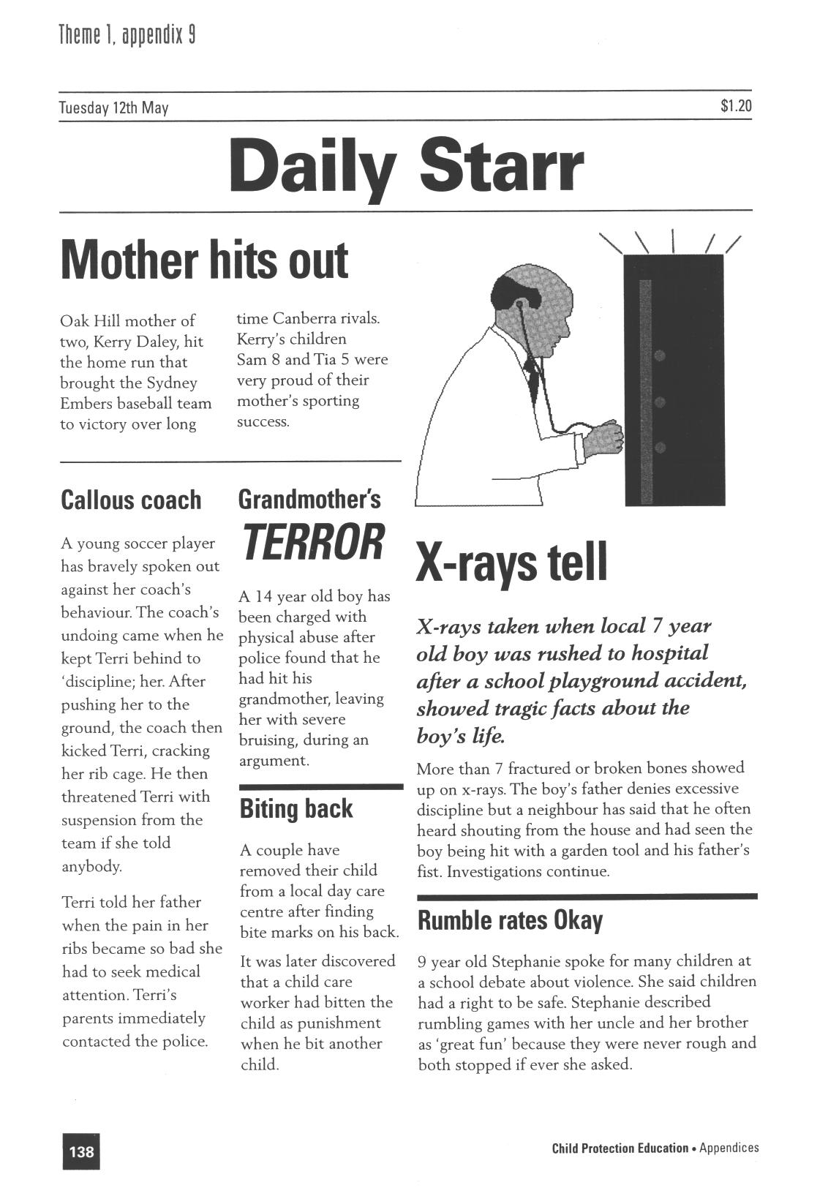
Reproduced from: NSW Department of School Education and Training (1998) Child Protection Education: Curriculum materials to support teaching and learning in PDHPE, Stages 1, 2 and 3.

Lesson 7 What is sexual abuse?

Enduring Understandings | Outcomes |  | Indicators
E.2. Recognise and develop skills for maintaining positive relationships.  E.3. Recognise that to be healthy means to belong to a community and maintain relationships. | SLS2. 13 Discusses how safe practices promote personal wellbeing  COS2.1 Uses a variety of ways to communicate with and within groups  INS2.3 Makes positive contributions in group activities  V4 Increasing accepts responsibility for personal and community health |  | - Compares the characteristics of people and situations that cause them to feel safe and unsafe  - Communicates how their body reacts and how they might feel in safe and unsafe situations  - Participates in the development of class definition for the term ‘sexual body parts  - Appreciates the need for safe practices in a range of situations
KidsMatter SEL Focus: Major - Relationship Skills - Refusal
Suggested Learning Experiences
As a class, students participate in the I feel game. Students sit in a circle and the teacher explains that everyone’s feelings are important and need to be expressed to someone trusted.
Teacher reads a sentence from the I Feel Activity. The student on the right repeats the statement and adds an ending. Students continue around the circle. Students may pass or repeat something already said.
When someone says hello to me, I feel …  When someone asks me to play with them, I feel …  When my father gives me a hug, I feel …  When I get into trouble, I feel …  When I get new clothes, I feel …  When I fall over, I feel …  When it is my birthday …  When someone hurts me … |  | When I get an award …  When no one wants to play …  When we go out for a special meal …  When someone uses my pencils without asking …  When I can share something good with someone …  When someone shares with me …
Teacher Note: Sexual abuse is wrong. If another person touches your sexual body parts in a way that is not OK or asks to touch their sexual parts, this is sexual abuse. Sexual abuse can also occur if a person shows you pictures or talks about sexual body parts in a way that is not OK.
Discuss WHO can touch the sexual parts of our body and WHEN. It is not appropriate for adults and older children to touch children’s sexual body parts. If adults or older children touch children in this way it is sexual abuse. (If you have a rash, are sore or injured, or need help to look after yourself, you or another person, such as a doctor, may need to touch the sexual parts of your body.)
Teacher reads Lian’s Story. Students discuss:
- What type of abuse was this? (Sexual abuse)
- What did Mike do that was wrong?
- Did Lian do anything wrong? (No)
- How did Mike trick Lian’s mother into thinking he was good and kind? (By looking after Lian every Tuesday, making food for her, helping her with her homework and buying her special gifts for her.)
5. How did Mike trick Lian into not telling? (He said that the family would be disgraced, Lian’s mother would lose her job, they would have no money and Lian would be blamed.)

6. What do you think Lian should do? (Tell her Mum about what Mike was doing. Refer to the
NO-GO-TELL strategies reinforcing how difficult it would be difficult for Lian to carry out each strategy and the reasons why it would be difficult).

TW: Students discuss who Lian could tell about Mike and what Lian would say. Children need to recognise there are support structures available for dealing with negative relationships. Children identify and share with a partner, who they could trust and tell if someone was sexually abusing them or someone they know.

Inform students that sexual abuse also includes situations if another person looks at a child’s sexual body parts or shows a child pictures or videos of these body parts when it is not appropriate. Children might feel confused about these activities or know immediately that they are not OK. Even if the person who does these things is a parent, caregiver or a responsible adult the situation could still be sexual abuse.
Resources  - NSW Department of Education and Training. (1997). Child Protection Education. Curriculum materials to support teaching and learning in PDHPE. Stage 2. Ryde: DET. Lian’s Story and I Feel Activity. page 53 and 56. | Assessment  Teacher observation of student contribution in class discussion relating to Lian’s story

Lessons 1-10 Adapted and reproduced with kind permission from: NSW Department of Education and Training. Child Protection Education. Curriculum materials to support teaching and learning in PDHPE. Stage 2.
Lian’s Story – Sexual abuse

Since Lian’s Mum and Dad had separated, she lived with the Mum most of the time and stayed at her Dad’s house on weekends. Today Lian walked home slowly. It was a Tuesday. Every Tuesday Lian’s mum went to a training course after work. The course didn’t finish until 10pm so Lian’s mother came home quite late.

Lian’s older cousin Mike would come over to look after Lian. Mike was a shift worker. He told Lian’s mother that he didn’t mind coming over on a week night because he could sleep in the next morning. Mike would make Lian something to eat, help her with her homework and send her to bed on time.

At first Lian really looked forward to Tuesday nights. Mike would often bring Lian and her Mum the latest magazines. Sometimes he would bring Lian something special like a new toy or a computer game. Once Mike bought Lian a picture kit for her school project and they worked on it till bedtime.

On Tuesday nights when it was time for Lian to go to bed she would go upstairs, put on her pyjamas and get into bed. Then Mike would come upstairs and they would read a book or a magazine together. He would always kiss her goodnight on her forehead or face before he turned out the light.

One night Mike sat on Lian’s bed and showed her a new magazine. The magazine had a picture of naked men and women. Mike told Lian that it was ok for him to show her these pictures because he was her cousin. Mike stared at Lian in a way that made her feel too embarrassed to say that she didn’t like the magazine.

The next Tuesday night after they had finished looking at the magazine Mike kissed Lian on her head. The kissing continued and Mike touched her private parts. She felt confused and uncomfortable.

Lian tried to tell him to stop. Mike got angry. He told Lian that this game was special and she was stupid and ungrateful if she didn’t play. Mike later told Lian that the new magazines and touching games were a secret. If Lian ever told anyone about their secret the whole family would be disgraced and her Mum might lose her job. Then they would have no money and Lian would be blamed for bringing trouble to the family.

Lian started having trouble sleeping. She started having nightmares and didn’t want Tuesday nights to come around.

Lian asked her Mum if she could stay at her Dad’s house on Tuesday nights. Lian’s Mum got cross. She told Lian that she was lucky to have such a good and kind cousin as Mike.

Lian started getting into trouble at school. She was angry and tired most of the time. She found it hard to concentrate. Lian stopped playing with her classmates. Lian hated Tuesday nights.

Reproduced from: NSW Department of School Education and Training (1998) Child Protection Education: Curriculum materials to support teaching and learning in PDHPE, Stages 1, 2 and 3.
Lesson 8 What are the effects of abuse?

Enduring Understandings | Outcomes | Indicators
E.3. Recognise that to be healthy means to belong to a community and maintain relationships. | IRS2.11 Describes how relationships with a range of people enhance wellbeing  PSS2.5 Uses a range of problem-solving strategies  V4 Increasing accepts responsibility for personal and community health | - Describe or depict things that others may do to place them at risk  - Analyses problem situations  - Appreciates the need for safe practices in a range of situations
KidsMatter SEL Focus: Major - Self Awareness - Identifying emotions
Suggested Learning Experiences
Revise the ways that children can be hurt—their bodies (physically), their feelings (emotionally) and their thinking (mentally). As a class, students brainstorm a list of actions that can hurt a child physically, mentally and emotionally.

What are some of the possible effects of abuse? (physical, emotional and mental). Students share their responses with the class and teacher records the students’ ideas on the board. Students use a grid to classify their responses under the following headings:

Physical Effects | Feelings | Thinking | School Work | Social Life
Burnt arm | Angry  Ashamed  Bad  Bitter  Confused  Fearful  Guilty  Lonely  Sad  Stupid  Trapped | Think it’s his fault  Think he’s stupid  No one wants him  Nightmares – no sleep  Scared about what might happen next | Get into trouble  Homework problems  Might not be able to do his work  Might fall asleep during class | Stops going to the park  Loses his friends  Feels lonely  Scared to go home

TW: As a class, discuss:
- What if in Eric’s story the abuse continued for a few months, what might happen? (The harm might get greater.)
- Did Eric deserve to be abused? (No. Children have a right to be safe. Adults have a responsibility to protect children. Abuse of children is never OK.)
- What could Eric do? (Eric needs to talk to a trusted adult.)
Revise the responsibility we have to protect and care for ourselves and others. Remind children that there are support structures available for dealing with these issues. If a friend was ever abused and told you then you should tell your teacher or parent.

Resources  - NSW Department of Education and Training. (1997). Child Protection Education. Curriculum materials to support teaching and learning in PDHPE. Stage 2. Eric’s Story Activity. Ryde: DET. page 55.  - I Feel Activity. page 56 |  | Assessment  Student contribution in class discussion in response to the case study, Eric
Lessons 1-10 Adapted and reproduced with kind permission from: NSW Department of Education and Training. (1997). Child Protection Education. Curriculum materials to support teaching and learning in PDHPE. Stage 2.
Lesson 9 How can I protect myself and others?

Enduring Understandings | Outcomes |  | Indicators
E.1. We each have a responsibility to protect and care for our personal safety and that of others.  E.3. Recognise that to be healthy means to belong to a community and maintain relationships. | SLS2.13 Discusses how safe practices promote personal wellbeing  COS2.1 Uses a variety of ways to communicate with and within groups  V4 Increasing accepts responsibility for personal and community health |  | - Recognises behaviours that are risky and identifies people who can help  - Shares ideas, feelings and opinions with others about issues such as bullying  - Appreciates the need for safe practices in a range of situations
KidsMatter SEL Focus: Major - Relationship Skills - Refusal
Suggested Learning Experiences
Revise classroom rules and identify the rules that promote safety. Discuss why it is important to follow these rules.

Students discuss some of the external signs that might indicate an unsafe situation, for example, when at home alone online, walking home, answering the telephone or opening the door when alone, being threatened by someone, someone touching your private/sexual parts when it is not necessary.

As a class view the Cyberquoll video clip Episodes 1 & 2 on www.cybersmart.gov.au
The teacher can select from a number of lesson plans form the website which relate to Episode 2 e.g. Lesson 2-1 Getting it started, Lesson 2-2 The Golden Rules, Lesson 2-3 Cyber dilemmas.

Students discuss: What safety rules apply to these situations? As a class, students listen to the teacher read the unfinished story from Troy’s Story and respond to the following questions:
- What were some safety rules that Troy followed? (Troy told his parents where he was going).
- What were some of the external signs which helped Troy realise he might be unsafe? (He was alone, the toilet block was a long way from the family BBQ, strange noises were coming from inside).
- What were some of the strategies Troy used when he realised he might be unsafe? (Troy didn’t go inside the toilet block alone. The children made loud noises so whoever was inside would know they were coming).

The teacher continues the unfinished story and class discusses the following:
- Was Troy unsafe? (Yes). Why? (Troy was by himself. The older boy tried to do something that was not OK).
- Did Troy have a right to say ’no’ to the older boy? (Yes. All children have a right to be safe and have their bodies and privacy respected by others).
- What the older boy did is not OK. What is this called? (Sexual abuse).
- What could Troy do? (NO-GO-TELL).

TW: Teacher reviews the NO-GO-TELL strategy (explain that it is a way of protecting ourselves and others):
NO – if someone acts in a way that does not respect your right to be safe and have your body respected, you can say ‘NO. STOP THAT’. ‘You SHOULDN’T do that’. ‘I DON’T want you to do that’.
GO – If you can, you should go away from the situation. You should go to a place or to people with whom you feel safe.
TELL – If you have been harmed or still feel unsafe, you should always tell a trusted adult about the situation. Telling as soon as possible can make telling easier.

As a class, suggest situations when you would need to use this strategy. Rehearse saying NO, GO and TELL, loudly and assertively.

Resources  - NSW Department of Education and Training. (1997). Child Protection Education. Curriculum materials to support teaching and learning in PDHPE. Stage 2. Troy’s Story Activity. Ryde: DET. page 91.  - www.cybersmart.gov.au |  | Assessment  Student responses in discussion relating to the unfinished story

Lessons 1-10 Adapted and reproduced with kind permission from: NSW Department of Education and Training. (1997). Child Protection Education. Curriculum materials to support teaching and learning in PDHPE. Stage 2.

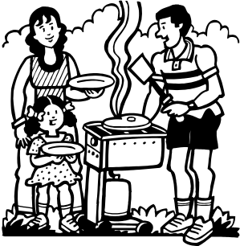
A large family was having a barbeque together in a park near a new sports centre. Troy needed to go to the toilet and told his parents where he was going. When Troy reached the toilet block he realised it was a long way from the barbeque area. He could hear strange noises coming from inside.

Troy decided to go back to the group and ask some of his cousins to come with him to make sure he was safe. As a result, three children went with him back to the toilet block. Although they all felt a little worried they made loud noises to make sure whoever was inside knew that there were a lot of children coming. The children went inside and saw two possums there. The possums ran away.

After the barbeque, Troy needed to go to the toilet again. His cousins had gone home. He told his parents where he was going and they joked about the possums. Troy laughed too.

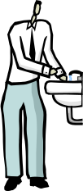When Troy reached the toilet block it was quiet inside. Troy was still a little worried and thought about his safety strategies. He went inside and saw an older boy standing at the wash basin. The older boy at first talked in a friendly way to Troy, but then he tried to touch Troy’s private parts.

Troy felt unsafe and he knew his parents were a long way away. He thought about his safety strategies and what he could do.

Lesson 10 How can I protect myself and others?

Enduring Understandings | Outcomes |  | Indicators
E.1. We each have a responsibility to protect and care for our personal safety and that of others.  E.3. Recognise that to be healthy means to belong to a community and maintain relationships. | SLS2.13 Discusses how safe practices promote personal wellbeing  COS2.1 Uses a variety of ways to communicate with and within groups  PSS2.5 Uses a range of problem-solving strategies  V4 Increasing accepts responsibility for personal and community health |  | - Recognises behaviours that are risky and identifies people who can help  - Practises assertive ways to deal with unsafe situations  - Analyses problem situations  - Appreciates the need for safe practices in a range of situations
KidsMatter SEL Focus: Major: Relationship Skills - Refusal; Responsible Decision Making - Assuming personal Responsibility
Suggested Learning Experiences
As a class, revise the NO-GO-TELL strategy by discussing actions that can be taken for each strategy. When discussing the TELL strategy, the teacher invites students to list trusted people who could do something to help. Teacher reinforces the concept of network people. (Network people should be adults that you see or talk to regularly, you trust and who listen to you because they care about you. Network adults also need to be people who will be able to help you).

As a class, students create a shared meaning for network adults. Individually, students complete the Adults I Know Activity.

As a class, students create a shared explanation of the purpose of TELLING a trusted adult network member. (The purpose of telling is to receive protection and help to stop the unsafe or abusive behaviour). Students play the Secrets Cards Activity. In small groups, students receive a set of secrets cards and take turns to read their card and decide whether their secret should be kept or they should TELL.

Students revise the concept of protection (eg protection is being safe from harm or danger) and the different ways that children may be hurt (physically, emotionally and mentally—their thinking may be hurt). Individually, students complete ‘I can help keep myself safe from harm or danger by …’. Remind students that adults have a responsibility to protect children from harm. However, because trusted adults may not always be around, there are many things that children can do to help protect themselves or to seek help from adults.

Students individually write some strategies they could use in the following My Strategies/What If? Activity. Students are encouraged to choose strategies that suit them personally and they believe they can carry out. Remind students about the KIDSHELPLINE.
Resources  - NSW Department of Education and Training. (1997). Child Protection Education. Curriculum materials to support teaching and learning in PDHPE. Stage 2. I Know and Secrets Cards Activity. Ryde: DET. pages 150 and 156. |  | Assessment  Student demonstration and responses of the NO-GO-TELL strategy  Sample Assessment Task: My Strategies/What if?
Lessons 1-10 Adapted and reproduced with kind permission from: NSW Department of Education and Training. (1997). Child Protection Education. Curriculum materials to support teaching and learning in PDHPE. Stage 2.
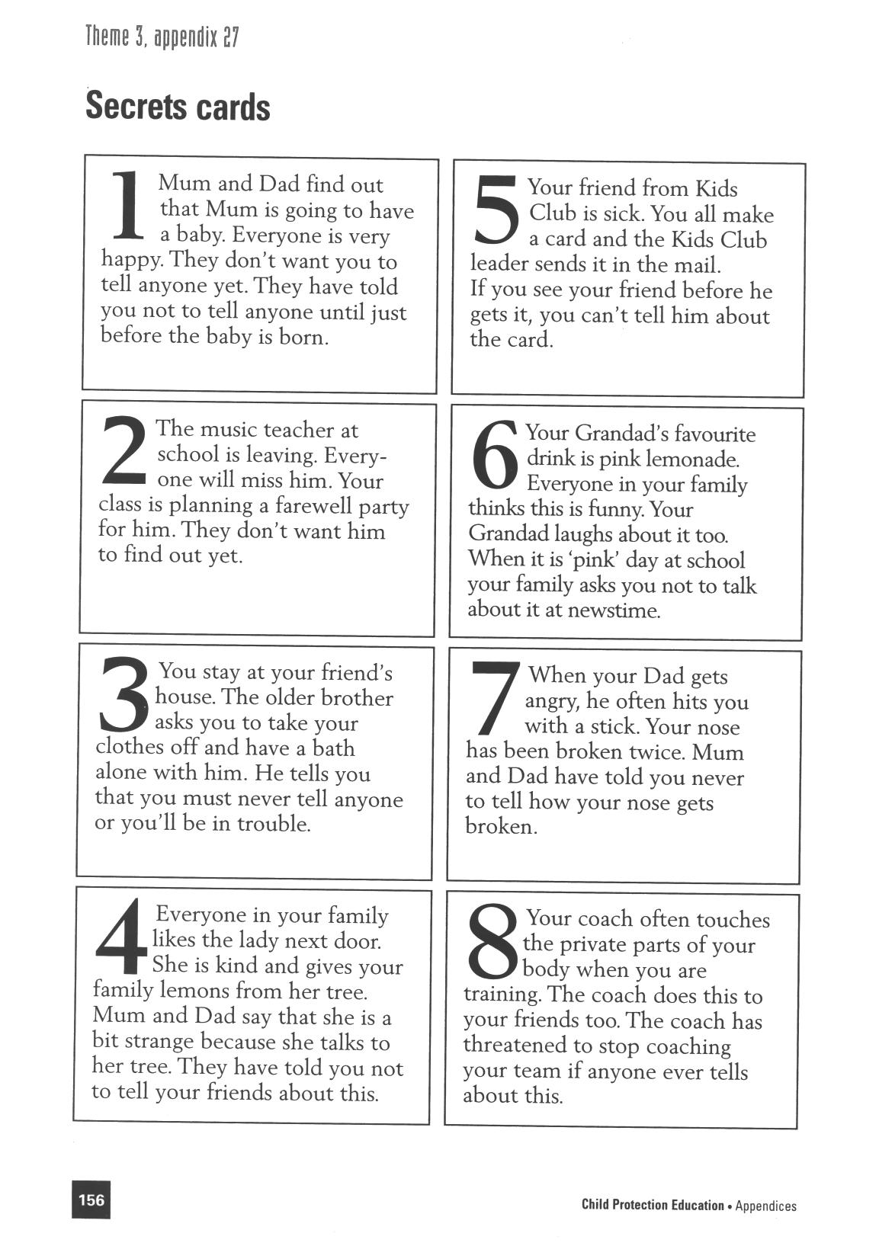
Reproduced from: NSW Department of School Education and Training (1998) Child Protection Education: Curriculum materials to support teaching and learning in PDHPE, Stages 1, 2 and 3.

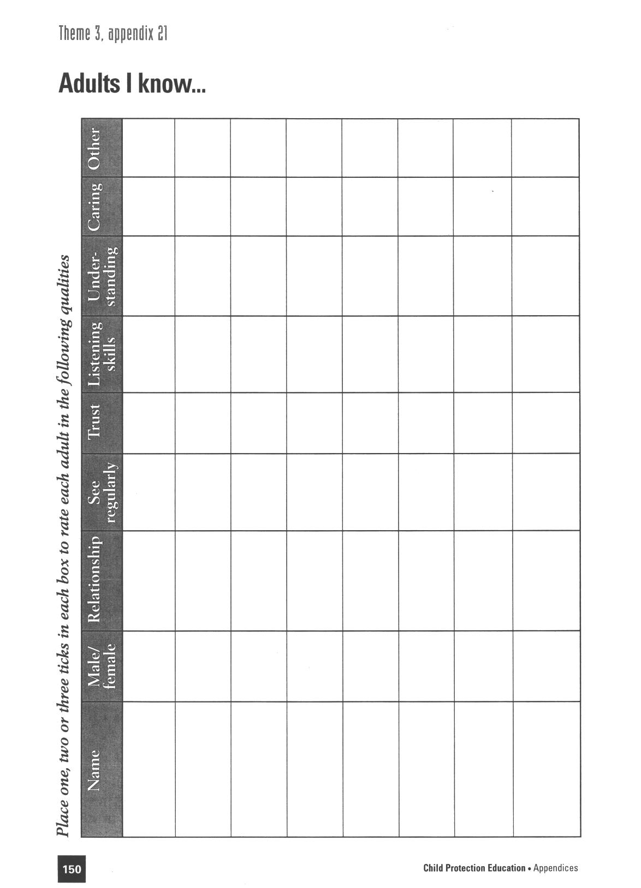

Reproduced from: NSW Department of School Education and Training (1998) Child Protection Education: Curriculum materials to support teaching and learning in PDHPE, Stages 1, 2 and 3.

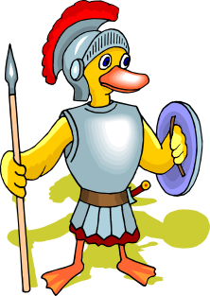
My strategies/What if?

Student: __________________________________________

This task provides students with the opportunity to demonstrate their standard of achievement of the following outcomes:

Outcomes | Indicators | Working Towards | Achieved with support | Achieved
SLS2.13 Discusses how safe practices promote personal wellbeing | Recognises behaviours that are risky and identifies people who can help
IRS2.11 Describes how relationships with a range of people enhance wellbeing | Practises assertive ways to deal with unsafe situations
COS2.1 Uses a variety of ways to communicate with and within groups | Identify ways in which they can protect themselves from harm
Students individually write some strategies they could use in the following What if? situations. Students are encouraged to choose strategies that suit them personally and they believe they can carry out.

Catholic Values/Beliefs: Positive relationships are sustained by sympathy, love, trust and forgiveness. All human life is sacred and we should appreciate and respect ourselves and others.

SKILLS FOR TELLING eg tell a trusted adult from your network.
SECRETS eg never keep a secret if it causes you to feel unhappy.
NO-GO-TELL ASSERTIVENESS eg be strong and clear with your voice.
FEEL-THINK-ACT eg think about how you will act if you have warning signals.
BRIBES AND THREATS eg you do not have to do favours for gifts.

What if you were with a group of friends who were planning to do something that you
didn’t want to do because it was unsafe?
_________________________________________________________________
_________________________________________________________________
What if every time you walked to school a group of older students would follow you,
call you names and threaten to throw your school bag in the river (down the drain)?
_________________________________________________________________
_________________________________________________________________
What if an adult you lived with hit you really hard and told you that you were stupid,
hopeless and that no one loved you, and did this every day?
_________________________________________________________________
_________________________________________________________________
What if somebody regularly made you look at pictures that showed sexual behaviour and they told you that you had to keep it a secret, always?
_________________________________________________________________
_________________________________________________________________
What if someone did something that was not OK and then said it was all your fault and
you would be in trouble if you told?
_________________________________________________________________
_________________________________________________________________
What if a person whom you knew gave you gifts but then asked for favours (that were
not OK) because you took the gifts?
_________________________________________________________________
_________________________________________________________________
What if you told a trusted adult about abuse but they didn’t believe you and didn’t take
action to protect you?
_________________________________________________________________
_________________________________________________________________

TEACHER REFLECTION - UNIT EVALUATION
Unsatisfactory
Satisfactory

Poor
Good

A. A. EVIDENCE
To what extent does the assessment evidence provide:
1. A valid and reliable measure of the targeted outcomes/enduring understandings?
2. Sufficient information to support inferences about each
student’s understanding/level of achievement?
3. Opportunities for students to demonstrate their understandings through authentic learning tasks?
B. LEARNING EXPERIENCES AND INSTRUCTION
To what extent did students:
1. Achieve the outcomes and the enduring understandings of the unit (the big ideas as opposed to basic facts and skills)?
2. Know where they were going and why (in terms of unit goals, requirements, and evaluative criteria)?
3. Deepen their knowledge and understanding of the outcomes & big ideas of the Unit (through inquiry, research, problem solving, and experimentation)?
4. Receive explicit instruction on the knowledge and skills needed to equip them for the required performances?
5. Have opportunities to rehearse, revise, and refine their work based on feedback?
6. Self-assess and set goals prior to the conclusion of the unit?

PTO

1. What did students learn? (What knowlege and skills did they learn to deepen their understanding of the outcomes/big ideas of the unit?)

2. How do you know what they learnt? (What evidence do you have to support your judgement?)

3. What would you refine to improve student learning outcomes?

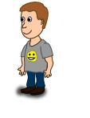
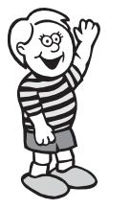
Student Unit Reflection
Stage 2

Student Name: Class:
Unit/Topic:

One important thing I have learnt about/learnt to do during this unit is… | What I learnt will help me in my life because…
A question about this unit that I asked in class was… | Something that still puzzles me is...
A question about this unit that I asked at home was… | If I wanted to research more about this unit I could…
Something I am going to value/appreciate more about myself because of what I have learnt in this unit is… | I think the effort I put into my learning in this unit was:  (Circle one number)  No effort 0 1 2 3 4 5 6 7 8 9 10 Most effort

