ACTION PACKED
Stage: 2 | Unit Duration: 10 Lessons |  | Weeks 1 2 3 4 5 6 7 8 9 10 |  |  | Terms 1 2 3 4
KidsMatter SEL Focus:
Enduring Understandings:  E.1. We have a responsibility to make wise decisions about our lifestyle choices to ensure health and well being.  E.2. A balanced lifestyle of physical activity and nutrition is an essential part of who we are.  E.3. As we are created in the image and likeness of God we accept responsibility for community and personal health by participating in physical activity. |  |  | Essential Questions:  - What is health and a balanced lifestyle?  - How does physical activity and nutrition affect my health?
Major Outcomes  Knowledge and Understanding  ALS2.6 Discusses the relationship between regular and varied physical activity and health  Skills  DMS2.2 Makes decisions as an individual and as a group member  Values and Attitudes  V4 Increasingly accepts responsibility for community and personal health |  |  | Contributing Questions/Lesson Overview  1. Who is healthy?(E.1)  2. What is health? (E.1,E.2)  3. What is a healthy lifestyle? (E.1,E.3)  4. What is physical activity?(E.2,E.3)  5. What is accumulated physical activity?(E.2)  6. What are the long term effects of physical activity? ( E.1, E.2, E3)  7. What are the long term effects of physical activity? ( E.1, E.2, E3)  8. What is healthy eating? (E.1,E.3)  9. How does advertising affect my food choices?(E.3)  10. How does health and physical activity change with age?( E.1,E.2)  KidsMatter SEL Focus  Major: Responsible Decision Making - Analysing situations; Self-Management - Goal setting;  Minor: Self Awareness – Identifying emotions; Responsible Decision Making – Problem Solving; Responsible Decision Making – Assuming personal responsibility; Responsible Decision Making –Analysing situations
Contributing Outcomes
Knowledge and Understanding
PHS2.12 Discusses the factors influencing personal health choices
GDS2.9 Describes life changes and associated feelings
Skills
INS2.3 Makes a positive contribution in group activities
PSS2.5 Uses a range of problem-solving strategies
COS2.1 Uses a variety of ways to communicate with and within groups
Values and Attitudes
V5 Willingly participates in regular physical activity

Catholic Dimension/Towards Wholeness (TW) (Also refer to overview of TW for this unit)

Active Lifestyle
We were all created by a loving, caring God whose intention is that we should live active and fulfilling lives. In being fully human, we reflect the creative majesty of God. We all have an important responsibility, therefore, to value and care for ourselves, each other and all creation. In our effort to care for ourselves properly, we should monitor all aspects of our work, rest, leisure and exercise.

Growth and Development
God has created each of us to grow into the fullness of life. We are made in God’s image and therefore, we are of inherent dignity and worth. Our sexuality is an intrinsic part of ourselves, to be celebrated and expressed with joy and responsibility, according to God’s plan. Each person grows and changes, passing through stages on a journey towards full maturity. God is with us on this journey, reassuring and challenging. We are never alone.

Personal Health Choices
Throughout our lives, we all face having to make personal decisions relating to nutrition, hygiene, consumerism, drug use and disease prevention. So many conflicting opinions and values influence children in making decisions that have direct relevance to their health and well-being. Taught from a Catholic perspective, this strand seeks to develop the children’s abilities to observe, explore, interpret and judge, informed by an emerging integrated value system that is based on the values of the Gospel.
Foundation Statements
Students describe the factors that influence healthy lifestyle decisions and demonstrate an understanding of the decision making process. They examine how the use of drugs such as tobacco and alcohol can cause harm. They investigate nutritional choices relating to cultural beliefs, special dietary needs and ‘fast food’. Students demonstrate behaviours to stay safe at home, on and near roads, when travelling to and from school, and near water! They demonstrate the capacity to deal with unsafe situations including abuse, bullying and harassment.

Students recognise individual strengths and limitations and they identify characteristics that make them unique. They explore body changes that occur during life, including puberty. Students explain how positive relationships are formed and the importance of effective communication of feelings and needs in maintaining relationships. They recognise the rights, values and feelings of others and devise strategies to solve problems, recognise and accept differences and manage conflict.

Suggested Correlation With Other KLAs  English  - Explanation  - Information report  - Poetry – Acrostic Poem  Science and Technology  - Living Things – body systems  -Designing/making a model of a body system  - Products and Services  -Investigating fast food packaging and labelling |  |  |  | Mathematics  - Measurement  - Time  - Working mathematically  - Data  Creative and Practical Arts  - Visual Arts  - Drama  Information Technology  - PowerPoint Presentation
Technology

The following websites have been selected to enhance various concepts being taught throughout this unit. Most of the sites listed can be linked to more than one of the lessons being taught. Teachers may like to add them to the school intranet site.

- http://www.cyh.com/HealthTopics/HealthTopicDetailsKids.aspx?p=335&np=284&id=1429
- http://www.cyh.com/HealthTopics/HealthTopicDetailsKids.aspx?p=335&np=285&id=1448
- http://www.cyh.com/HealthTopics/HealthTopicDetailsKids.aspx?p=335&np=307&id=1519
- http://www.cyh.com/games/wordsearch/fitness/index.html
- http://www.ramogames.com/games/Lunch-Crunch.htm
- http://www.kidshealthandfitness.org.au/lq/learningquest.aspx
- http://www.measureup.gov.au/internet/abhi/publishing.nsf

http://kidshealth.org/kid/stay_healthy/index.html

Subject Matter  Active Lifestyle  Components of an Active Lifestyle  - Concept of being physically active  - Importance of a balanced lifestyle  - rest, relaxation  - active and passive pursuits  - leisure  - nutrition  - regular participation in activity  Ways to be Active  - Participating in recreational activities that encourage physical activity |  | Effects of Physical Activity  - Effects on the body  - immediate, long term  - Feelings about being active before, during, after  - Benefits of participation  - enjoyment, friendship  - Recording activity levels  - activities I participate in regularly  - activities I would like to learn  Growth and Development  The Body  - Body parts  - internal, external  - Body systems  - skeletal |  |  | Personal Health Choices  Making Decisions  - Identifying choices  - Making choices  - Influences on decisions  - Reasons for choices/decisions  - Effects of actions  - Possible solutions  Nutrition  - Food groups  - Balanced eating habits  - Food choices for good health
Unit Evaluation  Sample teacher and student evaluations are included at the end of the unit. |  |  |  | Assessment  Assessment strategies are included in each lesson.  The assessment task for this unit is in Lesson 9.

An Overview of Towards Wholeness (TW) in the PDH Unit
Action Packed - Stage: 2
Key God’s Word:
Leisure gives the learned person the chance to acquire wisdom; a person with few commitments can grow wise. (Ecc 38:24-34) TW p.18
The Scriptures give several insights into how our lifestyle is to be viewed. Trust in God is contrasted with worrying about livelihood. (See Mt 6:19-34) TW p.18
We should see ourselves as co-workers with God.
‘For we are God’s servants, working together; you are God’s field, God’s building.’ (1 Cor 3:9) TW p.18
Enduring Understandings | Beliefs and Values | Lesson Overview/Links
E.1. We have a responsibility to make wise decisions about our lifestyle choices to ensure health and well being. | - Responsible decision making takes place in a Christian context. TW p.38  - We have a responsibility to promote our health by making wise decisions based on Gospel values. TW p.38  - Our responsibility towards our gift of life is to make lifestyle choices that ensure health and well being. TW p.35  - Life is a precious gift entrusted to us by God. TW p.41 | 1. Who is healthy?  2. What is health?  3. What is a healthy lifestyle?  6. What are the long term effects of physical activity?  7. What are the long term effects of physical activity?  8. What is healthy eating?  10. How does health and physical activity change with age?
E.2. A balanced lifestyle of physical activity and nutrition is an essential part of who we are. | - People should be allowed sufficient leisure to cultivate all aspects of Human life and their gifts and talents. TW p.17  - We are called to live life to the full. TW p.17  - We have a duty to care for our whole selves, eg. mental, social, physical, cultural and spiritual. TW p.17  - As we are created in the image and likeness of God we accept responsibility for personal health by participating in physical activity. | 2. What is health?  3. What is a healthy lifestyle?  4. What is physical activity?  5. What is accumulated physical activity?  6. What are the long term effects of physical activity?  7. What are the long term effects of physical activity?  10. How does health and physical activity change with age?
E.3. As we are created in the image and likeness of God we accept responsibility for community and personal health by participating in physical activity. | - Responsible decision making takes place in a Christian context. TW p.35  - We have a responsibility to promote our health by making wise decisions based on Gospel values. TW p.35  - Our responsibility towards our gift of life is to make lifestyle choices that ensure health and well being. TW p.35 | 4. What is physical activity?  6. What are the long term effects of physical activity?  7. What are the long term effects of physical activity?  8. What is healthy eating?  9. How does advertising affect my food choices?

Lesson 1 Who is healthy?

Enduring Understanding | Outcomes |  | Indicators
E.1. We have a responsibility to make wise decisions about our lifestyle choices to ensure health and well being. | ALS2.6 Discusses the relationship between regular and varied physical activity and health  PSS2.5 Uses a range of problem-solving strategies  DMS2.2 Makes decisions as an individual and as a group member  V4 Increasingly accepts responsibility for community and personal health |  | - Describes healthy and unhealthy factors in case studies  - Analyses case studies to determine the meaning of health  - Clarifies reasons for ranking the case study as excellent or poor health  - Values the need to pursue healthy lifestyles
KidsMatter SEL Focus: Major - Responsible Decision Making - Analysing situations
Suggested Learning Experiences

Each student writes down a definition of health in their own words. Students share their definitions and then agree on a class definition of what is health? (Health is a general condition of the body and mind).

Students read the Who is Healthy? activity and rank each one from poor to excellent.
(Display on Smartboard or Handout.)

As a whole class discuss:
- What are the factors in each case study that are healthy and unhealthy? (record on sheet)
- Why do people have different viewpoints about what is healthy? Can a disabled person in a wheelchair be healthy? Can a person with asthma be healthy?

TW: Ask the students to give reasons why is it important to stay healthy? After the responses are given, the teacher writes on the board the belief statement, “Life is a precious gift entrusted to us by God.” The children are then given the opportunity to add more or change their responses.
Resources  - Who is Healthy? Activity  - http://www.au/science/WellbeingForKids.html |  | Assessment  Student discussion and ranking of Who is Healthy? Activity.

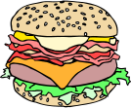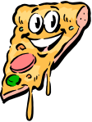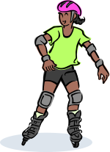
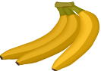

1. Tony is 31 years old and has smoked since he was 15. He works in an office and does no exercise except for a little gardening on the weekend. Tony played football every weekend in winter until he was 25. He still looks fit and is not overweight. Tony lives with his wife and three children but does not play very much with his children and has started to fight with his wife.

1 ___________ 2 ____________3 ____________4 ____________5
Poor Healthy Excellent

2. James is a 50-year-old office worker. He gave up smoking 10 years ago and four weeks ago stopped work because it was getting too stressful. He is a big man carrying extra weight. He has lots of friends and he tells great jokes. James likes eating out with his friends four times a week. He has started a new business from home so he can spend more time with his family.

1 ___________ 2 ____________3 ____________4 ____________5
Poor Healthy Excellent

3. Elyse is a 42-year-old teacher with three children. She works at school full time, but sometimes does not get enough sleep because she has asthma. Elyse tries to cook healthy meals for her family and does not drink alcohol or smoke. She plays netball on weekends in winter and walks three times a week for 45 minutes with friends. She spends a lot of time in the car driving her children to sport and other activities and goes to Mass each week.

1 ___________ 2 ____________3 ____________4 ____________5
Poor Healthy Excellent


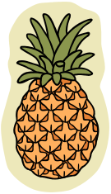
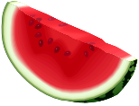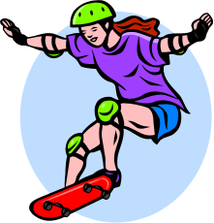

4. Caitlin is a very fit 25-year-old fitness instructor. She spends an hour each day doing her own exercises at the gym. Caitlin teaches fitness classes to adults and children for four hours each day. She tries to eat healthy food which is low in fat. Sometimes Caitlin does not go out with her friends because she would rather go to the gym than stay out late at a party and drink alcohol. She lives alone, does not have many friends and visits her family every month.

1 ___________ 2 ____________3 ____________4 ____________5
Poor Healthy Excellent

5. Liam is 50 years old and has heart disease. Six months ago Liam was told by his doctor to start eating foods low in fat and to walk for 30 minutes each day. He feels healthy and has lost weight since going on the new diet and exercising program. Liam has a wife, two children and four grand-children. He is happy and has lots of friends and sometimes goes to church.

1 ___________ 2 ____________3 ____________4 ____________5
Poor Healthy Excellent

What are the common healthy factors in each case study?
________________________________________________________
________________________________________________________
________________________________________________________
________________________________________________________

What are the unhealthy factors in each case study?
________________________________________________________
________________________________________________________
________________________________________________________
________________________________________________________
Lesson 2 What is health?

Enduring Understandings | Outcomes |  | Indicators
E.1. We have a responsibility to make wise decisions about our lifestyle choices to ensure  health and well being.  E.2. A balanced lifestyle of physical activity and nutrition is an essential part of who we are. | ALS2.6 Discusses the relationship between regular and varied physical activity and health  DMS2.2 Makes decisions as an individual and as a group member  V4 Increasingly accepts responsibility for community and personal health |  | - Defines what is health.  - Considers the relationship between the 4 areas of health  - Values the need to pursue healthy lifestyles
KidsMatter SEL Focus: Major - Responsible Decision Making – Analysing situations; Minor – Self Awareness – Identifying emotions
Suggested Learning Experiences
The class reviews student definitions of health. Reflect back on the case studies of the previous lesson.
The teacher introduces the definition of health outlined on the What is Health? activity. The teacher explores with the class 4 possible categories or areas of health. They are:
- Physical health – having a healthy body (general fitness, being well and not sick, good energy levels, good nutrition, body weight, good functioning body organs)
- Social health – having positive relationships that are loving, caring and cooperative
- Mental health – being able to make decisions, express our feelings, cope with life and think positively about ourselves (self-esteem) and life.
- Spiritual health – being connected to our Catholic faith, being a disciple of Jesus, being connected to our family, friends and community.

Students complete the What is Health? Activity by listing some key words under each Health heading. Students share with a friend to increase their list.

TW: Teacher discusses the concept of well-being (wellness) in relation to health. This definition of health focuses on the whole person (physical, social, mental and spiritual), not just the old view of health which referred to health as the opposite of disease or illness. We all have a duty of care to look after our whole selves and make lifestyle choices that ensure health and well being.

In groups, discuss:
- When is a person healthy? (eg when all 4 areas of health are balanced).
- How can I influence my health? (eg our lifestyle choices, attitudes/values, heredity and behaviour, nutrition, physical activity, drug use and relationships influence our health).
- What other factors influence my health? (eg physical environment {air, land, water and human impact}, social relationships, economic – money, job; political – government).
- Why is your health a balancing act? (visualise a tight rope walker at a circus or a gymnast on a beam; your health changes with age; certain events in your life, sickness etc)
Students make up an acrostic poem for the term ‘health’.
H ealthy relationships
E nergy
A balanced diet
L ots of physical activity
T o be a disciple of Jesus
H appy and well
Resources  - What is Health? Activity |  | Assessment  Student responses to health questions

Health means different things to different people. Health is the relationship between the different areas of our life that balance to produce wellbeing. The four areas of health are physical, social, mental and spiritual.

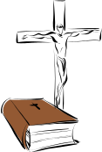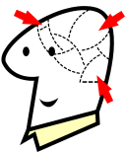

Spiritual

__________________
___________________
___________________________
___________________________
___________________________
___________________________
___________________________
___________________________
___________________
___________________

Mental

__________________
____________________
___________________________
___________________________
___________________________
___________________________
___________________________
___________________________
___________________
___________________

HEALTH

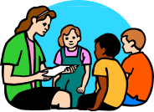

Physical

__________________
___________________
___________________________
___________________________
___________________________
___________________________
___________________________
___________________________
___________________
___________________

Social

_________________
___________________________
___________________________
___________________________
___________________________
___________________________
___________________________
___________________________
___________________
___________________

Lesson 3 What is a healthy lifestyle?

Enduring Understandings | Outcomes |  | Indicators
E.1. We have a responsibility to make wise decisions about our lifestyle choices to ensure health and well being.  E.2. A balanced lifestyle of physical activity and nutrition is an essential part of who we are. | ALS2.6 Discusses the relationship between regular and varied physical activity and health  COS2.1 Uses a variety of ways to communicate with and within groups  V4 Increasingly accepts responsibility for community and personal health |  | - Describes links between nutrition, exercise, rest, sleep and lifestyle balance  - Uses pictures to illustrate the different aspects of lifestyle  - Discusses ways to improve lifestyle  - Values the need to pursue a healthy lifestyle
KidsMatter SEL Focus: Minor - Responsible Decision Making – Problem Solving
Suggested Learning Experiences
As a class, prepare a mind map that represents ‘What makes a balanced lifestyle?’ Discuss the need for sleep, exercise etc.
Using a large coloured circle divided into 24 slices (sectors), each student estimates how many slices in their day they spend:
- Eating
- Sleeping
- Exercising
- Doing school work
- Playing
- Resting
- Getting clean –teeth, bath, hair
- Dressing
(Teacher might wish to create a worksheet for this activity)
As a class, students compare their estimates for each activity and discuss the components of a balanced healthy lifestyle – adequate nutrition, rest, sleep, exercise, schoolwork. Refer to mind map and add any other information.
TW: As a class, discuss why it is important to have a balanced lifestyle. Students complete the A Balanced Lifestyle Activity. Revise the belief that we all have a duty of care to look after our whole selves and make lifestyle choices that ensure health and well being. Students think about the 3 questions on the A Balanced Lifestyle activity sheet and share with a friend. (Useful website: http://www.healthykids.nsw.gov.au/).

People should be allowed sufficient leisure to cultivate all aspects of Human life, their gifts and their talents. We are called to live life to the full. Our responsibility towards our gift of life is to make lifestyle choices that ensure health and well being.
Resources  - Magazines, scissors, glue  - A Balanced Lifestyle Activity  - http://www.healthykids.nsw.gov.au/ |  | Assessment  Student work sample of collage and  A Balanced Lifestyle Activity

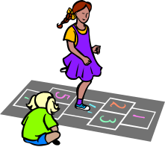

1. A balanced lifestyle includes:

_______________________________________________________________
_______________________________________________________________
_______________________________________________________________
_______________________________________________________________
_______________________________________________________________

2. A balanced lifestyle is important because:

_______________________________________________________________
_______________________________________________________________
_______________________________________________________________
_______________________________________________________________
_______________________________________________________________

3. Four ways I can improve my lifestyle are:

_______________________________________________________________
_______________________________________________________________
_______________________________________________________________
_______________________________________________________________
_______________________________________________________________

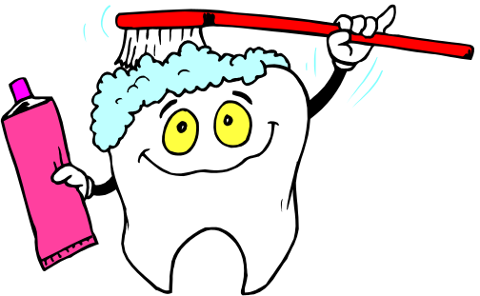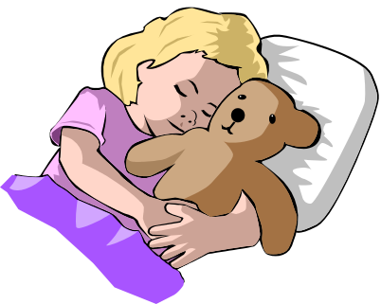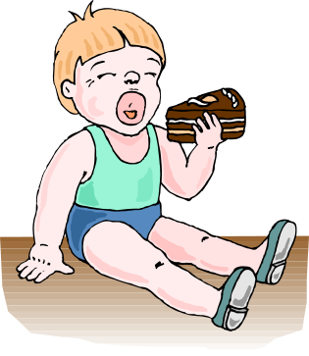

Lesson 4 What is physical activity?

Enduring Understandings | Outcomes | Indicators
E.2. A balanced lifestyle of physical activity and nutrition is an essential part of who we are.  E.3 As we are created in the image and likeness of God we accept responsibility for community and personal health by participating in physical activity. | ALS2.6 Discusses the relationship between regular and varied physical activity and health  COS2.1 Uses a variety of ways to communicate with and within groups  DMS2.2 Makes decisions as an individual and as a group member  V4 Increasingly accepts responsibility for community and personal health | - Identifies the activities people participate in to maintain an active lifestyle  - Participate in class discussions and brainstorming activities.  - Considers health and skill-related benefits of physical activity  - Values the need to pursue healthy lifestyles
KidsMatter SEL Focus: Major - Responsible Decision Making – Analysing situations;
Self-Management - Goal setting
Suggested Learning Experiences
TW: As a class, students brainstorm and record the different ways to be active. Each person should be allowed sufficient leisure activities to develop all aspects of their life, gifts and talents. Teacher should ensure that the discussion includes more than just organised sports, eg riding a bike, gardening, walking the dog, walking to the shop or school, riding a skateboard, surfing, swimming etc.

TW: Using the What is Physical Activity? teacher fact sheet, introduce and discuss the meaning of the terms:
- physical activity
- exercise
- fitness

Teacher uses What are the benefits of physical activity? fact sheet to discuss the terms ‘health benefits’ and ‘skill benefits’. Discuss How do our values influence our participation in physical activity?

Students set a personal goal based on the list they devised earlier to increase/improve their level of physical activity. Students record weekly physical improvement in these goals in their homework diary.

In small groups, students use the list they devised earlier, of physical activities in which they participate. Students classify these activities according to health or skill-related benefits using the What Are The Benefits Of Physical Activity? Sheet (A3 size). Some activities will be listed in more than one category.

Groups share their charts with the class and justify their classification of activities.

As a whole class, discuss the meaning of the saying ‘A healthy mind and healthy body’.
Resources  - Cardboard or butchers paper and textas  - What Are The Benefits Of Physical Activity? Activity made into A3 size for each group  - What is Physical Activity? teacher fact sheet  - http://www.healthykids.nsw.gov.au/topics/2098.html/GettingActive |  |  | Assessment  Student work samples of retrieval chart

Teacher Fact Sheet

Physical activity can mean different things to different people.
TW: As we are created in the image and likeness of God we accept responsibility for personal health by participating in physical activity.

Physical Activity | Is any activity where we are active and need energy to perform it, eg exercise, sport, leisure activities and household activities (gardening, vacuuming), walking the dog.
Exercise | Is a type of physical activity to help people get fit. Exercise helps people to lose weight, improve muscle tone/strength, improve fitness and energy, reduce stress. It is planned and done regularly.
Physical Fitness | Is what you get out of doing physical activity. Being fit can help you in two ways:  1. Health benefits – stronger heart, better breathing/respiration, better flexibility, more energy, stronger muscles, a healthy weight (not obese), improved confidence or self esteem, more friends, etc.  2. Skill benefits – improved agility, balance, speed, power, coordination and reaction time.

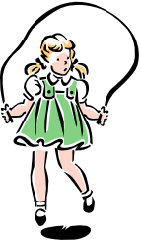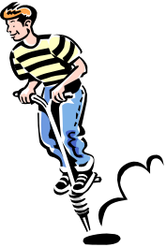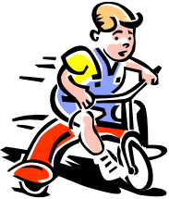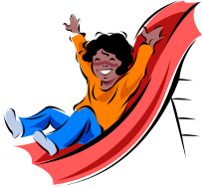

Catholic Values/Beliefs: We are called to live life to the full. A balanced lifestyle that includes physical activity enables us to do this and is an essential part of who we are. As we are created in the image and likeness of God we accept responsibility for personal health by participating in physical activity.

Select six (6) physical activities. Place an ‘X’ in the column if there is a benefit from doing that activity.

Physical Activity | Health Benefits |  |  |  |  | Skill Benefits
Physical Activity | Healthy Body | Self Esteem | Fun | Friends | Fitness | Balance | Speed | Power | Coordination | Reaction Time
Eg Riding my bike | X |  | X |  | X | X | X |  | X | X

Lesson 5 What is accumulated physical activity?

Enduring Understandings | Outcomes |  | Indicators
E.2. A balanced lifestyle of physical activity and nutrition is an essential part of who we are. | ALS2.6 Discusses the relationship between regular and varied physical activity and health  INS2.3 Makes positive contributions in group activities  COS2.1 Uses a variety of ways to communicate with and within groups  V4 Increasingly accepts responsibility for community and personal health |  | - Identifies the activities people participate in to maintain an active lifestyle  - Creates a log of activity and discusses patterns of participation  - Participates in developing class definitions  - Values the need to pursue healthy lifestyles
Suggested Learning Experiences

TW: We are called to live life to the full. We have a duty to care for our whole selves, e.g. mental, social, physical, cultural and spiritual.

As a class, define the term ‘accumulated’. Discuss ways to accumulate activity. Students identify ‘incidental exercise’ that could accumulate to a minimum of 30 minutes per day.

Students predict the total amount of time they spend on physical activity throughout the week.

In small groups, students reflect and complete the Physical Activity Diary Activity for the week.

Discuss how you could improve/maintain your participation in physical activity in a week. What other activities would you like to learn?

HOME TASK: Students plan and devise 3 questions to survey their parents and carers about their participation in physical activity, eg
- What physical activities do you participate in?
- How many minutes of physical activity do you do each day/week?
- How do you feel about physical activity?
- What influences the types of physical activity you do?
- Has this changed over time and with age?
Students share and review their collected data.

Resources  - Physical Activity Diary Activity  - Calculator |  | Assessment  Teacher observation of student contribution to class discussion relating to predicted minutes of physical activity

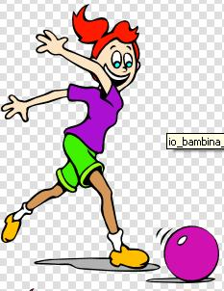

Day of the Week | Activities | Time Spent on Activity  Mins/Hours | Daily Time Total
Best Daily Total = |  | Weekly Total =

Lessons 6 and 7 What are the long term effects of physical activity?

Enduring Understandings | Outcomes |  | Indicators
E.1. We have a responsibility to make wise decisions about our lifestyle choices to ensure health and well being  E.2. A balanced lifestyle of physical activity and nutrition is an essential part of who we are  E.3 As we are created in the image and likeness of God we accept responsibility for community and personal health by participating in physical activity | ALS 2.6 Discusses the relationship between regular and varied physical activity and health  COS2.1 Uses a variety of ways to communicate with and within groups  V5 Willingly participates in regular physical activity |  | - Identifies effects of physical activity on specific body systems.  - Communicates ideas through drama.  - Appreciates the need to participate in physical activity
KidsMatter SEL Focus: Major - Responsible Decision Making – Analysing situations
Suggested Learning Experiences

Students participate in a minor game/relay such as Pair tag, Chain tag, Red rover, Stuck in the mud, Giant’s treasure.

Students record how their bodies responded to the physical activity games (the short-term effects), eg hot, sweaty, puffed, refreshed, healthy, strong, fit, powerful, happy, tired, stretched.

In small groups, students are allocated a body system and research the long term effects of exercise on the body, eg circulatory system, respiratory system, muscular system. Using the information from the fact sheet Effects of Physical Activity on the Body, and teacher reference material, students use the Jigsaw Activity and form expert groups. Expert groups report back their findings to their home group on their selected body system. http://www.teachers.ash.org.au/jmresources/systems/body.html

OR

Students script a short play that depicts the long term effects of exercise on their body system. Students create props such as balloons for lungs, crepe paper streamers intertwined for blood vessels, a pump for a heart, drawings of body organs. The class may like to present their play for the school assembly.

Students could present this information on a chart for the classroom wall labelled Body Systems and Physical Activity.
Resources  - Craft materials  - Effects of Physical Activity on the Body Fact Sheet  - Teacher reference material on body systems |  | Assessment  Teacher observation of student contribution to scripted play Body system research topic

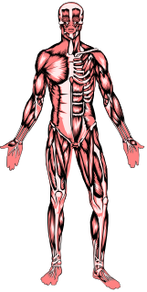
BODY SYSTEM | EFFECTS OF EXERCISE
Circulatory System: consists of blood, the heart and blood vessels. It is the transport system for the body and delivers oxygen and nutrients to all parts of the body and removes carbon dioxide and wastes. | Circulation is improved, resting heart rate is slower, working heart rate is higher, blood pressure is lower.
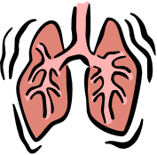Respiratory System: consists of the mouth, nose, lungs, ribs, bronchioles and diaphragm. Breathing is the main function of this system. Breathing is the process by which air is moved in and out of the lungs. It is controlled by the brain. | Lungs grow stronger and can exercise for greater amounts of time without getting puffed. When resting time between breaths is longer, breaths are deeper.
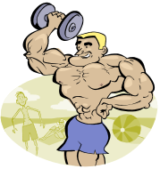Muscular System: consists of over 600 muscles in the body. The role of muscles is to contract. When the muscles contract, the body is able to move. | Muscles become firm, toned and more shapely, muscles can work for longer periods of time without getting tired, muscle strength improves over time.

DID YOU KNOW?
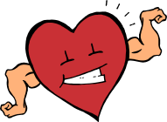Other Benefits of Physical Activity:  - Better weight control  - Less stress  - Better social life – friends  - Better flexibility  - More energy | The Heart: is a muscular pump that keeps the blood circulating through the body. It is slightly larger than a clenched fist and is the shape of a large pear. The heart beats about 100,000 beats per day. In one day the heart can pump about 12,000 litres of blood, which is enough to fill a small petrol tanker.
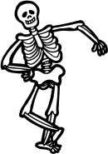Everyone: should be active for 30 minutes each day – ideally seven days a week – to gain health benefits. | Skeletal System: consists of 206 bones. It provides a frame for the body and protects vital organs. It works with the muscles to help the body move.

Lesson 8 What is healthy eating?

Enduring Understandings | Outcomes | Indicators
E.1. We have a responsibility to make wise decisions about our lifestyle choices to ensure health and well being.  E.3 As we are created in the image and likeness of God we accept responsibility for community and personal health by participating in physical activity | ALS2.6 Discusses the relationship between regular and varied physical activity and health  HS2.12 Discusses the factors influencing personal health choices  DMS2.2 Makes decisions as an individual and as a group member  V4 Increasingly accepts responsibility for community and personal health | - Describes how healthy eating influences health  - Explains the need for good nutrition  - Considers individual diets and ranks them as healthy or unhealthy  - Values the need to pursue healthy lifestyles
KidsMatter SEL Focus: Major - Self Management -Goal setting; Minor - Responsible Decision Making –Analysing situations; Responsible Decision Making - Problem Solving
Suggested Learning Experiences
As a class, discuss what are the two major choices we make everyday about the foods we eat, eg What foods do we eat and How much do we eat? Everyday we are faced with choices about the foods we eat. Obesity and lifestyle diseases such as heart disease, cancer and diabetes can be linked to poor eating habits. It is important to have good information about what is healthy eating as this influences the choices and decisions we make about what we eat and how much.
Useful website – http://www.healthykids.nsw.gov.au/topics/2015.html

TW: In groups, discuss what influences your food choices, eg. family, individual choices, money, types of foods available, information about what are healthy and unhealthy foods, your concern/value for health, time it takes to prepare food, advertising. We are also influenced by our responsibility towards our gift of life, to make good choices that promote healthy eating.

Students use the Healthy Food Plate Activity and write down the foods in the appropriate section of the plate that they would eat on a typical day. Display the completed food plates and rank them from healthiest to unhealthiest. Explain your ranking. Students can use the Pyramid, http://teamnutrition.usda.gov/resource/mpk_close.pdf and the teacher fact sheet to analyse their diet. How did your daily diet rank?

Students compare their diet to the healthy eating pyramid and set a weekly goal to incorporate a balanced eating plan. This will be recorded in their diary and complement physical goal setting.

The homework activities will focus on improving nutrition over the last 3 weeks of the Term/Unit.
Using the Body Weight Activity, discuss:
- the relationship between Food Eaten (intake) and Food Used (expenditure) through activity and metabolism and its effect on body weight.
- the meaning of kilojoule, nutrient, metabolism and obesity. This information can be found inside the pyramid at the above website

In small groups discuss:
- why are so many Australian children overweight? (eg sedentary lifestyle, playing on the computer, playstation and TV, high fat diet, not enough physical activity). Years ago we referred only to adults as having a sedentary lifestyle; now some children have sedentary lifestyles. As a result child obesity and overweight children has increased to 30% and childhood diabetes has also increased.

- The worksheet from www.nutritionaustralia.org/Food_Facts/Fact_Sheets/about%20_the_healthy_eating_pyramid.asp
- what can a person do to reduce their weight? (eg follow a healthy eating plan, eat a variety of foods, especially fresh fruits and vegetables (including legumes), bread (especially wholegrain), rice pasta and other grain products, eat moderate amounts of fish, lean meat, poultry and reduced fat dairy products, limit fat intake, especially saturated fat (animal products), increase dietary fibre (found in plant foods only), limit alcohol intake, do regular physical activity.

To maintain good health (and weight) you should do 30 minutes of moderate exercise on most days. This can be accumulated by doing 10 minute bouts of exercise. Remember, you only have to do physical activity regularly, not seriously. This can include walking, swimming, dancing and gardening. You will need to do activity for periods of longer than 30 minutes if you want to lose weight.

Discuss where an overweight person can go to get help, eg doctor, nutritionist, hospital, local community health centre.

Resources  - Body Weight Activity  - Healthy Food Plate Activity  - Australian Guide to Healthy Eating Food Plate  - www.nutritionaustralia.org/Food_Facts/Fact_Sheets/about%20_the_healthy_eating_pyramid.asp  - Australian Guide to Healthy Eating Teacher Fact Sheet  - Game – Mypyramid blast off at http://teamnutrition.usda.gov/resource/game/BlastOff_Game.html |  |  | Assessment  Student work sample of Body Weight Activity

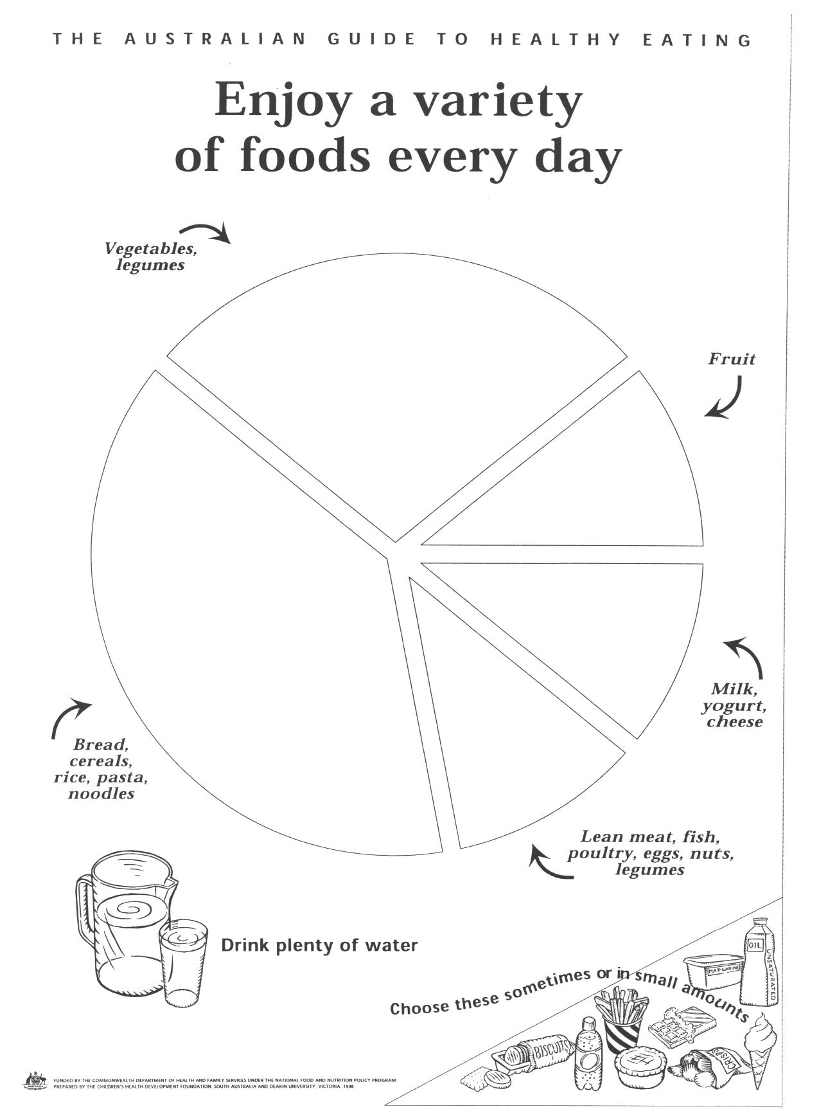

Reproduced from: Commonwealth Department of Health and Family Services (1998) The Australian Guide to Healthy Eating.
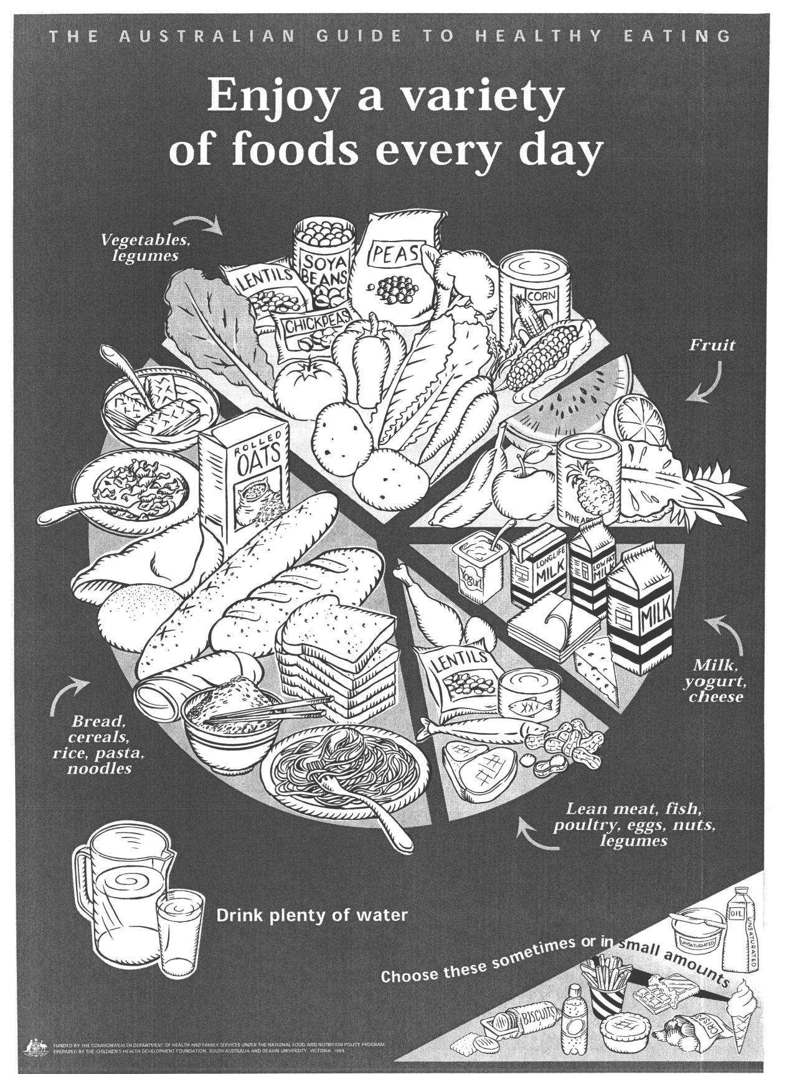

Reproduced from: Commonwealth Department of Health and Family Services (1998) The Australian Guide to Healthy Eating.

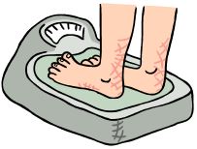

It‘s a Balancing Act!

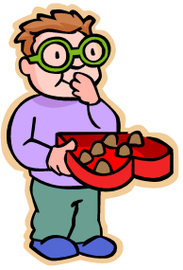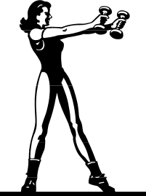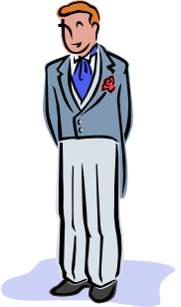

Food Eaten  Food used  + | Food used  Food eaten  + | Food eaten Food used  +
Weight Increases | Weight Decreases | Weight is Balanced

What we do and what we eat affects our weight. The food we eat is sometimes called food intake. Food is used by the body during physical activity and for metabolism. Metabolism is the chemical process inside the body that converts food into energy.

Did you know?
- A kilojoule is a metric measure of the energy value in food. Children 4–7 years need 6400-8300 kilojoules per day and 8–11 year olds need 7700-9800 kilojoules per day.
- A nutrient is the chemical substance in food that nourishes the body in a certain way.
- Obesity is a health condition where a person has too much body fat. In Australia over 25% of children are either overweight or obese. This is because they have low physical activity levels and a high fat diet.
- A third of children under 12 years do not eat any fruit or fruit products.
- 1 in 5 children do not eat any vegetables or vegetable products.

Why are so many Australian children overweight?
_____________________________________________________________________
_____________________________________________________________________
What can a person do to reduce their weight?
_____________________________________________________________________
_____________________________________________________________________
Where can an overweight person get help?
_____________________________________________________________________
_____________________________________________________________________
Lesson 9 How does advertising affect my food choices?

Enduring Understandings | Outcomes |  | Indicators
E.3 As we are created in the image and likeness of God we accept responsibility for community and personal health by participating in physical activity | PHS2.12 Discusses the factors influencing personal health choices  DMS2.2 Makes decisions as an individual and as a group member  V4 Increasingly accepts responsibility for community and personal health |  | - Explains the need for good health practices  - Considers advertising techniques used to influence people  - Values the need to pursue healthy lifestyles
KidsMatter SEL Focus: Minor - Responsible Decision Making – Assuming personal responsibility
Suggested Learning Experiences
Students record a list the food advertisements that are aired on TV during an agreed timeslot and then categorise them as healthy and unhealthy foods. OR

Students brainstorm food adverts and categorise into unhealthy/healthy. Teacher displays magazine pictures of food. As a class, discuss the techniques used by companies to promote foods and to influence your choice to try it, eg looks good, tastes good, saves time, associated with beautiful people, famous people use it, colourful, fresh, fast – quick and easy.

In groups, students design and create a healthy food advertisement poster or powerpoint presentation. Include in the poster the dietary guidelines for children to encourage healthy choices.

The Dietary Guidelines for Children and Adolescents
- Encourage and support breastfeeding
- Children need appropriate food and physical activity to grow and develop normally.
- Enjoy a wide variety of nutritious foods.
- Eat plenty of breads, cereals, vegetables (including legumes) and fruits.
- Low fat diets are not suitable for young children.
- Encourage water as a drink. Alcohol is not recommended for children.
- Eat only a moderate amount of sugars and foods containing added sugars.
- Choose low salt foods.
OR
Students interview the school canteen manager. What type of foods are the most popular? Why do students choose these? How do you choose what foods to sell? How do you advertise and market different food products? How do values influence our food choices? Students prepare an information report on the school canteen interview. They need to include recommendations for healthy choices of food.
TW: Responsible decision making takes place in a Christian context. We have a responsibility to promote our health by making wise decisions based on Gospel values. Our responsibility towards our gift of life is to make lifestyle choices that ensure health and well being.
Resources  - Magazine pictures of food  - Powerpoint  - Craft materials  - School Canteen Manager and menu  - http://www.healthykids.nsw.gov.au/topics/2098.html/Getting Active/ www.nutritionaustralia.org/Food_Facts/Fact_Sheets/about%20_the_healthy_eating_pyramid.asp |  | Assessment  Student work sample of healthy food advertisement or Information report written after interviewing the school canteen manager.

How Does Advertising Affect My Food Choices?

Catholic Values/Beliefs: We have a responsibility to promote our health by making wise decisions based on Gospel values. Our responsibility towards our gift of life is to make lifestyle choices that ensure health and well being.

Student: __________________________________________________________
Healthy Food Advertisement or School Canteen Information Report

This task provides students with the opportunity to demonstrate their standard of achievement of the following outcomes:
Outcomes | Indicators | Working towards | Achieved with support | Achieved
PHS2.12 Discusses the factors influencing personal health choices | Explains the need for good health practices
DMS2.2 Makes decisions as an individual and as a group member | Considers advertising techniques used to influence people
TASK:
In groups, students design and create a healthy food advertisement poster/powerpoint/photostory. Include in the poster the dietary guidelines for children. OR
Students interview the school canteen manager. What type of foods are the most popular? Why do students choose these? How do you choose what foods to sell? How do you advertise and market different food products? Students prepare an information report.

Lesson 10 How does health and physical activity change with age?

Enduring Understandings | Outcome |  | Indicators
E.1. We have a responsibility to make wise decisions about our lifestyle choices to ensure health and well being.  E.2. A balanced lifestyle of physical activity and nutrition is an essential part of who we are. | ALS2.6 Discusses the relationship between regular and varied physical activity and health  INS2.3 Makes a positive contribution in group activities  V4 Increasingly accepts responsibility for community and personal health  V5 Willingly participates in regular physical activity |  | - Identifies the activities people participate in to maintain an active lifestyle  - Participates in group discussions about changes to health and physical activity with age  - Values the need to pursue healthy lifestyles  - Recognises the value of lifelong commitment to regular physical activity
Suggested Learning Experiences

Teacher displays 3 pictures – a young child, an adult and an elderly person. Students brainstorm the types of physical activities that each person may do and record these on the board in 3 columns.

Students review:
- How does physical activity contribute to a healthy lifestyle?
- How does health and physical activity change with age?

In small groups, students complete the How does health and physical activity change with age? Activity. Photocopy this activity onto an A3 sheet. Magazines may be used to illustrate the group’s response.

Students share their responses with the class and discuss, ‘What factors can influence our health and physical activity?’ eg, family, culture, values and beliefs, friends, interests/hobbies, weather, leisure time, money, transport, facilities, specific health needs – swimming for asthma, walking for a healthy heart.

Teacher reviews the enduring understandings and the outcomes of the unit with the class and students reflect on their understanding and achievement of these. Students think about other related questions or big ideas that individuals, the community and the government may need to think about and plan for in the future?

TW: We have a responsibility to promote our health by making wise decisions based on Gospel values.
Life is a precious gift entrusted to us by God. People should be allowed sufficient leisure to cultivate all aspects of Human life and their gifts and talents.

Resources  - Pictures of a child, an adult and an elderly person  - How does health and physical activity change with age? Activity and Teacher Fact Sheet  - Magazines with health/physical activity pictures |  | Assessment  Student responses to How does health and physical activity change with age?

Teacher Fact Sheet

Person | What does this group think about their health? | How is this group physically active?
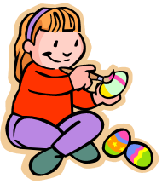Child  0-12 years | - They usually don’t think about their health  - Health habits are being developed  - If they get sick parents care for them  - The don’t think about the benefits of healthy eating and physical activity | - A range of activities, eg tennis, soccer, netball, basketball, t-ball, dance, cricket, football, etc.  - It is usually fun, with friends and active  - They do physical activities a few times a week and are keen to learn new skills
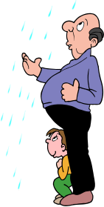Adult  40-59 years | - Usually concerned about their health. They understand the importance of a healthy lifestyle  - Get regular medical checks by the doctor  - They talk to friends about their health and diseases such as cancer, diabetes and heart disease. | - Gym, walking, bush walking  - Often less physical activity because they work and look after a family  - Physical activities are usually related to children’s activities or family and social events  - Some people plan for exercise into their weekly diary.
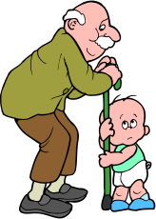Aged person  60-85 years | - Keeping healthy is a priority  - Can suffer from diseases/illnesses because they are getting older  - Value the doctor’s advice and new medical treatments. | - Bowls, golf, walking, dance  - As people get older their type of physical activity is less active/energetic  - People retire from work  - Money and transport can influence how often they do physical activity.

What factors influence our health and physical activity?
_________________________________________________
_________________________________________________
_________________________________________________
_________________________________________________
_________________________________________________
_________________________________________________
_________________________________________________

Person | What does this group think about their health? | How is this group physically active?
Child
0-12 years
Adult
40-59 years
Aged person
60-85 years

What things influence our health and physical activity?
_________________________________________________
_________________________________________________
_________________________________________________
_________________________________________________
_________________________________________________
_________________________________________________
_________________________________________________

TEACHER REFLECTION - UNIT EVALUATION

Unsatisfactory
Satisfactory

Poor
Good

A. A. EVIDENCE
To what extent does the assessment evidence provide:
1. A valid and reliable measure of the targeted outcomes/enduring understandings?
2. Sufficient information to support inferences about each
student’s understanding/level of achievement?
3. Opportunities for students to demonstrate their understandings through authentic learning tasks?
B. LEARNING EXPERIENCES AND INSTRUCTION
To what extent did students:
1. Achieve the outcomes and the enduring understandings of the unit (the big ideas as opposed to basic facts and skills)?
2. Know where they were going and why (in terms of unit goals, requirements, and evaluative criteria)?
3. Deepen their knowledge and understanding of the outcomes & big ideas of the Unit (through inquiry, research, problem solving, and experimentation)?
4. Receive explicit instruction on the knowledge and skills needed to equip them for the required performances?
5. Have opportunities to rehearse, revise, and refine their work based on feedback?
6. Self-assess and set goals prior to the conclusion of the unit?

PTO

1. What did students learn? (What knowlege and skills did they learn to deepen their understanding of the outcomes/big ideas of the unit?)

2. How do you know what they learnt? (What evidence do you have to support your judgement?)

3. What would you refine to improve student learning outcomes?

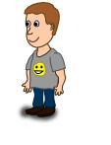
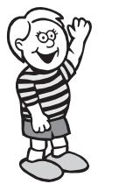
Student Unit Reflection
Stage 2

Note: Teacher reviews the enduring understandings and major outcomes of the unit with the class. Students reflect on their understanding and achievement of these and the teacher provides feedback on how to improve. Students can think about other related questions or big ideas that individuals, the family, the community, other agencies and the government may need to think about, plan for or research in the future?

Student Name: Class:
Unit/Topic:
One important thing I have learnt about/learnt to do during this unit is… | What I learnt will help me in my life because…
A question about this unit that I asked in class was… | Something that still puzzles me is...
A question about this unit that I asked at home was… | If I wanted to research more about this unit I could…
Something I am going to value/appreciate more about myself because of what I have learnt in this unit is… | I think the effort I put into my learning in this unit was: (Circle one number)  No effort 0 1 2 3 4 5 6 7 8 9 10 Most effort

