STREET SENSE

Updated January 2017
Stage: 1 | Unit Duration: 10 Lessons |  | Weeks 1 2 3 4 5 6 7 8 9 10 |  | Terms 1 2 3 4
Enduring Understandings  E.1 We have a responsibility to make informed choices about personal safety that ensure optimal health and well being.  E.2 Individuals are entrusted to be responsible for themselves and to show care and concern for others. |  |  | Essential Questions  - What is safe and unsafe behaviour for pedestrians, passengers and when you ride or skate?  - How can I keep myself and others safe in a range of traffic environments that can change?
Major Outcomes  Knowledge and Understanding  SLS1.13 Recognises that their safety depends on the environment and the behaviour of themselves and others.  Skills  COS1.1 Communicates appropriately in a variety of ways.  Values and Attitudes  V4 Increasingly accepts responsibility for personal and community health. |  |  | Lesson Overview  - When and where should I hold an adult’s hand? (E.1)  - How should I cross the road? (E.1, E.2)  - How can I keep safe in a carpark or driveway? (E.1)  4 – 6. How can I be a safe passenger? (E.1, E.2)  7. Where can I be safe on wheels? (E.1)  8-9. Why is wearing a helmet important? (E.1)  10. How can I help my friends and family to travel safely? (E.1, E.2)  KidsMatter SEL Focus:  Major: Responsible Decision Making - Assuming personal Responsibility; Self-Management - Goal setting  Minor: Responsible Decision Making - Problem-Solving
Contributing Outcomes

Knowledge and Understanding
IRS1.11 Identifies ways in which they communicate, cooperate and care for others.
Skills
PSS1.5 Draws on past experiences to solve familiar problems.
DMS1.2 Recalls past experiences in making decisions.

Catholic Dimension/Towards Wholeness (TW) (Also refer to overview of TW for this unit)
Interpersonal Relationships
Human beings find their true place within community; they grow towards maturity through the relationships they maintain. We all depend on each other and, as we mature, we grow in awareness of our responsibility for each other. Alone and isolated we cannot develop our gifts and live as God intended. Among family, friends, members of our peer group and others, we find our place as contributing members of society. It calls us all to enter freely into loving and forgiving relationships that are embedded in community, to develop such qualities as honesty, respect, empathy, openness and a commitment to equality.
Safe Living
This strand seeks to develop an ability and a commitment to act in ways that will protect self and others from harm. It emphasises respect for the human person and the development of a co-operative, caring society. Sound Christian decision-making is based on a well-formed conscience which draws inspiration from the life and teaching of Christ and from his Church. Within this strand, students learn to respect the rights of others and to value acceptance, tolerance, justice and personal freedom. They learn that their own decisions have consequences for themselves and others.
Foundation Statement
Students describe ways to keep healthy and safe and explore choices relating to food, sun protection and personal safety. They identify the appropriate use, administration and storage of medicines. Students describe strategies to stay safe at home, on and near roads, when travelling to and from school and near water. They recognise safe and unsafe environments and situations and suggest a range of protective strategies for dealing with unsafe situations.
Students describe similarities and differences between themselves and others. They describe different body parts and how the body grows and changes. Students explore different types of relationships and describe the skills needed to develop and maintain positive relationships. They identify the effects of bullying.
Suggested correlations with other KLAs  English  - Narrative Text (concept development)  - Personal Response  - Factual Recount  - Exposition  - Talking and Listening  Creative Arts  - Drama – Performing and Appreciating  - Visual Arts – Making and Appreciating  - Music – Listening and Performing |  |  | Science and Technology  - Information and Communication  - Investigating signs and symbols that give messages related to safety  - Designing/making posters to promote road safety  Mathematics  - Data - Data Representation  HSIE  - Social Systems and Structures  - Roles and responsibilities  - Safety rules within the community  - Purposes of rules
Technology

The following website has been selected to enhance various concepts being taught throughout this unit.
Safety Town Website
https://www.safetytown.com.au/

Subject Matter  Interpersonal Relationships  Relationships  - Recognising individual needs  - Permission and choices  Communication  - Expressing needs, wants and feelings  - Verbal and nonverbal  - Giving and receiving messages  Families  - Rights and responsibilities |  | Peers  - Cooperating  Groups  - Interacting with adults  Safe Living  Personal Safety  - Warning signals  - Safe/unsafe situations  - People who can help  - Responding to unsafe situations |  | Road Safety  - Pedestrian safety  - Places to cross safely  - Safe crossing procedures  - Passenger safety  - Use of a seatbelt  - Safe entry and exit from a vehicle  - Safety on wheels  - Wear a helmet
Unit Evaluation  Sample teacher and student unit evaluations are included at the end of the unit. |  |  | Assessment  Assessment strategies are included throughout the unit.

An Overview of Towards Wholeness (TW) in the PDH Unit
Street Sense - Stage 1

Key God’s Word:

Take care of others. (Rm 12: 3-13) TW p.29

Do what is right. (Mt 6:8) TW p.31

God wants us to be safe and will protect us as we come and grow now and forever. (Ps 121: 5-8) TW p.41

Enduring  Understandings | Towards Wholeness  Beliefs and Values | Lesson Overview
E.1 We have a responsibility to make informed choices about personal safety that ensure optimal health and well being. | - Life is a precious gift entrusted to us by God. p.41 | 1. When should I hold an adult’s hand?  2. How should I cross the road?  3. How can I keep safe in a carpark or driveway?  4 – 6. How can I be a safe passenger?  7. Where can I be safe on wheels?  8-9. Why is wearing a helmet important?  10. How can I help my friends and family to travel safely?
E.2 Individuals are entrusted to be responsible for themselves and to show care and concern for others. | - We have a responsibility to protect and care for others. p.41  - A communal approach to safe living and the establishment of caring networks is essential for the provision of safe environments. p.41 | 2. How should I cross the road?  4 – 6. How can I be a safe passenger?  7. Where can I be safe on wheels?  10. How can I help my friends and family to travel safely?

Lesson 1 When and where should I hold an adult’s hand?

Enduring Understandings | Outcomes |  | Indicators
E.1 We have a responsibility to make informed choices about personal safety that ensure optimal health and well being. | SLS1.13 Recognises that their safety depends on the environment and the behaviour of themselves and others.  COS1.1 Communicates appropriately in a variety of ways.  IRS1.11 Identifies ways in which they communicate, cooperate and care for others.  V4 Increasingly accepts responsibility for personal and community health. |  | - Describes what is needed for them to travel to and from school safely  - Describes when and where they hold an adult’s hand  - Identifies people they can trust  - Values their health and safety and that of others
KidsMatter SEL Focus:Major - Responsible Decision Making - Assuming personal Responsibility
Suggested Learning Experiences
IMPORTANT: Teacher needs to register and log in to Safety Town website (ST). This site is used constantly throughout the unit. (See “How to Log in details”)

TW: Teacher Note - The ten lessons in this unit can all be related to the belief that life is a precious gift entrusted to us by God and that we take care of others and do what is right. It is important to emphasise this to the children wherever appropriate in the planned learning experiences.

Students read the ebook, Where's Banjo, Mum
Be sure to have students identify the Hold My Hand sign on page 1. Teacher highlights how holding a grown-up’s hand in any situation keeps us safe. Students describe where they have seen the Hold My Hand sign.

Hold a Grown-ups Hand Hooley Dooleys You Tube

As a class, complete the Worksheet Sentence matching. Prompt students with strategies for identifying sentence structure, e.g. full stop at the end.

Ask students what they do after school:
- Where do they wait to be picked up?
- Who picks them up after school?
- What do they do if their parent/carer is late?
- What do they do if it is raining?

Discuss school rules and procedures for pick up time at school:
- safe procedures for boarding a bus, e.g. waiting in line, letting passengers get off before boarding, remaining a step back from the kerb, holding a grown up's hand while waiting for the bus
- strategies to use when a grown-up’s hand isn’t available to hold, e.g. hold a stroller, shopping trolley, bag.

Ask students to recall procedures for safely crossing at pedestrian crossings, e.g. holding a grown up's hand, stopping and waiting a step back from the kerb, looking both ways, listening, waiting for vehicles to stop before walking, looking and listening for vehicles while walking straight across the road.

Discuss the dangers of moving vehicles. Focus on reversing vehicles.
- How do you know a car is reversing? Can a driver see you?
- What do you need to look out for when walking in a car park?
- What can you do to stay safe when walking through a carpark?
- What do you need to look out for when walking on a footpath, crossing a driveway?

Students trace around a hand, cut out the hand shape and fold fingers over. On the fingers, identify and record the names of several adults with whom they regularly travel and/or who could be ‘hand holders’.

Home Task:
Students draw or use a photo of themselves on the take home note Always hold my hand. Use the word bank to complete the sentences, e.g.
- I always need to hold a grown-up’s hand when I am crossing the road, walking on the footpath or in a carpark.
- When I am walking, I need to look and listen for cars, trucks, buses, people on bikes, other pedestrians, vehicles moving in driveways and carparks, etc.

Resources  - Safety Town Website  https://www.safetytown.com.au/  - How to login details  - Ebook, Where's Banjo, Mum  - A3 copy of Worksheet Sentence matching  - Pencils  - Paper  - Coloured art paper  - Scissors  - Home Task: Always Hold my Hand |  | Assessment  Student response in discussion relating to when hand holding is essential.

Registering for to Safety Town
It is quick and easy to register a Safety Town account. Go to http://www.safetytown.com.au and click the Enter option.
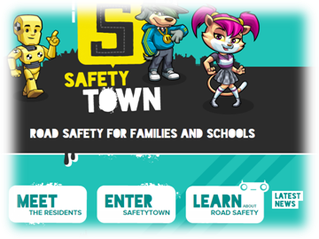

You will be taken to the Activities page. There is a Register option in the top right.
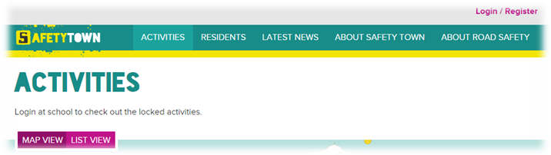

You must have an educational email address to register an account with Safety Town. If you don’t have one and think you should be eligible for an account please contact support@safetytown.com.au
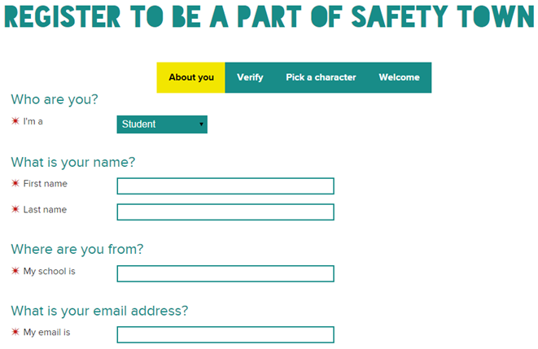

Enter all your details. When you select a school, start typing the name of your school and the list will be populated automatically as you type. Use the down arrows, or press the appropriate option. If you are a Home Schooler, please start typing that and you will see the ‘Home Schooler’ option. Road Traffic Safety educators should use ‘Transport’.
Your password must be at least six characters and contain an uppercase, lowercase, number, and special character.

NOTE: You must choose carefully whether you are a student, teacher or parent as this option cannot be changed after your account is created

When all your information is provided, click the Next, Verify button. You will be informed that a verification email has been sent to your email address.
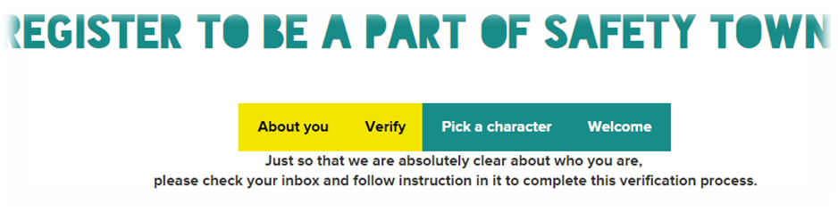
You will now receive an email from Safety Town with an activation link. Copy this link and paste it into your browsers address. You will be taken to the Login page.
One logged in, you have the option of choosing a Safety Town character, name and hobby. The Safety Town character you choose will introduce you to each activity when you choose to do them.
Congratulations and welcome to the Safety Town family. Explore and have fun while learning all about Road Safety!

Logging in to Safety Town

To log into Safety Town go to http://www.safetytown.com.au and click the Enter option.
You will be taken to the Activities page. There is a Login option in the top right.

You are now at the Login page. You can also bookmark this URL to take you directly to the Login page: https://www.safetytown.com.au/accounts/auth/login/
You will be taken to your Profile page.
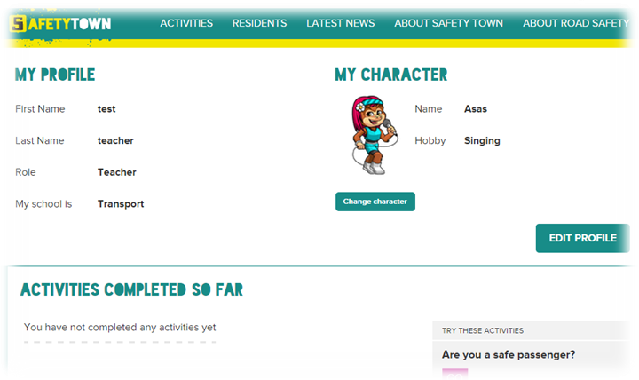
Use the navigation bar at the top to access the site, or try one of the suggested activities that appear on the right side of the page.

Lesson 2 How should I cross the road?

Enduring Understandings | Outcomes |  | Indicators
E.1 We have a responsibility to make informed choices about personal safety that ensure optimal health and  well being.  E.2 Individuals are entrusted to be responsible for themselves and to show care and concern for others. | SLS1.13 Recognises that their safety depends on the environment and the behaviour of themselves and others.  COS1.1 Communicates appropriately in a variety of ways.  PSS1.5 Draws on past experiences to solve familiar problems.  V4 Increasingly accepts responsibility for personal and community health. |  | - Describes what is needed for them to travel to and from school safely  - Describes how they use their senses when crossing the road  - Follows basic safety procedures  - Values their health and safety and that of others
KidsMatter SEL Focus: Major - Responsible Decision Making - Assuming personal Responsibility
Suggested Learning Experiences
Ask students to recall a recent pedestrian journey.

Students fold a piece of paper into four squares. In each square they record their answer to the following questions:
- Where did you walk to?
- Who did you walk with?
- How did you cross the road safely?
- What type of crossing did you use?

TW: Teacher raises the students’ awareness of the responsibility we have to protect and care for ourselves and others. We can do this by learning and practising safe actions near roads.

Students share their responses and discuss the variety of walking journeys and crossings used.
Discuss with students the safe behaviours they use when crossing roads, e.g. hold a grown-up’s hand or arm, cross at pedestrian lights, crossings, refuges or overhead bridges.

Display photos from the Pedestrian safety image gallery and ask students:
- What makes this a safer place to cross the road?
- Can you see any dangers or risks in this scenario? What are they?
- How could this scenario be made safer?
Walk around the school to observe different crossing facilities.
Ask students:
- Where are the safest places to cross the road around our school?
- What makes these places safer choices?
- Are they always safe places to cross? Why?
Discuss:
- Who helps us to be a safe pedestrian? e.g. crossing supervisor, parents, carers, teachers
- What road crossing facilities should we use to be safe? Why?
- Why is it important to hold an adult’s hand when crossing the road?
- What might make a crossings less safe?, e.g. time of day, weather conditions, different drivers
- Why is it important to watch what you are doing and not be distracted? e.g. not wear earphones or play ball games

Display the Safety Town Poster: Use a Safe Place to Cross the Road. Use this as a focal point to create a Mind Map of safe places to cross e.g. use a pedestrian crossing, cross at the lights, look both ways, hold an adult’s hand.

Resources  - Safety Town Website  https://www.safetytown.com.au/  - How to login details  - Safety Town Posters:  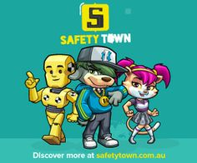  - Safety Town Website : Pedestrian safety image gallery |  | Assessment  Student‘s responses during creation of Mind Map.

Lesson 3 How can I keep safe in a carpark or driveway?

Enduring Understandings | Outcomes |  | Indicators
E.1 We have a responsibility to make informed choices about personal safety that ensure optimal health and well being. | SLS1.13 Recognises that their safety depends on the environment and the behaviour of themselves and others.  COS1.1 Communicates appropriately in a variety of ways.  V4 Increasingly accepts responsibility for personal and community health. |  | - Identifies the dangers present in car parks and driveways and appropriate safe practices  - Explains the particular dangers in carparks and driveways  - Values their health and safety and that of others
KidsMatter SEL Focus: Minor - Responsible Decision Making - Problem-Solving
Suggested Learning Experiences
Students identify the different carparks with which they are familiar.
- What can we see in a car park? (brake lights, cars, trucks, people, trolleys)
- What can we hear in a car park? (engines reversing, horns, warning tones on trucks, doors closing, people talking, babies crying, footsteps, trolleys)
- What do we hold in a car park? (a grown-up’s hand, trolley, stroller, pram, bag)

Students discuss features of their driveways or their friends’ driveways.
- What can we see in a driveway? (brake lights, reverse lights, toys, bikes, pets)
- What do we do in a driveway? (drive forward/backward, ride bike, rollerblade)
- What should we watch or listen for in a driveway? (reverse lights, driver’s face, engine noise, safe place to stand where driver can see you)

TW: Teacher revises the belief that we have a responsibility to protect and care for ourselves and others. We can do this by learning and practising safe actions near roads and driveways.

Brainstorm the best ways to keep safe in a car park or on a driveway and illustrate their safe ideas.
Click on Hands are for Holding when you’re crossing the road text. Scroll down to “Hands are for Holding by the Hooley Dooleys”. Click on the “Display the front cover…” link.
Read and ask students:
- Who can you see on the cover of this book?
- What are they doing?
- Where are they?
- Why do you think they are holding hands?
Share the text with the audio. Ask students to share their experiences of holding hands:
- Whose hand do you hold when crossing the road?
- Why do you need to hold an adult's hand when crossing the road?
- Why do you need to hold an adult's hand when walking near the road?
- What can you hold onto if you can't hold an adult's hand?
As a class, students create actions for pp.13 -16 of the song “In the Carpark”, using the lyrics supplied on the next page. Perform. If time substitute words for “In the Driveway” and repeat.
HOME TASK: Draw a picture of their driveway at home with their parents and mark on it ‘safety spots’ to stand when a car is moving in or out. Share illustrations of safe practices with parents.

Resources  - Safety Town Website  https://www.safetytown.com.au/  - Hands are for Holding when you’re crossing the road text  - RTA. NSW. (2001). Move Ahead With Street Sense. Stage 1. Sydney: RTA. In the Car Park song – words. p.47. Alternate words following. |  | Assessment  Student responses in discussion relating to car park and driveway hazards

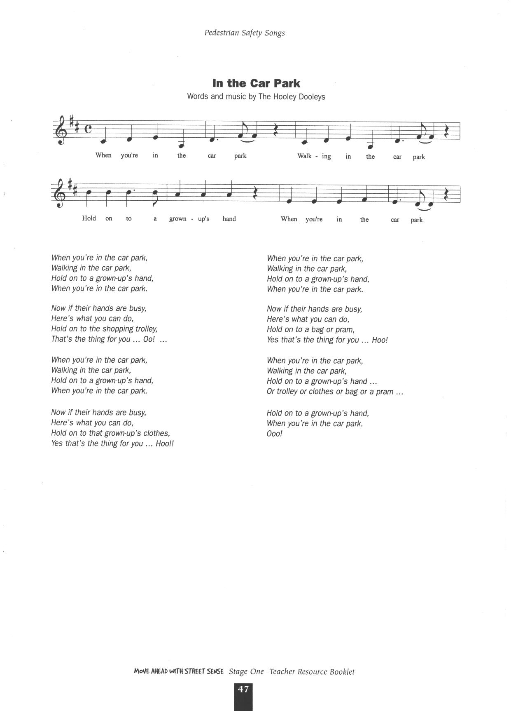
Reproduced from: Roads and Traffic Authority NSW (2000) Move Ahead with Street Sense Stages 1-3.

DRIVEWAY SONG
(To the Tune of In the Car Park by the Hooley Dooleys)

When you’re in the driveway
Playing in the driveway
Watch out for a moving car
When you’re in the driveway.

Now if a car is coming
Here’s what you can do
Move onto your ‘safety spot’
That’s the thing for you… Ooo…

When you’re in the driveway
Playing in the driveway
Watch out for a moving car
When you’re in the driveway.

Now if your spot’s not there
Here’s what you can do
Look into the driver’s face
That’s the thing for you… Ooo…

When you’re in the driveway
Playing in the driveway
Watch out for a moving car
When you’re in the driveway.

Now when you’re finished playing,
Here’s what you must do
Put away your bikes and skates
That’s the thing for you… Ooo…

When you’re in the driveway
Playing in the driveway
Watch out for a moving car
And move and look and pack up the toys

Watch out for a moving car
When you’re in the driveway.
Ooo!

Lesson 4 -6 How can I be a safe passenger?

Enduring Understandings | Outcomes |  | Indicators
E.1 We have a responsibility to make informed choices about personal safety that ensure optimal health and well being. | SLS1.13 Recognises that their safety depends on the environment and the behaviour of themselves and others.  COS1.1 Communicates appropriately in a variety of ways.  V4 Increasingly accepts responsibility for personal and community health. |  | - Explains why we need to wear the correct restraint  - Describes the correct way to wear a seatbelt  - Identifies the safest door to use when getting out of a car  - Follows basic safety procedures  - Appreciates the need for safe practices
KidsMatter SEL Focus: Major - Responsible Decision Making - Assuming personal Responsibility
Suggested Learning Experiences

Ask students:
- Why is it important to sit in a car seat or booster seat?
- Why you can’t use the seatbelt like a grown-up?
- Why do you think a grown-up should always check that you’re buckled up properly?

Class explore and complete the EveryBODY buckle up epuzzle. Click on Start Activity.
As students complete each stage of the epuzzle, discuss how the different systems of the body work together to keep us alive.
Students locate their own collar bones, ribs, hips and pelvis. Ask students to give reasons why their seatbelt fits across these parts of their body.
Discuss and reinforce with students:
- collar bones, hips, pelvis, ribs are strong bones
- use the right car seat for their age and size
- stay in a booster seat until they are at least 145cm
- a grown-up should check car seats and seatbelts are fitted correctly
- make sure seatbelts are worn correctly whether awake or asleep
sit in the back seat
Students complete the worksheet and share with parents and carers.

TW: Remind students that wearing a seatbelt is one responsible way we can protect and care for ourselves. (Phrases could include: Make the safe choice…. Be responsible….Protect yourself….Care for your body…..)

Learn the words to Twinkle Twinkle Seatbelt Song and/or I’m a Little Seatbelt. (See resource sheets).
Everybody do this and Rain is Falling Down – optional)

Display the poster: “Always buckle up your seatbelt” Safety Town poster.

Show images of child restraints and booster seats from childcarseats.com.au or the Passenger safety image gallery.
Ask students to identify the:
- type of seat they use
- type of seat siblings use

In pairs, students write a list of reasons why they need to buckle up in the correct seat for their age and size. Construct a class list of reasons.

Highlight that the Safety Door sticker is on the window next to the passenger in the epuzzle.
Ask:
- Why do you think it is called the Safety Door?
- Why is the kerb side the safest place to get in and out of a vehicle?
Attach the Safety Door stickers to the EveryBODY buckle up worksheet to send home to parents and carers. These may be ordered from:
https://www.bspg.com.au/javelin/customer/home?ows_portal=1

Sing this song, Buckle Up and Be Safe by The Wiggles (0:31sec). It reinforces all safety messages.
http://roadsafety.transport.nsw.gov.au/campaigns/theyre-counting-on-you/child-car-seats.html

Play a game of Heads or Tails to consolidate this information. Choose statements at random from the Heads to Tails - behaviours in cars statements.

As a class, discuss activities to play safely when travelling by car on a long trip. Students may have ideas they use in their family. Discuss responses. Teachers may choose to use the following questions as a guide:
- Is the activity fun?
- Will it disturb the driver?
- Can it be done while they are buckled up?
- Does it involve a lot of movement?
- Can everyone in the car participate?
- What might happen if we are too noisy and move too much as passengers?

TW: Teacher poses the question “How does playing these types of activities show a responsibility for protecting yourself and others in the car?” Bring the students to the understanding that drivers need to be able to concentrate on the road, the cars around them and keep their passengers safe. Driving is a complex task, therefore it is the passenger’s responsibility to behave sensibly when travelling in a car.

In groups students develop role plays based on the following scenarios. In the role play, students must devise effective strategies to address safety issues, showing responsibility in protecting and caring for themselves and others.
- Your best friend comes to your house every Friday and as your dad starts the car to drive off, your friend only pretends to do up the seatbelt. You know this is unsafe. What would you do?
- You are travelling in the car and your friend starts to put an arm out the window to feel the wind. You know that your friend could be injured by doing this. What would you do?
- You go shopping with your parents and have lots of shopping bags. Your mum starts to put them in the back seat with you. You know things like shopping should be stored safely in the boot. You know that if they aren’t, they might move around the car and hit people. What would you do?
- Your family is talking about going on holidays and taking the dog with them in the car. The dog doesn’t have a seat belt and you know that everyone needs to be buckled up in a car. What would you do?

TW: We all have a responsibility in protecting and caring for themselves and others.

Students present their role plays and discuss the safety strategies developed.

Resources  - Safety Town Website  https://www.safetytown.com.au/  - www.kidsandtraffic.mq.edu.au for more songs and other resources  - Art paper and materials for posters  - Worksheet EveryBODY buckle up (this can also be generated at the end of the epuzzle)  - Images of child restraints and booster seats from childcarseats.com.au  - Passenger safety image gallery  - Buckle Up and Be Safe by The Wiggles Song  - Heads to Tails - behaviours in cars statements. |  | Assessment  Student work samples of student’s safety worksheet, “EveryBODY Buckle Up”.

TWINKLE TWINKLE SEATBELT SONG
(To the tune of “Twinkle Twinkle Little Star”)

Twinkle twinkle little star
You must wear a seatbelt in the car.
If your Mum or Dad forgets,
You must call out “Not ready yet!”
Twinkle Twinkle little star
You must wear a seatbelt in the car!

Twinkle twinkle little star
You must wear a seatbelt in the car.
If your Mum or Dad forgets,
Over your shoulder, across you lap,
Click, Clack, Front n Back
Twinkle Twinkle little star
You must wear a seatbelt in the car!

I’M A LITTLE SEATBELT
(Sung to the tune of I’m a little teapot)
http://roadsafety.transport.nsw.gov.au/downloads/littleseatbelt.mp3

I’m a little seatbelt in the car,
Before we go driving near or far,
Time to slip your arms in, there you are,
Buckle me up, now you’re a star.
I’m a little seatbelt in the car,
Before we go driving near or far,
Time to slip your arms in, there you are,
Buckle me up, now you’re a star.

EVERYBODY DO THIS
http://roadsafety.transport.nsw.gov.au/downloads/everybodydothis.mp3
Everybody do this, do this, do this
Everybody do this,
Just like me!
Everybody click-clack, click-clack, click-clack,
Everybody click-clack,
Front and back!
Everybody click-clack, click-clack, click-clack,
Everybody click-clack,
Girls and boys!
Everybody click-clack, click-clack, click-clack,
Everybody click-clack,
Mums and dads!
Everybody click-clack, click-clack, click-clack,
Everybody click-clack,
In the car!

WHEN WE’RE WALKING
(Sung to the tune of Rain is falling down)
http://roadsafety.transport.nsw.gov.au/downloads/whenwalking.mp3

Hold a grown up’s hand, hold a grown up’s hand,
When we’re walking to the shops,
Hold a grown up’s hand.
Hold a grown up’s hand, hold a grown up’s hand,
When we’re walking near the cars,
Hold a grown up’s hand.
Hold a grown up’s hand, hold a grown up’s hand,
When we walk across the road,
Hold a grown up’s hand.
Hold a grown up’s hand, hold a grown up’s hand,
When we walk across the road,
Hold a grown up’s hand.
Lesson 7 Where can I be safe on wheels?

Enduring Understandings | Outcomes |  | Indicators
E.1 We have a responsibility to make informed choices about personal safety that ensure optimal health and well being. | SLS1.13 Recognises that their safety depends on the environment and the behaviour of themselves and others.  DMS1.2 Draws on past experiences in making decisions.  V4 Increasingly accepts responsibility for personal and community health. |  | - Describes how to keep safe on wheels  - Identifies safe places to ride  - Predicts consequences of options in order to make decisions  - Values their health and safety and that of others
KidsMatter SEL Focus: Major - Responsible Decision Making - Assuming personal Responsibility

Suggested Learning Experiences
TW: Life is a precious gift entrusted to us by God.
Click on Safety on Wheels Image Gallery. Scroll down to places. Students view images of where students ride. Discuss what makes different places unsafe and safe places to ride.
In small groups, students look at different images. Ask students to discuss the safety features of the location they’ve been given. Is it a safe place to ride? Why or why not?
Discuss why students should:
- ride away from roads, driveways and carparks
- have adult supervision while riding
- choose fenced areas to ride, away from cars.
Label sections of the room as 1, 2, 3 and 4.
Read each scenario aloud and the related four choices. Students choose their option and move to the number indicating their choice. Students share opinions with students who chose the same option, then with students who chose different options. Offer students the opportunity to change their position after hearing other responses.
Discuss:
- What are the possible dangers in each situation? Why?
- How could the dangers be managed to make the situation safer?
- How would you feel if you have to tell others that you don’t want to do what they’ve suggested?
- What might they say to you about your choice?
- How would you feel? Would it change your decision?
Brainstorm the places in the local area where it would be suitable to ride a bike/scooter or skate. Draw yourself riding or skating in one of these places.
Resources  - Safety on Wheels Image Gallery  - Safe Places to Ride Scenarios |  | Assessment  Student’s drawing of safe place to ride or skate.
Lesson 8 - 9 Why is wearing a helmet important?

Enduring Understandings | Outcomes |  | Indicators
E.1 We have a responsibility to make informed choices about personal safety that ensure optimal health and well being. | SLS1.13 Recognises that their safety depends on the environment and the behaviour of themselves and others.  DMS1.2 Draws on past experiences in making decisions.  V4 Increasingly accepts responsibility for personal and community health. |  | - Describes how to keep safe on wheels  - Identifies protective equipment for cycling and skating  - Predicts consequences of options in order to make decisions  - Values their health and safety and that of others
KidsMatter SEL Focus:Major - Responsible Decision Making - Assuming personal Responsibility
Suggested Learning Experiences
TW: Life is a precious gift entrusted to us by God.

Students predict what would happen to an egg or a piece of fruit if dropped on a hard surface.
Students feel their heads and discuss what would happen if their head hit a hard surface.
Ask students:
- Why is your brain important? What does it do?
- Why do you need to protect it?
- In what ways do you protect it?
- How does a helmet protect your head?

Invite a community member to talk to the class about helmets. Invitees may include a police officer, doctor, nurse, bike or sports shop owner.
Ask them to speak about:
- the importance of wearing a helmet
- selecting a helmet that fits correctly
- Australian standards approved helmets
- checking bicycles and scooters for correct size
- maintenance of bicycles and wheeled devices
- safety features that must be on bicycles, e.g. brakes, bell, reflector

OR

Display a selection of helmets or view the appropriate pictures from the Image Gallery. Discuss the safety features, e.g. hard outer shell, helmet liner, straps, buckle, ventilation holes, standards-approved label.
Ask students:
Why do you think helmets are this shape?
Why does the foam shell have a hard outer cover?
Is the colour a safety feature? Why?
Which colours might be more easily seen?

Play a game of Heads down, thumbs up.
Students put heads down on the desk with their eyes closed and listen to the statements read from the worksheet. Students respond with their thumbs up if they agree or with their thumbs down if they disagree. Discuss responses.

As a class view Always Wear a Helmet – Start Activity

Complete the two statements on the Always wear a helmet worksheet.

Teacher organises an ill-fitted helmet. Students help fix it so it is efficient and safe to wear.

HOME TASK:
Share the How to Fit a Helmet instructions on Always wear a helmet worksheet with their parents.

Resources  - Safety Town Website  https://www.safetytown.com.au/  - Image Gallery  - Heads down, thumbs up  - Always wear a helmet worksheet |  | Assessment  Student work samples related to the Cycling Helmet activity.

Lesson 10 How can I help my friends and family to travel safely?

Enduring Understandings | Outcomes |  | Indicators
E.1 We have a responsibility to make informed choices about personal safety that ensure optimal health and wellbeing.  E.2 Individuals are entrusted to be responsible for themselves and to show care and concern for others. | SLS1.13 Recognises that their safety depends on the environment and the behaviour of themselves and others.  COS1.1 Communicates appropriately in a variety of ways.  DMS1.2 Draws on past experiences in making decisions.  V4 Increasingly accepts responsibility for personal and community health. |  | - Describes a range of safety strategies to use in response to unsafe behaviour or situations  - Expresses feelings about safe and unsafe situations  - Predicts consequences of options in order to make a decision  - Values their health and safety and that of others
KidsMatter SEL Focus: Major - Responsible Decision Making - Assuming personal Responsibility; Self-Management - Goal setting
Suggested Learning Experiences

TW: Life is a precious gift entrusted to us by God.

Students complete the Let’s go riding activity.

In the activity, they make choices about riding on behalf of the character. Choices include:
If students make an unsafe choice, they revisit the different screens to improve the safety of the rider.
When all of the safest choices have been made, students are able to download and print the Let’s go riding worksheet. The worksheet can be taken home to share the safety on wheels messages with parents and carers.

At the end of the activity, teacher generates Let’s go riding worksheet. You might print a copy of each of vehicle sheet, as the children’s modes of transport may vary. Then children could complete them in groups.

Groups share their statements with class.

Show videos two to five to the class (Length: 31, 32, 34, and 37 sec)
Discuss strategies that would make the scenario safer.
Ask the following questions:
- What would you do?
- What would you do to make it safer?
- What were the possible dangerous endings?
Children share a time when they have experienced or seen unsafe behaviours.

Students choose one scenario and develop a picture/poster of how to keep safe in that situation.
Resources  - Safety Town Website  https://www.safetytown.com.au/  - Let’s go riding activity |  | Assessment  Picture/poster of how to keep safe in dangerous situations.

Safety With Your Helmet
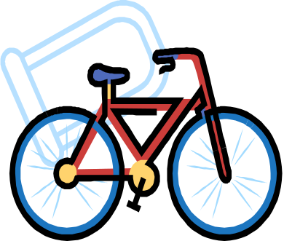
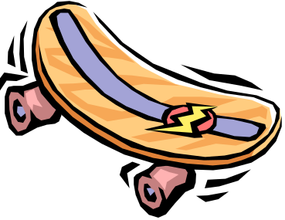

Student: _________________________________________________

Catholic Values/Beliefs:
- Take care of others. (Rm 12: 3-13)
- Do what is right. (Mt 6:8)
- God wants us to be safe and will protect us as we come and grow now and forever. (Ps 121: 5-8)

This task provides students with the opportunity to demonstrate their standard of achievement of the following outcomes:
Outcomes | Indicators | Working towards | Achieved with support | Achieved
SLS1.13 Recognises that their safety depends on the environment and the behaviour of themselves and others. | Explains the importance of wearing a helmet
DMS1.2 Draws on past experiences in making decisions. | Recalls reasons for the importance of wearing a helmet.
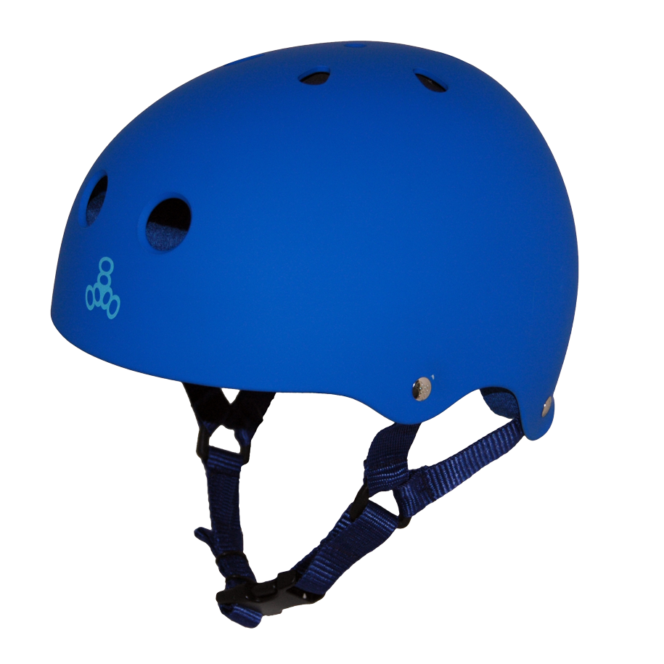
TASK

Complete the two statements on the Always wear a helmet worksheet.
I wear my helmet when…
I wear my helmet because…
HOME TASK:
Share the How to Fit a Helmet instructions on Always wear a helmet worksheet with their parents.

TEACHER REFLECTION - UNIT EVALUATION

Unsatisfactory
Satisfactory

Poor
Good

A. A. EVIDENCE
To what extent does the assessment evidence provide:
1. A valid and reliable measure of the targeted outcomes/enduring understandings?
2. Sufficient information to support inferences about each
student’s understanding/level of achievement?
3. Opportunities for students to demonstrate their understandings through authentic learning tasks?
B. LEARNING EXPERIENCES AND INSTRUCTION
To what extent did students:
1. Achieve the outcomes and the enduring understandings of the unit (the big ideas as opposed to basic facts and skills)?
2. Know where they were going and why (in terms of unit goals, requirements, and evaluative criteria)?
3. Deepen their knowledge and understanding of the outcomes & big ideas of the Unit (through inquiry, research, problem solving, and experimentation)?
4. Receive explicit instruction on the knowledge and skills needed to equip them for the required performances?
5. Have opportunities to rehearse, revise, and refine their work based on feedback?
6. Self-assess and set goals prior to the conclusion of the unit?

PTO
1. What did students learn? (What knowlege and skills did they learn to deepen their understanding of the outcomes/big ideas of the unit?)

2. How do you know what they learnt? (What evidence do you have to support your judgement?)

3. What would you refine to improve student learning outcomes?

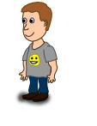
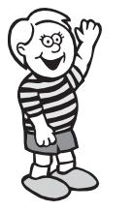
Student Unit Reflection
Stage 1

Student Name: Class:
Unit/Topic:
Completing the sentences below will help me to remember the important things I learnt about how to keep myself happy, healthy and safe.

One of the things I enjoyed learning about was….  ☺ | One thing I would change is….  ☹
  One thing I enjoyed sharing with my family at home was…. | What things from this unit would I like to learn more about?

The rating I give myself for how hard I worked in this unit is…

1 2 3 4 5

