STREET SENSE
Stage: 1 | Unit Duration: 10 Lessons |  | Weeks 1 2 3 4 5 6 7 8 9 10 |  | Terms 1 2 3 4
Enduring Understandings  E.1 We have a responsibility to make informed choices about personal safety that ensure optimal health and well being.  E.2 Individuals are entrusted to be responsible for themselves and to show care and concern for others. |  |  | Essential Questions  - What is safe and unsafe behaviour for pedestrians, passengers and when you ride or skate?  - How can I keep myself and others safe in a range of traffic environments that can change?
Major Outcomes  Knowledge and Understanding  SLS1.13 Recognises that their safety depends on the environment and the behaviour of themselves and others.  Skills  COS1.1 Communicates appropriately in a variety of ways.  Values and Attitudes  V4 Increasingly accepts responsibility for personal and community health. |  |  | Lesson Overview  - When and where should I hold an adult’s hand? (E.1)  - How should I cross the road? (E.1, E.2)  - How can I keep safe in a carpark or driveway? (E.1)  - Why should I wear a seatbelt correctly? (E.1)  - How should I enter and exit a car? (E.1)  - What rules apply to different modes of transport? (E.1)  - How can I cooperate with the driver on a long journey? (E.2)  - How can I help my friends and family to travel safely? (E.1, E.2)  9. Where can I be safe on wheels? (E.1)  10. Why is wearing a helmet important? (E.1)  KidsMatter SEL Focus:  Major: Responsible Decision Making - Assuming personal Responsibility; Self-Management - Goal setting  Minor: Responsible Decision Making - Problem-Solving
Contributing Outcomes

Knowledge and Understanding
IRS1.11 Identifies ways in which they communicate, cooperate and care for others.
Skills
PSS1.5 Draws on past experiences to solve familiar problems.
DMS1.2 Recalls past experiences in making decisions.

Catholic Dimension/Towards Wholeness (TW) (Also refer to overview of TW for this unit)
Interpersonal Relationships
Human beings find their true place within community; they grow towards maturity through the relationships they maintain. We all depend on each other and, as we mature, we grow in awareness of our responsibility for each other. Alone and isolated we cannot develop our gifts and live as God intended. Among family, friends, members of our peer group and others, we find our place as contributing members of society. It calls us all to enter freely into loving and forgiving relationships that are embedded in community, to develop such qualities as honesty, respect, empathy, openness and a commitment to equality.
Safe Living
This strand seeks to develop an ability and a commitment to act in ways that will protect self and others from harm. It emphasises respect for the human person and the development of a co-operative, caring society. Sound Christian decision-making is based on a well-formed conscience which draws inspiration from the life and teaching of Christ and from his Church. Within this strand, students learn to respect the rights of others and to value acceptance, tolerance, justice and personal freedom. They learn that their own decisions have consequences for themselves and others.
Foundation Statement
Students describe ways to keep healthy and safe and explore choices relating to food, sun protection and personal safety. They identify the appropriate use, administration and storage of medicines. Students describe strategies to stay safe at home, on and near roads, when travelling to and from school and near water. They recognise safe and unsafe environments and situations and suggest a range of protective strategies for dealing with unsafe situations.
Students describe similarities and differences between themselves and others. They describe different body parts and how the body grows and changes. Students explore different types of relationships and describe the skills needed to develop and maintain positive relationships. They identify the effects of bullying.
Suggested correlations with other KLAs  English  - Narrative Text (concept development)  - Personal Response  - Factual Recount  - Exposition  - Talking and Listening  Creative Arts  - Drama – Performing and Appreciating  - Visual Arts – Making and Appreciating  - Music – Listening and Performing |  |  | Science and Technology  - Information and Communication  - Investigating signs and symbols that give messages related to safety  - Designing/making posters to promote road safety  Mathematics  - Data - Data Representation  HSIE  - Social Systems and Structures  - Roles and responsibilities  - Safety rules within the community  - Purposes of rules
Technology

The following websites have been selected to enhance various concepts being taught throughout this unit. Most of the sites listed can be linked to more than one of the lessons being taught. Teachers may like to add them to the school intranet site.
- http://www.rapsforkids.com.au/games.php
- http://shop.mynrma.com.au/game/game_content.html
- http://www.cornwall.gov.uk/default.aspx?page=14784
- http://www.zebracrossinggame.com/
- http://www.getstreetwise.com/gsw/quiz01.htm
- http://www.safetymatters.renault.co.uk/kids/?sub=games
- http://www.mesaaz.gov/police/kids/pdf/safe_trip_home_maze.pdf
- http://www.dotolearn.com/games/safetygames/activity_sheets/activity_streetsafety.htm

Subject Matter  Interpersonal Relationships  Relationships  - Recognising individual needs  - Permission and choices  Communication  - Expressing needs, wants and feelings  - Verbal and nonverbal  - Giving and receiving messages  Families  - Rights and responsibilities |  | Peers  - Cooperating  Groups  - Interacting with adults  Safe Living  Personal Safety  - Warning signals  - Safe/unsafe situations  - People who can help  - Responding to unsafe situations |  | Road Safety  - Pedestrian safety  - Places to cross safely  - Safe crossing procedures  - Passenger safety  - Use of a seatbelt  - Safe entry and exit from a vehicle  - Safety on wheels  - Wear a helmet
Unit Evaluation  Sample teacher and student unit evaluations are included at the end of the unit. |  |  | Assessment  Assessment strategies are included throughout the unit.

Lessons 1-10 are adapted and reproduced with kind permission from: RTA. NSW. (2001) Move Ahead with Street Sense Stage 1. Sydney. RTA.

An Overview of Towards Wholeness (TW) in the PDH Unit
Street Sense - Stage 1

Key God’s Word:

Take care of others. (Rm 12: 3-13) TW p.29

Do what is right. (Mt 6:8) TW p.31

God wants us to be safe and will protect us as we come and grow now and forever. (Ps 121: 5-8) TW p.41

Enduring  Understandings | Towards Wholeness  Beliefs and Values | Lesson Overview
E.1 We have a responsibility to make informed choices about personal safety that ensure optimal health and well being. | - Life is a precious gift entrusted to us by God. p.41 | 1. When should I hold an adult’s hand?  2. How should I cross the road?  3. How can I keep safe in a carpark or driveway?  4. Why should I wear a seatbelt correctly?  5. How should I enter and exit a car?  6. What rules apply to different modes of transport?  8. How can I help my friends and family to travel safely?  9. Where can I be safe on wheels?  10. Why is wearing a helmet important?
E.2 Individuals are entrusted to be responsible for themselves and to show care and concern for others. | - We have a responsibility to protect and care for others. p.41  - A communal approach to safe living and the establishment of caring networks is essential for the provision of safe environments. p.41 | 2. How should I cross the road?  7. How can I cooperate with the driver on a long journey?  8. How can I help my friends and family to travel safely?

Lesson 1 When and where should I hold an adult’s hand?

Enduring Understandings | Outcomes |  | Indicators
E.1 We have a responsibility to make informed choices about personal safety that ensure optimal health and well being. | SLS1.13 Recognises that their safety depends on the environment and the behaviour of themselves and others.  COS1.1 Communicates appropriately in a variety of ways.  IRS1.11 Identifies ways in which they communicate, cooperate and care for others.  V4 Increasingly accepts responsibility for personal and community health. |  | - Describes what is needed for them to travel to and from school safely  - Describes when and where they hold an adult’s hand  - Identifies people they can trust  - Values their health and safety and that of others
KidsMatter SEL Focus:Major - Responsible Decision Making - Assuming personal Responsibility
Suggested Learning Experiences
TW: Teacher Note - The ten lessons in this unit can all be related to the belief that life is a precious gift entrusted to us by God and that we take care of others and do what is right. It is important to emphasise this to the children wherever appropriate in the planned learning experiences.
Teacher and students read the shared book Where’s Banjo, Mum? Students match their experiences with Jess’ experiences in the book. Teacher shows the Hold My Hand sign on the book’s first page. Teacher distributes photocopies of pages from the book and students identify other places where the Hold My Hand sign could be placed. Teacher highlights how holding a grown-up’s hand in any situation keeps us safe.

Students describe when and where they should hold a grown-up’s hand on their way to or from school and where they have seen the Hold My Hand sign. As an individual or as a class, students write and illustrate a recount of a journey to or from school. They draw a Hold My Hand sign on those pages of the sequence where they need to hold a grown-up’s hand.

Students trace around both hands, cut out the hand shapes and put them together and fold fingers over. On the fingers, identify and record the names of several adults with whom they regularly travel and/or who could be ‘hand holders’.

Resources  - RTA. NSW. (2001). Where’s Banjo, Mum? Book. Move Ahead With Street Sense. Stage 1. Sydney: RTA  - Pencils  - Paper  - Coloured art paper  - Scissors |  | Assessment  - Student response in discussion relating to when hand holding is essential.

Lessons 1-10 are adapted and reproduced with kind permission from: RTA. NSW. (2001) Move Ahead with Street Sense Stage 1. Sydney. RTA.
Lesson 2 How should I cross the road?

Enduring Understandings | Outcomes |  | Indicators
E.1 We have a responsibility to make informed choices about personal safety that ensure optimal health and  well being.  E.2 Individuals are entrusted to be responsible for themselves and to show care and concern for others. | SLS1.13 Recognises that their safety depends on the environment and the behaviour of themselves and others.  COS1.1 Communicates appropriately in a variety of ways.  PSS1.5 Draws on past experiences to solve familiar problems.  V4 Increasingly accepts responsibility for personal and community health. |  | - Describes what is needed for them to travel to and from school safely  - Describes how they use their senses when crossing the road  - Follows basic safety procedures  - Values their health and safety and that of others
KidsMatter SEL Focus: Major - Responsible Decision Making - Assuming personal Responsibility
Suggested Learning Experiences
Students list their senses and identify which senses assist us in crossing the road safely. Teacher promotes a discussion by asking when you cross the road:
- What sounds do you listen for? (vehicle engines getting louder/closer, vehicle horns)
- What do you look for? (vehicles approaching/driving by)
- Do you look for any safe pedestrian crossings/pedestrian lights to use to cross the road?
- Do you hold a grown-up’s hand?

TW: Teacher raises the students’ awareness of the responsibility we have to protect and care for ourselves and others. We can do this by learning and practising safe actions near roads, driveways and car parks.

Students brainstorm the safest places to cross a road. For example zebra crossing, straight section of the street or road, traffic lights.

Teacher introduces/revises the slogan, Stop, Look, Listen and Think. Children explain what each of the words of the slogan mean. Students draw a picture of themselves crossing the road safely and write the slogan Stop, Look, Listen and Think underneath their drawing.

OPTIONAL: Teacher may wish to film the school car part at drop off and pick up times and analyse the video during lesson 3.

HOME TASK: Children discuss Take Home Note C, Stop! Look! Listen! Think! with their parents.
Resources  - RTA. NSW. (2001). Move Ahead With Street Sense. Stage 1. Sydney: /RTA. Stop! Look! Listen! Think! Cards. page 54 and Take Home Note C Stop! Look! Listen! Think! p. 72-73  - Art paper  - Pencils |  | Assessment  Student‘s drawing of crossing the road safely.

Lessons 1-10 are adapted and reproduced with kind permission from: RTA. NSW. (2001) Move Ahead with Street Sense Stage 1. Sydney. RTA.
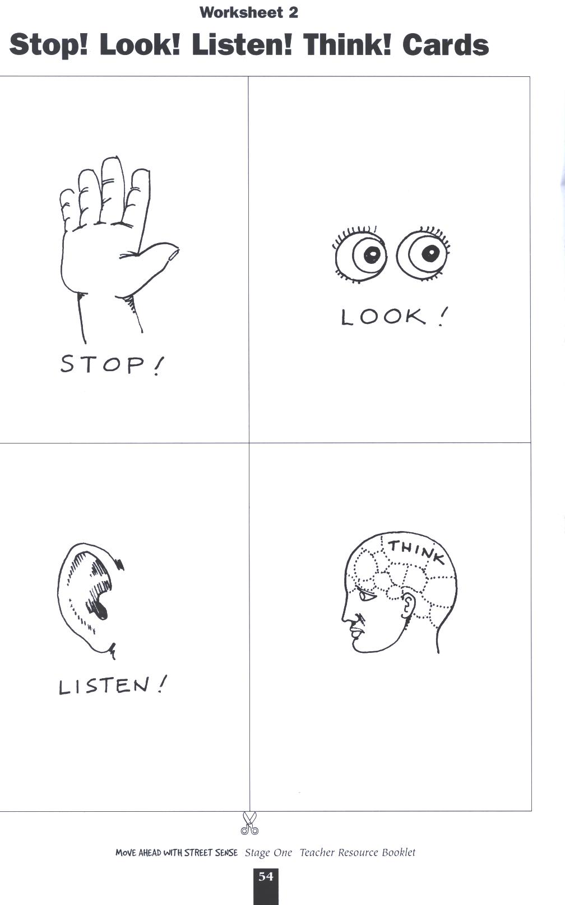

Reproduced from: Roads and Traffic Authority NSW (2000) Move Ahead with Street Sense Stages 1-3.

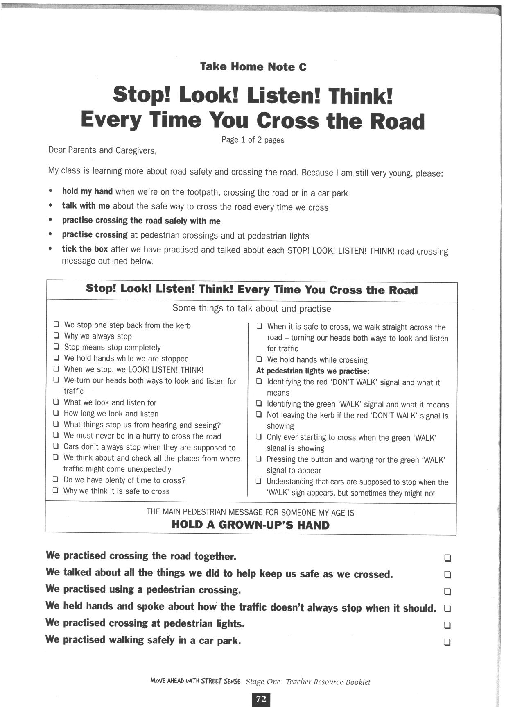
Reproduced from: Roads and Traffic Authority NSW (2000) Move Ahead with Street Sense Stages 1-3.
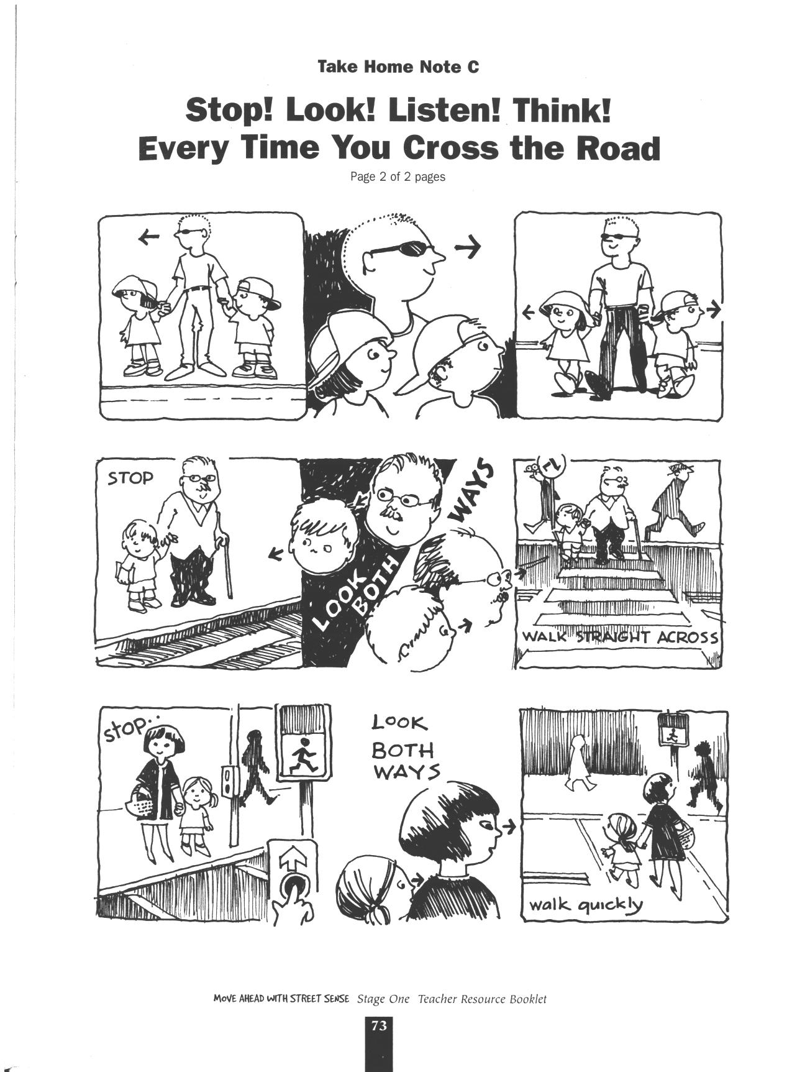

Reproduced from: Roads and Traffic Authority NSW (2000) Move Ahead with Street Sense Stages 1-3.
Lesson 3 How can I keep safe in a carpark or driveway?

Enduring Understandings | Outcomes |  | Indicators
E.1 We have a responsibility to make informed choices about personal safety that ensure optimal health and well being. | SLS1.13 Recognises that their safety depends on the environment and the behaviour of themselves and others.  COS1.1 Communicates appropriately in a variety of ways.  V4 Increasingly accepts responsibility for personal and community health. |  | - Identifies the dangers present in car parks and driveways and appropriate safe practices  - Explains the particular dangers in carparks and driveways  - Values their health and safety and that of others
KidsMatter SEL Focus: Minor - Responsible Decision Making - Problem-Solving
Suggested Learning Experiences
OPTIONAL: The class views the video of the school car park during drop off and pick up times and students list safe and unsafe practices from Lesson 2. Students identify the different carparks with which they are familiar.
- What can we see in a car park? (brake lights, cars, trucks, people, trolleys)
- What can we hear in a car park? (engines reversing, horns, warning tones on trucks, doors closing, people talking, babies crying, footsteps, trolleys)
- What do we hold in a car park? (a grown-up’s hand, trolley, stroller, pram, bag)

Students discuss features of their driveways or their friends’ driveways.
- What can we see in a driveway? (brake lights, reverse lights, toys, bikes, pets)
- What do we do in a driveway? (drive forward/backward, ride bike, rollerblade)
- What should we watch or listen for in a driveway? (reverse lights, driver’s face, engine noise, safe place to stand where driver can see you)

TW: Teacher revises the belief that we have a responsibility to protect and care for ourselves and others. We can do this by learning and practising safe actions near roads and driveways. Students identify and discuss what makes a car park or driveway unsafe for child pedestrians. They then brainstorm the best ways to keep safe in a car park or on a driveway and illustrate their safe ideas.

Students listen to and learn the words of the song In the Car Park. Teacher assists students to develop body percussion to accompany the song. Substitute words for ‘In the Driveway’ and repeat. Students discuss the range of alternatives suggested in the song for them to hold onto when a grown-up’s hand is occupied or unavailable.

HOME TASK: Draw a picture of their driveway at home with their parents and mark on it ‘safety spots’ to stand when a car is moving in or out. Share illustrations of safe practices with parents.

Resources  RTA. NSW. (2001). Move Ahead With Street Sense. Stage 1. Sydney: RTA. In the Car Park song – words. p.47. Alternate words following. |  | Assessment  Student responses in discussion relating to car park and driveway hazards

Lessons 1-10 are adapted and reproduced with kind permission from: RTA. NSW. (2001) Move Ahead with Street Sense Stage 1. Sydney. RTA.

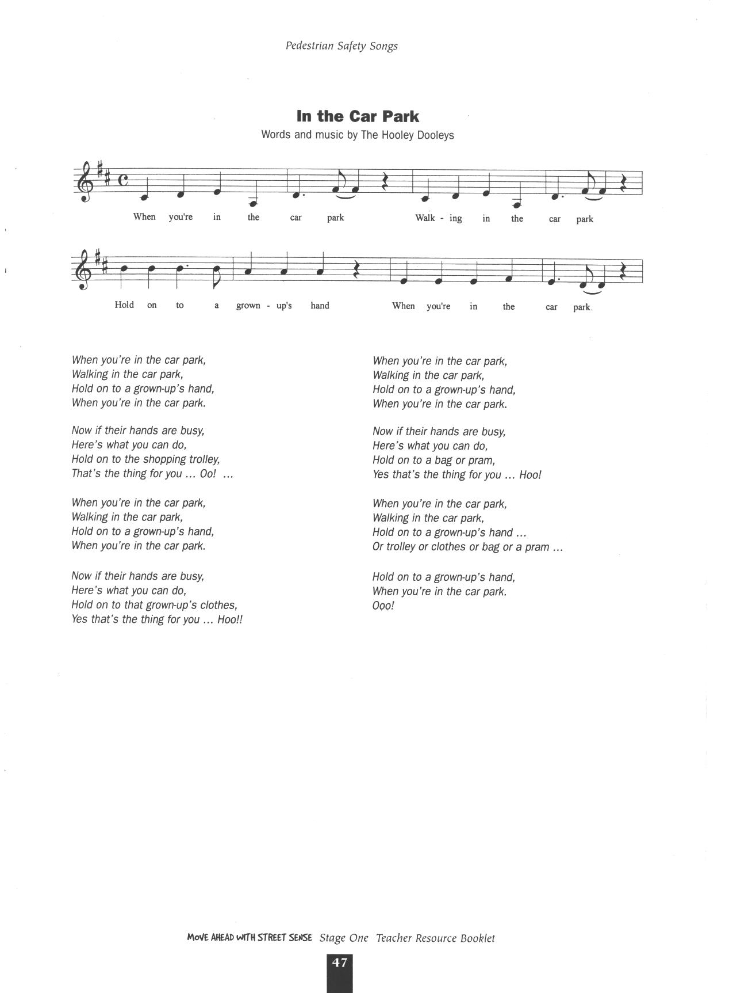
Reproduced from: Roads and Traffic Authority NSW (2000) Move Ahead with Street Sense Stages 1-3.

DRIVEWAY SONG
(To the Tune of In the Car Park by the Hooley Dooleys)

When you’re in the driveway
Playing in the driveway
Watch out for a moving car
When you’re in the driveway.

Now if a car is coming
Here’s what you can do
Move onto your ‘safety spot’
That’s the thing for you… Ooo…

When you’re in the driveway
Playing in the driveway
Watch out for a moving car
When you’re in the driveway.

Now if your spot’s not there
Here’s what you can do
Look into the driver’s face
That’s the thing for you… Ooo…

When you’re in the driveway
Playing in the driveway
Watch out for a moving car
When you’re in the driveway.

Now when you’re finished playing,
Here’s what you must do
Put away your bikes and skates
That’s the thing for you… Ooo…

When you’re in the driveway
Playing in the driveway
Watch out for a moving car
And move and look and pack up the toys

Watch out for a moving car
When you’re in the driveway.
Ooo!

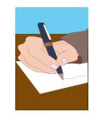
Driveway Safety – Parent Fact Sheet

Protect young children from off road injury - especially in home driveways.

Off road injury is most likely to happen to children under 3 years of age - they can easily get into the off road environment but don't yet know that they need to move out of the way of an approaching vehicle. Off road injury occurs on driveways, in car parks, on farms and private roads and involves cars or other vehicles.

Driveway injuries in children account for a significant proportion of paediatric pedestrian motor vehicle injuries & deaths in NSW. Figures from the New Children's Hospital, Westmead indicate that many of the children who were not killed (from March 1996 to December 1998) sustained severe and lasting physical & brain injuries. Parents, family members or friends are usually the drivers when children are injured off road.

Off road injuries often result from everyday incidents: -

- When a child is playing in an unfenced play area or in the street
- When a relative or family friend is driving off or returning home
- When the car is reversing
- When the driver has no idea that a child is behind the vehicle
- When the adult who is supervising the child is unaware that the child has slipped away.

Hold their hands or hold them close - even at home, young children always need an adult to be with them and keep them safe.

Lesson 4 Why should I wear a seatbelt correctly?

Enduring Understandings | Outcomes |  | Indicators
E.1 We have a responsibility to make informed choices about personal safety that ensure optimal health and well being. | SLS1.13 Recognises that their safety depends on the environment and the behaviour of themselves and others.  COS1.1 Communicates appropriately in a variety of ways.  V4 Increasingly accepts responsibility for personal and community health. |  | - Explains why we need to wear the correct restraint  - Describes the correct way to wear a seatbelt  - Appreciates the need to always wear a seatbelt or restraint
KidsMatter SEL Focus: Major - Responsible Decision Making - Assuming personal Responsibility
Suggested Learning Experiences

Students listen to The Seatbelt Song from Cassette 2 and develop actions. Alternatively, learn the words to Twinkle Twinkle Seatbelt Song and/or I’m a Little Seatbelt. (See resource sheets.)

Discuss why we always wear a seatbelt? What does ‘Click Clack Front ’n’ Back’ mean? Students identify restraints for children of different ages and sizes by examining Road Safety Photographs 1, nos 7, 8 and 9 or other pictures found in magazines. Students sort and label each picture with the correct restraint name and report to the class.

Discuss the correct way a seatbelt should fit. Using materials such as stockings, braids, masking tape and a chair, demonstrate how a seatbelt should fit properly. Discuss how different restraints might fit differently, e.g. baby capsule, child restraint: car seat/booster seat.

TW: Students design and prepare a safety poster to advertise the slogan ‘Click, Clack, Front ’n’ Back’. Remind students that wearing a seatbelt is one responsible way we can protect and care for ourselves. List some short phrases about responsible choices that will support the ‘Click, Clack’ slogans. (Phrases could include: Make the safe choice…. Be responsible….Protect yourself….Care for your body…..)

tudents develop a list of all the occupations where people have to wear a seatbelt to protect their body (For example truck driver, racing car driver, pilot, and astronaut) and discuss why these people would think it is important to buckle up.

Resources  - RTA. NSW. (2001). Move Ahead With Street Sense. Stage 1. Sydney: RTA. Seat belt song Cassette 2. p.49 and Road Safety Photographs 1. nos. 7-9.  - www.kidsandtraffic.mq.edu.au for more songs and other resources  - Art paper and materials for posters |  | Assessment  Student work samples of student’s safety poster advertising ‘Click, Clack, Front ’n’ Back’.

Lessons 1-10 are adapted and reproduced with kind permission from: RTA. NSW. (2001) Move Ahead with Street Sense Stage 1. Sydney. RTA.
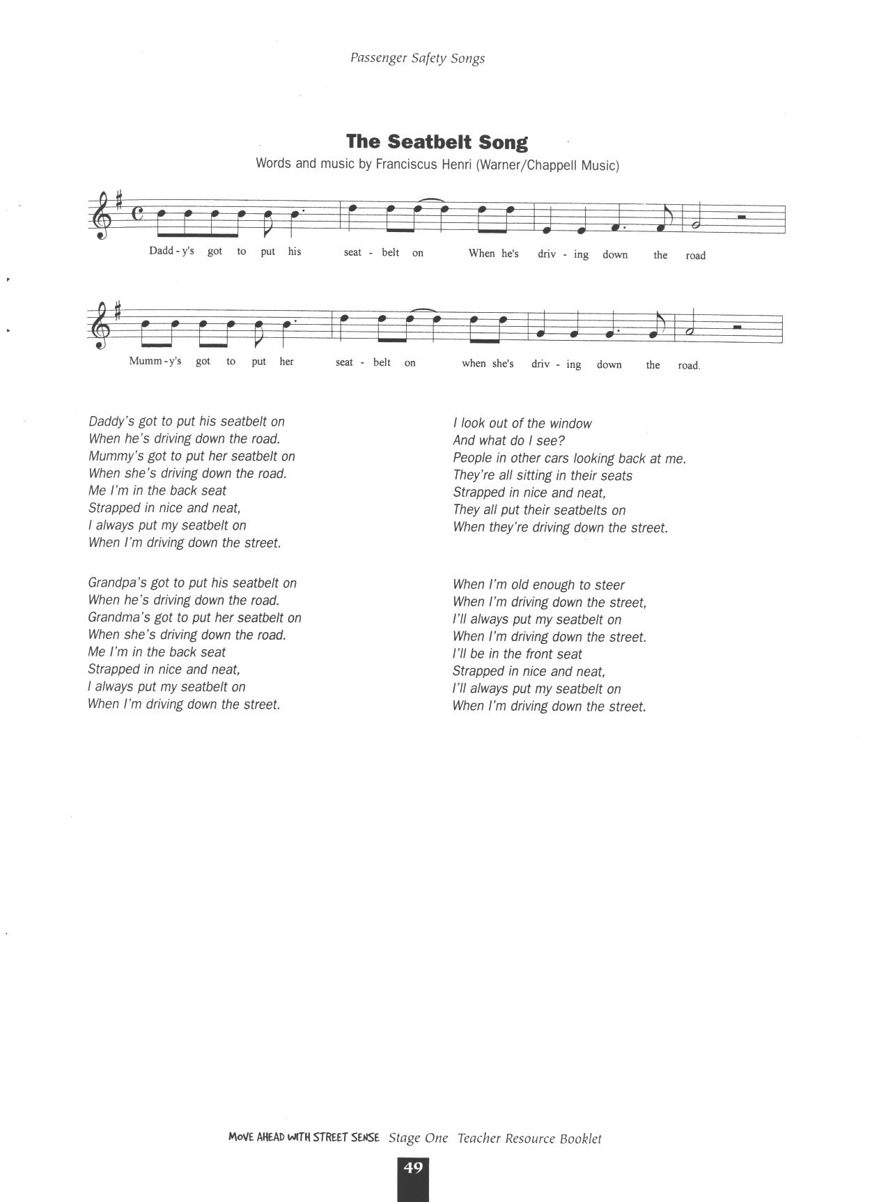

Reproduced from: Roads and Traffic Authority NSW (2000) Move Ahead with Street Sense Stages 1-3.

TWINKLE TWINKLE SEATBELT SONG
(To the tune of “Twinkle Twinkle Little Star”)

Twinkle twinkle little star
You must wear a seatbelt in the car.
If your Mum or Dad forgets,
You must call out “Not ready yet!”
Twinkle Twinkle little star
You must wear a seatbelt in the car!

Twinkle twinkle little star
You must wear a seatbelt in the car.
If your Mum or Dad forgets,
Over your shoulder, across you lap,
Click, Clack, Front n Back
Twinkle Twinkle little star
You must wear a seatbelt in the car!

http://www.rta.nsw.gov.au/roadsafety/downloads/littleseatbelt.mp3
http://www.rta.nsw.gov.au/roadsafety/downloads/whenwalking.mp3
http://www.rta.nsw.gov.au/roadsafety/downloads/everybodydothis.mp3

I’M A LITTLE SEATBELT
(Sung to the tune of I’m a little teapot)

I’m a little seatbelt in the car,
Before we go driving near or far,
Time to slip your arms in, there you are,
Buckle me up, now you’re a star.
I’m a little seatbelt in the car,
Before we go driving near or far,
Time to slip your arms in, there you are,
Buckle me up, now you’re a star.

EVERYBODY DO THIS
Everybody do this, do this, do this
Everybody do this,
Just like me!
Everybody click-clack, click-clack, click-clack,
Everybody click-clack,
Front and back!
Everybody click-clack, click-clack, click-clack,
Everybody click-clack,
Girls and boys!
Everybody click-clack, click-clack, click-clack,
Everybody click-clack,
Mums and dads!
Everybody click-clack, click-clack, click-clack,
Everybody click-clack,
In the car!

WHEN WE’RE WALKING
(Sung to the tune of Rain is falling down)

Hold a grown up’s hand, hold a grown up’s hand,
When we’re walking to the shops,
Hold a grown up’s hand.
Hold a grown up’s hand, hold a grown up’s hand,
When we’re walking near the cars,
Hold a grown up’s hand.
Hold a grown up’s hand, hold a grown up’s hand,
When we walk across the road,
Hold a grown up’s hand.
Hold a grown up’s hand, hold a grown up’s hand,
When we walk across the road,
Hold a grown up’s hand.
Lesson 5 How should I enter and exit a car?

Enduring Outcomes | Outcomes |  | Indicators
E.1 We have a responsibility to make informed choices about personal safety that ensure optimal health and well being. | SLS1.13 Recognises that their safety depends on the environment and the behaviour of themselves and others.  PSS1.5 Draws on past experiences to solve familiar problems.  V4 Increasingly accepts responsibility for personal and community health. |  | - Identifies the safest door to use when getting out of a car  - Follows basic safety procedures  - Appreciates the need for safe practices
KidsMatter SEL Focus: Major - Responsible Decision Making - Assuming personal Responsibility;
Minor - Responsible Decision Making - Problem-Solving
Suggested Learning Experiences
As a class brainstorm places where children enter and exit the car e.g. home, school, shops and sporting venues. Have students draw on their own experiences to discuss the safest ways to get in and out of the car. Revise your own school’s drop off and pick up procedures.

Students listen to and learn the song The Footpath Side, from Cassette 2. Alternatively use the words from this song as a poem. Discuss the importance of getting out of the car on the footpath side.

Using Road Safety Photographs 1, no. 10, students consider questions such as:
  - What are the children doing?
  - Which door are the children using to get out of the car?
  - Who helps you get in and out of a car?
  - What should you do before you get out of a car?

Students discuss why the rear passenger door is the safest one to use. Label the ‘safety door’ on the photograph and display it in the classroom.

HOME TASK: Students view the safety door sticker on Take Home Note E, Get In and Out on the Footpath Side. Discuss its possible uses. Students illustrate themselves getting in or out of a car with an adult and write about their picture.

Note: Teacher orders a set of safety door stickers from the RTA NSW Telephone: 02 8064 5520 or email www.bspg.com.au for the class to take home and stick on their car or contact your Road Safety Diocesan Adviser.

Resources  - RTA. NSW. (2001). Move Ahead With Street Sense. Stage 1. Sydney: RTA. Cassette 2 The Footpath Side. p.50. Road Safety Photos 1. no. 10. Safety Door Sticker. Take Home Note and Get In and Out on the Footpath Side. p.75. |  | Assessment  Teacher observation of student responses in discussion relating to safe entry and exit practices.

Lessons 1-10 are adapted and reproduced with kind permission from: RTA. NSW. (2001) Move Ahead with Street Sense Stage 1. Sydney. RTA.
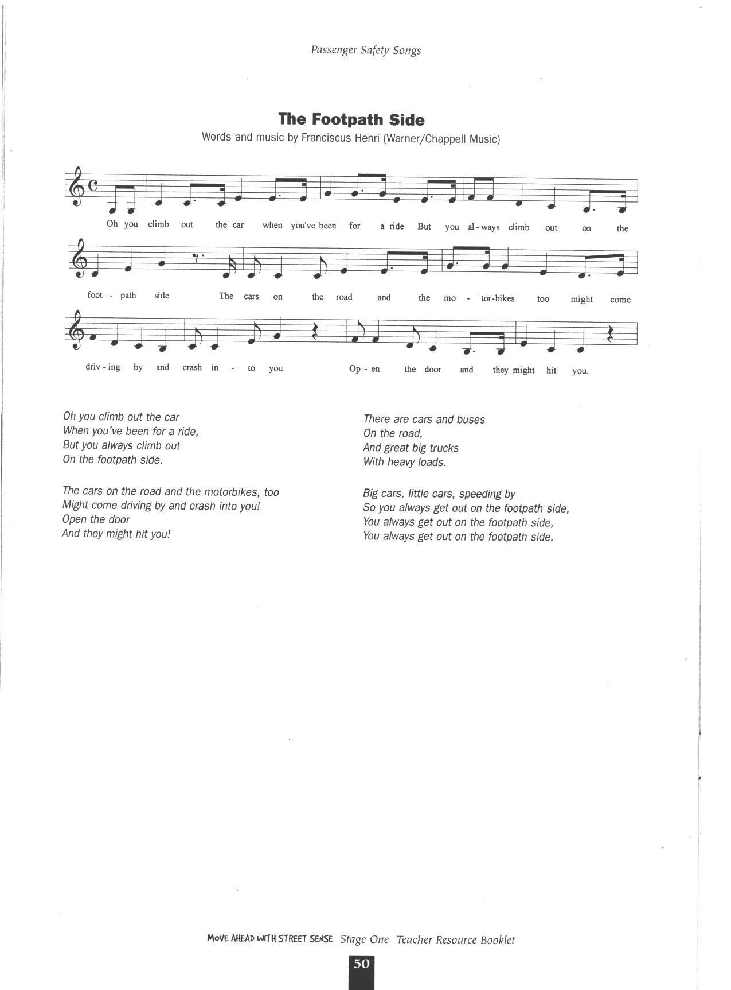

Reproduced from: Roads and Traffic Authority NSW (2000) Move Ahead with Street Sense Stages 1-3.
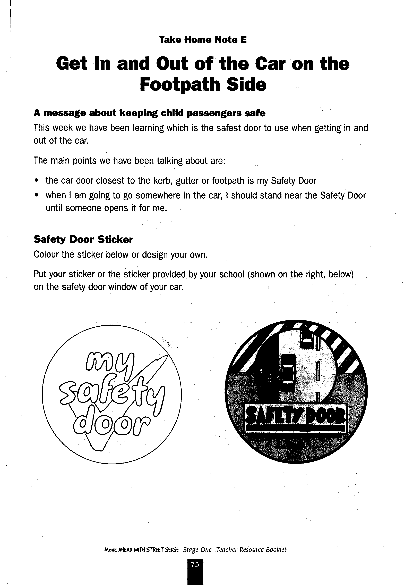

Reproduced from: Roads and Traffic Authority NSW (2000) Move Ahead with Street Sense Stages 1-3.
Lesson 6 What rules apply to different modes of transport?

Enduring Understanding | Outcomes |  | Indicators
E.1 We have a responsibility to make informed choices about personal safety that ensure optimal health and well being. | COS1.1 Communicates appropriately in a variety of ways.  DMS1.2 Recalls past experiences in making decisions.  V4 Increasingly accepts responsibility for personal and community health. |  | - Creates a poster about safety rules  - Predicts consequences of options in order to make a decision  - Appreciates the need for safe practices
KidsMatter SEL Focus: Major - Responsible Decision Making - Assuming personal Responsibility;
Minor - Responsible Decision Making - Problem-Solving
Suggested Learning Experiences

Identify modes of transport used by class members. An option could be that students make a pictograph of the modes of transport used by drawing their mode of transport.

Brainstorm safety habits that should be practised when using each mode of transport. For example, remaining seated on the bus until it stops, wearing a seatbelt in the car, wearing a helmet when riding a bike, holding an adult’s hand when crossing the road, standing behind the yellow safety lines on the train platform.

TW: Students design and display a poster promoting Safe Passenger Rules for each mode of transport, e.g. walk, train, bus, car, bike, ferry, motorbike. The poster could include safety measures for each stage of their journey. Students may include similar phrases from Lesson 4 about responsible choices that protect and care for themselves. For example, Make safe choices…. Be responsible….Protect yourself….Care for yourself and others.

Students display posters in the classroom or school grounds. Students speak at a whole school assembly about safe passenger rules and discuss the possible consequences of not practicing safety rules.

Resources  - Crayons/Coloured pencils  - Paper |  | Assessment  Student work sample of Safety Passenger Rules posters.

Lessons 1-10 are adapted and reproduced with kind permission from: RTA. NSW. (2001) Move Ahead with Street Sense Stage 1. Sydney. RTA.
Lesson 7 How can I cooperate with the driver on a long journey?

Enduring Lessons | Outcomes |  | Indicators
E.2 Individuals are entrusted to be responsible for themselves and to show care and concern for others. | SLS1.13 Recognises that their safety depends on the environment and the behaviour of themselves and others.  IRS1. 11 Identifies the ways in which they communicate, cooperate and care for others.  DMS1.2 Draws on past experiences in making decisions.  V4 Increasingly accepts responsibility for personal and community health. |  | - Lists things they can do to be a safe passenger.  - Discusses how they cooperate with others in work and play situations  - Predicts consequences of options in order to make decisions  - Values their health and safety and that of others
KidsMatter SEL Focus: Major - Responsible Decision Making - Assuming personal Responsibility
Suggested Learning Experiences

In small groups, students compile a list of activities to play safely when travelling by car on a long trip. Students may have ideas they use in their family or search the net for ideas. They share their responses and together check whether each activity is suitable or not by responding to the following questions:
- Is the activity fun?
- Will it disturb the driver?
- Can it be done while they are buckled up?
- Does it involve a lot of movement?
- Can everyone in the car participate?
- What might happen if we are too noisy and move too much as passengers?

TW: Teacher poses the question “How does playing these types of activities show a responsibility for protecting yourself and others in the car?” Bring the students to the understanding that drivers need to be able to concentrate on the road, the cars around them and keep their passengers safe. Driving is a complex task, therefore it is the passenger’s responsibility to behave sensibly when travelling in a car.

Students develop a class book called The Long Drive Survival Guide based on their work from the lesson. It lists brief instructions for each activity. Class may come up with their own title.

Resources  - A4 paper  - www.travelmate.com.au/funtrip |  | Assessment  Student responses in developing safe play activities for the car.

Lessons 1-10 are adapted and reproduced with kind permission from: RTA. NSW. (2001) Move Ahead with Street Sense Stage 1. Sydney. RTA.

Lesson 8 How can I help my friends and family to travel safely?

Enduring Understandings | Outcomes |  | Indicators
E.1 We have a responsibility to make informed choices about personal safety that ensure optimal health and well being.  E.2 Individuals are entrusted to be responsible for themselves and to show care and concern for others. | SLS1.13 Recognises that their safety depends on the environment and the behaviour of themselves and others.  COS1.1 Communicates appropriately in a variety of ways.  DMS1.2 Draws on past experiences in making decisions.  V4 Increasingly accepts responsibility for personal and community health. |  | - Describes a range of safety strategies to use in response to unsafe behaviour or situations  - Expresses feelings about safe and unsafe situations  - Predicts consequences of options in order to make a decision  - Values their health and safety and that of others
KidsMatter SEL Focus: Major - Responsible Decision Making - Assuming personal Responsibility; Self-Management - Goal setting
Suggested Learning Experiences
TW: Students develop role plays based on the following scenarios. In the role play, students must devise effective strategies to address safety issues, showing responsibility in protecting and caring for themselves and others.
- Your best friend comes to your house every Friday and as your dad starts the car to drive off, your friend only pretends to do up the seatbelt. You know this is unsafe. What would you do?
- You are travelling in the car and your friend starts to put an arm out the window to feel the wind. You know that your friend could be injured by doing this. What would you do?
- You go shopping with your parents and have lots of shopping bags. Your mum starts to put them in the back seat with you. You know things like shopping should be stored safely in the boot. You know that if they aren’t, they might move around the car and hit people. What would you do?
- Your family is talking about going on holidays and taking the dog with them in the car. The dog doesn’t have a seat belt and you know that everyone needs to be buckled up in a car. What would you do?

Students present their role plays and discuss the safety strategies developed.

Students discuss and read the messages used in Worksheet 9, Safe Passenger Origami Game. Students make the origami game and play it with their friends and family.

HOME TASK: In preparation for next lesson, have students discuss with their family two places at or near their home where it would be suitable to ride a bike/scooter or skate.

Resources  - RTA. NSW. (2001). Move Ahead With Street Sense. Stage 1. Sydney: RTA. Worksheet 9 Safe Passengers Origami Game. p.64.  - Role play scenarios on flash cards |  | Assessment  Student responses in role plays.

Lessons 1-10 are adapted and reproduced with kind permission from: RTA. NSW. (2001) Move Ahead with Street Sense Stage 1. Sydney. RTA.
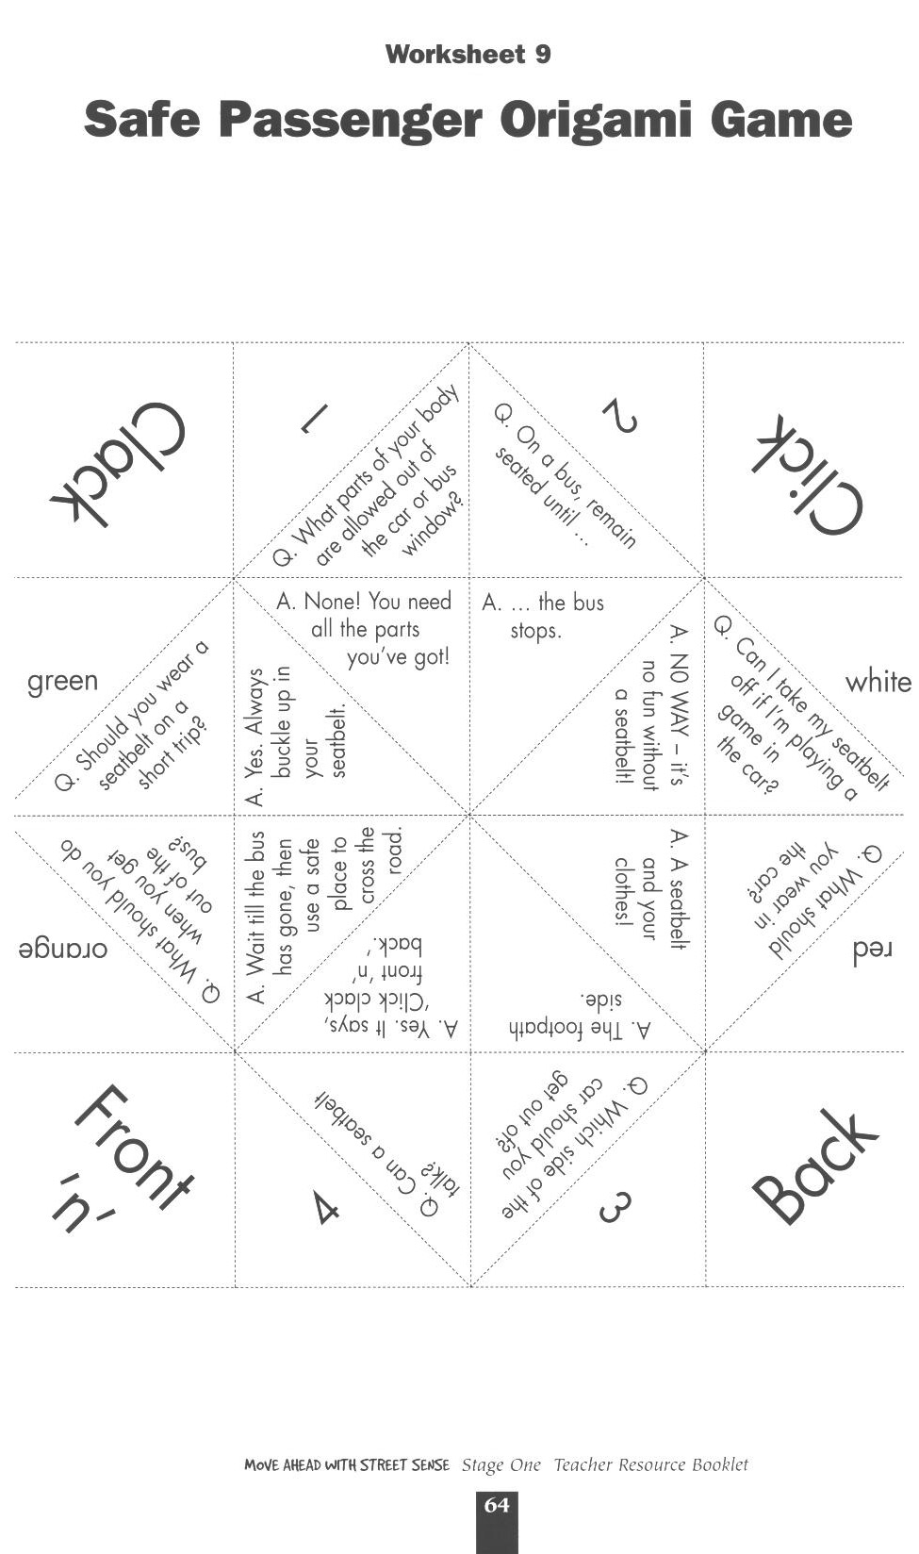

Reproduced from: Roads and Traffic Authority NSW (2000) Move Ahead with Street Sense Stages 1-3.
Lesson 9 Where can I be safe on wheels?

Enduring Understandings | Outcomes |  | Indicators
E.1 We have a responsibility to make informed choices about personal safety that ensure optimal health and well being. | SLS1.13 Recognises that their safety depends on the environment and the behaviour of themselves and others.  DMS1.2 Draws on past experiences in making decisions.  V4 Increasingly accepts responsibility for personal and community health. |  | - Describes how to keep safe on wheels  - Identifies safe places to ride  - Predicts consequences of options in order to make decisions  - Values their health and safety and that of others
KidsMatter SEL Focus: Major - Responsible Decision Making - Assuming personal Responsibility

Suggested Learning Experiences

TW: Life is a precious gift entrusted to us by God.

Students brainstorm characteristics of what makes a place safe to play.

As a class create a checklist of features that make a place safe to ride a bike/scooter or skate. Using the information from the previous lesson’s home activity, brainstorm the places in the local area where it would be suitable to ride a bike/scooter or skate. Complete Worksheet 13 Safe Places to Ride and Skate.

Students draw a picture of their home at the edge of a large sheet of paper. They cut and paste one of the drawings they have made on Worksheet 13, Safe Places to Ride and Skate, on the far side of the paper. They then fill the space between the two drawings with illustrations of how they could get to the safe riding/skating place using safe behaviour. For example, walking their wheeled toy to the park, being supervised by an adult, crossing at a marked crossing, wheeling their bicycle/scooter across the marked crossing, holding an adult’s hand.

OPTIONAL
Students locate safe places to ride or skate from photocopies of the inside back cover of the shared book, Jeffrey. Students colour in safe places on the map to use their wheels.

Resources  - RTA. NSW. (2001). Move Ahead With Street Sense. Stage 1. Sydney: RTA. Worksheet 13 Safe Places to Ride and Skate. p.68 and Jeffrey Book. (photocopies of the inside of the back cover)  - Art paper |  | Assessment  Student’s drawing of safe behaviours when getting from home to play area.

Lessons 1-10 are adapted and reproduced with kind permission from: RTA. NSW. (2001) Move Ahead with Street Sense Stage 1. Sydney. RTA.
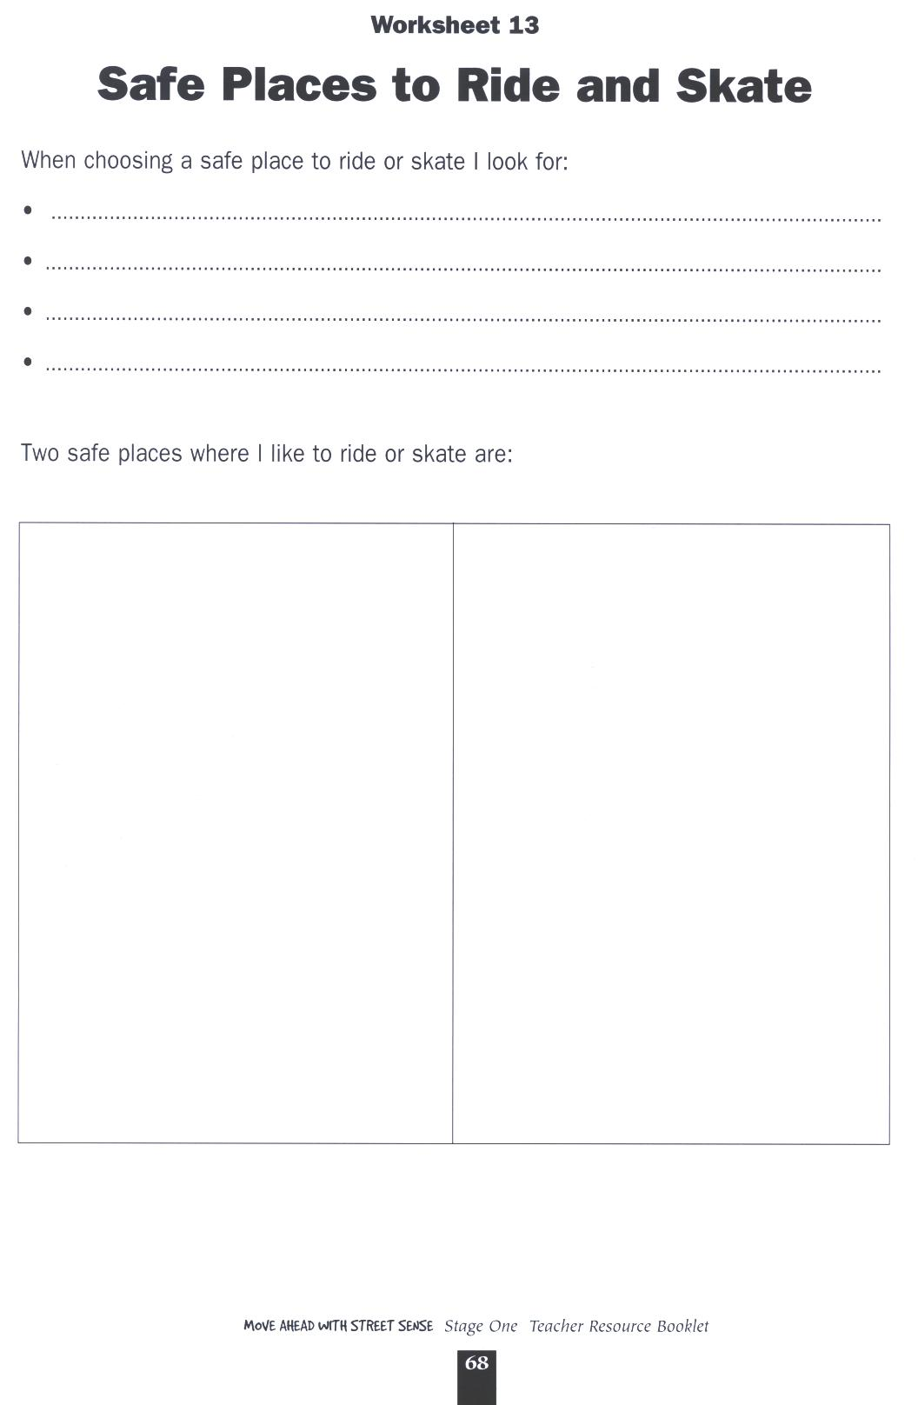

Reproduced from: Roads and Traffic Authority NSW (2000) Move Ahead with Street Sense Stages 1-3.
Lesson 10 Why is wearing a helmet important?

Enduring Understandings | Outcomes |  | Indicators
E.1 We have a responsibility to make informed choices about personal safety that ensure optimal health and well being. | SLS1.13 Recognises that their safety depends on the environment and the behaviour of themselves and others.  DMS1.2 Draws on past experiences in making decisions.  V4 Increasingly accepts responsibility for personal and community health. |  | - Describes how to keep safe on wheels  - Identifies protective equipment for cycling and skating  - Predicts consequences of options in order to make decisions  - Values their health and safety and that of others
KidsMatter SEL Focus:Major - Responsible Decision Making - Assuming personal Responsibility
Suggested Learning Experiences

TW: Life is a precious gift entrusted to us by God.

Students listen to the Silly Billy and Silly Gilly song from Cassette 2. Perhaps children could develop actions for each verse of the song.

Students predict what would happen to an egg or a piece of fruit if dropped on a hard surface. Teacher demonstrates with an egg or a piece of fruit either dropped or thrown at a wall. Collect different objects. For example a plastic bag, helmet, cardboard box and tape in the egg or fruit. Predict results now and test.

Students feel their heads and discuss what would happen if their head hit a hard surface.

Students label the points to remember when putting on a helmet using the Cycling Helmet Activity. For example, no cracks or indents in the helmet, the strap is firm under chin- but not tight, the buckle is inserted correctly, the V-straps are correctly positioned under both ears, the helmet is fitted firmly on the head and not wobbling around.
Students examine the photographs from the Bicycle Safety Photo Story and sequence the photos in the correct order. Discuss why it is important to always wear a helmet that is correctly fitted and check your bicycle before cycling.

HOME TASK:
Students complete the Six Point Bicycle Safety Check (bell, brakes, reflector, chain, tyres and pedals).

Resources  - RTA. NSW. (2001). Move Ahead With Street Sense. Stage 1. Sydney: RTA. Silly Billy and Silly Gilly Song Cassette 2. p.52. Cycling Helmet Activity 11. p.66 and Bicycle Safety Photo Story. Six Point Bicycle Safety Check. p.69 |  | Assessment  Student work samples related to the Cycling Helmet activity.  Optional Assessment: ‘Safety Around Wheels’ .

Lessons 1-10 Adapted and reproduced with kind permission from: RTA. NSW. (2001). Move Ahead With Street Sense. Stage 1. Sydney: Author.
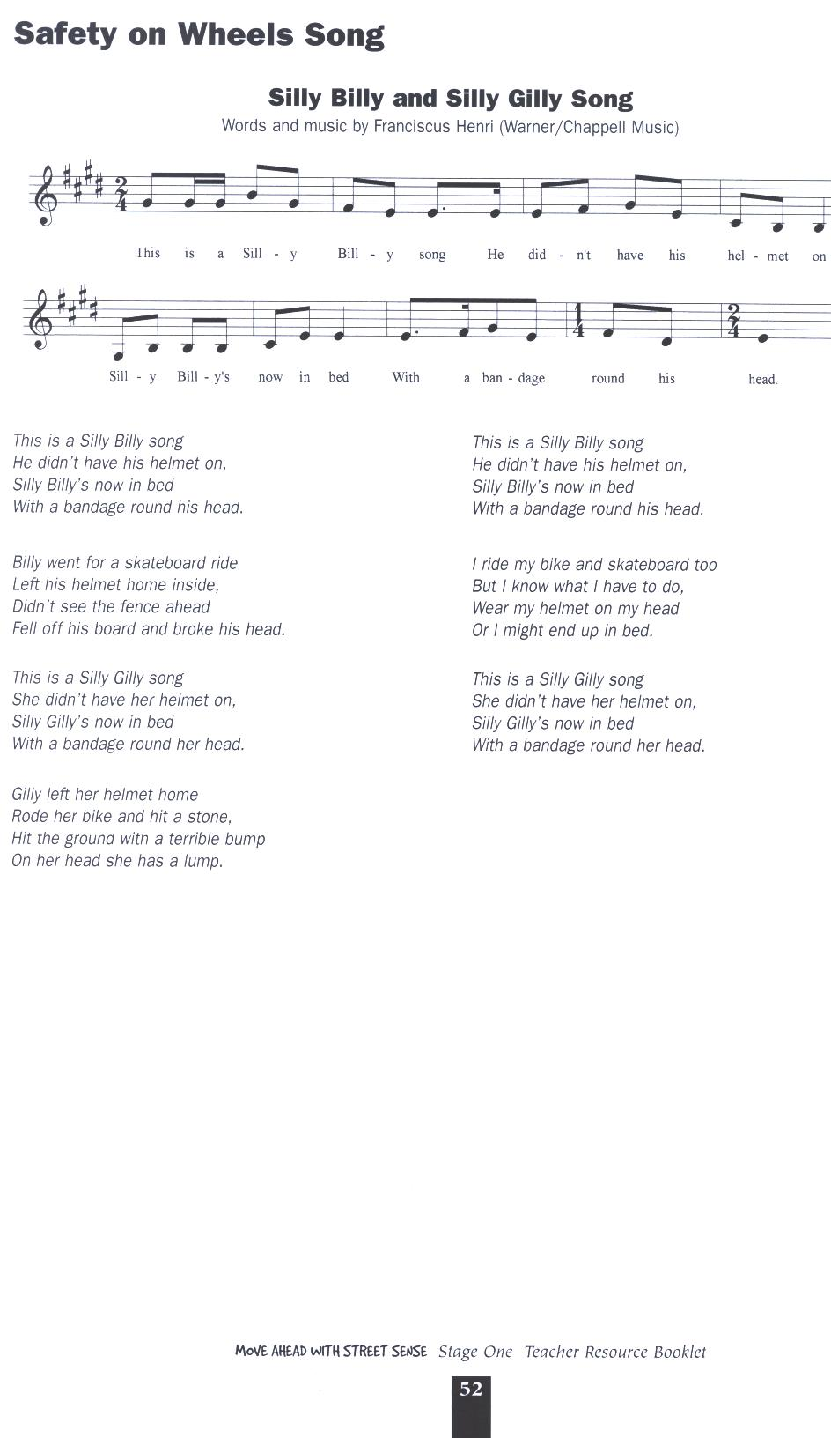

Reproduced from: Roads and Traffic Authority NSW (2000) Move Ahead with Street Sense Stages 1-3.
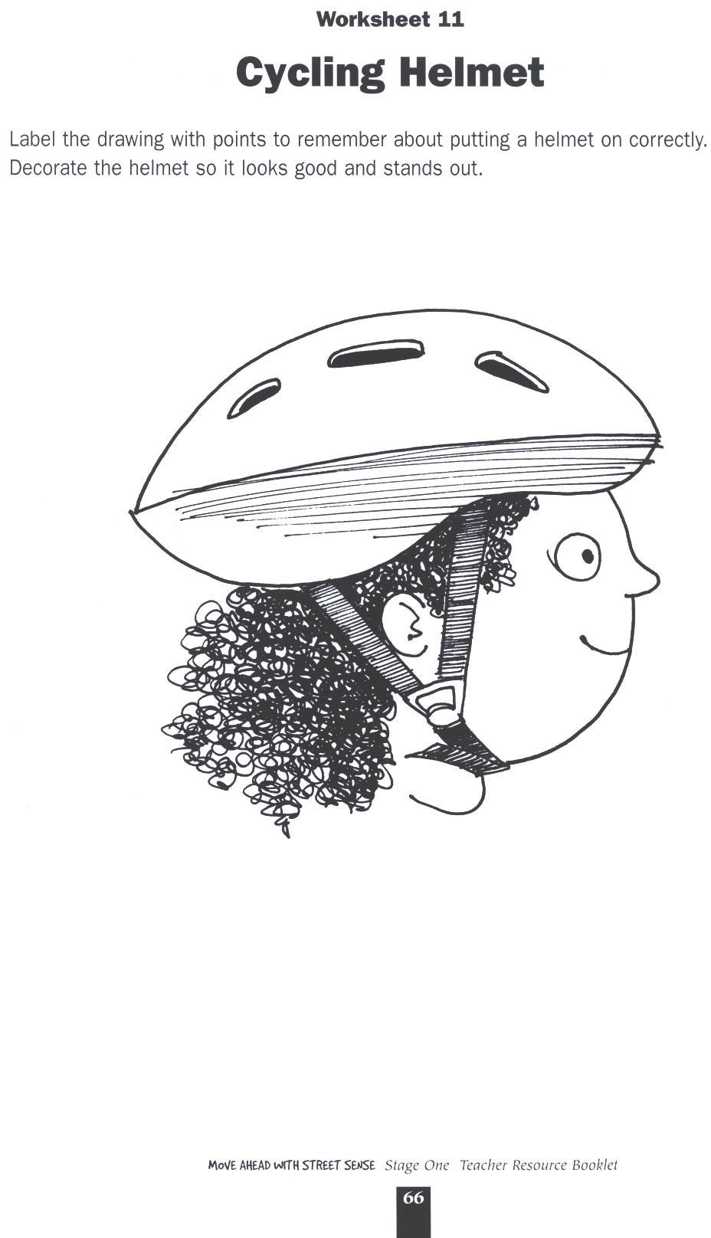

Reproduced from: Roads and Traffic Authority NSW (2000) Move Ahead with Street Sense Stages 1-3.
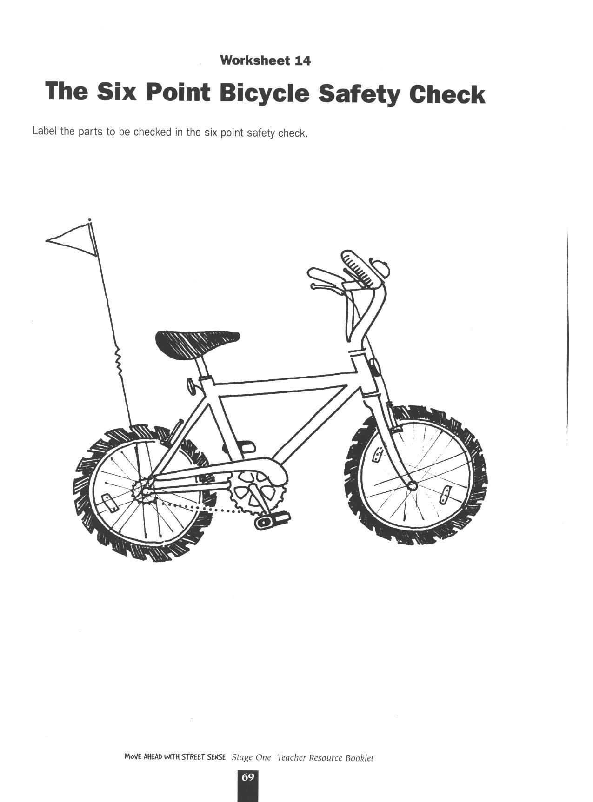

Reproduced from: Roads and Traffic Authority NSW (2000) Move Ahead with Street Sense Stages 1-3.

Safety Around Wheels
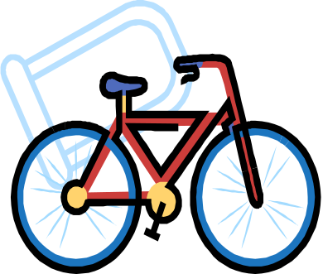
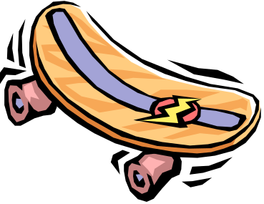

Student: _________________________________________________

This task provides students with the opportunity to demonstrate their standard of achievement of the following outcomes:

Outcomes | Indicators | Working towards | Achieved with support | Achieved
SLS1.13 Recognises that their safety depends on the environment and the behaviour of themselves and others. | Describes how to keep safe on wheels
DMS1.2 Draws on past experiences in making decisions. | Predicts consequences of options in order to make decisions
TASK
Students use Safety Around Wheels worksheet to draw or write a set of instructions for other children for what they must do to be safe around wheels when walking, playing or travelling.

OPTIONAL
Class as a whole decides which they consider to be the best three in each section and these are filmed and the DVD shown to the rest of the school to promote safety around wheels.

Safety Around Wheels

Catholic Values/Beliefs:
- Take care of others. (Rm 12: 3-13)
- Do what is right. (Mt 6:8)
- God wants us to be safe and will protect us as we come and grow now and forever. (Ps 121: 5-8)

Draw or write what we must do to be safe around wheels when we are:
Walking

Playing

Travelling

TEACHER REFLECTION - UNIT EVALUATION

Unsatisfactory
Satisfactory

Poor
Good

A. A. EVIDENCE
To what extent does the assessment evidence provide:
1. A valid and reliable measure of the targeted outcomes/enduring understandings?
2. Sufficient information to support inferences about each
student’s understanding/level of achievement?
3. Opportunities for students to demonstrate their understandings through authentic learning tasks?
B. LEARNING EXPERIENCES AND INSTRUCTION
To what extent did students:
1. Achieve the outcomes and the enduring understandings of the unit (the big ideas as opposed to basic facts and skills)?
2. Know where they were going and why (in terms of unit goals, requirements, and evaluative criteria)?
3. Deepen their knowledge and understanding of the outcomes & big ideas of the Unit (through inquiry, research, problem solving, and experimentation)?
4. Receive explicit instruction on the knowledge and skills needed to equip them for the required performances?
5. Have opportunities to rehearse, revise, and refine their work based on feedback?
6. Self-assess and set goals prior to the conclusion of the unit?

PTO
1. What did students learn? (What knowlege and skills did they learn to deepen their understanding of the outcomes/big ideas of the unit?)

2. How do you know what they learnt? (What evidence do you have to support your judgement?)

3. What would you refine to improve student learning outcomes?

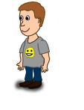
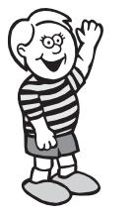
Student Unit Reflection
Stage 1

Student Name: Class:
Unit/Topic:
Completing the sentences below will help me to remember the important things I learnt about how to keep myself happy, healthy and safe.

One of the things I enjoyed learning about was….  ☺ | One thing I would change is….  ☹
  One thing I enjoyed sharing with my family at home was…. | What things from this unit would I like to learn more about?

The rating I give myself for how hard I worked in this unit is…

1 2 3 4 5

Holland, A.J., Liang, R.W., Singh, S.J., Schell, D.N., Ross, F.I., & Cass D.T. (2000). Driveway motor vehicle injuries in children. Medical Journal of Australia, 173 (4) 192-5.
NSW Child Death Review Team .(1998-1999). Child Death Review Team Annual Report.
Holland, A.J., Liang, R.W., Singh, S.J., Schell, D.N., Ross, F.I., & Cass D.T. (2000). Driveway motor vehicle injuries in children. Medical Journal of Australia, 173 (4) 192-5.

