MY BEAUT BODY
Stage: 1 | Unit Duration: 10 Lessons |  | Weeks 1 2 3 4 5 6 7 8 9 10 |  | Terms 1 2 3 4
Enduring Understandings  E.1 Each individual’s body is special and unique.  E.2 Our bodies change and grow to make us who we are.  E.3 We have the responsibility to make informed decisions about our environment. |  |  | Essential Questions  - How does my body grow and change?  - What factors can affect my health?
Major Outcomes  Knowledge and Understanding  PHS1.12 Recognises that positive health choices can promote wellbeing.  Skills  COS1.1 Communicates appropriately in a variety of ways.  Values and Attitudes  V1 Refers to a sense of their own worth and dignity. |  |  | Lesson Overview  1. How do I use my senses to listen? (E.1)  2. What are my body parts? (E.1)  3. How strong am I? (E.1)  4. How has my body changed? (E.2)  5. How do I feel about changes in my life? (E.2)  6. How am I unique? (E.1)  7. How do I protect myself from disease? (E.1)  8. How do I protect myself from the sun? (E.3)  9. What is pollution? (E.3)  10. How can pollution affect my health? (E.3)  KidsMatter SEL Focus  Major: Responsible Decision Making - Respecting others; Self-Awareness - Recognising Strengths;  Self-Awareness - Identifying emotions; Responsible Decision Making - Assuming personal Responsibility  Minor: Responsible Decision Making - Respecting others; Social Awareness – Appreciating Diversity; Self Awareness - Recognising Strengths; Responsible Decision Making - Problem-Solving; Self-Management - Goal setting
Contributing Outcomes

Knowledge and Understanding
GDS1.9 Describes the characteristics that make them both similar to others and unique.

Skills
MOS1.4 Demonstrates maturing performances of basic movement and emotional skills in a variety of predictable situations.
INS1.3 Develops positive relationships with peers and others.
DMS1.2 Recalls past experiences in making decisions.

Values and Attitudes
V2 Respects the right of others to hold different values and attitudes from their own.
V4 Increasingly accepts responsibility for personal and community health.
Catholic Dimension/Towards Wholeness (TW) (Also refer to overview of TW for this unit)
Growth and Development
God has created each of us to grow into the fullness of life. We are made in God’s image and therefore, we are of inherent dignity and worth. Our sexuality is an intrinsic part of ourselves, to be celebrated and expressed with joy and responsibility, according to God’s plan. Each person grows and changes, passing through stages on a journey towards full maturity. God is with us on this journey, reassuring and challenging. We are never alone.
Personal Health Choices
Throughout our lives, we all face having to make personal decisions relating to nutrition, hygiene, consumerism, drug use and disease prevention. So many conflicting opinions and values influence children in making decisions that have direct relevance to their health and well-being. Taught from a Catholic perspective, this strand seeks to develop the children’s abilities to observe, explore, interpret and judge, informed by an emerging integrated value system that is based on the values of the Gospel.

Foundation Statement
Students describe ways to keep healthy and safe and explore choices relating to food, sun protection and personal safety. They identify the appropriate use, administration and storage of medicines. Students describe strategies to stay safe at home, on and near roads, when travelling to and from school, and near water. They recognise safe and unsafe environments and situations and suggest a range of protective strategies for dealing with unsafe situations.

Students describe similarities and differences between themselves and others. They describe different body parts and how the body grows and changes. Students explore different types of relationships and describe the skills needed to develop and maintain positive relationships. They identify the effects of bullying.
Suggested correlations with other KLAs  English  - Narrative Text (concept development)  - Personal Response  - Factual Recount  - Factual Description  - Debate/Discussion  - Talking and Listening  Creative Arts  - Visual Arts – Making and Appreciating |  |  | Science and Technology  - Living Things  - Investigating growth/change  - Products and Services  - Investigating sun safe products  - Designing/making a sun safe hat  Mathematics  - Working Mathematically  - Measurement - Length  HSIE  - Change and Continuity  - Stages in a lifetime
Technology

The following websites have been selected to enhance various concepts being taught throughout this unit. Most of the sites listed can be linked to more than one of the lessons being taught. Teachers may like to add them to the school intranet site.
- http://www.dotolearn.com/games/songs/PartsofMe/index.htm

http://www.scholastic.com/magicschoolbus/games/sound/eargame.htm
- http://www.kidcyber.com.au/topics/body_senses.htm
- http://library.thinkquest.org/3750/
- http://www.learninggamesforkids.com/health_games_body_parts.html
- http://www.epa.gov/sunwise/kids.html
- http://funschool.kaboose.com/globe-rider/earth-day/games/game_clean_up_your_world.html
- http://kids.niehs.nih.gov/baylor/earth2b.htm
- http://www.kiddiesgames.com/en/sign_language_games.php
Subject Matter  Growth and Development  The Body  - Body parts  - - internal, external  - Body systems  - skeletal  - Senses  - sensory systems  - Body care and maintenance  Changes  - Body appearance  - Feelings about change  Personal Health Choices  Making Decisions  - Identifying choices |  | - Making choices  - Effects of actions  Health Services and Products  - People who keep me healthy  - home  - community  - Products that keep me healthy  Environmental Health  - Effects of Pollution  - school/home  - water/air/land  - Recycling  - Environmentally friendly products |  | Preventative Measures  - Sun protection  - Disease prevention  - immunisation  - Protective clothing and equipment  - Personal hygiene  - cleanliness  - clothing  - health care  - dental care  - ears and nose
Unit Evaluation  Sample teacher and student unit evaluations are included at the end of the unit. |  |  | Assessment  Assessment strategies are included throughout the unit.

An Overview of Towards Wholeness (TW) in the PDH Unit
My Beaut Body - Stage 1

Key God’s Word:

Our body is a gift of God, God’s temple to be treated with respect. (1 Cor 3:16) TW p.19

As God’s people we are of great uniqueness and diversity. (Gal 3: 28) TW p.19

Each individual is created in the image and likeness of God. (Gen 1:27-28) TW p.26

The sacredness of all creation. And God saw that it was good. (Gen 1:12) TW p.40

Enduring  Understandings | Towards Wholeness  Beliefs and Values | Lesson Overview
E.1 Each individual body is special and unique. | - Each person is unique, worthy of respect and love, created in the image and likeness of God. TW p.24  - I am special, as God loves me. TW p.24 | 1. How do I use my senses to listen?  2. What are my body parts?  3. How strong am I?  6. How am I unique?  7. How do I protect myself from diseases?
E.2 Our bodies change and grow to make us who we are. | - We should appreciate and respect our body and the bodies of others. TW p.35  - As we grow and develop we enjoy all our capacities and gifts, our intellect, our emotions, our spirit, our will and our physical bodies. TW p.27 | 4. How has my body changed?  5. How do I feel about changes in my life?
E.3 We have a responsibility to make informed decisions about our environment. | - An education in ecological responsibility for oneself, others and the earth is of great importance. TW p.40  - Christian concern for personal and relational health extends naturally to environmental and cosmic health. TW p.40 | 8. How do I protect myself in the sun?  9. What is pollution?  10. How can pollution affect my health?

Lesson 1 How do I use my senses to listen?

Enduring Understandings | Outcomes |  | Indicators
E.1 Each individual body is special and unique. | GDS1.9 Describes the characteristics that make them both similar to others and unique.  COS1.1 Communicates appropriately in a variety of ways.  V2 Respects the right of others to hold different values and attitudes from their own. |  | - Demonstrates ways of encouraging and caring for others  - Shows understanding about others’ feelings  - Shows sensitivity to the needs, rights, feelings and efforts of others
KidsMatter SEL Focus: Minor - Responsible Decision Making - Respecting others; Social Awareness – Appreciating Diversity
Suggested Learning Experiences
Select a student and trace around their body. Students identify the five senses of the body and label these on the traced body outline. This outline will be used during lesson 2 as well. Explain what each sense does. Using Our Body worksheet, students label the senses.
Students listen to a pre-recorded audio tape of sounds and identify different sounds – music, hands clapping, voices singing, kettle boiling, traffic, etc. Discuss how hearing helps us in our every day life. Possible responses may include: be safe, listen to instructions, know when my dog wants food, enjoy music, etc.
Teacher explains that when one of these senses doesn’t work properly or doesn’t work at all, we use the word, ‘impaired’ to describe it. Teacher and students read the book The Race and discuss the following questions:
- Which of Greg’s senses was impaired? (Teacher will need to define the term impaired for the class).
- How did Greg learn in class? What did he do to find out what the class was learning?
- How did the teacher find out that Greg couldn’t hear very well?
- How did the teacher help Greg?

TW: Teacher poses the question, “How should we treat people who are hearing impaired or who may have another sensory impairment?” Students share their responses in pairs, then in groups of four and then to the class. Teacher explains to the students that God made each of us and He loves us all. He wants us to always respect and love all people, no matter how they might look or how they might be different to ourselves.

HOME TASK: For Lesson 2, ask students who have had any x-rays taken of their body to bring them in. OR Teacher explains the need for hearing impaired people to use ‘Sign Language’ to communicate. Using the Sign Language Alphabet sheet, students with the help of their parents, practise spelling their names. Perhaps share this at the next ‘news’ session the following week.
Resources  - Mattingley, C. and Spudvilas, A. (1995). The Race. Sydney: Scholastic.  - Large paper for body outline  - My Body worksheet  - Audiotape of various sounds  - Sign Language Alphabet sheet |  | Assessment  Student responses in class discussion relating to The Race and the discussion relating to how we should treat people with a sensory impairment.
Adapted and reproduced with kind permission from: Board of Studies. NSW (1999). PDHPE K–6 Teaching Kit. I am Special. Sign Language Alphabet. Sydney. pages 34 and 42.

Can you carefully label the senses and the different parts of your body on the outline below.

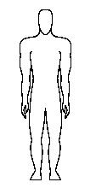
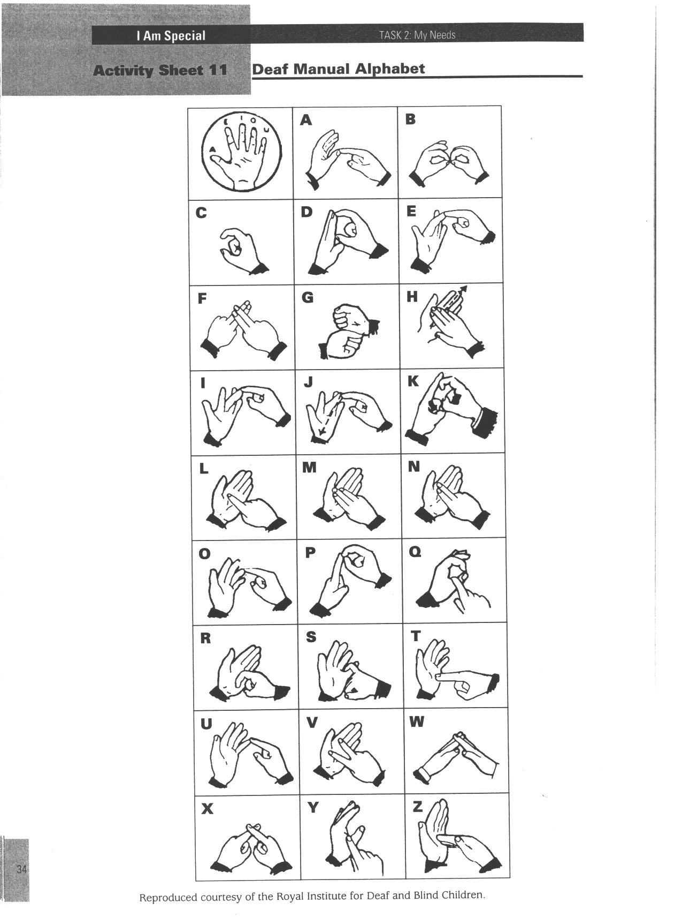

Reproduced from: Board of Studies NSW (1998) Personal Development, Health and Physical Education K–6 Teaching Kit: Interpersonal Relationships; Growth and Development; and Safe Living Stages 1-3.

Lesson 2 What are my body parts?

Enduring Understandings | Outcomes |  | Indicators
E.1 Each individual body is special and unique. | GDS1.9 Describes the characteristics that make them both similar to others and unique.  COS1.1 Communicates appropriately in a variety of ways.  V1 Refers to a sense of their own worth and dignity. |  | - Locates and names the parts of the body  - Creates a skeleton and shows understanding about its function  - Appreciates the need to care for their body.
Suggested Learning Experiences

Children identify any other body parts they might know and teacher labels on the body outline from the previous lesson. Teachers can ask students to identify the body parts in the X-rays Students’ responses may include parts inside and/or outside the body. Discuss the various functions of the major body parts. (If time permits, students can record the body parts onto the My Body worksheet from previous lesson.)

Brainstorm the different ways your body can move: bend, twist, swing, jump, kick, reach, etc. Teacher instructs the students to do a particular movement such as, “swing your knee forward and backward” or “bend over and touch your toes”. Instructions should include movements of the knee, elbow, shoulder and hip joints in order for the students to discover their range of movement. Teacher then explains that a ‘joint’ such as the knee, elbow, shoulder or hip, enable our bones and muscles to help us move in these different ways.

Teacher displays a chart of the skeletal system. As a class, discuss:
- What is the role of the skeleton? (protection, stability, support, movement)
- What would happen to the body if we didn’t have a skeleton?
- Who has ever broken a bone? (view any x-rays that students may have brought in)
- How can we protect our skeletal system?

Using the Make a Skeleton worksheet, create a human skeleton. This could be done as a whole class activity for display or as individuals.

OPTIONAL
Students play Simon Says using body parts or bone names –heart, lungs, stomach, thigh, upper arm, collarbone, shoulder blade, shin, breast bone, skull, etc.

Resources  - Body outline from previous lesson  - Chart of human skeleton  - X-rays  - My Body worksheet (from lesson 1)  - National Heart Foundation. Heart Health Manual. (1987). A Resource Kit for Primary Teachers. Make a Skeleton Activity |  | Assessment  Student response to skeletal system discussion.

Adapted and reproduced with kind permission from: National Heart Foundation. Heart Health Manual. (1987). A Resource Kit for Primary Teachers. Make a Skeleton Activity.
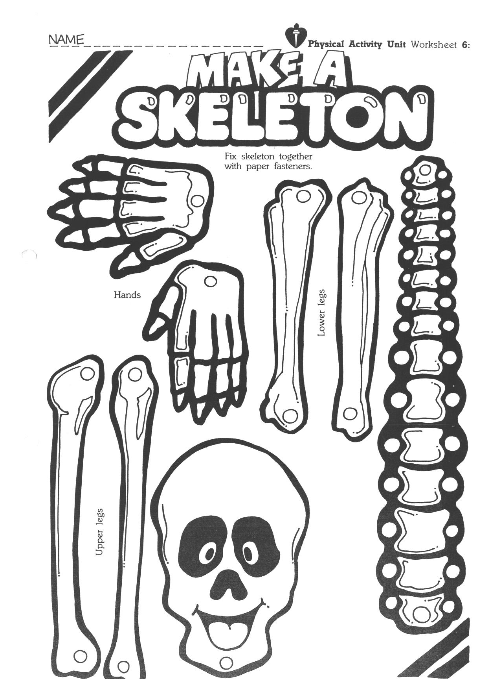

National Heart Foundation. Heart Health Manual. (1987). A Resource Kit for Primary Teachers. Make a Skeleton Activity.

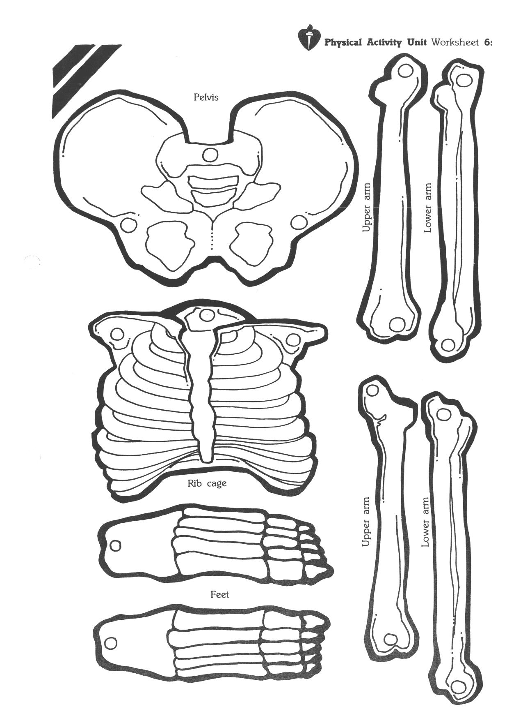

National Heart Foundation. Heart Health Manual. (1987). A Resource Kit for Primary Teachers. Make a Skeleton Activity.

Lesson 3 How strong am I?

Enduring Understandings | Outcomes |  | Indicators
E.1 Each individual body is special and unique. | GDS1.9 Describes the characteristics that make them both similar to others and unique.  MOS1.4 Demonstrates maturing performances of basic movement and emotional skills in a variety of predictable situations.  V1 Refers to a sense of their own worth and dignity. |  | - Identifies activities that require strength  - Demonstrates a range of strength-type activities  - Expresses a realistic perception of their personal capabilities
Suggested Learning Experiences

Teacher shows flash cards or stimulus pictures of various activities such as children running up a hill, playing marbles, skipping, lifting a box, digging a deep hole, riding a bike, reading a book, carrying a schoolbag, and pushing a wheelbarrow. Teacher discusses the concept of strength – push, pull, lift or carry. Students identify which activities require strength and rank the flash cards in order from activities needing a lot of strength to activities needing a little strength.

Students participate in a variety of fun strength games in a suitable outdoor space. Teacher needs to remind students to be respectful of each others’ different strengths and abilities. Strength games could include:
- Tug of war
- In groups, students have a relay carrying gym mat over short distance
- In groups, students push medicine ball or other heavy object to see how far they can go

As a class read and discuss the information from My Muscles worksheet or research online the different muscles and what they do.

Students draw a picture or take a digital image of themselves participating in a strength activity and identify the muscles they are using in the activity.

HOME TASK
Students bring photos to class to represent different life stages.

Resources  - Teacher prepared flash cards or stimulus pictures of activities  - Open grassed area with boundary markers  - Sport’s equipment  - My Muscles worksheet |  | Assessment  Students drawing and labelling of themselves participating in a muscle activity.
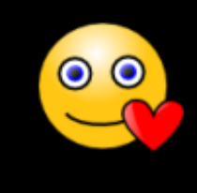

My muscles move my body. They move my body like strings move a puppet! My muscles are made out of many stretchy, elastic cells and fibers. I have more than 600 muscles in my body. My muscles make up half the weight of my body!

My muscles work in pairs. I have one muscle to pull my bone forward, and another muscle to pull my bone back. When one muscle is working (contracting), the other muscle is relaxing. My muscle pairs work very well together.

My muscles also help hold my organs in place. My muscles help my organs do their work, too. My diaphragm muscle helps my lungs breathe. My heart muscles make my blood move through my body. My muscles help me chew food and close my eyelids. My muscles help me run and play. My muscles even help me smile! Did you know it takes more muscles to frown than it does to smile?

Lesson 4 How has my body changed?

Enduring Understandings | Outcomes |  | Indicators
E.2 Our bodies change and grow to make us who we are. | GDS1.9 Describes the characteristics that make them both similar to others and unique.  DMS1.2 Recalls past experiences in making decisions.  V1 Refers to a sense of their own worth and dignity. |  | - Describes changes in their life  - Identifies changes in their life  - Accepts themselves as they grow and change
KidsMatter SEL Focus: Major - Responsible Decision Making - Respecting others; Self Awareness - Recognising Strengths
Suggested Learning Experiences

Students bring photos to class to represent different life stages. Place photos in a timeline and discuss the changes that have occurred.

TW: Students complete the What Can I do Now? Worksheet. Students identify the physical things they could do when they were one year old and compare them to the things they can do now. They then write these verbs around the hand prints, for example, sitting up, eating, crawling, babbling, dancing, catching, throwing, hitting, landing, jumping, running, balancing, kicking, bouncing, trapping, swimming. Teacher highlights that as we grow and change, we can enjoy doing more and more things. We need to respect that we all grow in different ways and are good at different things (we have gifts and talents).

Students prepare a Growth Caterpillar using sections of egg cartons. On each section of an egg carton students identify growth and development milestones in their lives, for example, when I was 1 year old I started to walk, when I was 2 years old I could feed myself. Students decorate their egg carton caterpillars using pipe cleaner feelers and legs. Students discuss their growth caterpillar with another student and highlight changes throughout their life.

Resources  - Photos of students throughout their lifetime  - What Can I do Now? worksheet  - Craft materials – pipe cleaners, paint, egg cartons |  | Assessment  Student worksheet What Can I do Now?

Name: __________________________ Date: _____________
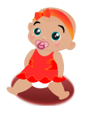
Write all the physical things you could do when you
were one year old around the small hand print.


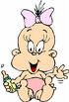

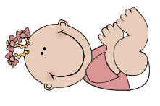

Trace around your own hand in the space below and write all the physical things you can do now, that you are older around the outline.

Lesson 5 How do I feel about changes in my life?

Enduring Understandings | Outcomes |  | Indicators
E.2 Our bodies change and grow to make us who we are. | GDS1. 9 Describes the characteristics that make them both similar to others and unique.  COS1.1 Communicates appropriately in a variety of ways.  V1 Refers to a sense of their own worth and dignity. |  | - Describes changes in their life  - Discusses feelings about change  - Accepts themselves as they grow and change
KidsMatter SEL Focus: Major - Self Awareness - Identifying emotions

Suggested Learning Experiences

Teacher and students read Changes, Window and/or The Ugly Duckling. Students identify the changes in or around the characters and make a list of how they would have felt before and after they changed.

Encourage children to reflect on times in their own lives where they have experienced change and/or the emotions felt by the character in the stories. As a class, students prepare a Changes Quilt by drawing pictures of these changes in their lives and how they felt. (Changes could include starting school, changing schools, moving house, having a new family member in the house - a baby, a grandparent coming to stay, parent starting a different job, a family member dying).

Students identify a range of people who they can talk to about their feelings about change and add these to their Change Quilt.
Resources  - Browne, A. (1997) Changes. London  - Baker, J. (1999) Window. Fox  - Christian Anderson, H. (1844) The Ugly Duckling. Retrieved from http://www.andersen.sdu.dk/vaerk/hersholt/TheUglyDuckling_e.html  - Large coloured squares of paper |  | Assessment Task  Student responses in class discussion relating to feelings and change.

Adapted and reproduced with kind permission from: Board of Studies. NSW. (1999). PDHPE K–6 Teaching Kit. I am Special. Changes In My Life Activity. p. 64.
Lesson 6 How am I unique?

Enduring Understandings | Outcomes |  | Indicators
E.1 Each individual body is special and unique. | PHS1.12 Recognises that positive health choices can promote wellbeing.  V1 Refers to a sense of their own worth and dignity.  COS1.1 Communicates appropriately in a variety of ways. |  | - Describes what people do to care for their body  - Accepts themselves as they grow and change  - Discusses how people care for their body
KidsMatter SEL Focus: Minor - Self Awareness - Recognising Strengths
Suggested Learning Experiences
Students describe themselves to a partner – hair colour, hair texture (wavy, curly, straight), skin colour, eye colour, tall/short, big/little feet. Students measure and record the length of their arms, legs, feet, hand span, circumference of neck or head with a strip of paper or tape measure. Choose one characteristic and graph the results to display in the classroom.

TW: Teacher discusses the concept of being unique and how special each of us is to God. Students discuss how important it is to look after their body, such a precious gift that has been given to them. Brainstorm what they can do to protect and respect their own body.

Students complete the sentence and record in their book ‘I can care for my unique body by ….’

TW: Teacher explains that most of the parts of the body are the same in boys and girls. However, there are parts of our bodies that make us different and they are our private parts. Show the video ‘Why Boys And Girls Are Different’. Discuss with students the correct use of names for the private parts of the body. Explain that by using the correct names for these parts, we show respect for each other. Remind the students that God made each of us and He loves us all. He wants us to always respect and love all people, no matter how they might look or how they might be different to ourselves.

Resources  - Tape measure or strips of paper to use as tape measures  - Art paper  - Pencils  - Why Boys And Girls Are Different Concordio Sex Education Video  Available from: Christian Multi-Media  PO Box 97  Ryde NSW 2113  Ph. 9588 2511 |  | Assessment  Student identifies ways that they care for their unique body.

Lesson 7 How do I protect myself from disease?

Enduring Understandings | Outcomes |  | Indicators
E.1 Each individual body is special and unique. | PHS1.12 Recognises that positive health choices can promote wellbeing.  COS1.1 Communicates appropriately in a variety of ways.  V4 Increasingly accepts responsibility for personal and community health. |  | - Describes how people care for them when they are sick  - Identifies preventive practices  - Creates a mobile about how to keep healthy  - Values the need to pursue healthy lifestyles
Suggested Learning Experiences

As a class, brainstorm all the diseases/illnesses/ailments that children have suffered from or know of, for example, measles, mumps, chicken pox, cold, flu, tonsillitis.

For each disease identified, students suggest products and people who helped them to get better and stay healthy. For example, cold – handkerchief, water, rest, chemist, medicine (analgesics - such as panadol/antibiotics), parent/carer, doctor.

Students play ‘Who am I?’ posing as people who help to keep students healthy. For example, I am someone who cleans and checks teeth? I am someone who sells medicines to help us get better?

Teacher explains the concept of immunisation. Class discuss:
- What is immunisation? (Medicine or injection to protect against disease).
- Why do we immunise children? (Immunisation reduces the risk of disease and spreading of disease).
- What diseases do we commonly immunise against? (Measles, German Measles, Polio, Diphtheria, Whooping Cough, Rota Virus, Meningococcal, Hepatitis B, Chicken Pox).

Students complete the How Do People Care For Me worksheet.
Resources  - Board of Studies. NSW. (1999). PDHPE K–6 Teaching Kit. I am Special. How Do People Care For Me. Sydney: BOS. p. 52 |  | Assessment  Students playing the Who Am I? game.

Adapted and reproduced with kind permission from: Board of Studies. NSW. (1999). PDHPE K–6 Teaching Kit. I am Special. How Do People Care For Me. Sydney: BOS. p. 52
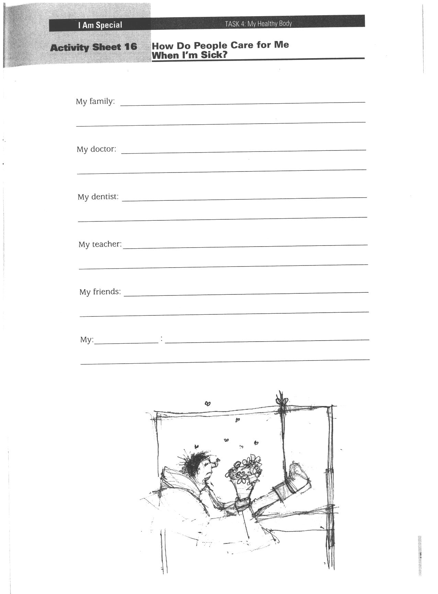
Reproduced from: Board of Studies NSW (1998) Personal Development, Health and Physical Education K–6 Teaching Kit: Interpersonal Relationships; Growth and Development; and Safe Living Stages 1-3.
Lesson 8 How do I protect myself from the sun?

Enduring Understandings | Outcomes |  | Indicators
E.3 We have a responsibility to make informed decisions about our environment. | PHS1.12 Recognises that positive health choices can promote wellbeing.  COS1.1 Communicates appropriately in a variety of ways.  V4 Increasingly accepts responsibility for personal and community health. |  | - Describes how people can be sun safe  - Discusses how people can be sunsafe  - Defends the need for making decisions that enhance health  - Appreciates the need for safe practices in a range of situations and environments
KidsMatter SEL Focus: Major - Responsible Decision Making - Assuming personal Responsibility;
Minor - Responsible Decision Making - Problem-Solving
Suggested Learning Experiences

Use stimulus pictures to help students brainstorm ways in which we care for ourselves:
- Physically - hygiene, exercise, road safety etc.
- Emotionally - being with supportive people - family/friends, talking about how you feel etc.
- Spiritually - going to Mass, praying etc.

Teacher shows a picture of children at the beach. As a class, students discuss what we can do to be sun safe. For example wear protective clothing, wear rash shirt, sit in the shade, sit under an umbrella, put on sunscreen (30+), wear sunglasses, wear a hat – SLIP, SLOP, SLAP, WRAP. Identify the aspect of health (physical, emotional or spiritual) to which sun safety belongs.

TW: Teacher models a variety of sun hats to the class – visor, legionnaire, straw hat, bucket, cap. Students identify which hat is the most effective in protecting themselves from the sun. Teacher discusses the importance of making responsible decisions when it comes to protecting our skin from the sun. Responsible decisions benefit ourselves and those around us. Students design a sun safe hat, labelling parts of the hat and what parts of the body they are protecting. Students share their hat design with the class and explain why they are sun safe.

Resources  - Picture of children at the beach  - A variety of sun hats |  | Assessment  Student sun hat design.
Lesson 9 What is pollution?

Enduring Understandings | Outcomes |  | Indicators
E.3 We have a responsibility to make informed decisions about our environment. | PHS1. 12 Recognises that positive health choices can promote wellbeing.  COS1.1 Communicates appropriately in a variety of ways.  V4 Increasingly accepts responsibility for personal and community health. |  | - Identifies environmental factors that impact on health – pollution  - Discusses how different types of pollution impact on health  - Appreciates the need to care for the environment
KidsMatter SEL Focus: Minor - Responsible Decision Making - Problem-Solving; Self-Management - Goal setting
Suggested Learning Experiences

In pairs, students share their ideas about what is pollution? Refer to ‘What is Pollution?’ teacher fact sheet.

Students brainstorm any types of pollution of which they might be aware - air, water, noise, soil. Identify sources of these types of pollution - transport, factory waste, litter, people, chemicals, gases.

Teacher writes the four types of pollution (air, water, noise, soil) on the board. Students suggest strategies to prevent or minimise the effect of pollution on our world. For example, recycle paper, glass and plastics, don’t turn up the volume of your stereo or T.V too high, don’t pour oil down the sink, put all rubbish in an appropriate bin.

TW: In small groups, students choose a type of pollution and design/create a poster that identifies the type of pollution, how it can affect their health and possible strategies to minimise the pollution. In their designs, students must include the following belief statement, “We need to care for ourselves, others and the earth.” Students present their posters to the class.

Resources  - What is pollution? Teacher Fact Sheet  - Poster paper  - Art materials |  | Assessment  Student work sample of pollution posters.

Teacher Fact Sheet
Environmental pollution refers to all the ways that humans harm the natural environment.

Types of Pollution | Examples
Air | - Smoke from combustion heaters  - Chemical fumes from factories  - Pollen from vegetation
Water | - Sewage  - Oil from kitchen waste
Soil or land | - Tips  - Litter
Noise | - Aeroplanes  - Cars  - Alarms  - Loud music

Sources of Pollution | Examples
Cars | - Fumes, noise of engines revving, loud music being played
Factories | - Pipes spilling into rivers, gaseous fumes, steam releases, visually not appealling
Farms | - Fertilizers washing into rivers, destruction of trees, gas from livestock animals
People | - Litter, sewage, loud noise
Planes | - Noise of take off and landing, fuel discharges

How can pollution be controlled?

- Government action – laws and organisations to protect the environment.
- Business – examining ways to reduce pollution (eg McDonalds packaging).
- People – not littering, conserving energy (eg switching the lights off), recycling.
- Science – research and design (eg designing cars that don’t pollute, reviewing the manufacturing process to minimise waste).

Lesson 10 How can pollution affect my health?

Enduring Understandings | Outcomes |  | Indicators
E.3 We have a responsibility to make informed decisions about our environment. | PHS1. 12 Recognises that positive health choices can promote wellbeing.  COS1.1 Communicates appropriately in a variety of ways.  V4 Increasingly accepts responsibility for personal and community health. |  | - Identifies environmental factors that impact on health – pollution  - Discusses the impact of pollution on our health  - Appreciates the need to recycle
KidsMatter SEL Focus: Minor - Responsible Decision Making - Problem-Solving; Self-Management - Goal setting
Suggested Learning Experiences

Students/teacher collect newspaper articles or research online the key pollution issues for their local area and discuss:
      - What are the key pollutants?
      - How do they affect our environment?
      - What action can be or is being taken to minimise harm?

Air Pollution: Teacher explains the effect exhaust from transport can have on our own health and the environment. Hold a class debate/dicussion on one of the air pollution issues below:
- Should polluters be penalised?
- Should motor vehicles be banned?
- Should I care about the air environment?
- Should I put up with other people who pollute the air?
- Is prevention better than a cure?

Noise Pollution: Walk around your school grounds and listen for as many sounds as possible: cars, trucks, birds, dogs, lawn mowers and all other noises. Think about how many of these sounds you normally notice. How many do you usually ignore? You may be so used to the noises that you don't notice them anymore. Think about the types of noises that bothered you the most. Then decide what you can do about them.
Water Pollution: Discuss how contaminants get into water bodies. Complete Water Pollution activity.
Soil Pollution and Land Fill: Students discuss how rubbish can lead to ill health and suggest ways to minimise rubbish in the playground, at home and in the community. For example, recycling, reusing plastic bags or containers, refusing extra bags at the shops, not accepting junk mail, etc.

TW: An education in ecological responsibility for oneself, others and the earth is of great importance. Christian concern for personal and relational health extends naturally to environmental and cosmic health. Discuss why Jesus would want us to care for and protect the environment?

OPTIONAL: Students make posters to inform the school community about the effects of polluting our environment.
Resources  - Water Pollution worksheet  - Art materials (optional) |  | Assessment  Student completion of Water Pollution activity.

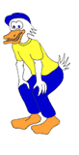

Do you know how our creeks, rivers, lakes, streams and beaches get polluted? Or have you ever wondered what those holes in the gutters were for?

Water pollution can come from a lot of different places, but the number one reason that our creeks, rivers, lakes, streams and beaches get dirty is from the water and other pollutants that flow into storm drains.

What’s storm water pollution? Storm water is the water that runs down the street when it’s raining. Storm water enters holes in the gutter called storm drains. Water that flows down the street when it’s not raining, like when you wash your car or water your lawn, is called urban runoff.

Confused yet? Take a look…
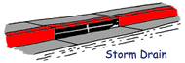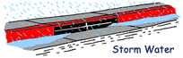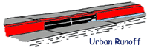
After storm water and urban runoff flow into the storm drain, it gets sent to the nearest creek, river, stream, lake or ocean so our streets don’t flood. That means any pollutant on the street or in urban runoff gets carried to our water bodies and eventually the ocean.
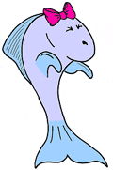
Yuck! Can you imagine swimming in all the gross stuff that’s on our streets? Soaps, grass clipping, litter, pet waste, pesticides and fertilisers, dirt and oil are just some of the pollutants that make our water unhealthy for people and other animals.

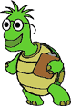
Can you think of all the pollutants that can float down a storm drain and contaminate our water?
Let’s make a list! Use the pictures to help you.

 | What’s causing the pollution? |  | What’s causing the pollution?
 |  | 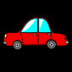
others |  | others

TEACHER REFLECTION - UNIT EVALUATION

Unsatisfactory
Satisfactory

Poor
Good

A. A. EVIDENCE
To what extent does the assessment evidence provide:
1. A valid and reliable measure of the targeted outcomes/enduring understandings?
2. Sufficient information to support inferences about each
student’s understanding/level of achievement?
3. Opportunities for students to demonstrate their understandings through authentic learning tasks?
B. LEARNING EXPERIENCES AND INSTRUCTION
To what extent did students:
1. Achieve the outcomes and the enduring understandings of the unit (the big ideas as opposed to basic facts and skills)?
2. Know where they were going and why (in terms of unit goals, requirements, and evaluative criteria)?
3. Deepen their knowledge and understanding of the outcomes & big ideas of the Unit (through inquiry, research, problem solving, and experimentation)?
4. Receive explicit instruction on the knowledge and skills needed to equip them for the required performances?
5. Have opportunities to rehearse, revise, and refine their work based on feedback?
6. Self-assess and set goals prior to the conclusion of the unit?

PTO

1. What did students learn? (What knowlege and skills did they learn to deepen their understanding of the outcomes/big ideas of the unit?)

2. How do you know what they learnt? (What evidence do you have to support your judgement?)

3. What would you refine to improve student learning outcomes?

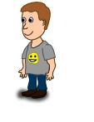
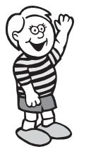
Student Unit Reflection
Stage 1

Student Name: Class:
Unit/Topic:

Completing the sentences below will help me to remember the important things I learnt about how to keep myself happy, healthy and safe.
One of the things I enjoyed learning about was….  ☺ | One thing I would change is….  ☹
  One thing I enjoyed sharing with my family at home was…. | What things from this unit would I like to learn more about?

The rating I give myself for how hard I worked in this unit is…

1 2 3 4 5

