KEEPING MYSELF SAFE AROUND MEDICINES
PUTTING SAFETY FIRST!
Stage: 1 Year: 2 | Unit Duration: 10 Lessons |  | Weeks 1 2 3 4 5 6 7 8 9 10 |  |  | Terms 1 2 3 4
Enduring Understandings  E.1 We have a responsibility to make informed choices about personal safety that ensure optimal health and well being.  E.2 Promote personal health and well being by following safe procedures. |  |  | Essential Questions  - How can I keep myself and others safe around medicines?  - How can I keep myself and others safe on or near the road?
Major Outcomes  Knowledge and Understanding  SLS1.13 Recognises that their safety depends on the environment and the behaviour of themselves and others.  Skills  DMS1.2 Recalls past experiences when making decisions.  Values and Attitudes  V1 Refers to a sense of their own worth and dignity. |  |  | Lesson Overview  (Note: Lessons 1-5 are not reproduced in this document for copyright purposes. Refer to the NSW Department of Education and Training (2002) K–6 Drug Education Resource p.27-37).  - What should I do to get help? (E.1)  - What needs to be kept in a safe place? (E.1)  - How do my friends and I use medicines safely?  (E.2)  - How can we store medicines safely? (E.1, E.2)  - How do I know what is safe for me? (E.2)  - How do I cross the road safely?(E.1, E.2)  - Where is it safe to cross? (E.1, E.2)  - How do I use pedestrian lights? (E.2)  - How do I cross the road safely? (E.2)  - Why use seatbelts? (E.1, E.2)  KidsMatter SEL Focus:  Major: Responsible Decision Making – Problem Solving; Responsible Decision Making – Assuming Personal Responsibility; Responsible Decision Making – Analysing Situation; Relationship Skills – Refusal; Social Awareness – Perspective Taking

Contributing Outcomes

Knowledge and Understanding
PHS1.12 Recognises that positive health choices can promote well being.
Skills
PSS1.5 Draws on past experiences to solve familiar problems.

Values and Attitudes
V4 Increasingly accepts responsibility for personal and community health.

Catholic Dimension/Towards Wholeness (TW) (Also refer to overview of TW for this unit)
Personal Health Choices
Throughout our lives, we all face having to make personal decisions relating to nutrition, hygiene, consumerism, drug use and disease prevention. So many conflicting opinions and values influence children in making decisions that have direct relevance to their health and well-being. Taught from a Catholic perspective, this strand seeks to develop the children’s abilities to observe, explore, interpret and judge, informed by an emerging integrated value system that is based on the values of the Gospel.

Safe Living
This strand seeks to develop an ability and a commitment to act in ways that will protect self and others from harm. It emphasises respect for the human person and the development of a co-operative, caring society. Sound Christian decision-making is based on a well-formed conscience which draws inspiration from the life and teaching of Christ and from his Church. Within this strand, students learn to respect the rights of others and to value acceptance, tolerance, justice and personal freedom. They learn that their own decisions have consequences for themselves and others.

Foundation Statement
Students describe ways to keep healthy and safe and explore choices relating to food, sun protection and personal safety. They identify the appropriate use, administration and storage of medicines. Students describe strategies to stay safe at home, on and near roads, when travelling to and from school, and near water. They recognise safe and unsafe environments and situations and suggest a range of protective strategies for dealing with unsafe situations.

Students describe similarities and differences between themselves and others. They describe different body parts and how the body grows and changes. Students explore different types of relationships and describe the skills needed to develop and maintain positive relationships. They identify the effects of bullying.

Suggested correlations with other KLAs  English  - Procedure  - Narrative Text (concept development)  - Personal Response  - Talking and Listening  Creative Arts  - Drama – Performing and Appreciating  - Visual Arts |  |  | Science and Technology  - Products and Services  - Investigating kitchen/laundry/bathroom/garage products  HSIE  - Social Systems and Structures  - Roles and responsibilities  - Safety rules within the community
Technology

The following websites have been selected to enhance various concepts being taught throughout this unit. Most of the sites listed can be linked to more than one of the lessons being taught. Teachers may like to add them to the school intranet site.
- http://www.cyh.com/HealthTopics/HealthTopicDetailsKids.aspx?p=335&np=285&id=2376
- http://pbskids.org/rogers/trafficLight.html
- http://www.cornwall.gov.uk/default.aspx?page=14784
- http://www.zebracrossinggame.com/
- http://www.roadsafetyni.gov.uk/index/education/kidzone/kidzone-games.htm
- http://www.rapsforkids.com.au/games.php
- http://shop.mynrma.com.au/game/game_content.html
- http://www.nhtsa.dot.gov/people/injury/childps/PlayItSafeWeb/pages/index.htm

Subject Matter  Personal Health Choices  Health Services and Products  - People who keep me healthy  - home  - community  Drug Use  - Purpose of medication  - Safe use of medication  - Administration of medicines  - Safe storage of medicines |  | Safe Living  Personal Safety  - Safe/unsafe situations  Home and Rural Safety  - Hazards inside/outside home: poisons/fuels/guns  - Safe handling of substances/animals  Road Safety  - Pedestrian Safety  - places to cross safely  - safe crossing procedures |  |  | - Passenger safety  - use of a seatbelt  - safe entry and exit from a vehicle  Emergency Procedures  - What to do in the event of an emergency
Unit Evaluation  Sample teacher and student unit evaluations are included at the end of the unit. |  |  |  | Assessment  Assessment strategies are included throughout the unit.

An Overview of Towards Wholeness (TW) in the PDH Unit
Keeping Myself Safe around Medicines/Putting Safety First! - Stage1

Key God’s Word:

Take care of others. (Rm 12: 3-13) TW p.29

Do what is right. (Mt 6:8) TW p.31

God wants us to be safe and will protect us as we come and go now and forever. (Ps 121: 5-8) TW p.41

Christians believe that their bodies are given to them as temples of the Holy Spirit and that freedom and dignity demand that they not abuse their bodies in any way. (1 Cor 6: 19-20) TW p.39

Enduring  Understandings | Towards Wholeness  Beliefs and Values | Lesson Overview
E.1 We have a responsibility to make informed choices about personal safety that ensure optimal health and well being. | - We have the responsibility to protect and care for ourselves and others. p.41  - We have a responsibility to promote our health by making wise decisions. p.38 | 1. What should I do to get help?  2. What needs to be kept in a safe place?  4. How can we store medicines safely?  6. How do I cross the road safely?  7. Where is it safe to cross?  10. Why use seatbelts?
E.2 Promote personal health and well being by following safe procedures. | - Effective decision-making is dependent on an informed conscience. p.39  - We appreciate and respect our bodies and those of others. p.35 | 3. How do my friends and I use medicines safely?  4. How can we store medicines safely?  5. How do I know what is safe for me?  6. How do I cross the road safely?  7. Where is it safe to cross?  8. How do I use pedestrian lights?  9. How do I cross the road safely?  10. Why use seatbelts?

Lessons 1-5 Keeping Myself Safe Around Medicines (Drug Education)

NOTE:
Lessons 1-5 are not reproduced in this document for copyright purposes. Refer to the NSW Department of Education and Training (2002) K–6 Drug Education Resource p. 27-37.

The K–6 Drug Education Resource can be found at

http://www.schools.nsw.edu.au/media/downloads/schoolsdrug/learning/yrk12focusareas/druged/k6_der.pdf

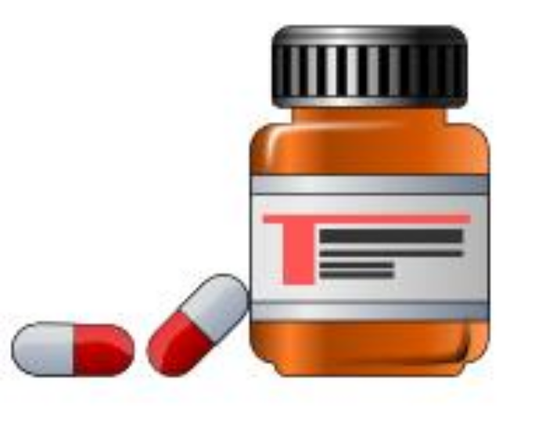
Towards Wholeness Learning Experiences And Organisation

The following TW lessons are to be taught in lessons 1 to 5 in conjunction with the K–6 Drug Education Resource.

Enduring Understandings | Lesson | Suggested Teaching Activities
E.1 We have a responsibility to make informed choices about personal safety that ensure optimal health and well being. | 1. What should I do to get help? | No TW Activity for this lesson.
E.1 We have a responsibility to make informed choices about personal safety that ensure optimal health and well being. | 2. What needs to be kept in a safe place? | TW: After discussing the questions related to the displayed cleaning products, teacher explains to the students the responsibility they have to protect and care for themselves and others. Teacher highlights that by keeping these products in special places, we are behaving responsibly.
E.2 Promote personal health and well being by following safe procedures. | 3. How do my friends and I use medicines safely? | TW: After directing the students to the unsafe practice of leaving the lids off medicines and not storing them properly, discuss the things that Jane did to show concern and care (appreciation and respect) for Emily’s health and safety.
E.1 We have a responsibility to make informed choices about personal safety that ensure optimal health and well being.  E.2 Promote personal health and well being by following safe procedures. | 4. How can we store medicines safely? | TW: After discussing where we should keep medicines, the teacher explains the responsibility we have to protect and care for ourselves and each other. The teacher then brings the children to the understanding that following safe steps for storing medicines is a wise decision that will keep ourselves and others safe.
E.2 Promote personal health and well being by following safe procedures. | 5. How do I know what is safe for me? | No TW Activity for this lesson.

Lesson 6 How do I cross the road safely?

Enduring Understandings | Outcomes |  | Indicators
E.1 We have a responsibility to make informed choices about personal safety that ensure optimal health and well being.  E.2 Promote personal health and well being by following safe procedures. | SLS1.13 Recognises that their safety depends on the environment and the behaviour of themselves and others.  PSS1.5 Draws on past experiences to solve familiar problems.  V4 Increasingly accepts responsibility for personal and community health. |  | - Describes what actions are needed for them to travel to and from school safely and practise these  - Determines a safe way to cross the road  - Appreciates the need for safe practices in a range of situations and environments
KidsMatter SEL Focus: Major - Responsible Decision Making - Analysing situations; Responsible Decision Making- Assuming personal Responsibility
Suggested Learning Experiences
TW: Teacher raises the students’ awareness of the responsibility we have to protect and care for ourselves and others. Building on from knowledge gained during Street Sense unit taught in Year 1, teacher reiterates the need to use the stop, look, listen and think process to cross roads safely (worksheet 2). Teacher discusses correct road crossing procedures and students sequence the cards correctly.

Choose two students, one to be the child and the other to be the adult, they demonstrate how to cross the road safely. Before they begin ask the questions: What can you hear/see? Are you holding the grown-up’s hand? Are there any safe road crossing places nearby?

Discuss different situations which could prove dangerous when crossing the road. For example:
- What’s coming along the road?
- Is the road straight?
- Is it curved?
- Can you see the traffic coming?
- Are there parked cars obstructing the view?
- Are there driveways?

In pairs, students take on the role of adult or child and demonstrate correct road crossing procedures. Use masking tape or chalk on the floor to indicate the road side kerb.

In small groups, students tell each other how they would complete the sentence, When I cross the road I ............................................ because ........................

OPTIONAL :Children use the interactive road safety games: http://nd.durham.gov.uk/kids/usp.nsf/pws/DCC+Kids+-+Games+-+HAL

Resources  - RTA. NSW. (2001). Move Ahead With Street Sense. Stage 1. Sydney: RTA. Stop! Look! Listen! Think! Cards p. 54.  - Interactive road safety websites |  | Assessment  Student participation in crossing road role play.
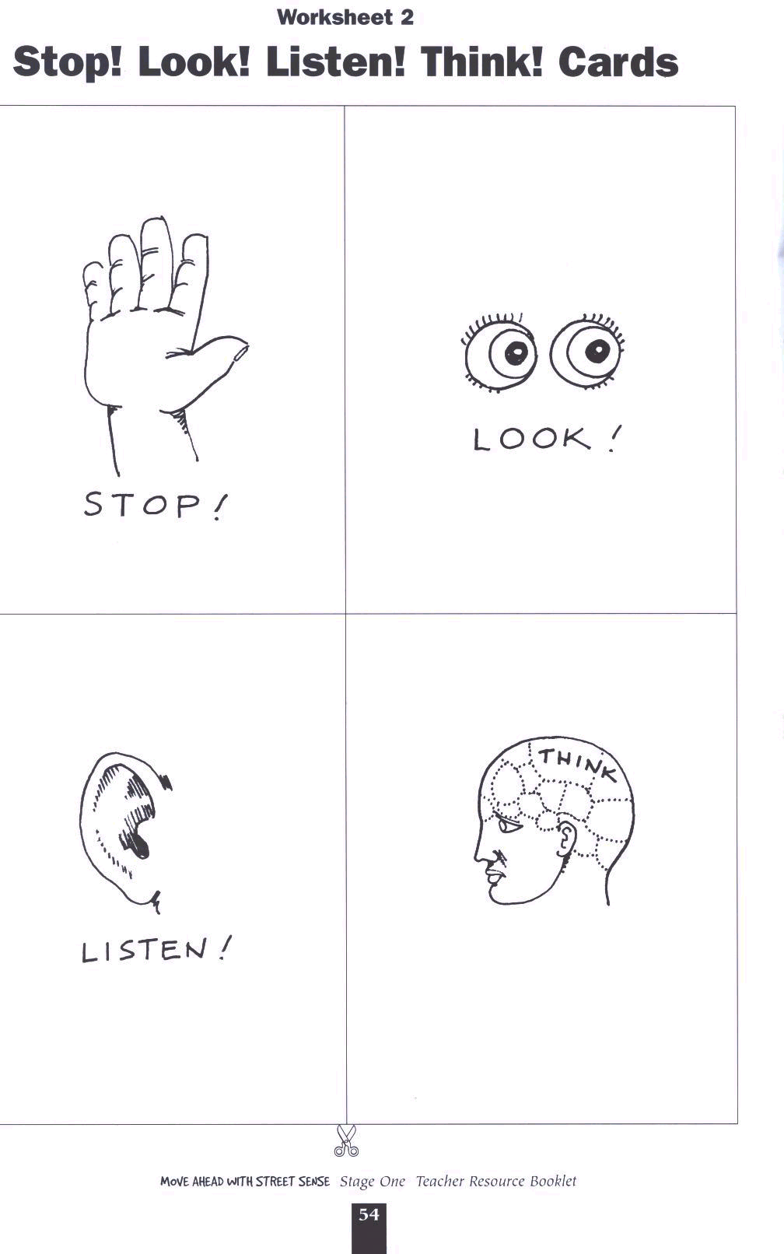
Reproduced from: Roads and Traffic Authority NSW (2000) Move Ahead with Street Sense Stages 1-3.
Lesson 7 Where is it safe to cross?

Enduring Understandings | Outcomes |  | Indicators
E.1 We have a responsibility to make informed choices about personal safety that ensure optimal health and well being.  E.2 Promote personal health and well being by following safe procedures. | SLS1.13 Recognises that their safety depends on the environment and the behaviour of themselves and others.  PSS1.5 Draws on past experiences to solve familiar problems.  V4 Increasingly accepts responsibility for personal and community health. |  | - Identifies and describes safe and unsafe places to cross the road  - Determines a safe way to cross the road  - Appreciates the need for safe practices in a range of situations and environments
KidsMatter SEL Focus: Major - Responsible Decision Making – Analysing situations
Suggested Learning Experiences

Using Road Safety Photographs 1, nos 2–5, students identify safe places for crossing the road. Students explain their responses.

In small groups, students discuss and list the places where they cross the road on their way to and from school. Students identify any pedestrian facilities they use that are similar to those in the photographs. Ask students to explain what makes a particular place more or less safe for crossing the road.

Using the pictures from Hold a grown ups’ hand when you cross the road worksheets, students identify why those crossing the road are doing so safely.

Divide the class into small groups. Each group is given a place from their local community and illustrates and labels the safest way to cross the road. For example outside the school, local shops, local park, main road.

Resources  - RTA. NSW. (2001). Move Ahead With Street Sense. Stage 1. Sydney: RTA. Safety Photographs 1, nos 2–5. Worksheets 3 (a), (b), (c), and (d). Hold A Grown-Up’s Hand When You Cross the Road P. 55–58.  - Pencils  - Art paper |  | Assessment  Teacher observation of small group activity.
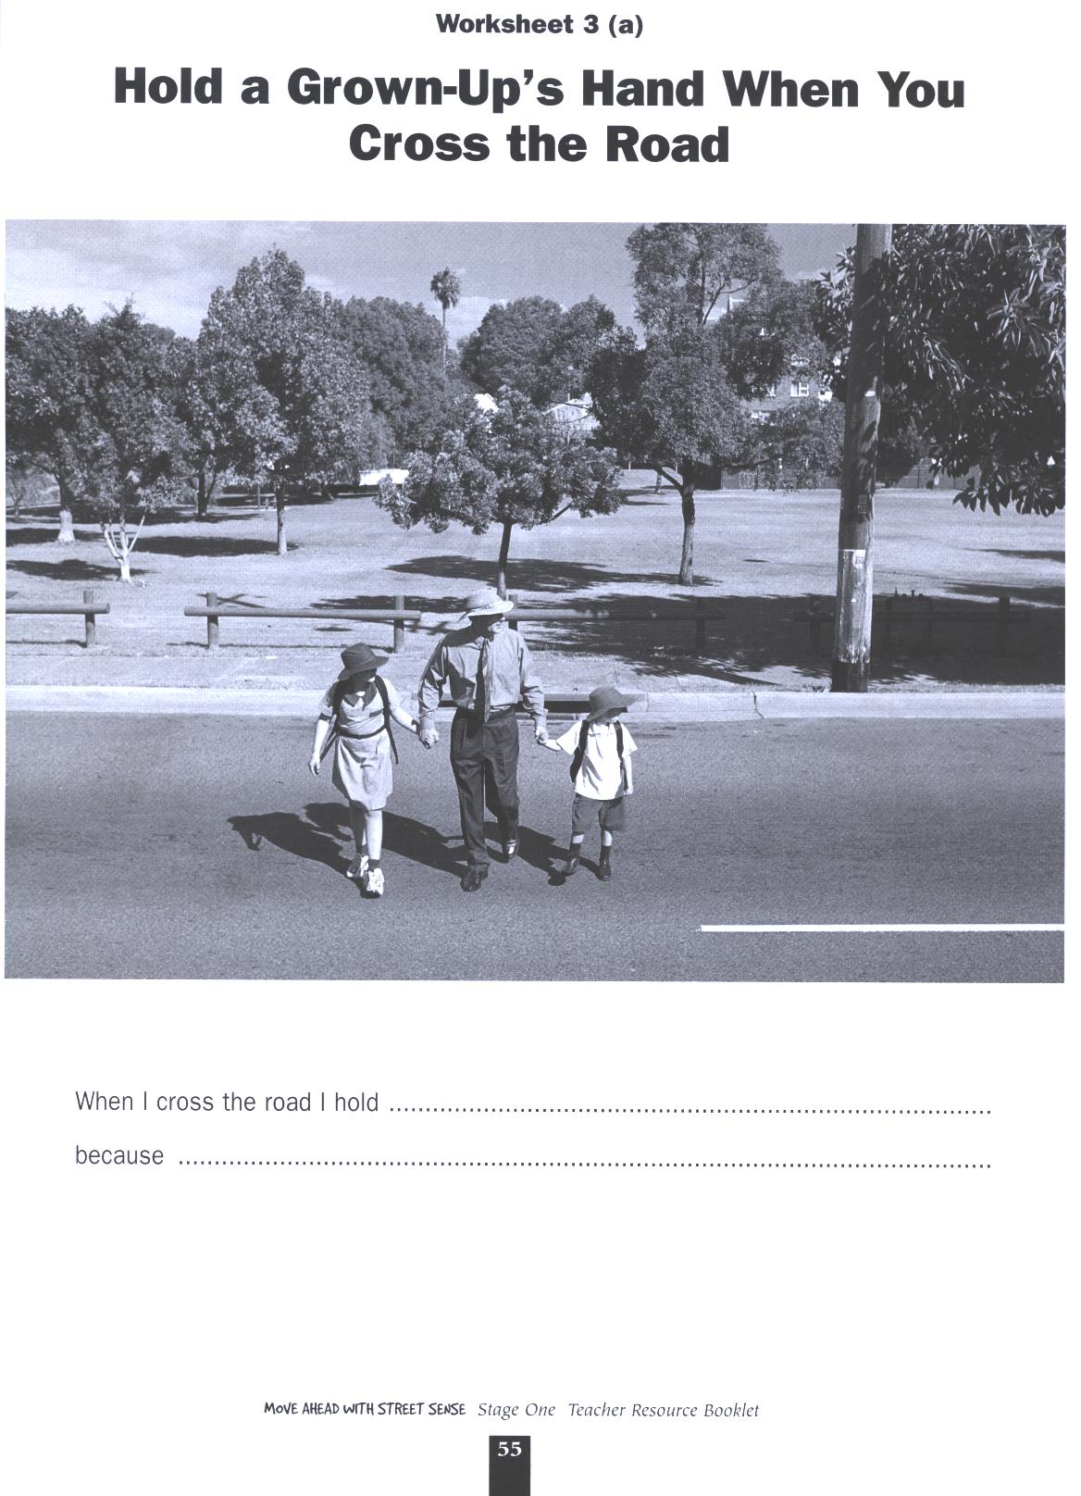

Reproduced from: Roads and Traffic Authority NSW (2000) Move Ahead with Street Sense Stages 1-3.

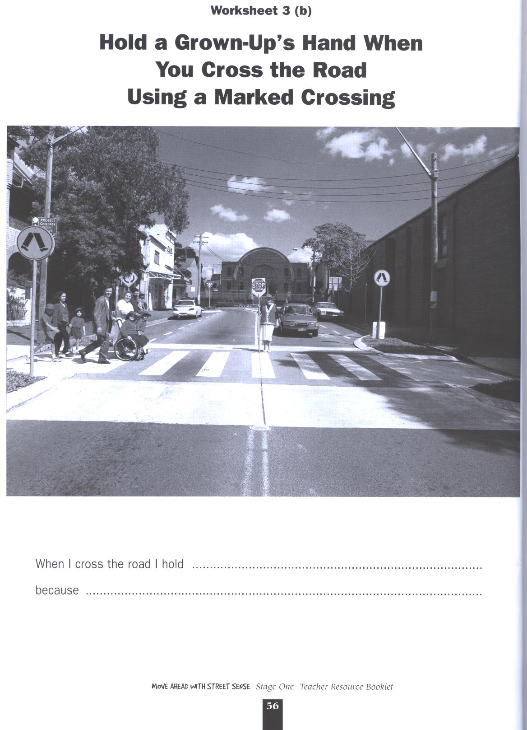

Reproduced from: Roads and Traffic Authority NSW (2000) Move Ahead with Street Sense Stages 1-3.

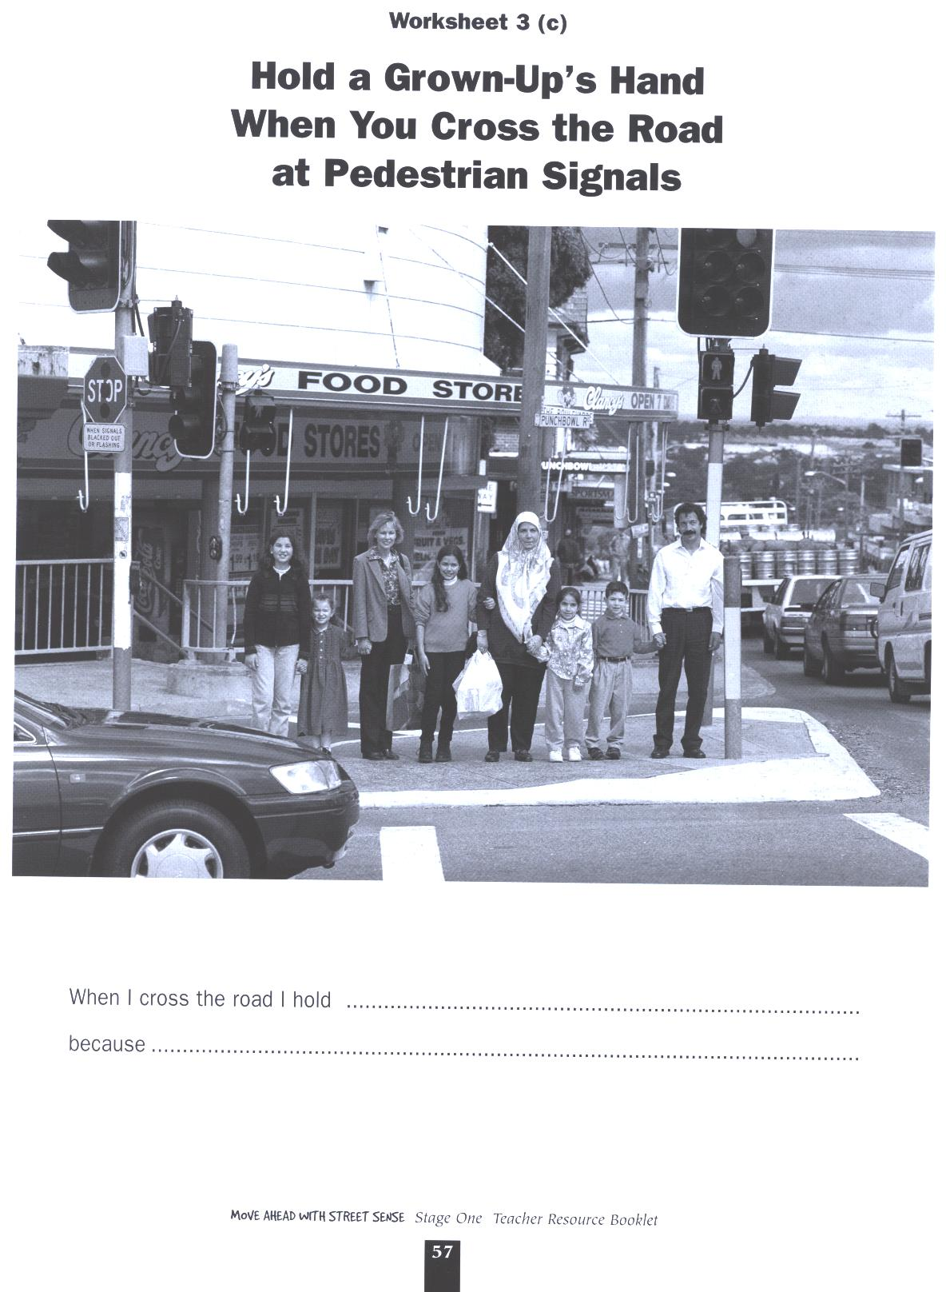

Reproduced from: Roads and Traffic Authority NSW (2000) Move Ahead with Street Sense Stages 1-3.

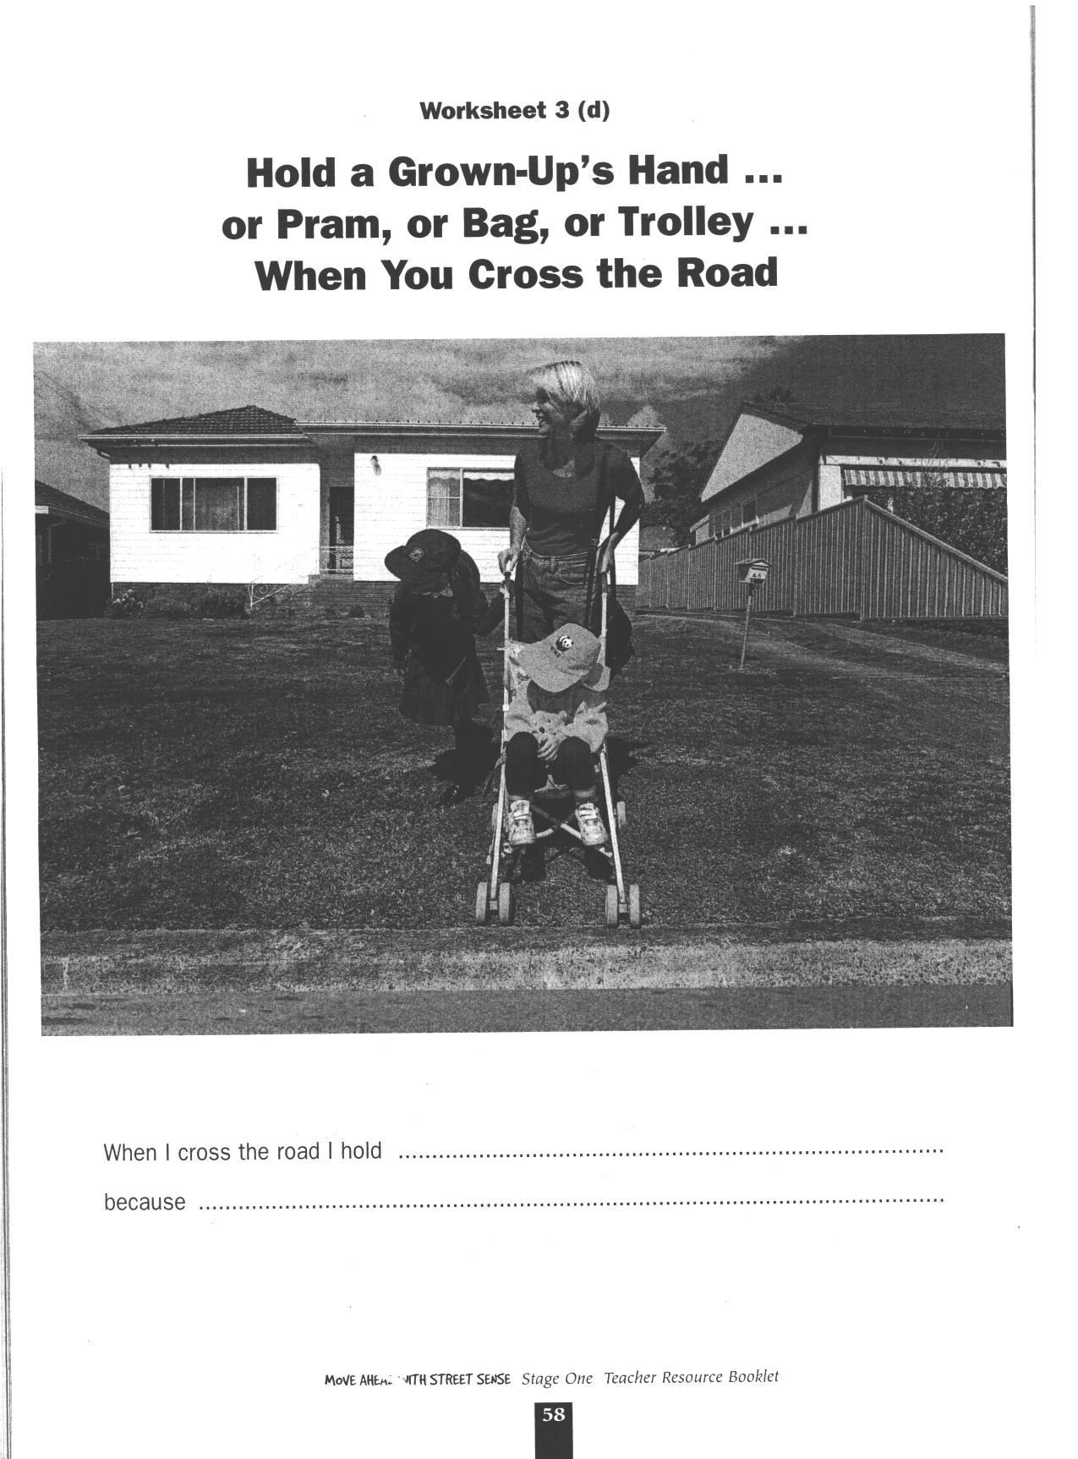

Reproduced from: Roads and Traffic Authority NSW (2000) Move Ahead with Street Sense Stages 1-3.
Lesson 8 How do I use pedestrian lights?

Enduring Understandings | Outcomes | Indicators
E.2 Promote personal health and well being by following safe procedures. | SLS1.13 Recognises that their safety depends on the environment and the behaviour of themselves and others.  PSS1.5 Draws on past experiences to solve familiar problems.  V4 Increasingly accepts responsibility for personal and community health. | - Explains the role of pedestrian lights  - Follows basic safety procedures  - Appreciates the need for safe practices in a range of situations and environments
KidsMatter SEL Focus: Major - Responsible Decision Making - Assuming personal Responsibility
Suggested Learning Experiences

Students use Road Safety Photographs 1, no 4 to discuss pedestrian lights or signals. Teacher discusses the different colours, symbols and sounds and when it is safe to cross. Make specific reference to the situation when the red DON’T WALK signal is activated. What do you hear when the Don’t Walk Sound is on? How does this sound help people?

Using the templates of the WALK/DON’T WALK signs provided in Worksheet 4 Pedestrian Signals students explain what the signals mean and where they see them. Children colour appropriately.

TW: Teacher raises the students’ awareness of the responsibility we have to protect and care for ourselves and others. We can do this by learning safe actions near roads, driveways and car parks. Students role play crossing safely at the lights using constructed lights.

MAKING LIGHTS
Cut out square shapes from cardboard boxes and infill with red and green cellophane and with the templates of the WALK/DON’T WALK signs provided in Worksheet 4, Pedestrian Signals. Use torches to light up the red, green and flashing red signals.

Resources  - RTA. NSW. (2001). Move Ahead With Street Sense. Stage 1. Sydney: RTA. Road Safety Photographs 1, no 4. Templates of the WALK and DON’T WALK signs Worksheet 4. Pedestrian Signals. page 59.  - Cardboard boxes (shoe boxes)  - Cellophane – red, green  - Torches |  | Assessment  Teacher observation of class discussion.
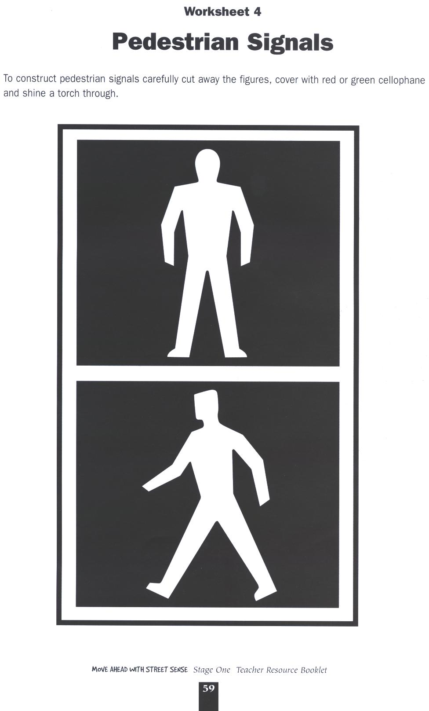

Reproduced from: Roads and Traffic Authority NSW (2000) Move Ahead with Street Sense Stages 1-3.
Lesson 9 How can I cross the road safely?

Enduring Understandings | Outcomes |  | Indicators
E.2 Promote personal health and well being by following safe procedures. | SLS1.13 Recognises that their safety depends on the environment and the behaviour of themselves and others.  DMS1.2 Recalls past experiences in making decisions.  V4 Increasingly accepts responsibility for personal and community health. |  | - Describes what actions are needed for them to travel to and from places safely and practices these  - Predicts consequences of options in order to make a decision e.g. where to cross safely?  - Appreciates the need for safe practices in a range of situations and environments
KidsMatter SEL Focus:Major - Responsible Decision Making - Assuming personal Responsibility
Suggested Learning Experiences

TW: Teacher revises the belief that we have a responsibility to protect and care for ourselves and others. We can do this by learning and practising safe actions near roads, driveways and car parks. As a class revise the important things that we have learnt about crossing the road safely.

Individually, students identify the three most important things that they would like to tell their families or the community about crossing the road safely. Using photocopies of Guide for Pedestrians Worksheet 5 students draw and specify three important messages about crossing the road safely, beginning with ‘Always remember ..................’. (If this assessment task is to be used for portfolios, a sample proforma has been included).

HOME TASK
Take the above assessment task home and share it with their families, explaining their choices. Encourage them to model such safe practices with their families when out and about.

Resources  - RTA. NSW. (2001). Move Ahead With Street Sense. Stage 1. Sydney: RTA.  Worksheet 5. Guide for Pedestrians. p.60. |  | Assessment  Student work sample of Know the Rules Activity.

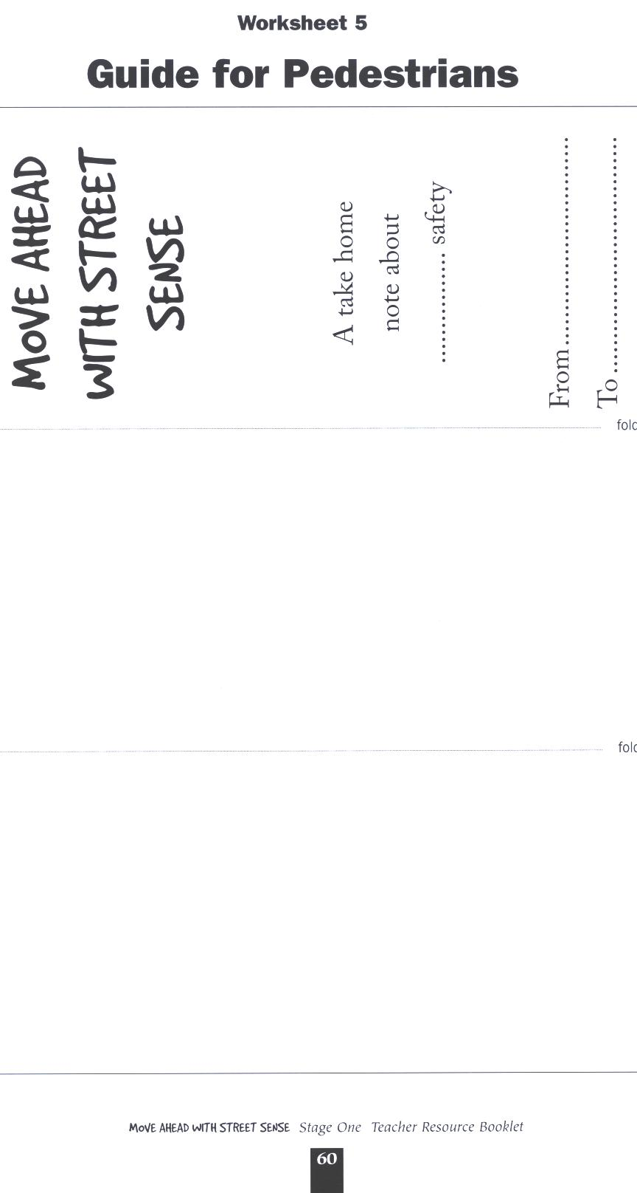

Reproduced from: Roads and Traffic Authority NSW (2000) Move Ahead with Street Sense Stages 1-3.

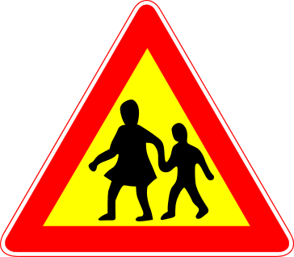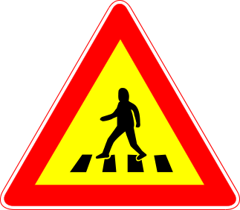

Lesson 9 – Know The Rules Activity

Student: ________________________________________

This task provides students with the opportunity to demonstrate their standard of achievement of the following outcomes:

Outcomes | Indicators | Working towards | Achieved with support | Achieved
SLS1.13 Recognises that their safety depends on the environment and the behaviour of themselves and others. | Identifies how to cross the road safely and safe places to cross
PSS1.5 Draws on past experiences to solve familiar problems. | Follows basic safety procedures
TASK:
Students identify the three most important things they would like to tell their families or the community about crossing the road safely and design a poster, using MAWSS Worksheet 5 Guide for Pedestrians.

Lesson 10 Why use seatbelts?

Enduring Understandings | Outcomes | Indicators
E.1 We have a responsibility to make informed choices about personal safety that ensure optimal health and well being.  E.2 Promote personal health and well being by following safe procedures. | SLS1.13 Recognises that their safety depends on the environment and the behaviour of themselves and others.  PSS1.5 Draws on past experiences to solve familiar problems.  V4 Increasingly accepts responsibility for personal and community health. | - Describes what actions are needed for them to travel to and from school safely and practices these  - Describes why it is important to wear a seatbelt  - Appreciates the need for safe practices in a range of situations and environments
KidsMatter SEL Focus: Major - Responsible Decision Making - Assuming personal Responsibility
Suggested Learning Experiences
Teacher and students read the shared book Jeffrey to the class and discuss the need to always wear a seatbelt whether you are on a long or short trip, asleep or awake and whether there are lots of passengers or only a few. Teacher reminds the students about safe entry and exit ‘rules’ from a vehicle.

Using photocopies of Worksheet 7 Always Buckle Up in Your Seatbelt, students draw themselves sitting between Kim and Ben, wearing a seatbelt. Students complete the sentences under the picture, ‘I like to wear my seatbelt because …’. Students may paste photocopies of photographs of themselves on this worksheet.

TW: Students discuss why it is important to always wear a seatbelt and what happens if passengers don’t wear seatbelts. Teacher reminds the students that we have a responsibility to protect and care for ourselves and others by following safety rules.

In groups, students solve the problem and then record their answers on Worksheet 8 Click Clack Front and Back.:
You are travelling in the back seat of a car with two friends. Everyone is safely buckled up. One of your friends decides to unbuckle his/her seatbelt. You know that your friend won’t be safe with a seatbelt unbuckled. What would you do?’

HOME TASK: Students take the worksheet home to parents and ask them to add other suggestions on how to manage this situation.

Resources  - RTA. NSW. (2001). Move Ahead With Street Sense. Stage 1. Sydney: RTA. Jeffrey Big Book. Worksheet 7. Always Buckle Up in Your Seatbelt. p.62. Appendix 7. Worksheet 8. Click Clack Front and Back. page 63.  - www.rta.nsw.gov.au/roadsafety/ |  |  | Assessment  Student work samples of Click, Clack, Front ’n’ Back Worksheet.

Lessons 6-10 Adapted and reproduced with kind permission from: RTA. NSW. (2001). Move Ahead With Street Sense. Stage 1. Sydney: Author.
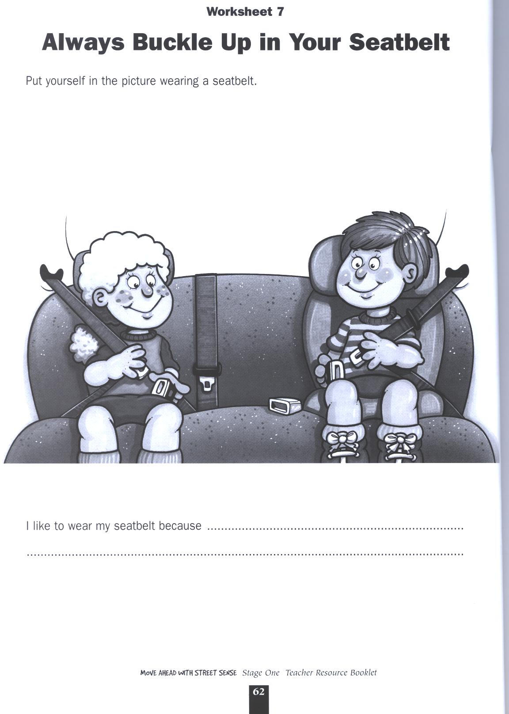

Reproduced from: Roads and Traffic Authority NSW (2000) Move Ahead with Street Sense Stages 1-3.
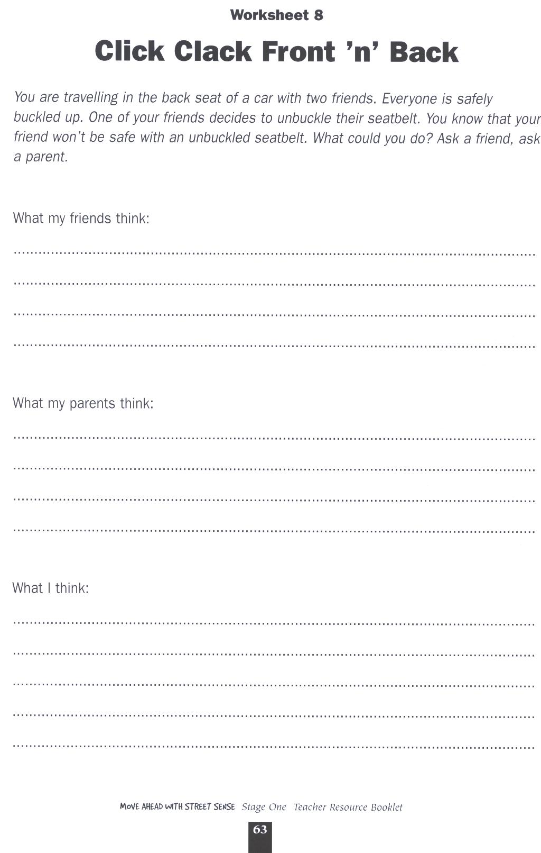

Reproduced from: Roads and Traffic Authority NSW (2000) Move Ahead with Street Sense Stages 1-3.

TEACHER REFLECTION - UNIT EVALUATION

Unsatisfactory
Satisfactory

Poor
Good

A. A. EVIDENCE
To what extent does the assessment evidence provide:
1. A valid and reliable measure of the targeted outcomes/enduring understandings?
2. Sufficient information to support inferences about each
student’s understanding/level of achievement?
3. Opportunities for students to demonstrate their understandings through authentic learning tasks?
B. LEARNING EXPERIENCES AND INSTRUCTION
To what extent did students:
1. Achieve the outcomes and the enduring understandings of the unit (the big ideas as opposed to basic facts and skills)?
2. Know where they were going and why (in terms of unit goals, requirements, and evaluative criteria)?
3. Deepen their knowledge and understanding of the outcomes & big ideas of the Unit (through inquiry, research, problem solving, and experimentation)?
4. Receive explicit instruction on the knowledge and skills needed to equip them for the required performances?
5. Have opportunities to rehearse, revise, and refine their work based on feedback?
6. Self-assess and set goals prior to the conclusion of the unit?

PTO

1. What did students learn? (What knowlege and skills did they learn to deepen their understanding of the outcomes/big ideas of the unit?)

2. How do you know what they learnt? (What evidence do you have to support your judgement?)

3. What would you refine to improve student learning outcomes?

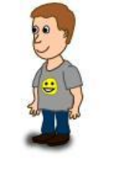
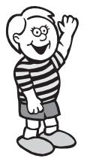
Student Unit Reflection
Stage 1

Student Name: Class:
Unit/Topic:
Completing the sentences below will help me to remember the important things I learnt about how to keep myself happy, healthy and safe.

One of the things I enjoyed learning about was….  ☺ | One thing I would change is….  ☹
  One thing I enjoyed sharing with my family at home was…. | What things from this unit would I like to learn more about?

The rating I give myself for how hard I worked in this unit is…

1 2 3 4 5

