KEEPING MYSELF SAFE
Updated January 2017

Stage: ES1 | Unit Duration: 10 Lessons |  | Weeks 1 2 3 4 5 6 7 8 9 10 |  | Terms 1 2 3 4
Enduring Understandings  E.1 We all have the right to feel safe.  E.2 We need to tell how we are feeling.  E.3 We have a responsibility to make good choices so we can live a happy and healthy life. |  |  | Essential Questions:  - What can I do to keep myself and others safe?  - What are safe and unsafe places, people and things?
Major Outcomes  Knowledge and Understanding  SLES1.13 Demonstrates an emerging awareness of the concepts of safe and unsafe living  Skills  INES1.3 Relates well to others in work and play situations  PSES1.5 Seeks help when needed when faced with simple problems.  Values  V4 Increasingly accepts responsibility for personal and community health |  |  | Lesson Overview  - What is a caring healthy relationship? (E.1,E.2,E.3)  - Why is trust important? (E.1,E.2)  - How does my body tell me I feel unsafe? (E.1)  - What is unsafe touching? (E.1,E.2)  - How can I ask for help when I feel unsafe? (E.1,E.2)  - How can I be safe when I cross the road? (E.1,E.3)  - How do I keep safe in the car? (E.3)  - How do I wear my helmet and where is it safe to ride and play? (E.3)  - How can I use the Internet and phones safely? (E.3)  Note: This is a sensitive issue unit which focuses on Child Protection Education (CPE) in Lessons 1-5. A parent note should go home prior to the unit. For further background information on CPE refer to the NSW Department of Education and Training Stage 1, Child Protection Education Resource.  KidsMatter SEL Focus:  Major: Relationship Skills – Building Relationships, Responsible Decision Making – Analysing situations, Self-Management - Managing emotions, Self-Awareness - Identifying emotions, Relationship Skills - Refusal, Responsible Decision Making - Assuming personal Responsibility,  Minor: Relationship Skills - Refusal
Contributing Outcomes

Knowledge and Understanding
IRES1.11 Identifies how individuals care for each other
Skills
COES1.1 Expresses feelings, needs and wants in appropriate ways
DMES1.2 Identifies some options available when making simple decisions
Values
V3 Enjoys a sense of belonging
Catholic Dimension/Towards Wholeness (TW) (Also refer to overview of TW for this unit)
Interpersonal Relationships
Human beings find their true place within community; they grow towards maturity through the relationships they maintain. We all depend on each other and, as we mature, we grow in awareness of our responsibility for each other. Alone and isolated we cannot develop our gifts and live as God intended. Among family, friends, members of our peer group and others, we find our place as contributing members of society. It calls us all to enter freely into loving and forgiving relationships that are embedded in community, to develop such qualities as honesty, respect, empathy, openness and a commitment to equality.

Safe Living
This strand seeks to develop an ability and a commitment to act in ways that will protect self and others from harm. It emphasises respect for the human person and the development of a co-operative, caring society. Sound Christian decision-making is based on a well-formed conscience which draws inspiration from the life and teaching of Christ and from his Church. Within this strand, students learn to respect the rights of others and to value acceptance, tolerance, justice and personal freedom. They learn that their own decisions have consequences for themselves and others.

Foundation Statement
Students make simple decisions in relation to health and safety and identify medicines and how to store them. They describe balanced eating habits and healthy personal habits as well as safe and unsafe situations at home, on and near roads, travelling to and from school and near water. Students identify people who can help and describe actions such as ‘no, go, tell’ that might be taken in unsafe situations.
Students identify personal characteristics and qualities, and physical changes that have occurred since birth and identify different parts of the body. With self control, students express feelings and develop positive relationships. They interact and communicate with peers in a variety of play and group situations, listening, sharing and showing concern when working with others.

Suggested correlations with other KLAs  English  - Narrative Text (concept development)  - Procedural Recount  - Exposition  - Personal Response  Creative Arts  - Visual Arts – Making and Appreciating  - Drama – Performing and Appreciating |  |  | Science and Technology  - Information and Communication  - Investigating signs that promote safety  - Design and make posters for road/water safety  HSIE  - Social Systems and Structures  - Roles and Responsibilities
Technology

The following websites have been selected to enhance various concepts being taught throughout this unit. Most of the sites listed can be linked to more than one of the lessons being taught. Teachers may like to add them to the school intranet site.
- http://www.cyh.sa.gov.au/HealthTopics/HealthTopicDetailsKids.aspx?p=335&np=288&id=1503
- http://www.cornwall.gov.uk/default.aspx?page=14784
- Safety Town Website - https://www.safetytown.com.au/
- http://www.cybersmart.gov.au/Young%20Kids.aspx

Subject Matter  Interpersonal Relationships  Relationships  - Trust  - Positive relationships  - Special people/things  - Rules in relationships  - People to go to for help |  | Safe Living  Personal Safety  - Warning signals  - Safe/unsafe situations  - Touching  - People who can help  - Assertiveness (No-Go-Tell)  - Telling (Persistence)  - Responding to unsafe situations |  | Road Safety  - Pedestrian safety  - Hold an adult’s hand  - Passenger safety  - Use of seatbelts and safety restraints  - Safety on wheels  - Safe places to play on wheels
Unit Evaluation  Sample teacher and student unit evaluations are included at the end of the unit. |  |  | Assessment  Assessment strategies are included throughout the unit.

An Overview of Towards Wholeness (TW) in the PDH Unit
Keeping Myself Safe-Early Stage 1

Key God’s Word:

‘God wants us to be safe and will protect us as we come and go now and forever.’ ’ (Ps 121:5-8)

Treat others as you would like them to treat you. (Mt 7:12)

Do what is right. (Mt 6:8)

Jesus, Mary and Joseph. (Lk 2:15-20)

Jesus in the Temple. (Lk 2:41-52)

Enduring Understandings | Beliefs and Values | Lesson Overview/Links
E.1 We all have the right to feel safe | - Each person has rights and responsibilities in relation to personal safety. TW p.41  - We have a responsibility to protect and care for ourselves. TW p.41  - We have a responsibility to protect and care for others. TW p.41  - We recognise the rights and dignity of others, through courtesy and respect. TW p.34 | 1. What is a caring healthy  relationship?  2. Why is trust important?  3. How does my body tell me I  feel unsafe?  4. What is unsafe touching?  5. How can I ask for help when I feel unsafe?  6 - 7. How can I be safe when I cross the road?
E.2 We need to tell how we are feeling | - Honest and open communication will enable us to become mature and responsible Christians, able to make and evaluate personal choices. TW p.32 | 1. What is a caring healthy  relationship?  2. Why is trust important?  4. What is unsafe touching?  5. How can I ask for help when I feel unsafe?
E.3 We have a responsibility to make good choices so we can live a happy and healthy life | - Honest and open communication will enable us to become mature and responsible Christians, able to make and evaluate personal choices. TW p.32  - Each person has rights and responsibilities in relation to personal safety. TW p.41 | 1. What is a caring healthy  relationship?  6 – 7. How can I be safe when I cross the road?  8. How do I keep safe in the car?  9. How do I wear my helmet and where is it safe to ride and play?  10. How can I use the Internet  and phone safely?
Lesson 1 What is a caring healthy relationship?

Enduring Understandings | Outcomes |  | Indicators
E.1 We all have the right to feel safe.  E.2 We need to tell how we are feeling.  E.3 We have a responsibility to make good choices so we can live a happy and healthy life. | SLES1.13 Demonstrates an emerging awareness of the concepts of safe and unsafe living  IRES1.11 Identifies how individuals care for each other  INES1.3 Relates well to others in work and play situations  V3 Enjoys a sense of belonging |  | - Talks about feeling safe/unsafe  - Identifies people who are strangers  - Identifies people they can trust  - Talks about their family and who cares for them  - Identifies categories of relationships  - Identifies people who keep them safe  - Values positive relationships
KidsMatter SEL Focus: Major - Relationship Skills - Building Relationships
Suggested Learning Experiences
Note: This is a sensitive issue unit which focuses on Child Protection Education (CPE) in Lessons 1-5. A parent note should go home prior to the commencement of the unit.

Teacher displays pictures of people interacting in social settings, eg family dinner, sporting activities, celebrations, BBQs. Students discuss the people in each of the pictures and suggest the possible connections between people in the pictures.

Teacher explains that we have relationships with people we know. We have connections with them. As a class, students brainstorm their relationships under three categories:
- Family (mother, father, brother, sister, aunty, foster mum). When discussing families link to the Holy Family - Read “Jesus, Mary and Joseph. (Lk 2:15-20)”.
- Friends (same age, same sport, same interests/hobbies/likes, same school)
- People who help me (teacher, doctor, shopkeeper, mail person, neighbour, coach, police officer).

As a class, discuss:
- What do we call people we do not have a connection or relationship with? (strangers)
- Why are they strangers? (their personality, family, address are not known to us)
- What do strangers look like? (the same as people we know)

TW: Read “Jesus in the Temple”. Discuss how Mary was worried about Jesus and how our own parents/caregivers, similarly, have a concern about our safety. Recall a time you may not have told your parents where you were going and you got lost. How did you feel? How did your parents feel?

Students make a paper chain representing the various people they are connected with.
Resources  - Pictures of people interacting in social gatherings  - Paper to make paper chain  - Bible/Scripture references |  | Assessment  Teacher observation and student responses to the relationships that they know and trust
Lesson 2 Why is trust important?

Enduring Understandings | Outcomes | Indicators
E.1 We all have the right to feel safe.  E.2 We need to tell how we are feeling. | IRES1.11 Identifies how individuals care for each other  COES1.1 Expresses feelings, needs and wants in appropriate ways  V4 Increasingly accepts responsibility for personal and community health | - Identifies people they can trust  - Identifies people they can trust and why  - Values their health and safety and that of others
KidsMatter SEL Focus: Major - Responsible Decision Making - Analysing situations;
Minor - Relationship Skills - Refusal
Suggested Learning Experiences

Teacher Note: Trust is a key concept in child protection education. Students need to pay particular attention to their warning signals when they are confused about changes in a trusting relationship. Betrayal of trust is a common factor in child abuse. Mixed up (or confused) is a feeling shared by many children at the onset of abuse. Confusion occurs because established roles within a relationship suddenly become blurred or changed. It is important to include ‘mixed up’ (or confused) as an important warning signal for students.

The teacher reads one or more of the following scenarios:

Thelma was in Kindergarten. One day when her class was in the library Thelma’s teacher asked someone to do a job. She needed someone to carry the special gold stickers back to the classroom and put them on her desk. The teacher chose Thelma because she knew she could trust Thelma to do this special job.

Leo was six years old. One day he found a ten dollar note. He took it home and told his family. They decided that they would keep the money for a week to see if they could find out who had lost it. If they couldn’t find out who lost the money then Leo could keep the money. Leo gave the money to his step-dad because he knew he could trust his step dad to look after it.

Alinta and Julian were good friends. They played together at playgroup. One day Alinta brought in a very special toy that she had been given for her birthday. Alinta didn’t want anyone to touch it because it was very special but she let her friend Julian have a turn of her toy because Alinta knew she could trust Julian to look after it.

Discussion based on the following questions:
- What is trust? (Trust is believing in another person to do the right thing. We have YES feelings about someone we trust.)
- In each scenario, why did each person trust the other?
- When can we trust other people? (When we know them and we believe they will do the right thing and when we have a YES feeling about them.)
- Can you trust everyone you know? Why not?

Trusting relationships are based on shared, prior experiences which form the basis for trust i.e. you cannot trust strangers as you do not have a relationship with them.

The Teacher informs students that sometimes people we care about can break our trust. Read one or more of the following What if? situations:
- What if Thelma put the stickers in her bag to take home instead of on the teacher’s desk?
- What if Leo’s step dad spent the ten dollars he was supposed to look after?
- What if Julian played roughly with Alinta’s toy and scratched it?

Discussion based on the following questions:
- How might the each person feel when their trust was broken? (Sad, mixed up, hurt feelings and thinking.)
- Why might they feel like that? (It can be hard to understand when someone you care for gives you NO feelings.)
- What body signals might each person have received with these feelings? (Tight/sick stomach, hot face, watery eyes.)
- What could each person do about their feelings and body signals? (TELL or talk to someone about how they feel and gain relief.)

TW: Read “Do what is right.” (Mt 6:8) and discuss how God wants us to make good choices so that we are protecting and caring for ourselves and others.

Individually students draw a picture of one adult they trust to complete the sentence
I trust …………………….. because ….

Reinforce the concept that trust involves knowing the person and believing that he or she will always do the right thing. Keep students’ work from the concluding Activity for reference when discussing networks.

Resources  - Scenarios | Assessment  Student responses to scenarios and people they can trust

Adapted and reproduced with kind permission from: NSW Department of School Education and Training. Child Protection Education Resource. Stage 1. (1998). page 54.
Lesson 3 How does my body tell me I feel unsafe?

Enduring Understandings | Outcomes |  | Indicators
E.1 We all have the right to feel safe. | SLES1.13 Demonstrates an emerging awareness of the concepts of safe and unsafe living  COES1.1 Expresses feelings, needs and wants in appropriate ways  V4 Increasingly accepts responsibility for personal and community health |  | - Talks about feeling safe and unsafe  - Identifies people who keep them safe  - Identifies people who can help them  - Discuss warning signs and signals  - Values their health and safety and that of others
KidsMatter SEL Focus: Major - Self Management - Managing emotions; Self Awareness - Identifying emotions
Suggested Learning Experiences
Teacher reads the story of Hansel and Gretel and students identify whether the particular situations in the story were safe or unsafe for the children.
Teacher defines a signal as something that gives us a message. Teacher discusses signals that we need to take notice of, eg Red light, ambulance siren, thunder, burglar alarm, radio warning. Students discuss warning signs and signals experienced in their body – butterflies in tummy, feeling hot, feeling anxious, fast heart beat, shaking, feeling sick, being sweaty, knowing something is not right.
Students colour different body parts that tell us that something is not right on the Body Reactions Activity. In what situations might Hansel and Gretel feel these warning signs? How could they tell when something was wrong?
Teacher re-reads a section in the book where Hansel and Gretel are in trouble. Students suggest who could help the children to feel safe. What questions could Hansel and Gretel ask the witch to find out if they were safe? What information do the children need to remember about the witch and the gingerbread house to tell their parent/s and the police?

TW: We have a responsibility to protect and care for others
- How did Hansel and Gretel care for each other?
- Can you think of any other ways they could have cared for each other?
- Explain that: Each person has rights and responsibilities in relation to personal safety

Resources  - Hansel and Gretel book  - NSW Department of School Education. (1997). Child Protection Education. Curriculum materials to support teaching and learning in PDHPE. Stage 1. Ryde. Body Reactions Activity. p. 109. |  | Assessment  Student response to Body Reactions Activity

Adapted and reproduced with kind permission from: NSW Department of Education and Training. Child Protection Education Resource. Stage 1. (1998).
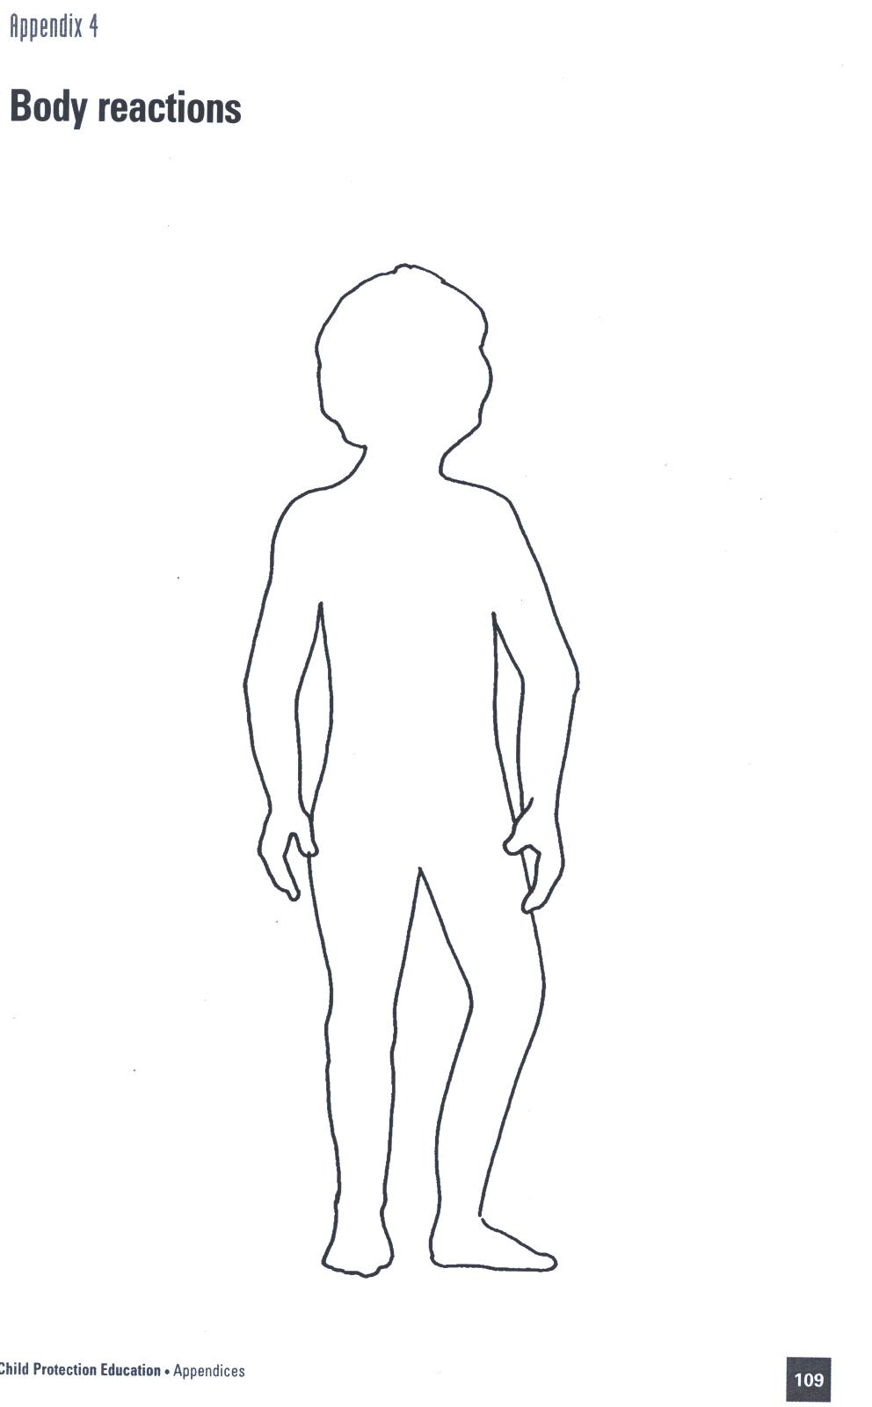

Reproduced from: NSW Department of School Education and Training (1998) Child Protection Education: Curriculum materials to support teaching and learning in PDHPE, Stages 1, 2 and 3.

Lesson 4 What is unsafe touching? (Protective behaviours/sensitive issue)

Enduring Understandings | Outcomes | Indicators
E.1 We all have the right to feel safe.  E.2 We need to tell how we are feeling. | SLES1.13 Demonstrates an emerging awareness of the concepts of safe and unsafe living  IRES1.11 Identifies how individuals care for each other  COES1.1 Expresses feelings, needs and wants in appropriate ways  V4 Increasingly accepts responsibility for personal and community health | - Talks about feeling safe and unsafe  - Identifies people who keep them safe  - Identifies people they can trust  - Identifies people who can help them  - Values their health and safety and that of others
KidsMatter SEL Focus: Major - Self Awareness - Identifying emotions
Suggested Learning Experiences

Students brainstorm words that describe different kinds of touch – kiss, rub, cuddle, pat, kick, hit, punch, shake, bite, smack, ruffle (hair). Teacher makes flashcards for these words. In pairs or as individuals, students mime (WITHOUT contact) these touch words.

Students categorise those touch words that are OK and those that are not OK. Those touches that are not OK give us NO feelings. Those touches that are OK give us YES feelings.

TEACHER NOTE: YES feelings are the way I feel when something happens to me that I like (students give examples of YES feelings). NO feelings are the way I feel when something happens to me that I don’t like (students give examples of NO feelings).

Students complete the following sentences:
- I get a NO feeling when …
- I get a YES feeling when…

Teacher calls out each word from the flash cards and students respond with YES or NO. Some words may appear in both categories. Teacher questions the students:
- Why are some words in both categories? (Depends on how the touch is made)
- Why do some people have different feelings about the same touch? (past experiences, cultural differences, family differences)

Teacher informs students that we can usually tell if touches are YES or NO touches by the signals our body gives us when we are touched.
- What are some body parts that you do not want others to touch (private parts and sensitive areas such as mouth, eyes and stomach)?

- Why? (If someone touches these parts it can hurt or you can get a NO feeling)
- When is it OK for someone to touch the private parts of your body? (when you are sick, hurt or need special medical care)
- What can you do if you experience unwanted touching or touching that gives you a NO feeling? (say NO if you can and tell someone about it)
- Why is it OK to say NO and tell about these kind of touches? (children have a right to feel safe)

Discuss words about HOW we can touch – light, soft, hard, roughly, carefully.

Teacher selects several students to demonstrate ways people touch each other (using the HOW words) on a soft toy. Students classify each touch as OK or not OK.

Teacher questions students:
- What could you do if the touch was not OK?
- Who could you tell if the touch was not OK?
- Brainstorm - What advice has mum or dad given you about - if someone touches your private parts and it gives you a NO feeling? Or if you are on the computer and you see an image of a naked person?
- Explain and demonstrate the ‘NO, GO, TELL’ strategy. Say NO to the person in a big loud voice, GO and find a trusted adult and TELL them what happened. Make sure they are listening to you even if they are busy. If the first adult does not listen and take action then go and tell another adult until you feel someone is going to listen and help you.

TW: We recognise the rights and dignity of others, through courtesy and respect
- What was Jesus’ message about caring for one another? (“Treat others as you would like them to treat you.” (Mt 7:12))
- What types of “OK touches” could you use at school with your friends to show respect? In what situations would they be appropriate? E.g. using hands to help up a friend who has fallen over on the playground, a light “tip” on the back when playing chasings on the playground.

Resources  - Blank flashcards  - Soft toys | Assessment  Student responses to categorising touch words

Adapted and reproduced with kind permission from: NSW Department of Education and Training (1997). Child Protection Education. Stage 1. Curriculum materials to support teaching and learning in PDHPE. Ryde: DET. page 46.
Lesson 5 How can I ask for help when I feel unsafe?

Enduring Understandings | Outcomes |  | Indicators
E.1 We all have the right to feel safe.  E.2 We need to tell how we are feeling. | SLES1.13 Demonstrates an emerging awareness of the concepts of safe and unsafe living  COES1.1 Expresses feelings, needs and wants in appropriate ways  V4 Increasingly accepts responsibility for personal and community health |  | - Talks about feeling safe and unsafe  - Identifies people who keep them safe  - Identifies people who can help them  - Values their health and safety and that of others
KidsMatter SEL Focus: Major - Relationship Skills - Refusal
Suggested Learning Experiences
As a class, students construct a list of adults that students know in the school and community. Students nominate individuals on the list that they can trust and feel safe with. Teacher ticks these adults on the board. Students nominate those adults whom they feel they could go to for help and the teacher circles these adults on the board.
Students provide examples of when they wanted to talk to someone but felt that the person did not listen. Students list the reasons the adult may not have been listening, eg busy, tired, in a hurry. Teacher introduces the word persistence and provides a simple definition of the word (keep trying). Students brainstorm situations when persistence might be necessary.
Teacher refers to the story of Hansel and Gretel and asks students how the children could respond when the witch in the gingerbread house makes them feel unsafe. Teacher introduces the concept of ‘No Go Tell’. The children in the story could shout NO, they could run away from the gingerbread house and tell an adult.
Teacher refers to school anti-bullying policy. Provide children with a clear definition of bullying and discuss the school procedures for managing incidents of bullying.
As a class, students practice the ‘No Go Tell’ strategy in response to the following situations:
- A big kid says ‘give me your lunch money’
- A big kid says ‘come home with him/her’
- A stranger says that ‘he has come to drive you home because your mum is late’
- A student in your grade will not let you join in with their game. (This happens on a regular basis.). Students identify some bullying incidents that they have experienced on the playground. Discuss ways to deal with these situations.

TW: Revise with students, the belief, “We have a responsibility to protect and care for others.” Bring students to the understanding that this is done when we ask trusted adults for help when we feel unsafe.

IT integration: in small groups or as a whole class (using the Smartboard) children explore strategies for dealing with bullying – www.bullyingnoway.com.au
Resources  - Story of Hansel and Gretel  - School Anti - bullying Policy |  | Assessment  Teacher observation of student participation in No Go Tell Activity

Adapted and reproduced with kind permission from: Board of Studies. NSW. (1999). PDHPE Modules. Sydney: BOS. page 242.
Lesson 6 - 7 How can I be safe when I cross the road?

Enduring Understandings | Outcomes | Indicators
E.1 We all have the right to feel safe.  E.3 We have a responsibility to make good choices so we can live a happy and healthy life. | SLES1.13 Demonstrates an emerging awareness of the concepts of safe and unsafe living  COES1.1 Expresses feelings, needs and wants in appropriate ways  V4 Increasingly accepts responsibility for  personal and community health | - Identifies people who keep them safe  - Identifies people who can help them  - Appreciates the need for safe practices in a range of situations and environments
KidsMatter SEL Focus: Major - Responsible Decision Making - Analysing situations
Suggested Learning Experiences

IMPORTANT: Teacher needs to register and log in to Safety Town website (ST). This site is used constantly throughout the unit. (See “How to Log in details”)

Ask students to think about their journeys as pedestrians at different times, e.g. to and from school, after-school activities, on weekends and holidays. Use pedestrian photos from the pedestrian safety image gallery and Google street view of your local area to stimulate discussion.
Ask students:
- Where do you often walk to?
- How do you keep safe when walking there?
- Who do you hold hands with when walking?
- Why do you need to hold a grown-up’s hand?
- What should you do if a grown-up’s hand isn’t available?
Emphasise to students that they:
- Always hold a grown-up’s hand, pram, trolley or a grown-up’s bag or clothes
- Walk on the footpath or away from the road
- Choose safer places to cross, e.g. pedestrian lights, crossings, overhead bridges
- Wait for the bus to go before crossing the road in a safe place with a grown-up
- Check for vehicles in driveways and car parks.

Using the Different Environment Gallery disuss the following questions in relation to footpaths, driveways, carparks and roads.
Hold a grown-up’s hand when you’re on the footpath
Use the footpath photos from the pedestrian safety image gallery. Ask students:
- What kind of footpaths or off-road walking paths are shown? How are they different?
- What dangers should you look out for when walking on these paths? Why do you think they are dangerous?
- What dangers are there at the bus stop? Why are they dangerous?
- How would you keep safe in these places?
- Why isn’t the footpath a safe place to play?
Hold a grown-up’s hand when you’re in a car park
Use the carpark photos from the pedestrian safety image gallery. Ask students:
- What are some of the dangers in carparks?
- How can you tell if a vehicle is reversing? What do you need to look and listen for?
- How can you keep safe in a carpark?
- Why isn’t a car park a safe place to play?
Hold a grown-up’s hand when you cross the road
Use the road crossing photos. Ask students:
- What are the dangers when crossing the road?
- What are the different markings or signs that tell you a place is a safer choice to cross?
- What if there’s no marked crossing? How do you choose a safer place to cross?
- How can you keep safe when crossing the road?
Hold a grown-up’s hand when you’re in a driveway
Use the driveway photos. Ask students:
- What are the dangers in and around driveways?
- Why isn’t it safe to play in the driveway?
- How can you keep safe around driveways?
Students identify which areas that they walk and where enter and leave the school. Discuss the school’s drop-off and pick-up rules and procedures. Ask students:
- What are some of the dangers to you when you’re arriving at or leaving school?
- How do you keep safe while you’re walking?
- Whose hand do you hold? Who do you walk with? What if their hand isn’t available for you to hold?
- Where do you cross the road? Why do you cross there?
- Where do you walk to keep safe away from vehicles and why?
Emphasise Hold a grown-up’s hand when you’re:
- on the footpath
- in a carpark
- in a driveway
- crossing the road.
On the worksheet Hold my hand to keep me safe, students trace the outline of their hand. Ensure their hand overlaps the adult hand to indicate they are holding hands. Students write the names of the adults they hold hands with when they walk to and from school.
Laminate and attach the worksheets to the school fence around entry and exit areas. Share the school pick up and drop off procedures and the take home note Hold my hand every time we cross the road with parents and carers.

TW: We have a responsibility to protect and care for ourselves. Link to how “God wants us to be safe and will protect us as we come and go now and forever”. (Ps 121:5-8)

Teacher selects students to role play correct way of crossing the road by creating a simple pedestrian crossing and sign in the classroom.

Play the song, Hands are for holding when you’re crossing the road.
Singalong and join in the actions. Discuss the messages within the song.

Read the ebook, Who is out walking? to find out who is keeping safe, holding a grown-up’s hand and staying close while out walking.
Point out and discuss how the children are keeping safe by maintaining physical contact with an adult when out walking, e.g. holding onto a pram, bag, trolley.

Students share their own pedestrian experiences.

Ask students to identify the repetitive text in each of the scenarios. Focus on the safety behaviours and vocabulary: ‘holding hands’, ‘to keep safe’ etc.

Create a word bank for students to refer back to when completing the worksheet, Who is out walking?

Students complete the worksheet I am holding hands and share it with their parents and carers.

Resources  - Safety Town Website  https://www.safetytown.com.au/  - How to login details  - Safety Town Posters:  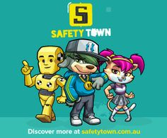  - Pedestrian safety image gallery  - Different Environment Gallery  - Worksheet Hold my hand to keep me safe  - Take home note  - Song, Hands are for holding when you’re crossing the road  - Ebook, Who is out walking?  - Worksheet I am holding hands |  |  | Assessment  Student work samples of painting of holding hands with an adult

Registering for to Safety Town
It is quick and easy to register a Safety Town account. Go to http://www.safetytown.com.au and click the Enter option.
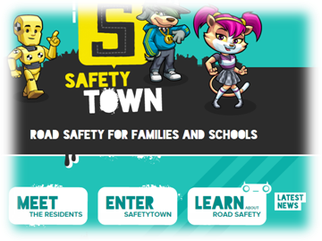

You will be taken to the Activities page. There is a Register option in the top right.
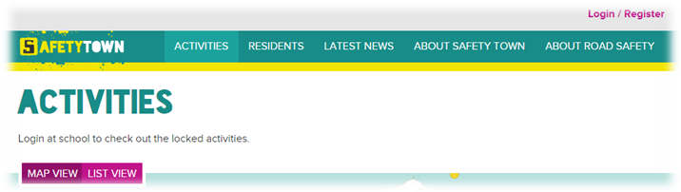

You must have an educational email address to register an account with Safety Town. If you don’t have one and think you should be eligible for an account please contact support@safetytown.com.au
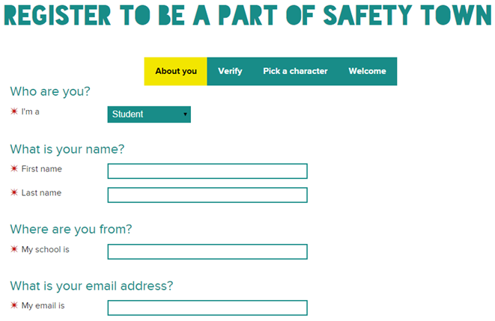

Enter all your details. When you select a school, start typing the name of your school and the list will be populated automatically as you type. Use the down arrows, or press the appropriate option. If you are a Home Schooler, please start typing that and you will see the ‘Home Schooler’ option. Road Traffic Safety educators should use ‘Transport’.
Your password must be at least six characters and contain an uppercase, lowercase, number, and special character.

NOTE: You must choose carefully whether you are a student, teacher or parent as this option cannot be changed after your account is created

When all your information is provided, click the Next, Verify button. You will be informed that a verification email has been sent to your email address.
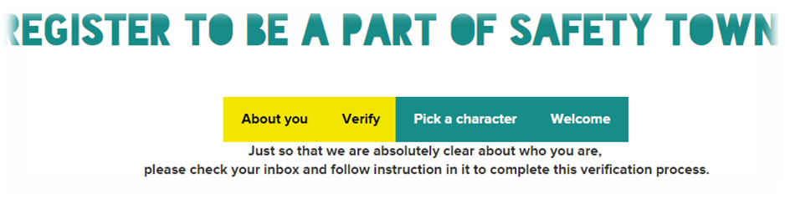
You will now receive an email from Safety Town with an activation link. Copy this link and paste it into your browsers address. You will be taken to the Login page.
One logged in, you have the option of choosing a Safety Town character, name and hobby. The Safety Town character you choose will introduce you to each activity when you choose to do them.
Congratulations and welcome to the Safety Town family. Explore and have fun while learning all about Road Safety!

Logging in to Safety Town

To log into Safety Town go to http://www.safetytown.com.au and click the Enter option.
You will be taken to the Activities page. There is a Login option in the top right.

You are now at the Login page. You can also bookmark this URL to take you directly to the Login page: https://www.safetytown.com.au/accounts/auth/login/
You will be taken to your Profile page.
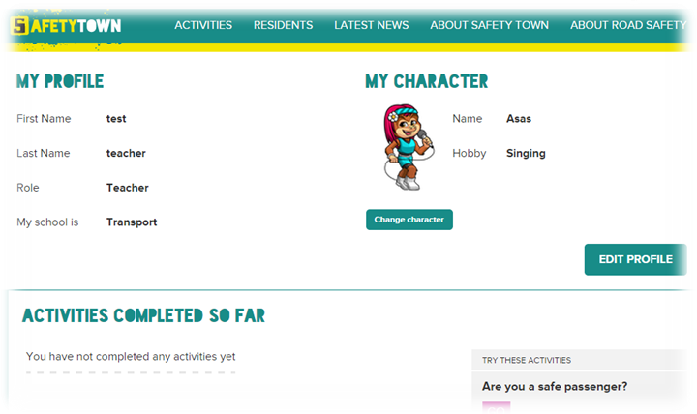
Use the navigation bar at the top to access the site, or try one of the suggested activities that appear on the right side of the page.

Lesson 8 How do I keep safe in the car?

Enduring Understandings | Outcomes |  | Indicators
E.3 We have a responsibility to make good choices so we can live a happy and healthy life. | SLES1.13 Demonstrates an emerging awareness of the concepts of safe and unsafe living  DMES1.11 Identifies some options available when making simple decisions  PSES1.5 Seeks help when needed when faced with simple problems.  V4 Increasingly accepts responsibility for personal and community health |  | - Identifies people who keep them safe  - Observes rules and procedures that keep them safe  - Demonstrates procedures for obtaining information and keeping safe  - Appreciates the need for safe practices in a range of situations and environments
KidsMatter SEL Focus: Major - Responsible Decision Making - Assuming personal Responsibility
Suggested Learning Experiences

Display the Safety Door sticker from the Passenger safety image gallery.

Ask students:
- Where do you think this sticker belongs? How do you know?
- Have you seen this sticker before? Where?
- Do you know what it’s for? Ask students to explain
- Why do you use the Safety Door?
- Where are some of the different places you get in and out of vehicles? e.g. school kiss and drop area, car parks, driveways, side of the road with kerb and gutter or gravel or grass verge, bus stop.
- Who helps you to get in and out of the car safely?
- Why is it important a grown-up helps you?
Play The footpath side song. Students do the actions to the song.

Share the Ebook text, Who is buckled up?
Students share their own passenger experiences by answering the questions at the end of the e-book.

As a group, students read the Ebook, But Why?
Students share their thoughts about the text, e.g. themes, characters and illustrations.
Focus the car trip and the conversation that took place.

Arrange four chairs into a car formation with front and back seats. Students take turns dramatising or acting out the following scenarios:
- A family of five are on a long holiday drive. One child is tired and starts to put his seatbelt under his arm to sleep more comfortably.
- Mum is driving one child to the shops. The child wants to sit in the front seat to see out the windscreen better.
- Grandpa is driving two children to school. They are fighting with each other in the back seat and grandpa is getting angry and distracted.
- Dad is driving his child and three friends to sport training. One of the friends pretends to buckle up.
- A friend says you can get a lift home from school with his family instead of catching the bus. There isn’t a spare seat for you.
- Mum is driving to the shops with three children. When they get to the shops, one of the children doesn’t want to go shopping. She just wants to stay in the car.
At the end of each scenario, discuss:
Why would this be unsafe? What is the safest thing to do?

TW: Wearing a seatbelt shows we are taking responsibility in protecting and caring for ourselves.

Play the song Click clack. Students sing along and perform the action of buckling up their seatbelts.

Resources  - Safety Town Website  https://www.safetytown.com.au/  - Passenger safety image gallery.  - The footpath side song.  - Ebook text, Who is buckled up?  - Ebook, But Why?  - Song, Click clack |  | Assessment  Participation in discussion about safety door and seatbelts.

Lesson 9 How should I wear my helmet and where is it safe to ride and play?

Enduring Understandings | Outcomes |  | Indicators
E.3 We have a responsibility to make good choices so we can live a happy and healthy life. | SLES1.13 Demonstrates an emerging awareness of the concepts of safe and unsafe living  DMES1.11 Identifies some options available when making simple decisions  V4 Increasingly accepts responsibility for personal and community health |  | - Identifies people who keep them safe  - Describes safe places to play  - Observes rules and procedures that keep them safe  - Appreciates the need for safe practices in a range of situations and environments
KidsMatter SEL Focus: Major - Responsible Decision Making - Assuming personal Responsibility
Suggested Learning Experiences

Ask students to look at the pictures on the worksheet Always wear a correctly fitted helmet. Discuss the steps required for a good helmet fit.
Use a child-sized helmet and a student to demonstrate each step of the procedure.
Point out the different parts of the helmet, e.g. adjustable chin straps, buckle, padded outer shell, ventilation holes and compliance label.
Explain to students what a compliance label is and why it is must be on a helmet. (AS/NZ 2063 or JAS-ANZ).

Display the words to the song, Buckle up your helmet.
Sing and learn the song together.
Note: sung to the tune of The Hokey Pokey.
Buckle up Your Helmet
You put your helmet on
You put your helmet on
You put your helmet on
So it fits just right
You hop on your bike
And you go for a ride
That’s what it’s all about!
Oh… Buckle up your helmet
Oh… Buckle up your helmet
Oh… Buckle up your helmet
So it fits just right!

Read the Ebook, Who is wearing a helmet?

Discuss why the people in the ebook are wearing helmets. Students talk about when and where they wear their helmets.
Students complete Worksheet Who is wearing a helmet?, and share with their parents and carers.

Display the photos from Safe places to ride and play and discuss what is safe or unsafe. Explore the safety of this local play area using the questions below.
- Do you think this is a safe place to play? Why? Why not?
- What could be changed or added to make this a safer place to play?
Draw attention to safety features and considerations such as:
- fences
- closed gates
- clear separation from cars and other vehicles
- no broken equipment or damaged fences or gates
- paved pathways for riding
- riding in shady areas and away from water
- an adult should always be there to supervise.

TW: Each person has rights and responsibilities in relation to personal safety. Therefore:
- To keep ourselves safe on the road when riding a bike, we need to….
- To keep others safe whilst we ride our bike we need to…..

Resources  - Safety Town Website  https://www.safetytown.com.au/  - Worksheet Always wear a correctly fitted helmet.  - Photos from Safe places to ride and play  - Ebook, Who is wearing a helmet?  - Worksheet Who is wearing a helmet?, |  | Assessment  Worksheet Who is wearing a helmet?

Lesson 10 How can I use the Internet and Phones safely?

Enduring Understandings | Outcomes |  | Indicators
E.3 We have a responsibility to make good choices so we can live a happy and healthy life. | SLES1.13 Demonstrates an emerging awareness of the concepts of safe and unsafe living  INES1.3 Relates well to others in work and play situations  V4 increasingly accepts responsibility for personal and community health |  | - Role-plays rules and procedures for safe Internet and phone use  - Observes rules and procedures for safe Internet and phone use  - Appreciates the need for safe practices for Internet and phone use
Suggested Learning Experiences
Survey students about home and school internet use. Class discusses when they use the internet and what they use the internet for? For example email, games, listening to music, accessing websites and chat-rooms.
As a class view the video clip on www.cybersmart.gov.au Hector’s World – Episode 1 (Details) and Episode 2 (Welcome to the Carnival).
Present students with the following scenario: “Sam is sitting in his/her bedroom at home. Mum and Dad are in the kitchen making dinner. Sam is learning about celebrations at school and wants to find some pictures about celebrations. When Sam’s information /pictures came up on the monitor a picture of people without clothes on appears.” What should Sam do now? As a class students brainstorm what Sam should do next? Discuss what Sam could have done to avoid the situation.
Class creates a list of rules on how to stay safe online. (Refer to www.cybersmart.gov.au for a more detailed lesson plan.
TW: Students role-play answering both land line and mobile phones. Discuss using these phones. Each person has rights and responsibilities in relation to personal safety. When we answer the phone, we need to be sensible and safe with the things we say.
Present children with appropriate and safe phone use procedure:
- Only answer the phone if you have been instructed to.
- Respond with “hello who is speaking please?”
- If you know who is speaking you may continue the conversation. (Let your parents know who you were talking to)
- If you don’t know who is calling, don’t disclose any information, go and get an adult to speak to the person on the phone.
- If an adult can’t come to the phone you can say: “Mum/Dad can’t come to the phone right now can I take a message?”
- Tell an adult that you have spoken to someone on the phone who you don’t know.
- Give them the message (if there is one)
- Teach children how to call the emergency services 000, allow children to role-play this scenario. (Record role-plays on a video camera and watch as a class.)
HOME TASK:
Children take home a copy of the procedure and practise with their parents.
Resources  - Play phones  - Internet on the computer  - Video camera |  | Assessment  Student role-plays, answering both land line and mobile phones.

Adapted and reproduced with kind permission from: RTA. NSW. (2001). Move Ahead With Street Sense. Stage 1.

TEACHER REFLECTION - UNIT EVALUATION

Unsatisfactory
Satisfactory

Poor
Good

A. A. EVIDENCE
To what extent does the assessment evidence provide:
1. A valid and reliable measure of the targeted outcomes/enduring understandings?
2. Sufficient information to support inferences about each
student’s understanding/level of achievement?
3. Opportunities for students to demonstrate their understandings through authentic learning tasks?
B. LEARNING EXPERIENCES AND INSTRUCTION
To what extent did students:
1. Achieve the outcomes and the enduring understandings of the unit (the big ideas as opposed to basic facts and skills)?
2. Know where they were going and why (in terms of unit goals, requirements, and evaluative criteria)?
3. Deepen their knowledge and understanding of the outcomes & big ideas of the Unit (through inquiry, research, problem solving, and experimentation)?
4. Receive explicit instruction on the knowledge and skills needed to equip them for the required performances?
5. Have opportunities to rehearse, revise, and refine their work based on feedback?
6. Self-assess and set goals prior to the conclusion of the unit?

PTO

1. What did students learn? (What knowlege and skills did they learn to deepen their understanding of the outcomes/big ideas of the unit?)

2. How do you know what they learnt? (What evidence do you have to support your judgement?)

3. What would you refine to improve student learning outcomes?

Student Unit Reflection
Early Stage 1

Student Name: Class:
Unit/Topic:
My teacher is helping me to learn how to keep myself happy, healthy and safe, and will help me write down the important things to remember from the work we have just completed.

One of the things I enjoyed learning about was….  ☺ | One thing I would change is….  ☹
One thing I enjoyed sharing with my family at home was….  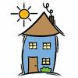 | What things from this unit would I like to learn more about?  

The rating I give myself for how hard I worked in this unit is…
☺ 😐 ☹

