ALL ABOUT MEDICINES/MAKING SAFE CHOICES
Stage: ES1 | Unit Duration: 10 Lessons |  |  |  | Weeks 1 2 3 4 5 6 7 8 9 10 |  | Terms 1 2 3 4
Enduring Understandings  E.1 We all have decisions and choices to make.  E.2 We need to think about our actions.  E.3 Life is a gift from God. |  |  |  |  | Essential Questions:  - What choices can I make to keep myself and others safe and healthy?  - What are the consequences of my choices and who can assist me?
Major Outcomes  Knowledge and Understanding  PHES1.12 Displays basic positive health practices  Skills  DMES1.2 Identifies some options available when making simple decisions  Values and attitudes  V4 Increasingly accepts responsibility for personal and community health |  |  |  |  | Lesson Overview  (Note: Lessons 1-5 are not reproduced in this document for copyright purposes. Refer to the NSW Department of Education and Training (DET) (2002) K–6 Drug Education Resource pp.9-15.) This resource is available for download from The Learning and Teachers Section of the DET website.  1. What keeps us healthy? (E.1,E.2,E.3)  2. Who helps me to stay healthy? (E.1,E.2)  3. What happens when we are sick? (E.2,E.3)  4. How can I stay safe in my home? (E.1,E.2,E.3)  5. What are the rules for taking medicines?  (E.2)  6. How can I make healthy choices? (E.1,E.2)  7. What are the effects of my choices? (E.2)  8. How can I keep my home/school safe and  clean? (E.2,E.3)  9. How can I keep safe around water? (E.2)  10. Who can help to keep me safe? (E.1,E.2,E.3)  KidsMatter SEL Focus  Major: Responsible Decision Making - Assuming personal Responsibility, Responsible Decision Making - Problem-Solving  Minor: Self-Management -Goal setting
Contributing Outcomes
Knowledge and Understandings
SLES1.13 Demonstrates an emerging awareness of the concepts of safe and unsafe living.
Catholic Dimension/Towards Wholeness (TW) (Also refer to overview of TW for this unit)

Personal Health Choices
Throughout our lives, we all face having to make personal decisions relating to nutrition, hygiene, consumerism, drug use and disease prevention. So many conflicting opinions and values influence children in making decisions that have direct relevance to their health and well-being. Taught from a Catholic perspective, this strand seeks to develop the children’s abilities to observe, explore, interpret and judge, informed by an emerging integrated value system that is based on the values of the Gospel.

Safe Living
This strand seeks to develop an ability and a commitment to act in ways that will protect self and others from harm. It emphasises respect for the human person and the development of a co-operative, caring society. Sound Christian decision-making is based on a well-formed conscience which draws inspiration from the life and teaching of Christ and from his Church. Within this strand, students learn to respect the rights of others and to value acceptance, tolerance, justice and personal freedom. They learn that their own decisions have consequences for themselves and others.
Foundation Statement
Students make simple decisions in relation to health and safety and identify medicines and how to store them. They describe balanced eating habits and healthy personal habits as well as safe and unsafe situations at home, on and near roads, travelling to and from school and near water. Students identify people who can help and describe actions such as ‘no, go, tell’ that might be taken in unsafe situations.
Students identify personal characteristics and qualities, and physical changes that have occurred since birth and identify different parts of the body. With self-control, students express feelings and develop positive relationships. They interact and communicate with peers in a variety of play and group situations, listening, sharing and showing concern when working with others.
Suggested correlations with other KLAs  English  - Factual Description  - Observation  - Discussion  - Procedure (Following directions/instructions)  Creative Arts  - Drama – Performing and Appreciating |  |  |  | HSIE  - Social Systems and Structures  - Roles and Responsibilities  - Environments  - Relationships with places, eg home/school
Technology

The following websites have been selected to enhance various concepts being taught throughout this unit. Most of the sites listed can be linked to more than one of the lessons being taught. Teachers may like to add them to the school intranet site.
- http://www.royallifesaving.com.au/www/html/444-games-zone.asp
- http://rileychildrenshospital.com/games/waterwise/waterwise.html
- http://www.cyh.com/HealthTopics/HealthTopicDetailsKids.aspx?p=335&np=288&id=2236
- http://www.homesafetygame.com/
- http://www.cpsc.gov/KIDS/kidsafety/memory/index.html
Subject Matter  Personal Health Choices  Health Services and Products  - People who keep me healthy  - home  - community  - administration of medicines  Drug Use  - Identifying medicines  - Safe use of medicines  - Safe storage |  | Environmental Health  - Keeping the environment clean  - school/home  Safe Living  Personal Safety  - Safe/unsafe situations  - people who can help  - Responding to unsafe situations |  |  |  | Home and Rural Safety  - Hazards inside/outside home  - poisons  Water Safety  - Never swim alone  - Water safety awareness  Emergency Procedures  - Seeking assistance  - Identifying an emergency situation
Unit Evaluation  Sample teacher and student unit evaluations are included at the end of the unit. |  |  | Assessment  Assessment strategies are included throughout the unit.

An Overview of Towards Wholeness (TW) in the PDH Unit
All about Medicines/Making Safe Choices-Early Stage 1
Key God’s Word:
‘God wants us to be safe and will protect us as we come and go now and forever.’(Ps 21:5-8)

‘Caring for one another ... let love make you serve one another. For the whole law is summed up in one commandment. Love your neighbour as you love yourself. But if you act like wild animals, hurting and harming one another then watch out, or you will completely destroy one another.’ (Gal 5:13-15)

We all have the right to feel safe and in possession of full human dignity. Christian decision-making always considers the place of the needy, threatened and outcast.(Ps 12:5; Lk 19:1-10)
Enduring Understandings | Beliefs and Values | Lesson Overview/Links
E.1 We all have decisions and choices to make. | - Each person has rights and responsibilities in relation to personal safety. TW p.41  - We have a responsibility to protect and care for ourselves. TW p.41  - We have a responsibility to protect and care for others. TW p.41  - Our responsibility towards our gift of life is to make lifestyle choices that ensure health and well-being. TW p.35 | 1. What keeps us healthy?  2. Who helps me to stay  healthy?  4. How can I stay safe in my  home?  6. What choices do I make at home and at school?  10. Who can help to keep me  safe?
E.2 We need to think about our actions. | - Each person has rights and responsibilities in relation to personal safety. TW p.41  - We have a responsibility to protect and care for ourselves. TW p.41  - We have a responsibility to protect and care for others. TW p.41  - Our responsibility towards our gift of life is to make lifestyle choices that ensure health and well-being. TW p.35 | 1. What keeps us healthy?  2. Who helps me to stay  healthy?  3. What happens when we are sick?  4. How can I stay safe in my  home?  5. What are the rules for  taking medicines?  6. How can I make healthy  choices?  7. What are the effects of my choices?  8. How can I keep my  home/school safe and clean?  9. How can I keep safe around water?  10. Who can help to keep me  safe?
E.3 Life is a gift from God. | - Life is a precious gift entrusted to us by God. TW p.41  - Life is a sacred gift from God. TW p.35  - The sacredness of all creation. ‘And God saw that it was good.’ (Gen 1:12) TW p.40  - All God’s creation is good and sacred, calling for careful human stewardship. TW p.40 | 1. What keeps us healthy?  3. What happens when we are sick?  4. How can I stay safe in my  home?  6. How can I make healthy  choices?  8. How can I keep my home/school safe and clean?  10. Who can help to keep me  safe?
Lessons 1-5 All About Medicines – Drug Education

NOTE:
Lessons 1-5 are not reproduced in this document for copyright purposes. Refer to the NSW Department of Education and Training (2002) K–6 Drug Education Resource p.9-15.

The K–6 Drug Education Resource is available from the NSW Department of Education and Training from DET Sales:

Phone: (02) 9793 3086
Fax: (02) 9793 3242
Mail: PO Box 218
Bankstown NSW 2200

Or it can be found at
http://www.schools.nsw.edu.au/media/downloads/schoolsdrug/learning/yrk12focusareas/druged/k6_der.pdf and downloaded.

The NSW Department of Education and Training has also produced a resource entitled ‘Out of Reach’. It can be purchased from the above DET sales contact. The kit includes a Big, Book, Teacher manual, audio tape of story and six copies of the book for classroom discussion groups. Of the five lessons in the teacher’s manual two would be useful to include in this unit:
Lesson 2. Identifying hazardous substances.
Lesson 5. People who can help in an emergency.

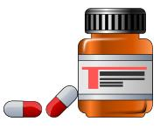

TOWARDS WHOLENESS TEACHING ACTIVITIES

Enduring Understandings | Lesson | Suggested Teaching Activities
E.1 We all have decisions and choices to make.  E.2 We need to think about our actions.  E.3 Life is a gift from God. | 1. What keeps us healthy? | TW: At the end of the lesson, bring the students to the understanding that life is a gift given to us by God. It is our responsibility to look after our own life by making healthy choices about the things we do and the things we eat.  Each student chooses three pictures from inside the healthy body outlines and justifies their choice to a partner.
E.1 We all have decisions and choices to make.  E.2 We need to think about our actions. | 2. Who helps me to stay healthy? | Activity 2, of Lesson 2.  TW: Teacher introduces the belief that we have a responsibility to protext and care for ourselves and others.  Sometimes other people in our lives help us to protect and care for ourselves by helping us to make healthy choices about what we do and what we eat.  Students list who has a healthy influence on their lifestyle and how they influence them.
E.1 We all have decisions and choices to make.  E.2 We need to think about our actions. | 3. What happens when we are sick? | TW: At the beginning of the lesson revise the belief that we have a responsibility to protect and care for ourselves.
E.1 We all have decisions and choices to make.  E.2 We need to think about our actions.  E.3 Life is a gift from God. | 4. How can I stay safe in my home? | TW: Teacher reads ‘Safe Storage of Medicines’ story. Revise the belief that we have a responsibility to protect and care for ourselves and others.  Brainstorm safe ways to store medicines. Discuss how this is acting responsibly.
E.2 We need to think about our actions. | 5. What are the rules for taking medicines? | TW: Teachers revises the need for students to make responsible choices about safety procedures, in order to protect and care for themselves and others.

Lesson 6 How can I make healthy choices?

Enduring Understandings | Outcomes |  | Indicators
E.1 We all have decisions and choices to make.  E.2 We need to think about our actions. | PHES1.12 Displays basic positive health practices  DMES1.2 Identifies some options available when making simple decisions  V4 Increasingly accepts responsibility for personal and community health |  | - Makes simple choices  - Generates a number of possible solutions to a problem  - Identifies good and poor choices  - Values the need to make good health choices
KidsMatter SEL Focus: Minor - Self-Management - Goal setting
Suggested Learning Experiences
Teacher explains the concept of choice – having different things to choose from and the notion of good choices and poor choices.

Students are provided with a situation requiring a choice, eg. what game to play, who to go to for help when hurt, who to ask for help when children are bullying you. Students brainstorm the choices available in each situation.

TW: Revise with the students that the gift of life is given to us by God. It is our responsibility to look after our life by making wise choices about the things we do and the things we eat.
Students brainstorm a list of wise choices and poor choices they have made.

Good Choices Poor Choices
- eating a healthy snack - eating too much junk food
- helping tidy my bedroom - leaving my mess around the house
- being kind to a friend - saying mean things to someone else
- crossing at the school crossing - crossing the road alone
- wearing a helmet when riding a bike - riding a bike near the traffic

Students select three choices that they make at home and school and draw a picture that represents their choices. Teacher selects several students to justify their choices.

Resources  - Letterbox catalogues (food related)  - Drawing paper  - Pencils  - I Can Make Choices Activity |  | Assessment  Teacher observation of student responses in an How Can I Make Wise Choices Activity

Lesson 6 – How Can I Make Good Choices?

Student: ________________________________________

Good choices | Poor choices
_____________________________________________________________________ | ______________________________________________________________________________

This task provides students with the opportunity to demonstrate their level of achievement of the following outcomes:
Outcomes | Indicators | Working Towards | Achieved with support | Achieved
PHES1.12 Displays basic positive health practices | Makes simple choices
DMES1.2 Identifies some options available when making simple decisions | Identifies good and poor choices
Task:
Students draw three good / poor health choices that they make at home or school and teacher scribes.
Lesson 7 What are the effects of my choices?

Enduring Understandings | Outcomes |  | Indicators
E.2 We need to think about our actions. | PHES1.12 Displays basic positive health practices  DMES1.2 Identifies some options available when making simple decisions  V4 Increasingly accepts responsibility for personal and community health |  | - Makes simple choices  - Generates a number of possible solutions to a problem  - Values the need to make good health choices
Suggested Learning Experiences
Teacher tells the class that she/he has forgotten her/his hat today and has playground duty. Students identify the teacher’s problem and brainstorm choices the teacher has. Students identify consequences of each action, eg. not wear a hat on duty – get sunburnt.

Teacher displays a variety of sun hats to the class and students select the hat that best protects the face from the sun. Students identify the parts of the body not protected by each hat and suggest ways to improve the hats.

Teacher introduces the sun safe practices outlined on the Prevention of Skin Cancer Teacher Fact Sheet.

Discuss various skin tones and the need for sun safety regardless of cultural background.

TW: Students draw a picture of themselves and their family doing their favourite physical activity. Teacher reminds the students that good sun safety choices help to keep themselves and others safe. Teacher needs to reinforce sun safety messages by ensuring that students draw themselves and their family with:
- Sunscreen
- A hat
- A shirt with collar and sleeves
- Sunglasses
- Playing in the shade
Resources  - Variety of hat types – visor, legionnaire, cap, straw boater  - Drawing paper and pencils  - Prevention of Skin Cancer Teacher Fact Sheet |  | Assessment  Student’s drawing of themselves wearing sun protection.

Adapted and reproduced with kind permission from: Board of Studies. NSW. (1999). PDHPE Modules. Sydney: BOS. page 218.
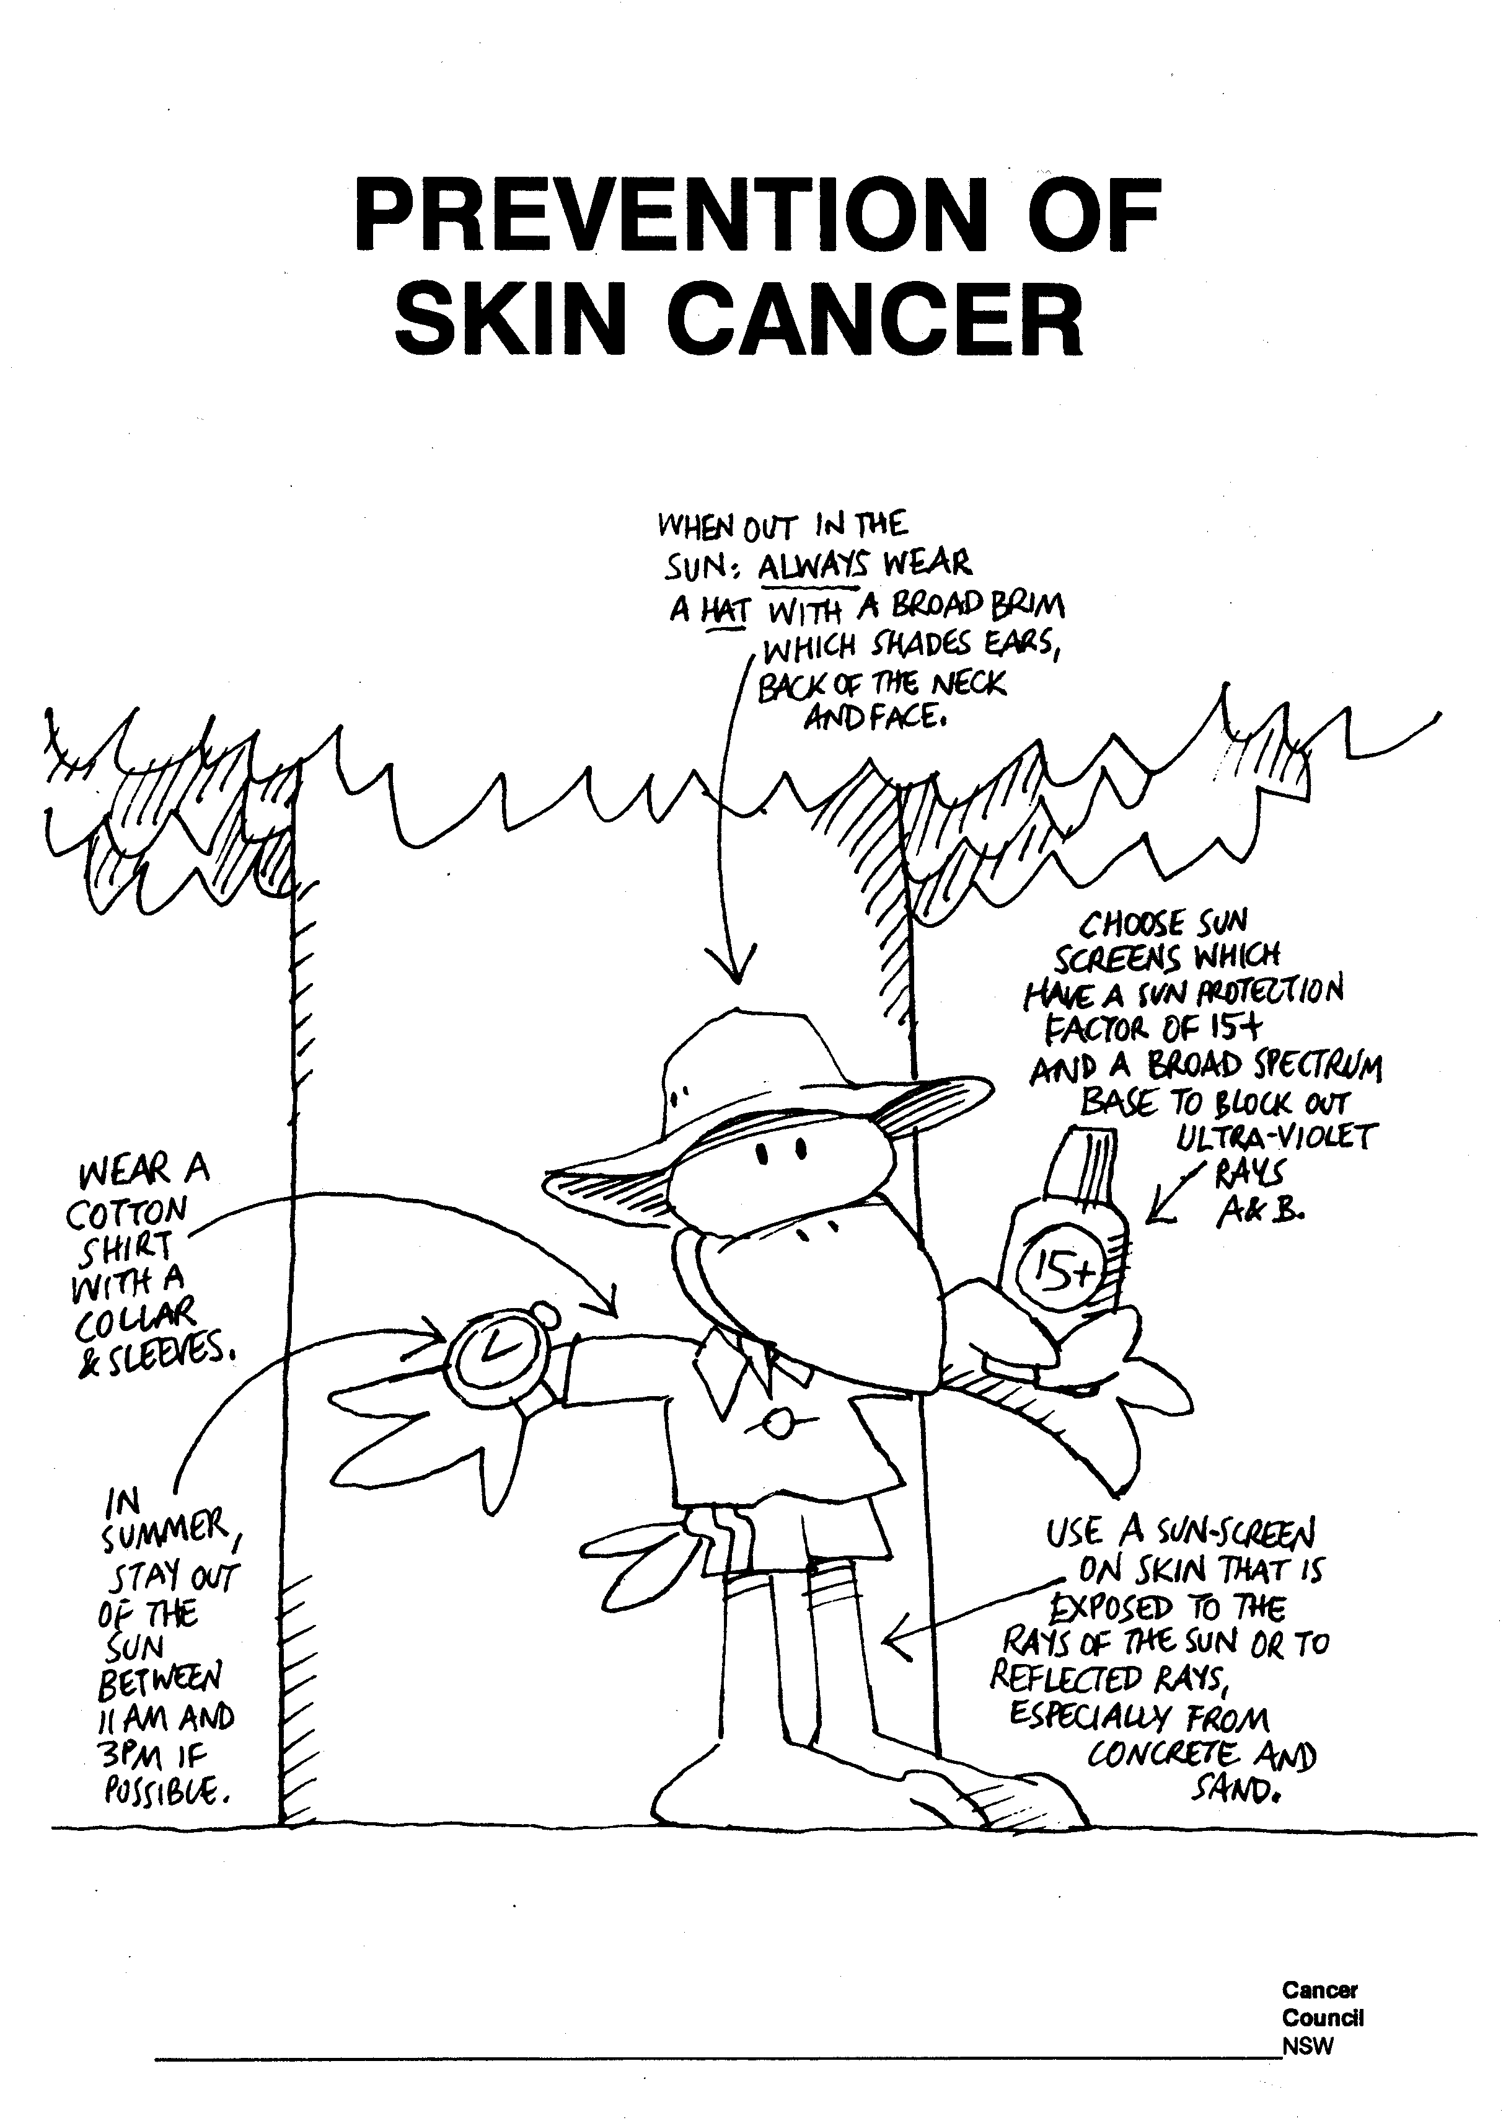

Reproduced from: The Cancer Council NSW.

Lesson 8 How can I keep my home/school safe and clean?

Enduring Understandings | Outcomes |  | Indicators
E.2 We need to think about our actions.  E.3 Life is a gift from God. | SLES1.13 Demonstrates an emerging awareness of the concepts of safe and unsafe living  V4 Increasingly accepts responsibility for personal and community health |  | - Describes safe places to play  - Values the need to make good and safe health choices
KidsMatter SEL Focus: Major - Responsible Decision Making - Assuming personal Responsibility
Suggested Learning Experiences

Students walk around the school to identify and discuss safe and unsafe areas to play. Highlight out of bounds areas and discuss why they are out of bounds. Take digital photos of these areas to label and display in the classroom and around the school. In addition, observe cleanliness of the playground, eg. rubbish, lunch boxes, lost property.

Have a class discussion of safe places to play in and around the home. Students brainstorm a list of these places.

TW: What do we currently do to keep our classroom and playground clean? Why do we need to keep our classroom and playground clean. Bring students to the understanding that all of creation is good. (Read Gen 1:12 ‘And God saw that it was good.’) Talk about the jobs we have in our classroom and as a whole school. All of creation is a gift from God and we are called to care for it through good choices and good actions.
Teacher shows pictures (from sources such as newspaper, magazines or online resources) that show how God’s creation has not been looked after in some environments. Discuss whose responsibility this was, and how they could make it better. Remind students that we need to think about our actions.

HOME: Talk to your parents about jobs/responsibilities that you have, to keep the home clean and safe. Eg. Packing up toys after play time, so that the area is tidy and safe.

Optional: Take a digital before and after photo of a messy then tidy bedroom that the child has personally cleaned up. Email the photo to the class teacher.

Students complete the Clean and Safe Activity. Teacher explains the importance of everyone taking responsibility for keeping our homes/school safe and clean.

Resources  - Digital Camera  - Clean and Safe Activity |  | Assessment  Teacher observation of student responses in Brainstorm Activity and discussions

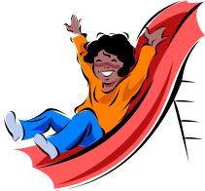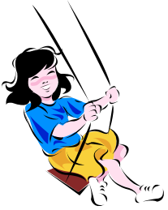

Draw a picture to match each label.

 | Home | School
Safe areas to play

Unsafe areas to play

 | My Classroom | The Playground
What can I do to keep my school clean?

 | My bedroom | Another area
What can I do to keep home clean?

Lesson 9 How can I keep safe around the water?

Enduring Understandings | Outcomes | Indicators
E.2 We need to think about our actions. | SLES1.13 Demonstrates an emerging awareness of the concepts of safe and unsafe living  DMES1.2 Identifies some options available when making simple decisions  V4 Increasingly accepts responsibility for personal and community health | - Indicates a number of possible actions for safety  - Identifies ways to keep safe around water  - Appreciates the need for safe practices around water
KidsMatter SEL Focus: Major - Responsible Decision Making - Assuming personal Responsibility
Suggested Learning Experiences

Teacher shows pictures of water environments – pool, river, beach, dam, bay. Students identify the different types of environments and suggest possible hazards at each environment.
Students brainstorm a set of safety rules for one of these water environments.
TEACHER NOTE: It is important to instill in the students an understanding of the concept of never swimming alone as there is no one to help if you get into trouble.
Use How Can I Keep Safe Around Water Activity. Teacher places each label onto the top of an A3 page for students to illustrate in pairs and make a class book. Students lie on the floor and imagine that they are struggling in deep water at one of the above environments. Students brainstorm possible actions to take.
TEACHER NOTE: ‘Float and Wave action’: FLOAT means to assume a relaxed position in the water, preferably on the back. Don’t panic! WAVE means to raise one arm high in the air and signal for help.
- Teacher mimes the ‘Float and Wave’ action
- Students roll onto their back and mime the ‘Float and Wave’ action.
TW: Bring students to the understanding that by learning a variety of ways to help someone in trouble, we are taking responsibility to protect and care for ourselves and others. ‘God wants us to be safe and will protect us as we come and go now and forever.’ (Ps 21:5-8)
Teacher displays a variety of articles such as buckets, blow up balls, towels, stick, umbrella handle. Students discuss which items could be used to help a person in trouble in the water to float. The teacher demonstrates throwing different items to a partner who is ‘Floating and Waving’. Teacher revises the concept of never swimming alone as there is no one to help.

Students view the Pete and Penny video Safety Around Water.
Resources  - Teacher prepared pictures of aquatic environments  - How Can I Keep Safe Around Water? Activity  - Pete and Penny video Safety Around Water . MBF.  - Kick boards |  |  | Assessment  Students identify ways to keep safe around water
Adapted and reproduced with kind permission from: Board of Studies. NSW. (1997). PDHPE K–6 Teaching Kit. Watch Your Step. Sydney: BOS. page 43.
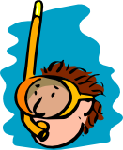

POOL SAFETY

Always walk around the pool

Swim with an adult watching you

Look before you enter the water

Know which is the shallow and deep end

Respect others’ safety

BEACH SAFETY

Swim between the flags

Swim with an adult watching you

Look before you enter the water

Listen for instruction from lifeguards

Slip, Slop, Slap, Wrap

Lesson 10 Who can help to keep me safe?

Enduring Understandings | Outcomes |  | Indicators
E.1 We all have decisions and choices to make.  E.2 We need to think about our actions.  E.3 Life is a gift from God. | PHES1.12 Displays basic positive health practices  SLES1.13 Demonstrates an emerging awareness of the concepts of safe and unsafe living  DMES1.2 Identifies some options available when making simple decisions  V4 Increasingly accepts responsibility for personal and community health |  | - Identifies health care workers who can help them, eg doctors, nurses, dentists  - Identifies people who keep them safe  - Indicates a number of possible actions for safety  - Nominates people who can help in particular situations, eg. in the playground  - Values the need to make good health choices
KidsMatter SEL Focus: Major - Responsible Decision Making - Problem-Solving
Suggested Learning Experiences

In pairs students circle the safe pictures on the Home Safety Check Activity. Students discuss each picture and the possible hazards. Students describe accidents that they have had at home and school. Students try to identify what caused each accident. Student’s brainstorm who helped them in each situation.

TW: Bring students to the understanding that, as part of God’s family, we all have a responsibility to help each other in times of need.
In small groups, students role play how they would deal with a school accident such as falling over in the playground and injuring an arm/leg. Students present their role plays.
Teacher questions students:
- What did you do to help the injured child?
- Who did you go to for help?
- What people in the community help to protect our health and safety? (police, fire, ambulance, dentist, doctor).

Students complete the Community Helpers Activity and draw lines to match community helpers with the health and safety issue, eg ambulance – accident, dentist – broken tooth, house on fire – fire brigade, SES – disasters. Emphasise that these community helpers in the Activity can be done by both men and women. Is a firefighter always a man?

Student’s role play dialing 000 on the telephone and give their name, type of accident, address. Teacher reminds students to stay on the phone until the operator tells them what to do.

Resources  - Home Safety Check Activity  - Community Helpers Activity  - Telephone |  | Assessment  Teacher observation of student participation and responses in role play situation

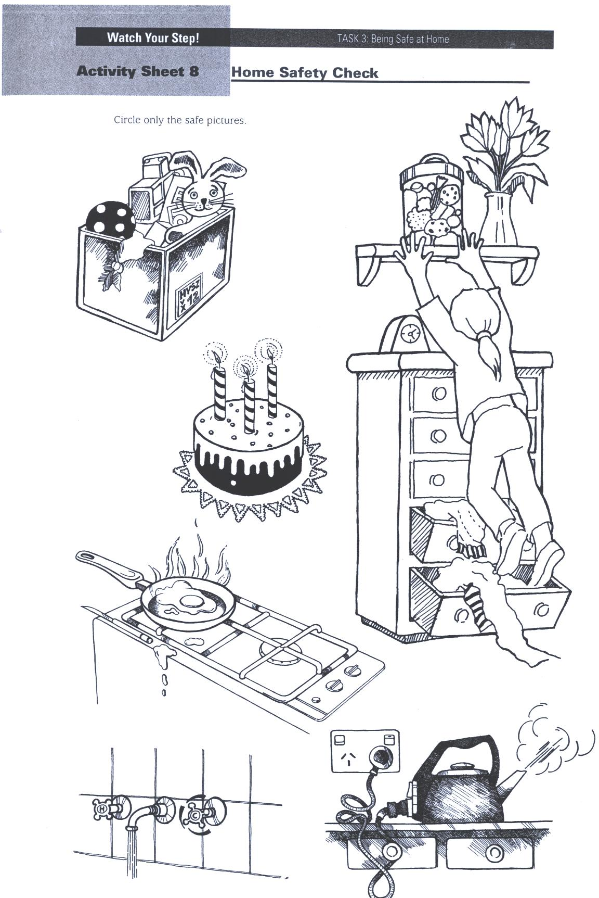

Reproduced from: Board of Studies NSW (1998) Personal Development, Health and Physical Education K–6 Teaching Kit: Interpersonal Relationships; Growth and Development; and Safe Living Stages 1-3.

Match the community helpers with the health and safety issue.
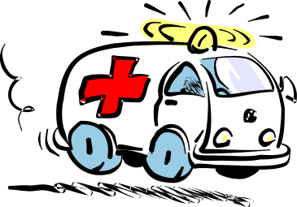
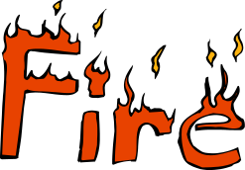

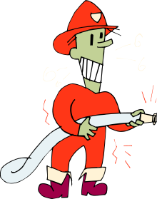
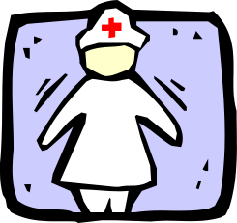
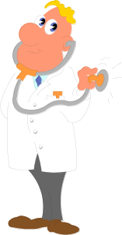
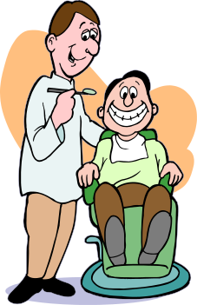
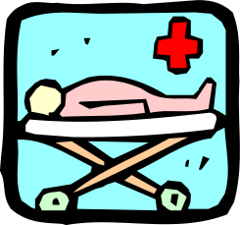
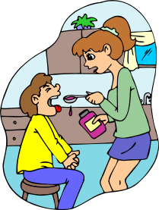
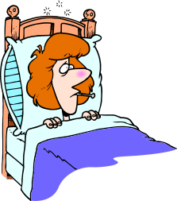
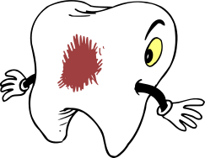

TEACHER REFLECTION - UNIT EVALUATION

Unsatisfactory
Satisfactory

Poor
Good

A. A. EVIDENCE
To what extent does the assessment evidence provide:
1. A valid and reliable measure of the targeted outcomes/enduring understandings?
2. Sufficient information to support inferences about each
student’s understanding/level of achievement?
3. Opportunities for students to demonstrate their understandings through authentic learning tasks?
B. LEARNING EXPERIENCES AND INSTRUCTION
To what extent did students:
1. Achieve the outcomes and the enduring understandings of the unit (the big ideas as opposed to basic facts and skills)?
2. Know where they were going and why (in terms of unit goals, requirements, and evaluative criteria)?
3. Deepen their knowledge and understanding of the outcomes & big ideas of the Unit (through inquiry, research, problem solving, and experimentation)?
4. Receive explicit instruction on the knowledge and skills needed to equip them for the required performances?
5. Have opportunities to rehearse, revise, and refine their work based on feedback?
6. Self-assess and set goals prior to the conclusion of the unit?

PTO
1. What did students learn? (What knowlege and skills did they learn to deepen their understanding of the outcomes/big ideas of the unit?)

2. How do you know what they learnt? (What evidence do you have to support your judgement?)

3. What would you refine to improve student learning outcomes?

Student Unit Reflection
Early Stage 1

Student Name: Class:
Unit/Topic:
My teacher is helping me to learn how to keep myself happy, healthy and safe, and will help me write down the important things to remember from the work we have just completed.

One of the things I enjoyed learning about was….  ☺ | One thing I would change is….  ☹
One thing I enjoyed sharing with my family at home was….   | What things from this unit would I like to learn more about?  

The rating I give myself for how hard I worked in this unit is…
☺ 😐 ☹

